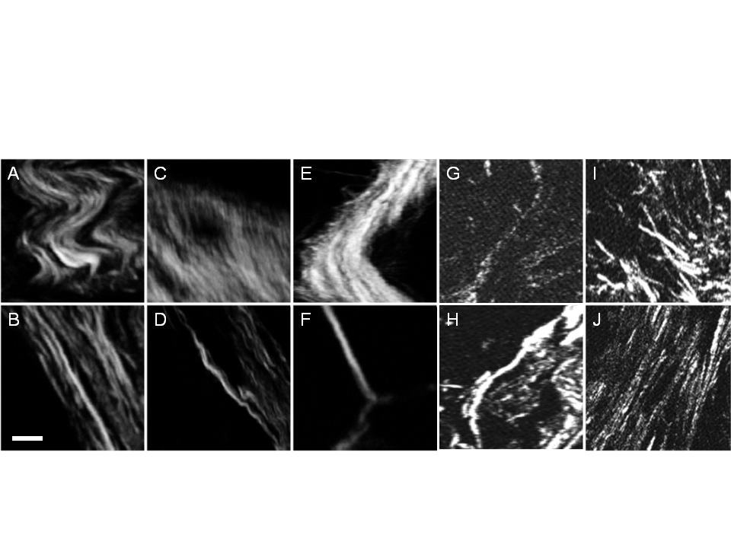

Figure . Representative collagen patterns observed in human breast cancer tissue sections demonstrating the heterogeneous nature of collagen structure. Wavy (A) and straight (B). Dense (C) and well defined (D). Thick bundles (E) and thin strands (F). Discontinuous (G) and continuous (H). Crossing (I) and parallel (J). Scale bar is 10 microns.

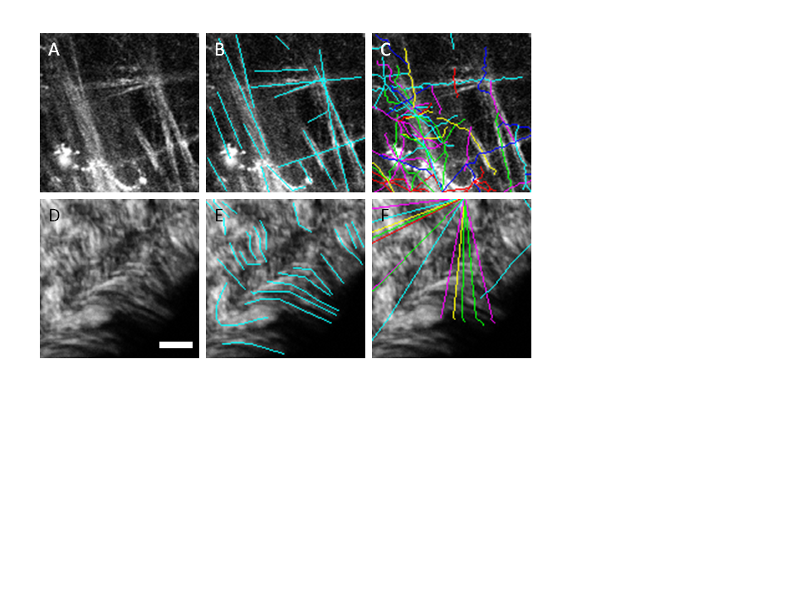

Figure . Fibers extracted by the FIRE algorithm alone without preprocessing. A and D are the original images, B and E show manual segmentations of the fibers, D and F show the automatic fiber segmentations that are extracted by the FIRE algorithm and show many falsely segmented fibers. Scale bar is 25 microns.

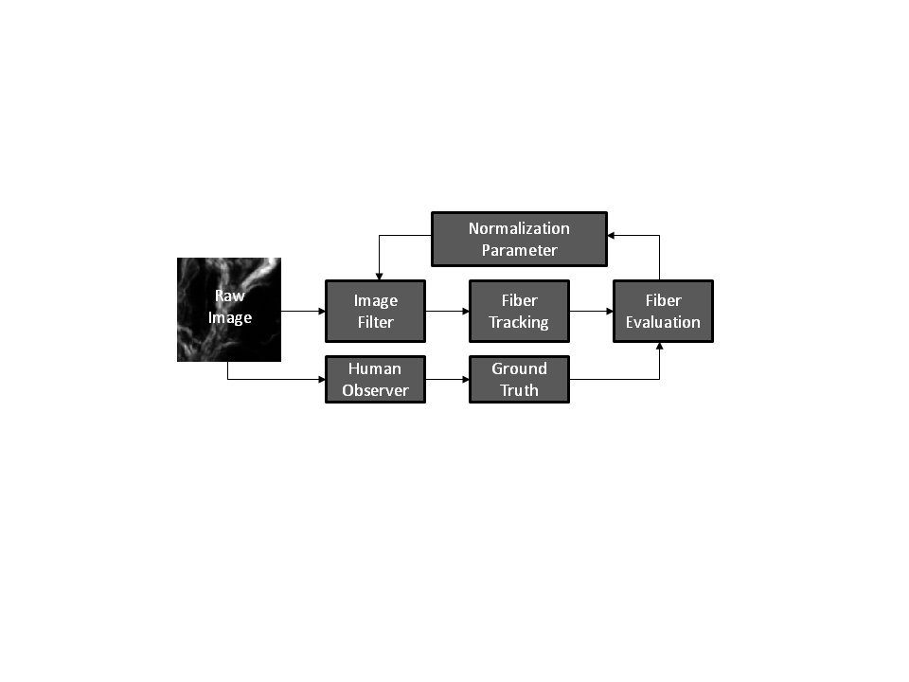

Figure . Diagram of the approach for quantitative collagen analysis showing the iterative process for optimizing the performance of a single image processing filter for fiber tracking. The raw image is processed by the image filter using an initial normalization parameter, the result of which is sent to the FIRE fiber tracking algorithm. Automated fiber extractions are compared against manually performed fiber extractions. Several normalization parameters are evaluated and one optimal parameter was selected for each filter that optimized the fiber evaluation result.

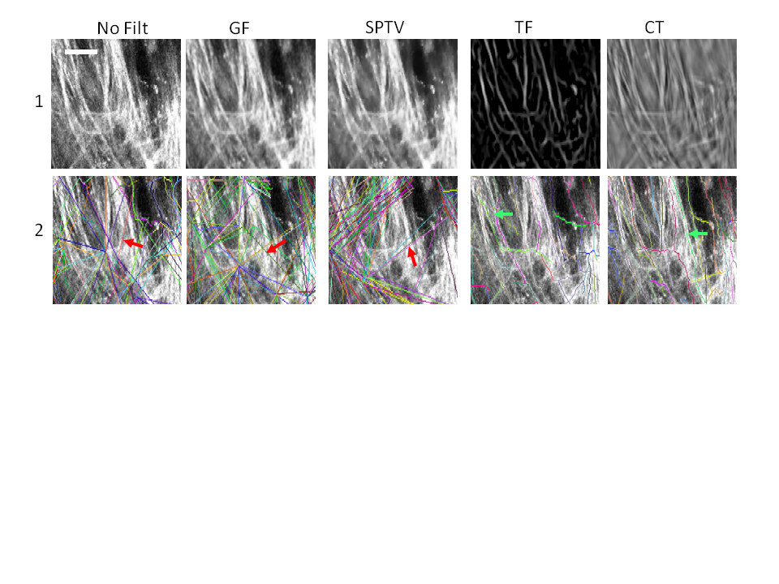

Figure . Output of the image processing techniques (row 1) and output of the fiber tracking algorithm (row 2) for a single test case. The first column is without a filter, column 2: GF, column 3: SPTV filter, column 4: TF, and column 5: CT. Scale bar is 25 microns.

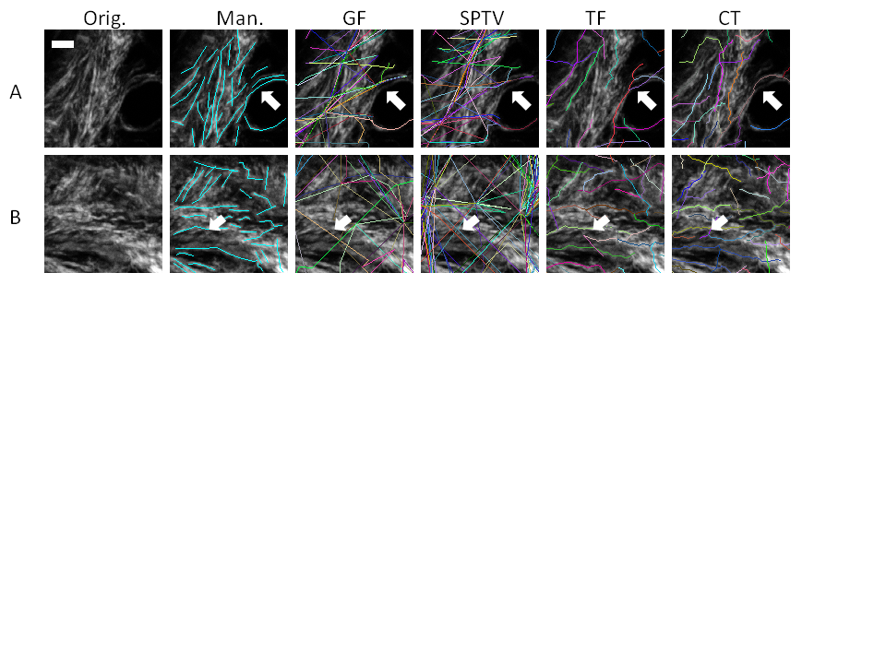

Figure . Two test cases (A&B), showing different processing methods in each column. The original image (column 1) is shown overlayed with a manual segmentation (column 2), GF (column 3), SPTV (column 4), TF (column 5), and CT filter (column 6) where each filter is followed by FIRE fiber extraction. Scale bar is 25 microns. 

Figure . F-measure, recall, and precision results comparing the automated segmentation techniques to the manual segmentations of three independent raters, for 25 test cases, representing a total of 9290 fiber evaluations. The error bars indicate the standard deviation between average F-measure, recall and precision scores of each of the raters. Recall is the fraction of relevant fibers that were found. Precision is the fraction of fibers found that were relevant. F-measure is the harmonic sum of recall and precision.





Figure . Distribution of lengths (top row) and angles (bottom row) of all fibers in all simulated test cases. Ground truth data is on the left and the results of the automated CT+FIRE algorithm are shown on the right.

# Supplemental Figures



Figure . Parameter optimization for F-measure score. We optimized one parameter in each algorithm to maximize the F-measure score. In this case, we would select parameter setting 4 for CT, 2 for TF, 4 for STV, and 1 for GF. We used this method tried to find a global maximum for the parameters used in each algorithm. The parameter that was adjusted for each algorithm is described in the methods section.