# Title Page

**Perforce Notes**

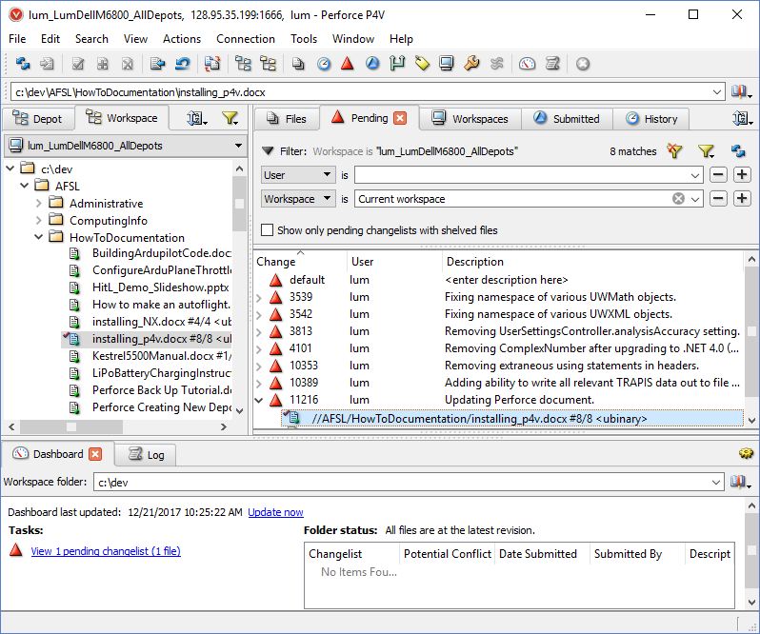

Figure : P4V interacting with UWAFSL files.

## Publication Number

AFSL-2015-15

See \\AFSL\TechnicalDataPackage\AFSLPublicationNumbers.docx for list of publication numbers.

## Date of Issue

April 5, 2018

# Record of Manual Revisions

Table : Record of manual revisions

|  |  |  |  |  |  |  |
| --- | --- | --- | --- | --- | --- | --- |
| **Revision** | **Date** | **Pages Affected** | **Revisions** | **Author** | **Check** | **Approved** |
| 1 | 05/20/16 | All | Created document | Christopher Lum |  | Christopher Lum |
| 2 – 8 | various | Various | See Perforce |  |  |  |
| 9 | 12/21/17 | Various | Consolidated all files into a single document | Christopher Lum |  | Christopher Lum |
| 10 | 12/22/17 | Various | Adding links to YouTube videos | Christopher Lum |  | Christopher Lum |
| 11 | 01/12/18 | Various | Moved notes from new member orientation document to this doc | Christopher Lum |  | Christopher Lum |
| 12 | 04/05/18 | Various | Moving document location and consolidating notes on Perforce | Christopher Lum |  | Christopher Lum |

# Table of Contents

Contents

1. Title Page 1

1. Publication Number 1

2. Date of Issue 2

2. Record of Manual Revisions 2

3. Table of Contents 3

4. Nomenclature & Glossary 4

5. Introduction 5

1. Other Documentation 5

6. Installing P4V 6

7. Using Workspaces 7

1. Creating a New Workspace 7

2. Modifying a Workspace 14

3. Workspaces on Macs 15

8. Basic Operations with Perforce 16

9. General Notes 16

10. Administrative Operations 18

1. Creating a New Depot 18

2. Installing a New License 19

3. Setting up a Perforce Server 20

4. Backing Up a Perforce Server 20

5. Changing Passwords 31

11. Perforce Company Contact Information 32

12. Bibliography 34

# Nomenclature & Glossary

Table : Nomenclature and glossary of terms

|  |  |  |
| --- | --- | --- |
| **Term** | **Definition** | **Comment** |
| AFSL | Autonomous Flight Systems Laboratory |  |
| P4V | Perforce Visual Client | Small client application that is installed on client computers so they can communicate with the Perforce Server. |
| UW | University of Washington |  |

# Introduction

This document records notes regarding how to utilize Perforce within the UW AFSL.

## Other Documentation

* None

# Installing P4V

1. Go to <http://faculty.washington.edu/lum/AFSL/> and download either “p4vinst.exe” or “p4vinst64.exe” (depending if you are on a 32 or 64 bit version machine). Note that AFSL only support Windows machines[1].
2. Double click on the .exe to start the install process. You should see a welcome screen similar to Figure 2.

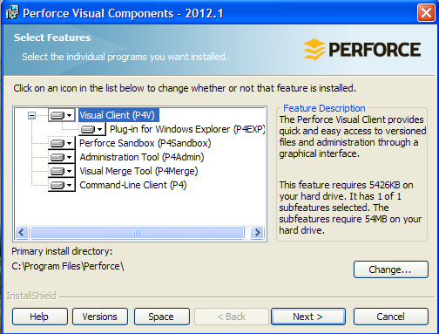

Figure : installation welcome screen.

1. It is easiest to install all components so simply click “Next” to continue.
2. You should next be brought to a screen where you can configure the client properties. Change the server to “128.95.35.199:1666” (IP address of 128.95.35.199 and port 1666) and put in a dummy value for the user name (we will set this correctly later). Your screen should be similar to Figure 3.

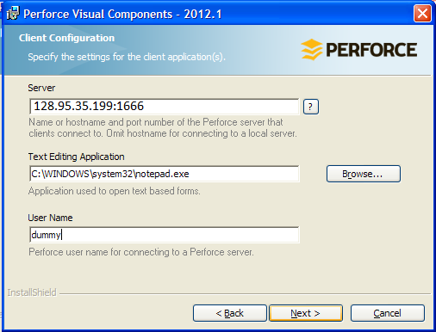

Figure : Client Configuration screen.

1. Click continue/next several times to begin the install.
2. When the install finishes, click “Finish” to close the installer.

# Using Workspaces

The AFSL Perforce server houses thousands of files for multiple projects. To avoid downloading all these files, one needs to specify which files you would like copied to your local machine. This list of files is called a “workspace”.

A YouTube video outlining creating a workspace is located [here](https://youtu.be/Yvgxx2vwsRY).

## Creating a New Workspace

1. Launch the P4V application (sometimes it is installed in the “Perforce” folder, Figure 4)

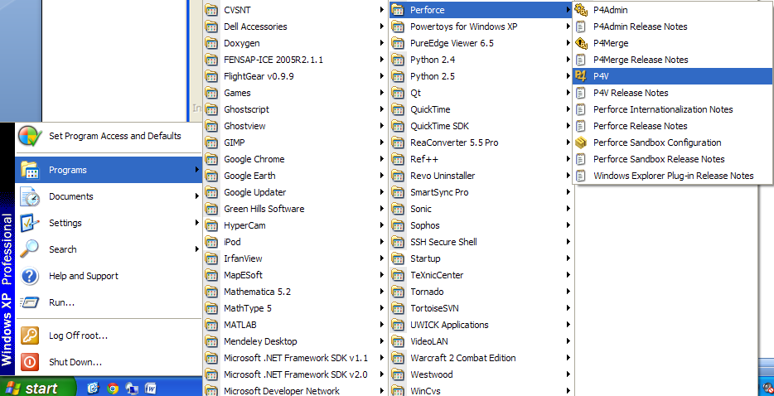

Figure : Launching the P4V application

1. It may prompt you to run a connection wizard (Figure 4), press “Skip” to bypass this process (we will setup the connection later)

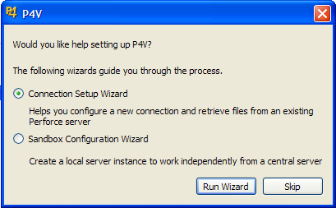

Figure : Skip the connection setup wizard

1. You will now setup your connection. On the resulting window, ensure that the server IP address and port are appropriate (see previous instruction). To select the User, click on “Browse…” and in the resulting window, select your name (Figure 6).

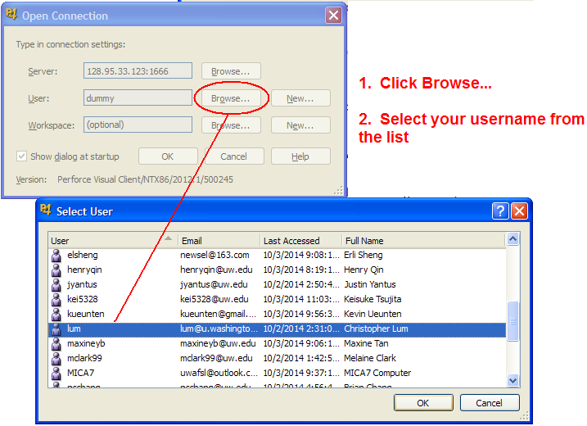

Figure : Choosing the user name

1. At this point, you may want to obtain assistance from a more experienced lab member to help walk you through the remaining steps.
2. Create a folder on your hard drive where we will store all files downloaded from the server. It is recommended that you make the path short (for example, D:\afsl as shown in Figure 7).

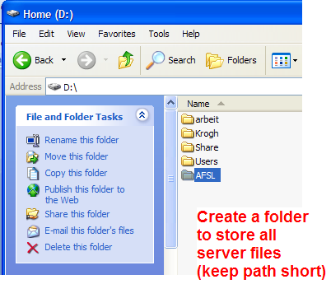

Figure : Create a folder on your machine to store all server files (keep path short)

1. Return to P4V and create a new workspace by clicking on “New…”.
2. Change the “Workspace root” to the folder you just created on your hard drive. This tells Perforce where to download all files to.
3. Open up the “Workspace mappings” (click on the triangle) and ensure that the appropriate depots are selected. Some things to note:
   1. A depot is a collection of files that are part of a specific project.
   2. A workspace is simply a list of depots that you would like to sync to your local machine.
   3. Note that the depots shown in Figure 8 are old and may not be the most appropriate mapping.
   4. If you do not want to select everything, right click on the depot you do not want and select ‘clear’ to remove it from your workspace (effectively saying that you do not want to download this from the server).
   5. You can always modify your workspace later so getting the list of depots correct at this point is not crucial.
   6. You may want to obtain guidance from a lab member with more experience to select the appropriate depots for your work.

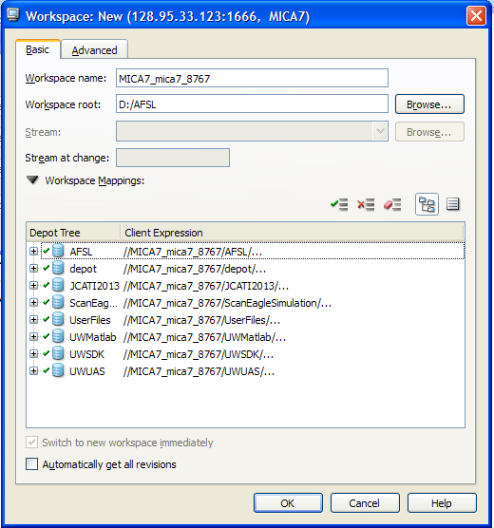

Figure : Setting up basic workspace settings

1. Click on the “Advanced” tab and check “compress” and “rmdir” (Figure 9).
   1. For Macs delete everything from the “Host” box, and leave it blank.

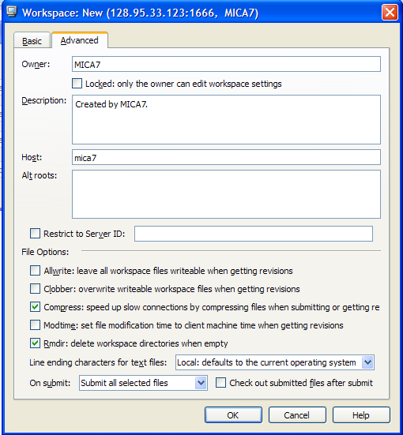

Figure : Setting up advanced workspace settings

1. Click “OK” to create the workspace.
2. Click “OK” to launch the P4V with you logged in and with the workspace you just created.
3. You may need to turn on the “Dashboard” in P4V. To do this, select “View > Dashboard” (Figure 10). The dashboard will appear in the bottom left.

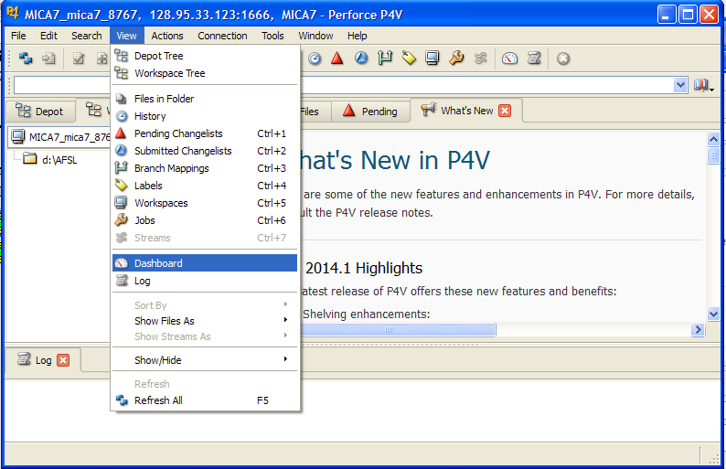

Figure : Turning on the “Dashboard”

1. Click on “Get latest revisions” then “Get revision” to begin downloading files to your machine (Figure 11). Note that this first download may take a long time depending on the number of files. You should do this on a fast internet connection (subsequent interactions will only download changes and will go much faster).

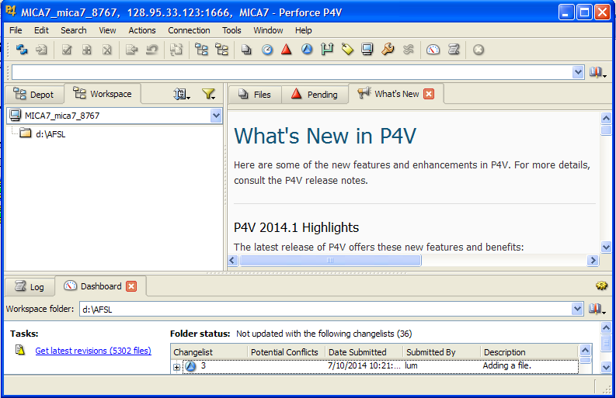

Figure : Click “Get latest revisions” to download all files.

## Modifying a Workspace

One can modify an existing workspace to include or exclude files.

A YouTube video outlining how to modify a workspace is located [here](https://youtu.be/m5huqed5uNc).

1. Open P4V and ensure that the “workspaces” tab is open (View > Workspaces).
2. Find the workspace you would like to modify (note that you may need to manipulate the filters to find the desired workspace).
   1. Right click > Edit Workspace
3. In the resulting window, find the desired depot and right click > Include Tree > OK (Figure 12).
4. Select ‘Get Latest’ to download files.

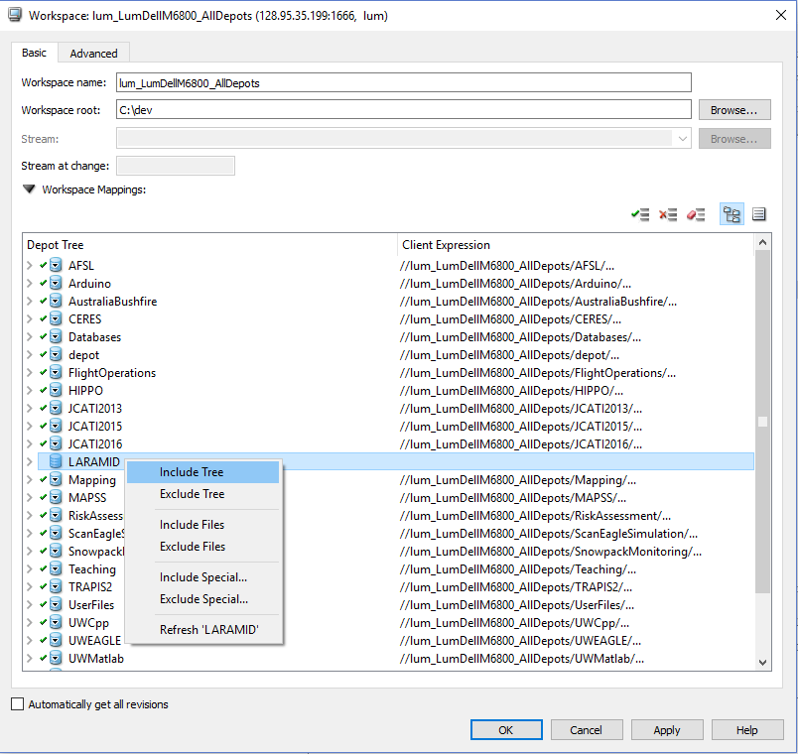

Figure : Including the ‘LARAMID’ depot to the workspace.

## Workspaces on Macs

**Problem Description**

Perforce uses an ID or ‘hostname’ to identify workstations. Unfortunately, the hostnames of Mac computers are, by default, dependent on the Internet network your computer is connected to. For instance the UW network will automatically change the hostname from “myname.local” to “[UW generated ID].dhcp4.washington.edu”

To ensure that Perforce correctly identifies your workstation it is necessary to manually change back to the hostname that Perforce is expecting.

Note that your hostname <myname.local> should be unique so generic hostnames like “user.local” or “mac.local” may cause problems.

**Fix**

1. Open a terminal window
   1. [Permanent] type “sudo scutil --set hostname <myname.local>” and press *enter*.
   2. [Temporary] type “sudo hostname <myname.local>” and press *enter*.
2. The system will prompt you for an administrator password – type it in and then *enter*.
3. Confirm the hostname has been updated by typing “hostname” then *enter*.

Note that the temporary fix will allow the hostname to change each time you connect to a network so you will have to manually override it again (and again, and again…).

**Source**

* <http://answers.perforce.com/articles/KB/2985>
* <http://superuser.com/questions/49891/how-can-i-stop-mac-os-x-overriding-my-hostname-when-i-receive-a-dhcp-request-on>

**Another Method (Workspace for Mac)**

Download P4V from: <https://www.perforce.com/downloads/helix-visual-client-p4v>

You can skip the registration. If you want to register, the company name is “University of Washington” and the role is “student”

Open the P4V application after downloading.

Then follow the steps outlined in this Document.

# Basic Operations with Perforce

A YouTube video outlining how to perform basic operations with Perforce is located [here](https://youtu.be/_5_LK_0H22I).

# Deleting a Perforce Workspace

A YouTube video outlining how to delete a Perforce workspace and associated files is located [here](https://youtu.be/dHMXgDzV1Hc).

# General Notes

* Files that are managed by Perforce are ‘Read only’. Do not remove ‘read only’ property using Windows Explorer! If you would like to edit a file, you MUST check them out through P4V which in turn will remove the ‘read only’ status and allow you to edit the file.
* Remember that you are working on a large, distributed team
  + Recall that any changes you make will be mirrored on every else’s machine.
  + Do NOT use hard coded paths for code or other references. For example, something like “filePath = ‘C:\lum\documents\AFSL\HowToDocumentation\myFile.docx’ “ is a bad idea because this file will not be in the same location on everyone’s machine. Therefore use relative directory addressing whenever possible.
* Do not check out binary files if someone else already has them checked out (see Figure 13).
  + If you are working on a binary file, you can lock the file (right click on file and select ‘Lock’) to ensure others do not attempt to check this out.
  + When working with binary files, check these back in ASAP as other people cannot use the file until you check it back in.
* Storage space on Perforce is valuable. Once you check something into Perforce, it will reside on the server’s hard drive forever, even if you delete it. Therefore do NOT check in large files or data sets into Perforce. For large data sets, use the lab’s network drive (see the dedicated section of this document for more details).

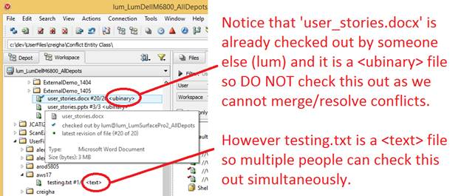

Figure 13: Do not check out binary files if someone else has them checked out already.

# Administrative Operations

The following sections discuss administrative operations with Perforce. General lab members do not need to read these sections.

## Creating a New Depot

Creating a new depot must be done on the server by an administrator. In this example, we create a depot called "UWSDK"

1. Open P4Admin > File > New > Depot. Choose to create a local depot. You should see the new, empty depot appear as shown in Figure 14.

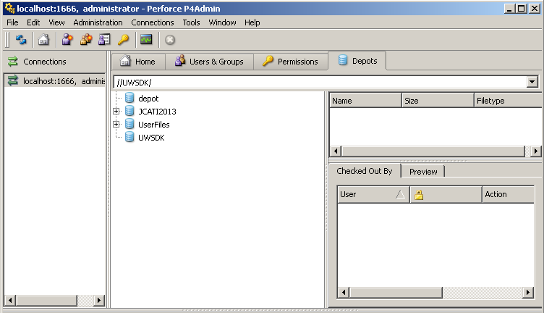

Figure : New, empty depot called ‘UWSDK’ on the server.

1. Open P4V and edit the workspace to include this new depot (see Section 2 to modify a workspace).

At this point you may encounter the following:

* + A message similar to "P4V is having trouble translating the location … to a valid workspace location. To filter using this location, drag the folder from the workspace tree to the workspace folder field or include the depot location in your workspace view." (Figure 15)
  + You will not be able to add files to a changelist at this point.

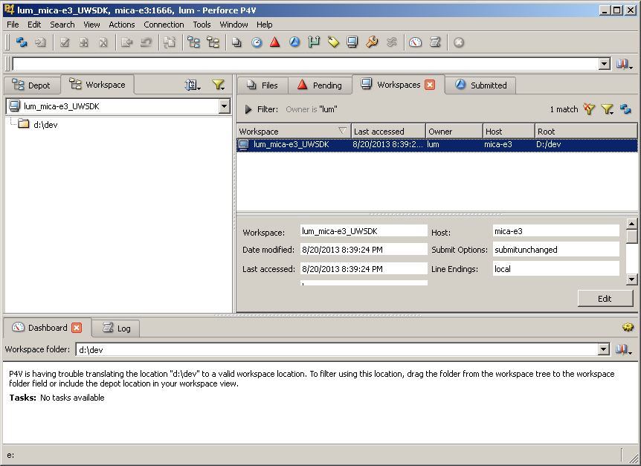

Figure : Trouble translating the workspace.

The problem is that within the workspace root, Perforce is expecting there to be a folder with the same name as the depot (in this case 'UWSDK')

1. To fix this, create a folder with the same name as the depot (in this case create a folder called 'UWSDK' within D:\dev\)
2. Add files within this folder, add them to a changelist, and submit in order to populate the depot.
   * Note: The depot will not be usable until the first changelist is submitted in this fashion.

## Installing a New License

If the license expires, you will need to request a new license from Perforce (see Section 11 for contact info).

If you change IP address or port number of the server, you may need to request a new license (<http://www.perforce.com/change-server-request> ).

In either event, you will then need to reinstall the new license.

### Method 1: Simple Installation

1. Obtain a new license file and save/rename this as ‘license’ (with no file extension).
2. Stop the Perforce server by running ‘p4 admin stop’ from the command line. If this does not work, simply skip this step and proceed.
3. Replace the existing ‘license’ file with this new one.
   1. The file is likely located in the ‘C:\Program Files\Perforce\Server’
4. Restart the computer.
5. Verify that the server has installed the new license.

If the above process does not work, you may need to use ‘Method 2: Complicated Manual Installation’

### Method 2: Complicated Manual Installation

1. 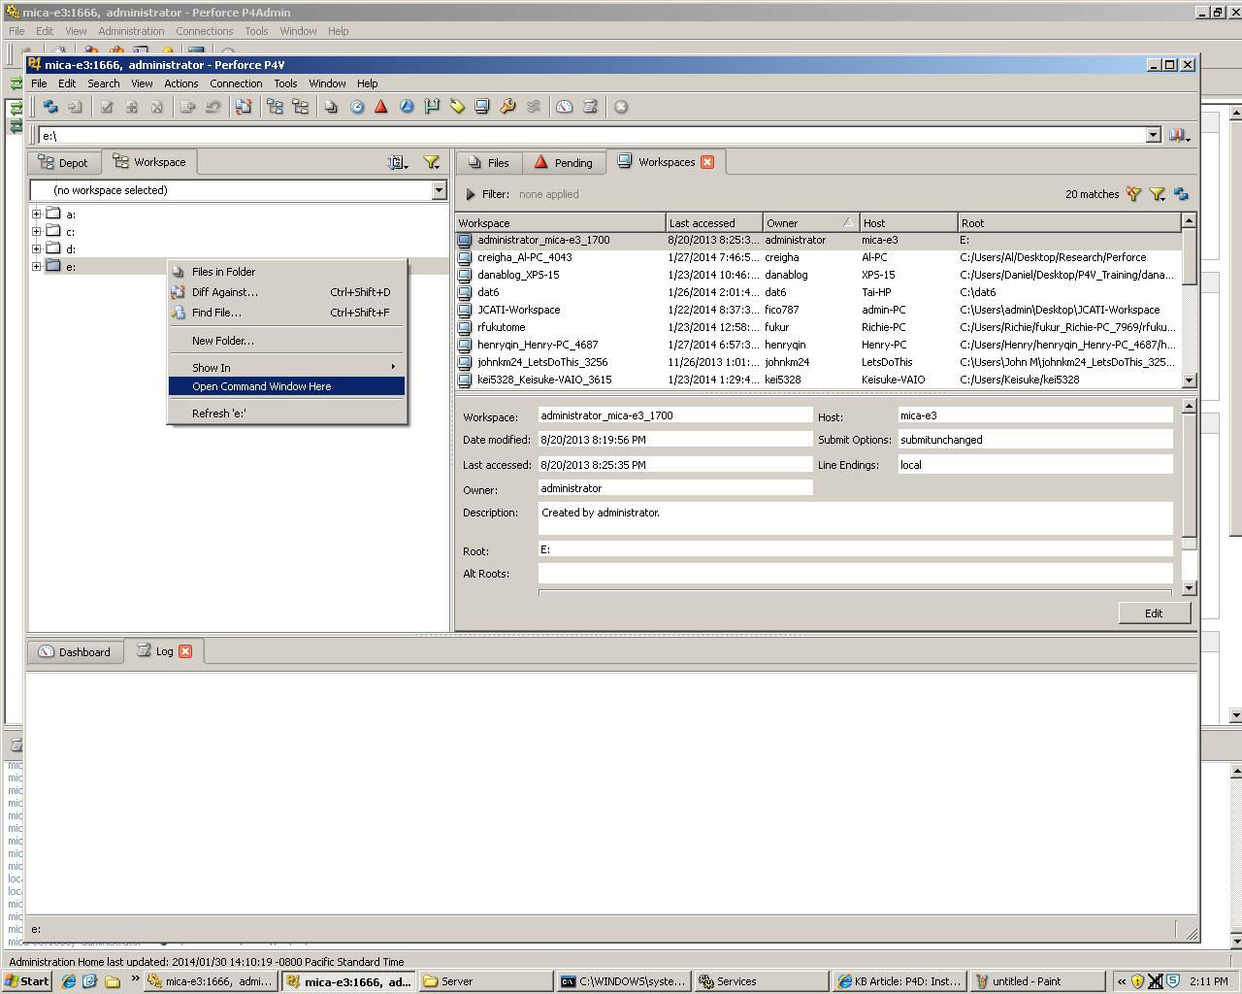Right-click on workspace, and open command window:
2. Type in “p4 admin stop” in the command window to stop the perforce server.

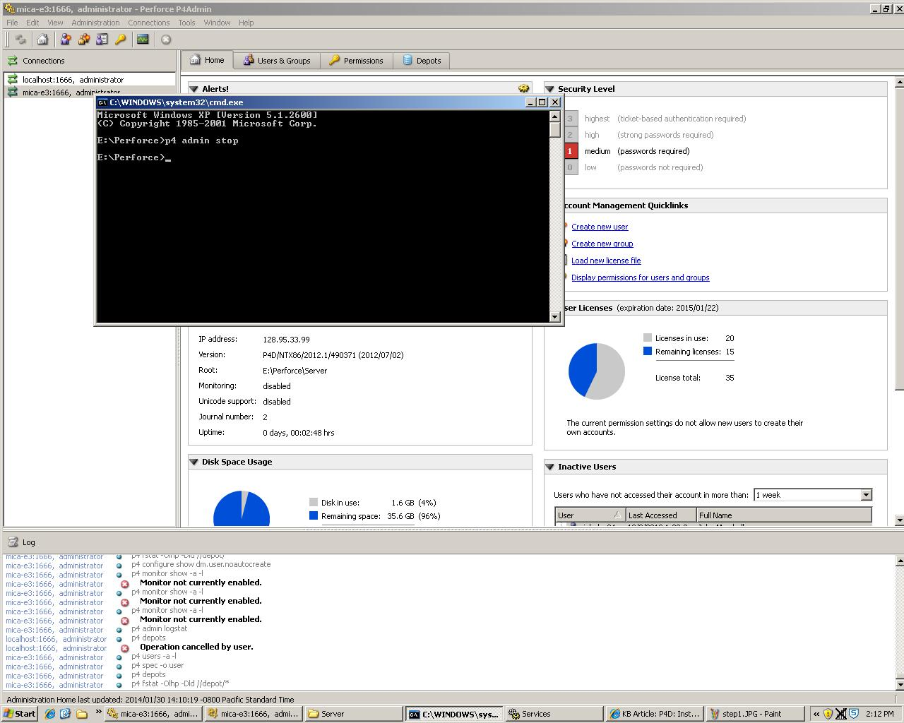

1. 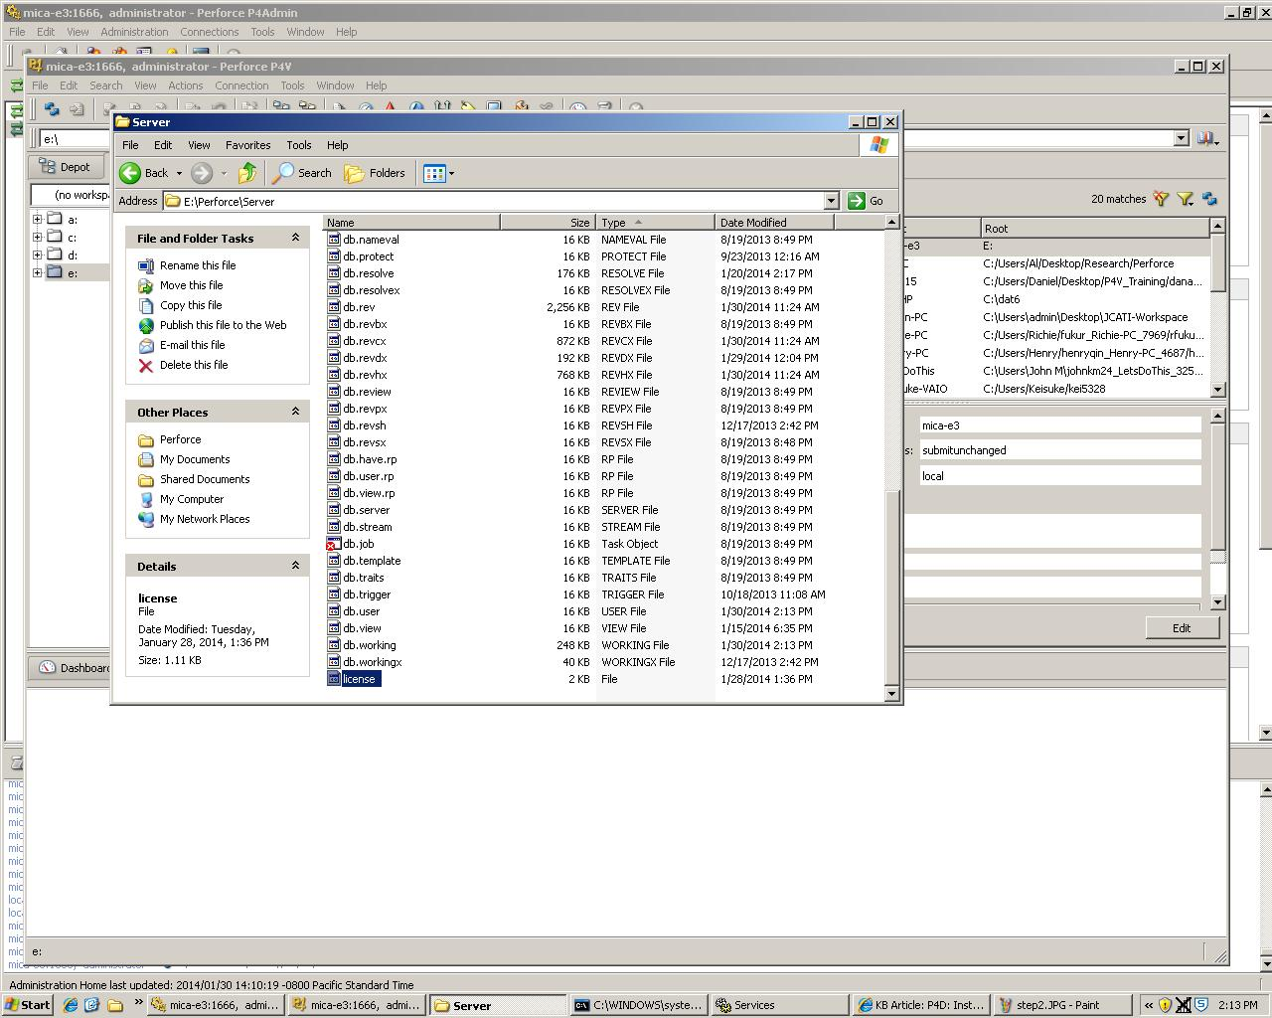Locate the Perforce root directory (i.e. E:\Perforce\Server folder). Replace the old license file with the new one, and rename the new license file as “license” with no other extensions.
2. 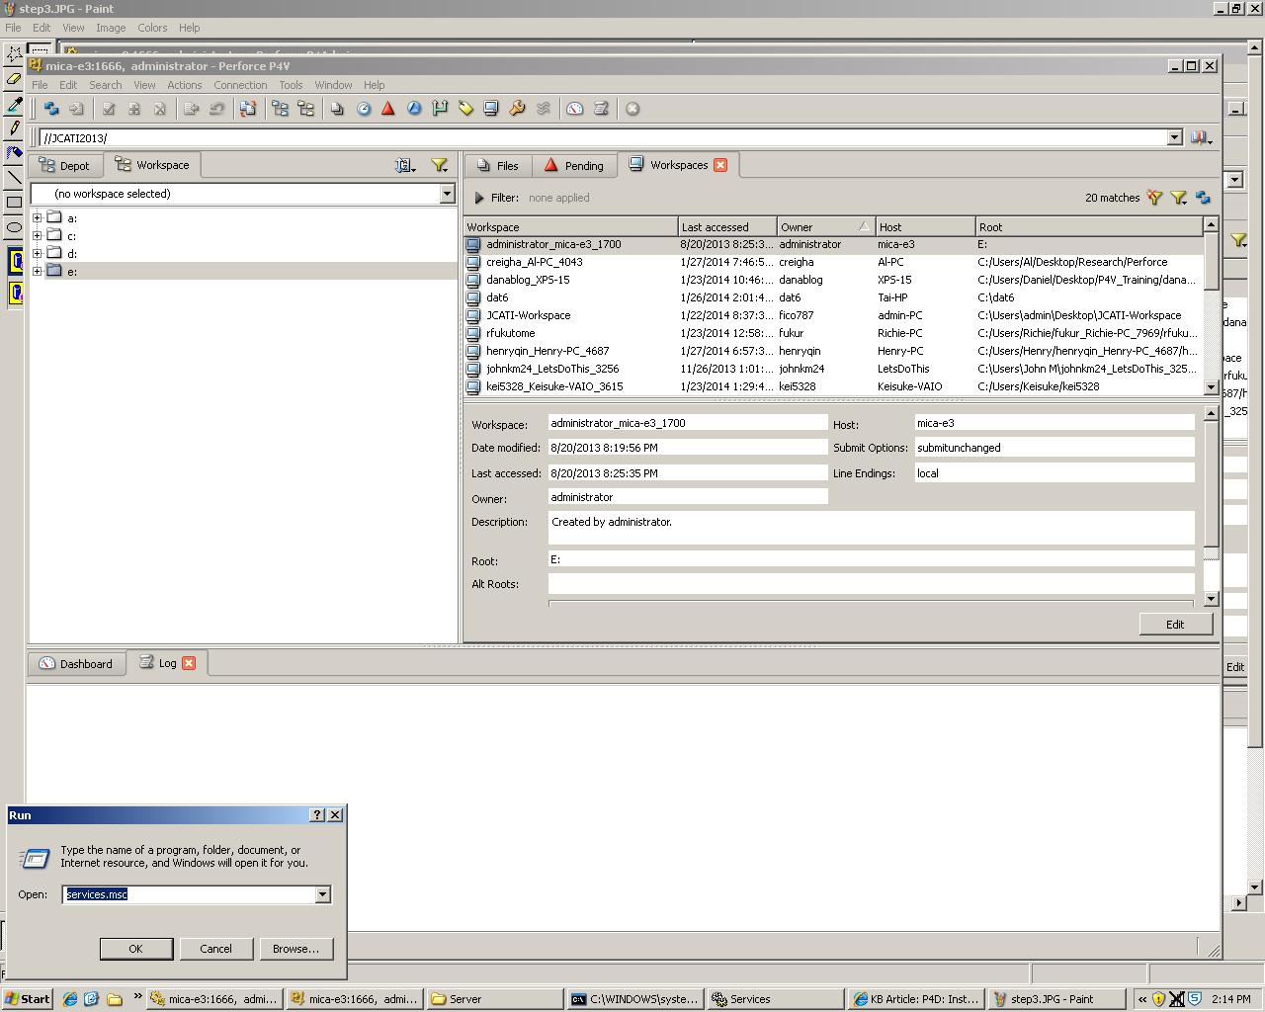 Go to the Services control panel (Start > Run, type 'services.msc' and hit enter).
3. 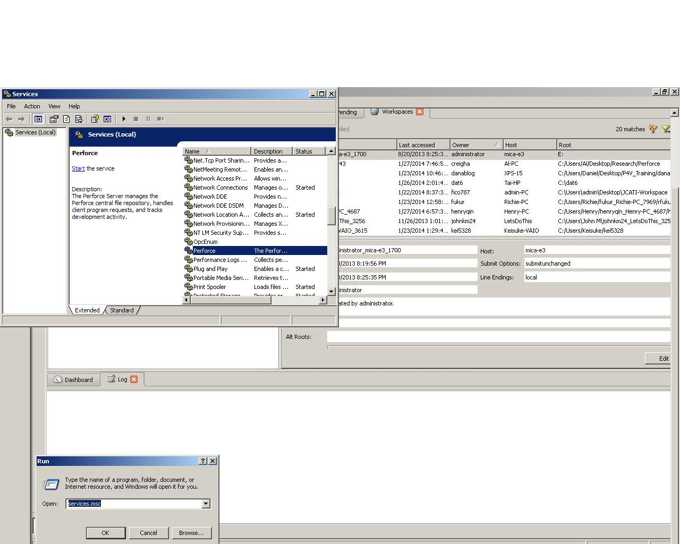Scroll to the Perforce server entry, then right click and select 'Start'.

Perforce should then automatically pick up the new license file. To check the installation, you can do the following

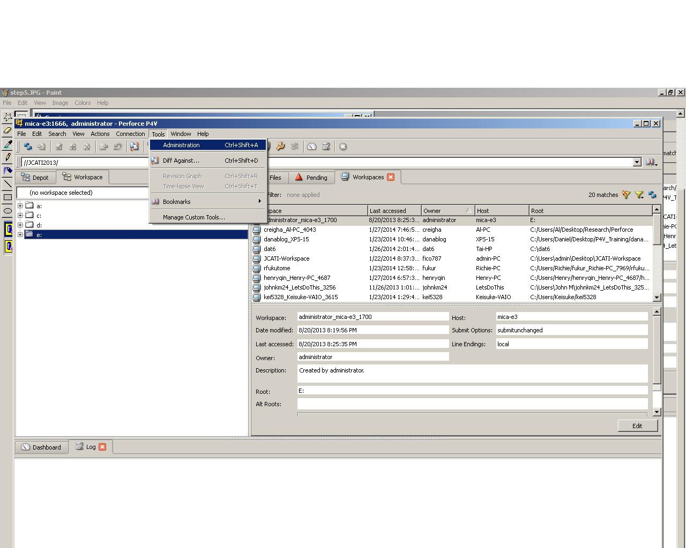Check 1: Launch Perforce as a superuser, Choose tool > Administration.

Check 2: Check to see if the User License window has updated expiration date and information.

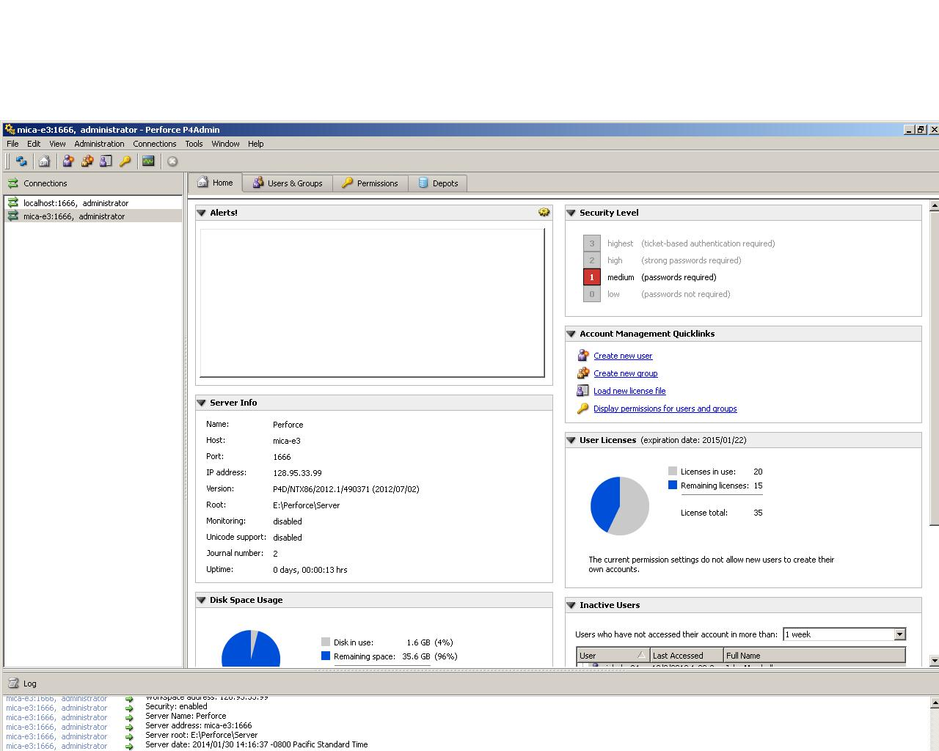

## Setting up a Perforce Server

This documents how to setup a new Perforce server.

1. Run either “perforce.exe” or “perforce64.exe” (depending if you are on a 32 or 64 bit version machine).
2. **Select Features**
   * Only need to include Server (P4D)
3. **Server Configuration**
   * Port Number: *1666* (default)
   * Install to: This is where the versioned files will be stored
4. Open P4Admin (see *AFSL\HowToDocumentation\installing_p4v.docx* for a link to the client installer)
5. **Open Connection**
   * Server: *localhost:1666*

Be sure to match the Port Number from step 3 above.

* + User: New…

This new user is the first and therefore sole user with superuser access. You will be able to specifically grant other administrators superuser access.

1. **Open Firewall Port**
   * You may need to open port 1666 on the server machine so that other computers can access the server. You may need to do this manually.
2. **Computer Setup**
   * Change power settings on computer to ensure it does not go to sleep as this will render the server inaccessible.

## Backing Up a Perforce Server

Creating a Back Up on the Perforce Server

* Access the perforce server computer (we will refer to this as “server”).

*Note: On the Server computer, the username and password (if any) of the P4V client will be needed.*

* Go to the *Start Menu* and then to the *Search Bar* (look the *Run* option on Windows XP). Type “cmd” to open the *Command Prompt* window.

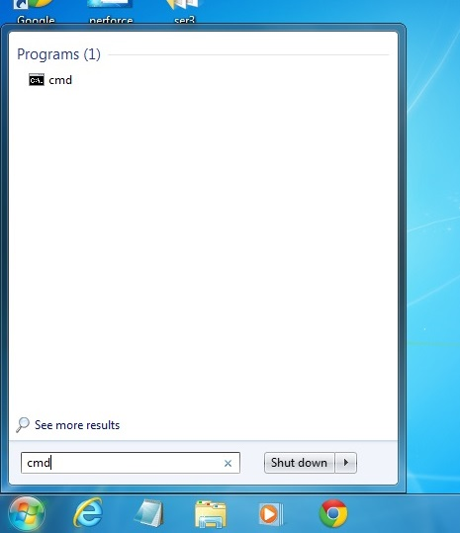

* On the *Command Prompt* window type “p4 admin checkpoint”. This operation will force Perforce to create a *Checkpoint* and a *Journal*. A *Checkpoint* is a file that backs up the *Depot*, while a *Journal* keeps track of all the modifications made to the *Depot*. Empirically this step is not necessary for a successful back up, yet it is highly recommended by Perforce.

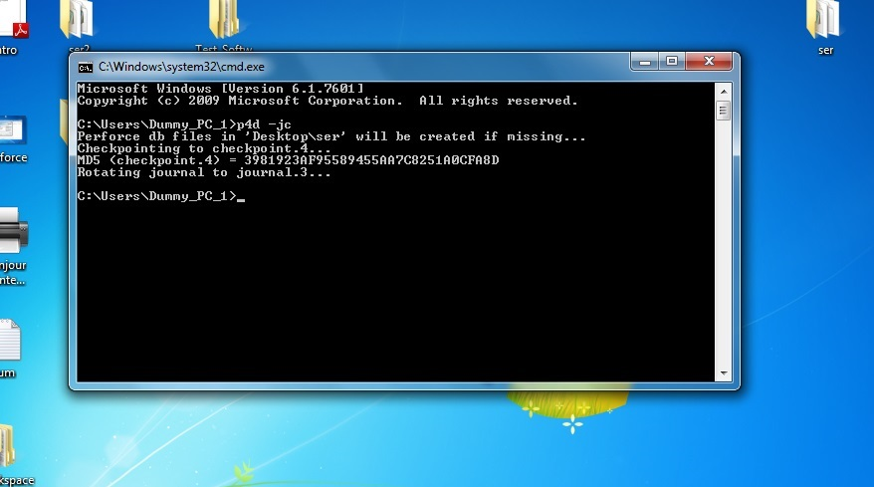

* Close the *Command Prompt* windows and open *Windows Explorer* (look for *My Computer* on Windows XP). Access the *C:* drive, go to *Program Files*, and then to the *Perforce* folder. Copy the *Server* folder and back it up on a storage or usb device.

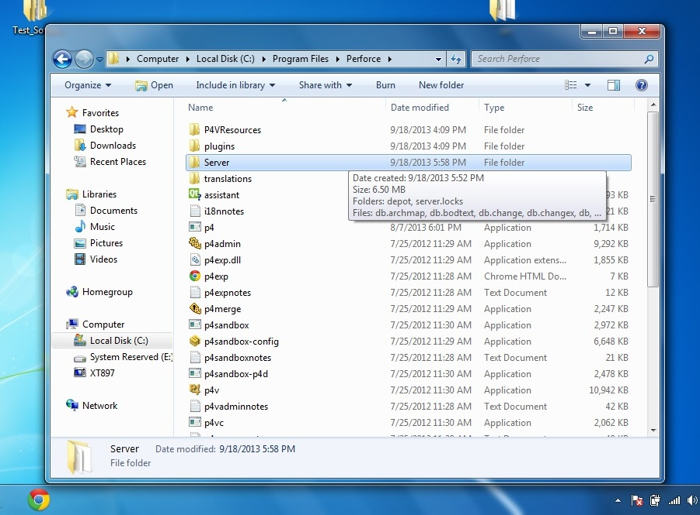

Restoring the Perforce Server on a Back Up Computer

* On the Back Up computer, access the Perforce website and download the P4D Server and the P4V Visual Client.

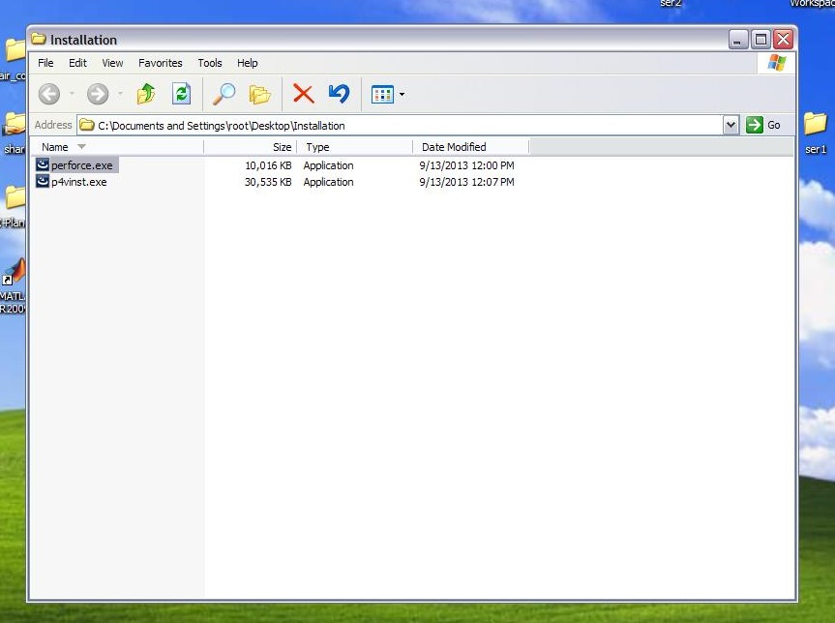

* Install the P4D Server only (*perforce.exe*). At the end of the installation process, a windows will pop up asking the user to restart the computer. Select the “*No*” option.

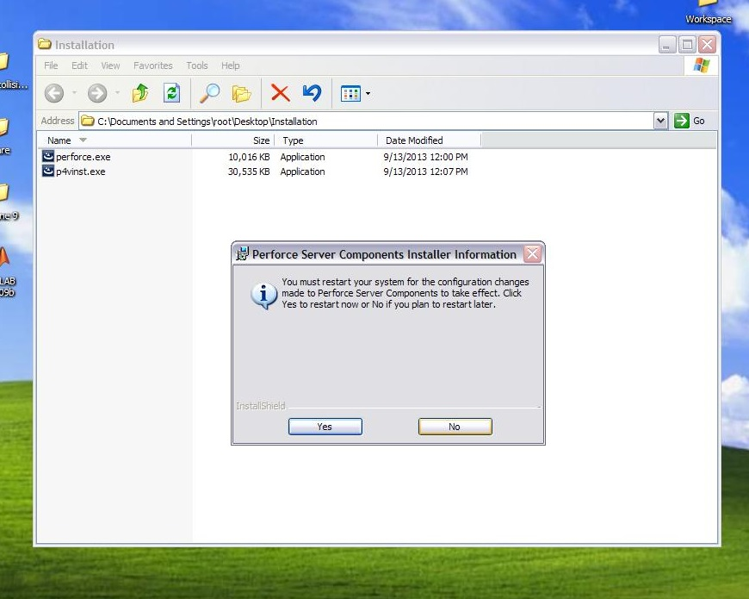

* Press the *ctrl, alt* and *delete* buttons at the same time to access the *Task Manager*.
* On the *Task Manager*, click on the *Process* tab. Select the *p4s.exe* program and then click on *End Process* to terminate it.

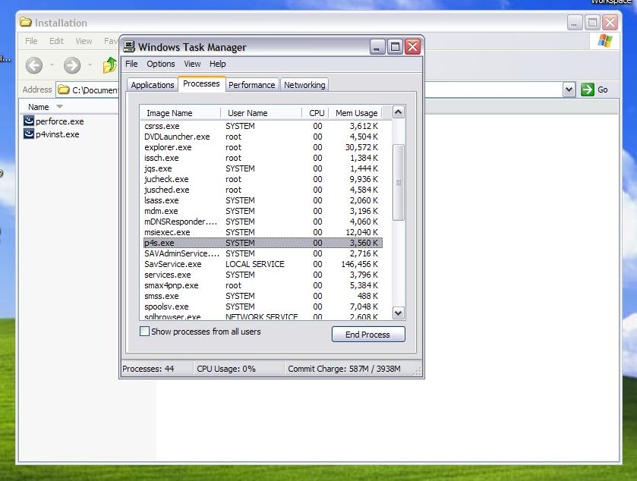

* Access My Computer, and then navigate to the *C:* drive*, Programs*, and then *Perforce*. Delete the *Server* folder, and paste in its place the *Server* folder copied from the Server computer.

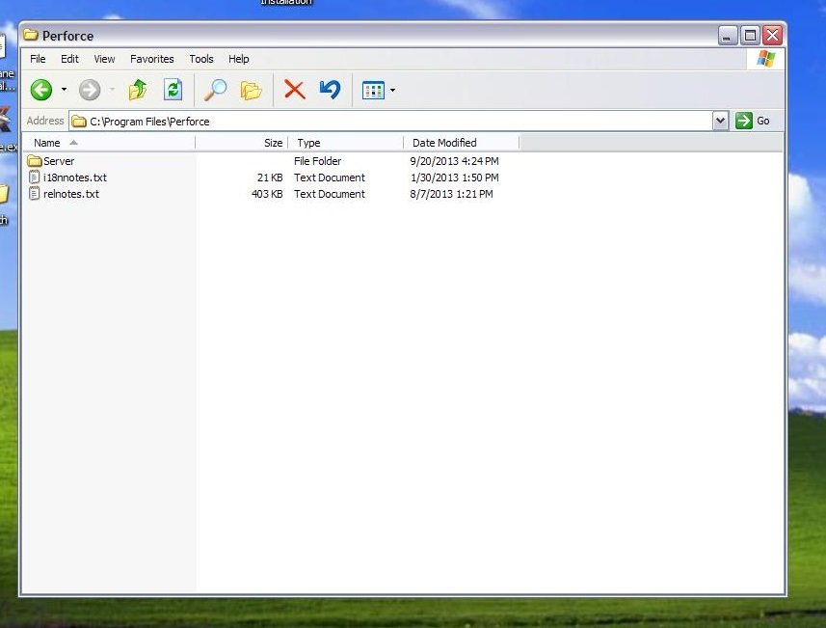

* Restart the computer.
* Once the computer is functional again, install the P4V client (*p4vinst.exe*) downloaded from the Perforce website.



* Once the installer starts, select the “*Run Wizard*” option.

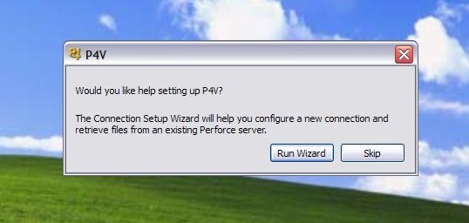

* On the Connection Setup Wizard windows, input “*localhost*” and “*1666*” respectively.

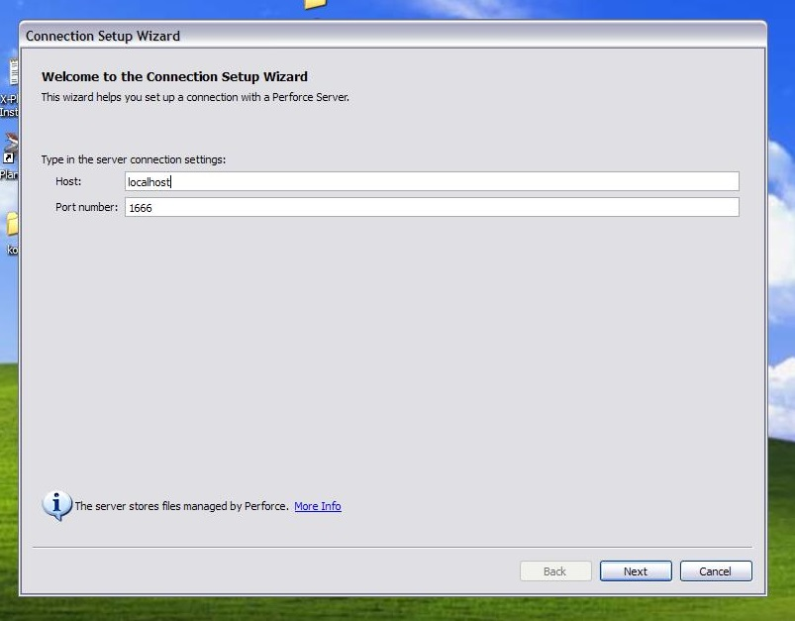

* On the next window, select the “*Log in the server…*”, and as user enter the username of the Server’s computer client.

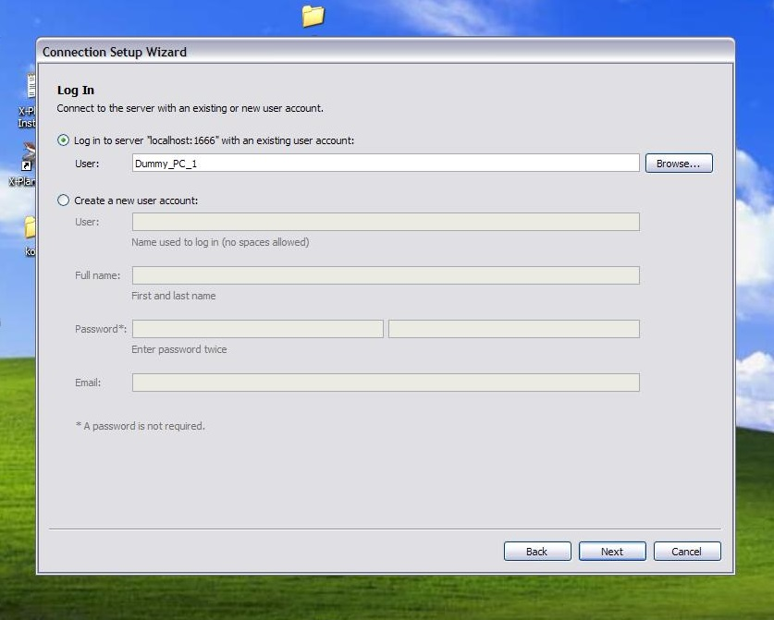

* On the next windows, create a folder where to map the *Workspace* on the pc.

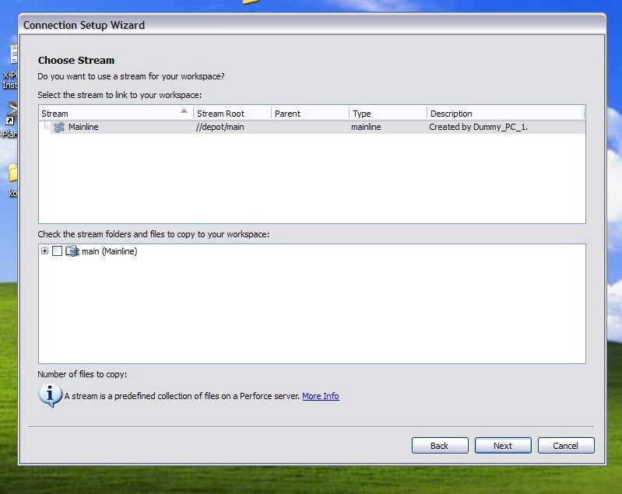

* When starting the P4V, the server should be completely back up.

## Changing Passwords

1. Login using AFSLSERVER account.
2. Go to ‘Permissions’ tab.
3. Right click on user and select ‘Change Password…’ (Figure 16).

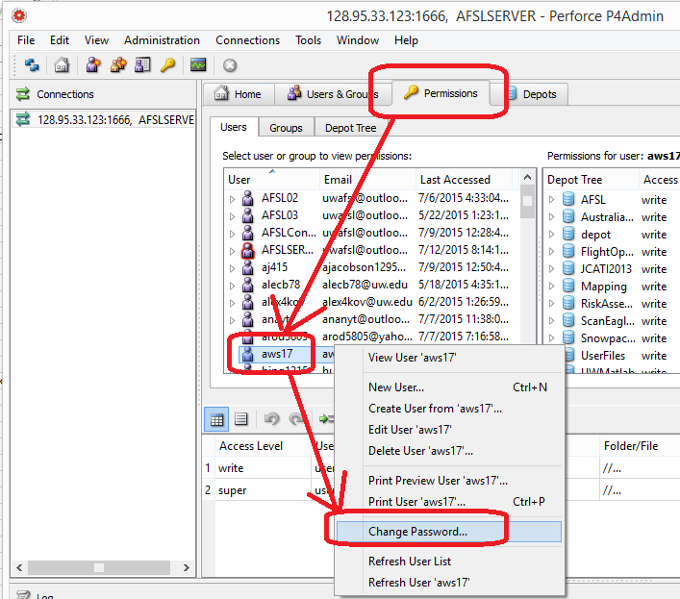

Figure : Changing password

# Perforce Company Contact Information

We’ve been successfully obtaining educational licenses from

Katie Bruun

Order Processing Representative

Inside Sales

[sales@perforce.com](mailto:sales@perforce.com)

Jennifer Hong

Order Processing Representative

Inside Sales

Perforce Software

2320 Blanding Ave

Alameda, CA 94501

510.864.7400

# Bibliography

**There are no sources in the current document.**

1. Users continually encounter problems using Macs for Perforce. If you would like to try to use Perforce for Mac, go to <https://www.perforce.com/downloads/helix> and download HELIX P4V: VISUAL CLIENT.