**NX Installation**

08/30/18: Updated with VPN instructions

# Notes

* You should do this while connected to a UW campus network as the license server must be accessed from a campus network.

# Installing NX

1. Contact Chris Lum to obtain the binary file (nx-10.0.0-64bit.zip).
2. Unzip the file.
3. From the unzipped folder, run ‘Launch.exe’
4. On the resulting page, click ‘Install NX’.

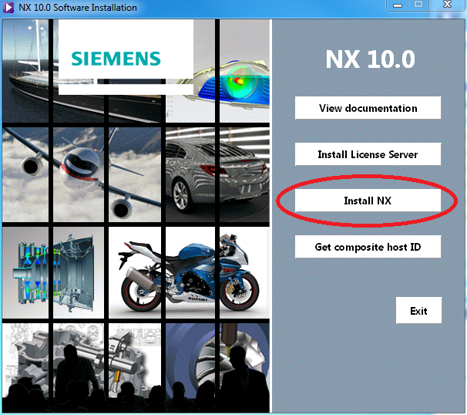

Figure : Select ‘Install NX’

1. Choose ‘English’ for the language. Choose the installation type you would like (it is recommended that you select ‘Typical’ which will install all components).
2. Choose a destination folder for the installation.
3. When asked to enter a license server or a license file, enter the port and server name of the UW license server by inputting ‘28000@license.me.washington.edu’ as shown in Figure 2.

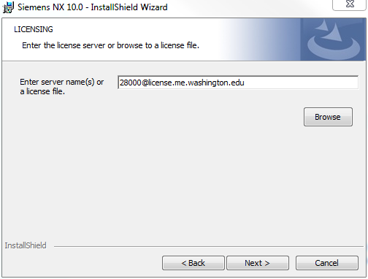

Figure : Entering the port and server name of the license server.

1. Press ‘Next’. Note that you may get a message that the connection failed. Press OK to continue.
2. Confirm that English is the selected language and press ‘Next’.
3. Review installation settings and press ‘Next’ to begin the install process.
4. Once the installation is complete, click finish to close the installer window.
5. Press ‘Exit’ to exit the launch window.
6. It may be useful to restart your computer at this point.

# Setting the Environment Variable

**Windows 7**

1. Start > Right click on computer > properties > Advanced system settings > click on “Environment Variables” near the bottom (Figure 3, far left)
2. Create an environment variable for the entire system by clicking on “New…” under the “System variables tab (Figure 3, middle).
   1. Enter in the variable name as "UGS_LICENSE_SERVER" and the variable value of "28000@license.me.washington.edu” (Figure 3, far right).

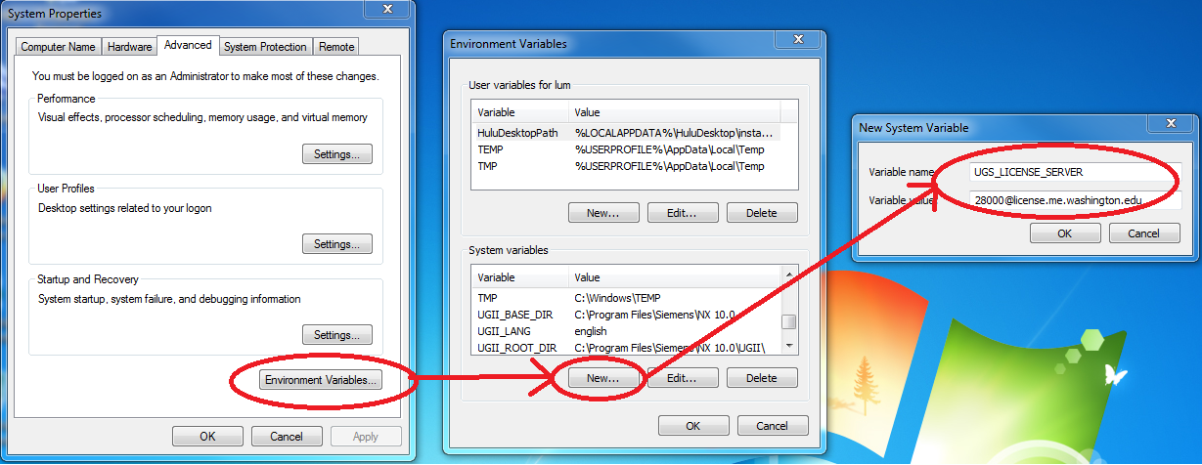

Figure : Creating the environment variable in Windows 7

**Windows 8**

1. Windows + S > Control Panel > System > Advanced system settings > Environment Variables.
2. Create an environment variable for the entire system using the same instructions/settings as described in the Windows 7 section

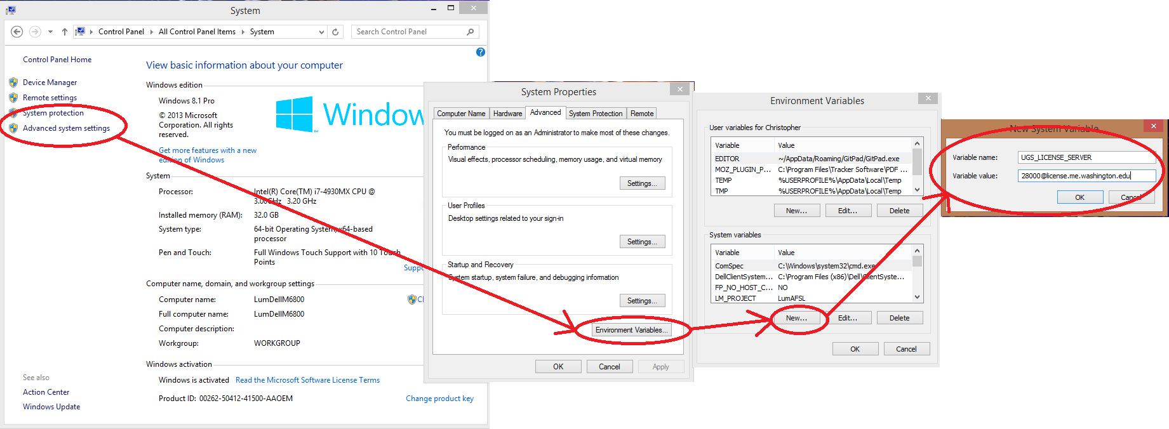

Figure : Creating the environment variable in Windows 8

# Opening the Firewall

We now need to open the port

1. Launch NX (Start > Siemens NX 10.0 > NX 10.0).
2. Upon first launch, you may encounter security alert as shown in Figure 5. Ensure that the option to allow NX to communicate through the firewall on private networks is checked and then press “Allow access”.

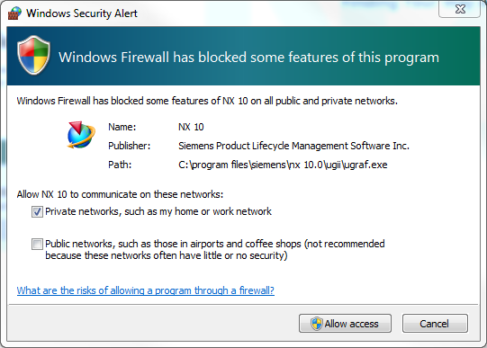

Figure : Allowing NX through the firewall

1. NX will launch and you will still encounter the error as shown Figure 6.

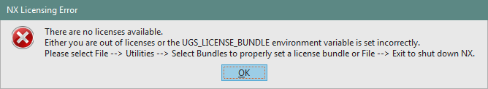

Figure : Licensing error.

1. Close NX.

# Applying the License

1. If you are not on the UW campus internet network, you should sign into the VPN using the Husky On Net system.
2. Start the NX Licensing Tool (Start > Siemens NX 10.0 > NX Licensing Tools > Licensing Tool) as shown in Figure 7.

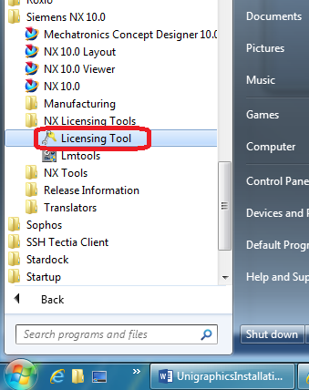

Figure : Starting the Licensing Tool

1. Click on “Bundle Settings” and move the two licenses from the “Available Bundles” to the “Applied Bundles” section as shown in Figure 8 and press “Apply”. Close the Licensing Tool.
2. Restart NX. It should start and you should be able to open and create new models.

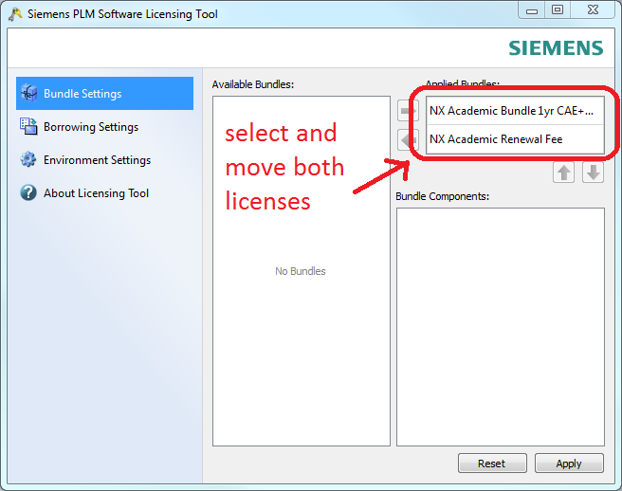

Figure : Selecting both licenses