# Start coding for APM in Visual Studio

Erli Sheng

11/17/2014

## Software to download:

1. Git-SCM
2. MHV_AVR
3. APM Firmware (ArduPlane-2.75 is used in this tutorial)
4. ArduPilot-Arduino-1.0.3-windows (specially modified Arduino IDE for APM)
5. Visual Studio 2008 – 2013 (One of them, just a full version. In this manual visual studio 2012 is used).
6. Visual Micro Plugin (Arduino for Visual Studio).
7. APM Mission Planner-latest

## Setup Operations

### Step 1 Install Git-SCM 1

<http://git-scm.com/download/win>

Just click next until the following screen appears and check options same as shown in picture below. Select the ‘Use Git from …’ and the Next button then Select ‘Windows- style, commit Unix …’the Run Git from Windows item and the Next button.

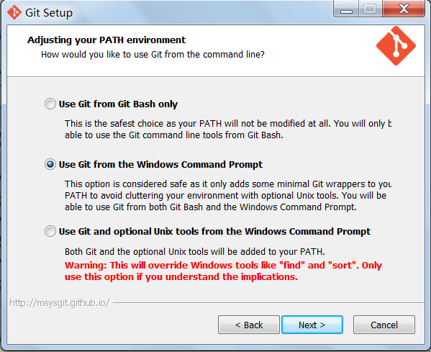 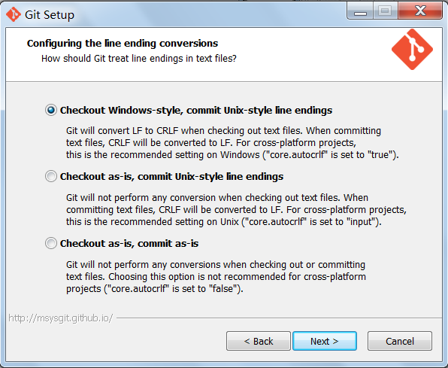

Wait until installation finishes and click Finish.

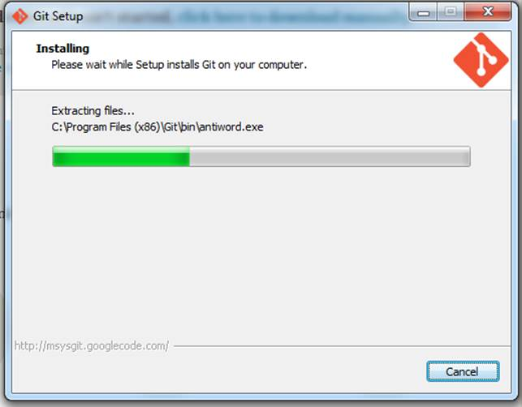

### Step 2 Download APM firmware

In your C: drive, make a folder called GIT.

Go to C:\GIT in windows Explorer (My computer)  
[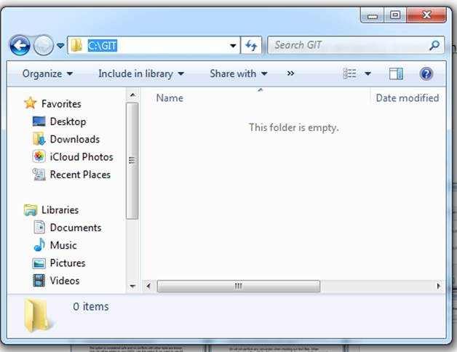](http://dev.ardupilot.com/wp-content/uploads/sites/6/2013/11/image020.jpg)

Right click anywhere in the folder and click ‘git bash’

[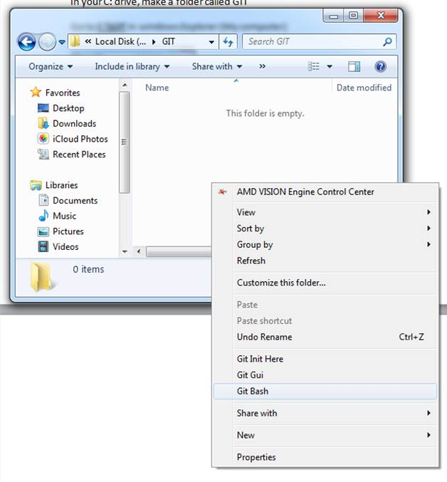](http://dev.ardupilot.com/wp-content/uploads/sites/6/2013/11/image022.jpg)

This screen will come up  
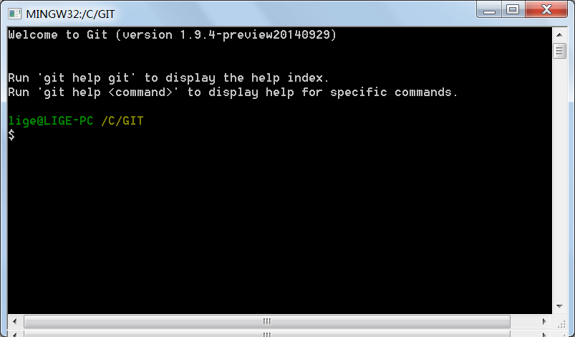

In this screen type

***git clone git://github.com/diydrones/ardupilot.git***

[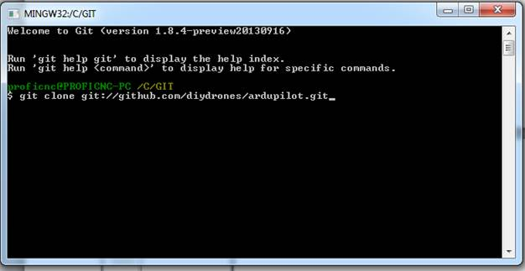](http://dev.ardupilot.com/wp-content/uploads/sites/6/2013/11/image026.jpg)

When it is finished it should look like this….

[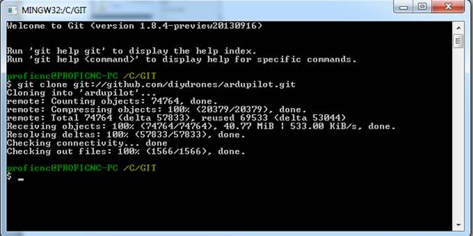](http://dev.ardupilot.com/wp-content/uploads/sites/6/2013/11/image028.jpg)

In this tutorial, the V2.75 firmware was used instead of the newest version of firmware. This is because the newest version of firmware can’t pass the ‘Build Solution’ option where as v2.75 can. So we need to download the V2.75 firmware from https://code.google.com/p/ardupilot-mega/downloads/list

After download is finished, just unzip to C:\GIT. In the C:\GIT, it should look like this.

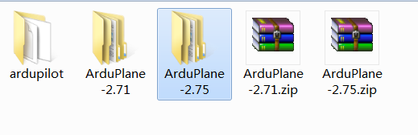

### Step 3 Install MHV_AVR_Tools to its default location.

Download MHV AVR TOOLs from link below:

https://infernoembedded.com/products/avr-tools/release

[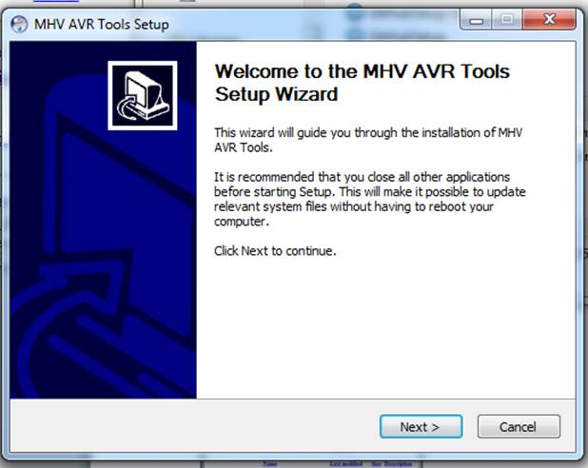](http://dev.ardupilot.com/wp-content/uploads/sites/6/2013/11/image030.jpg)[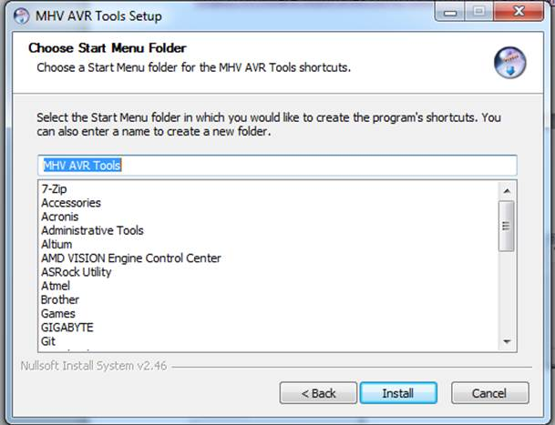](http://dev.ardupilot.com/wp-content/uploads/sites/6/2013/11/image038.jpg)

Select the Next button in the setup wizard screen then select the Install button for MHV AVR Tools

[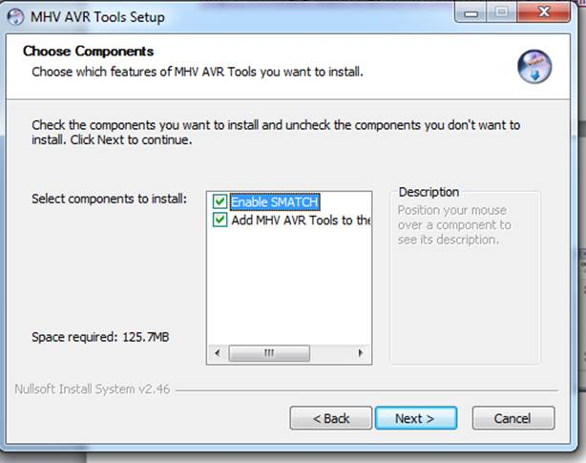](http://dev.ardupilot.com/wp-content/uploads/sites/6/2013/11/image036.jpg)[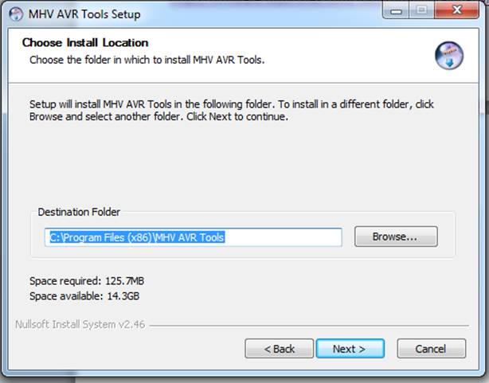](http://dev.ardupilot.com/wp-content/uploads/sites/6/2013/11/image034.jpg)

Check both items in the Choose Components Screen and select Next then select Next again to install to the default location

[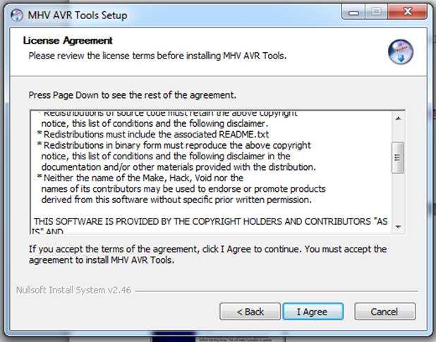](http://dev.ardupilot.com/wp-content/uploads/sites/6/2013/11/image032.jpg)

Select the I Agree button on the License Agreement screen

### Step 4 Install ArduPilot-Arduino IDE

**This is a new version, using the 4.7.2 version of GCC**

<http://firmware.diydrones.com/Tools/Arduino/ArduPilot-Arduino-1.0.3-gcc-4.8.2-windows.zip>

**Just unzip the special ArduPilot Arduino package to location you want. I unzipped this to my D:\Program Files (x86).**

### Step 5. Configure ArduPilot-Arduino IDE

**Go to your Arduino IDE folder, which is ‘D:\Program Files (x86)\ArduPilot-Arduino-1.0.3-windows’ for me.**

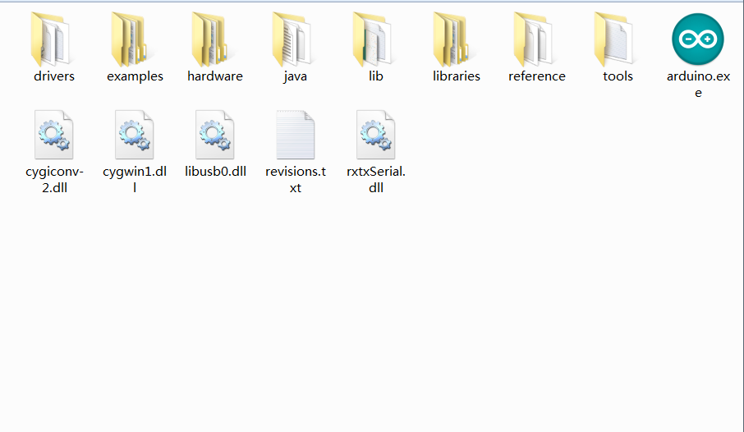

**Double click the Arduino icon**

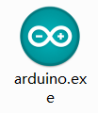

**When Arduino opens, go to the file menu**

[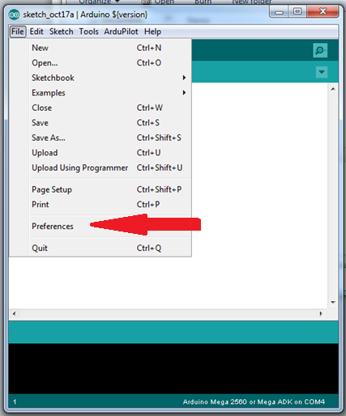](http://dev.ardupilot.com/wp-content/uploads/sites/6/2013/11/image042.png)

**Select preferences**

[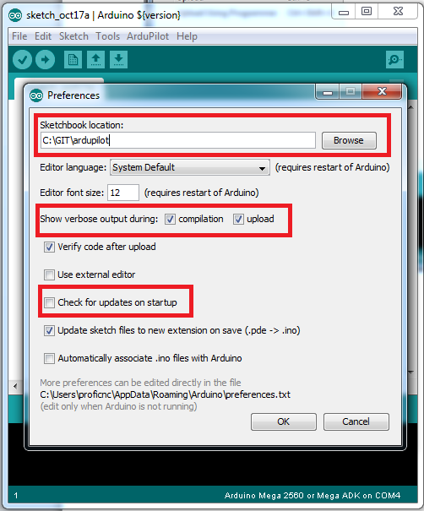](http://dev.ardupilot.com/wp-content/uploads/sites/6/2013/11/image044.png)

**Set Sketchbook location to your Ardupilot directory in your GIT folder.**

**Also set verbose for both compile and upload**

**And DO NOT check for updates on start-up… (Remember, this is a special version just for ArduPilot.)**

**Click OK and close Arduino**

### Step 6 Installation of Visual Studio



You need a licensed full version of Visual Studio Pro 2008, 2010 or 2012 installed. Visual Micro does not work with the free Express versions of Visual Studio. If you’ve already have one, go to next step directly. Visual Studio 2012 is used in this example.

### Step 7 Installation of Visual Micro

Download and install Visual Micro from the [Visual Micro](http://www.visualmicro.com/) website and compete the [setup](http://www.visualmicro.com/post/2011/10/04/How-to-test-a-new-installation-of-Arduino-for-Visual-Studio.aspx).  Instructions are at the site.

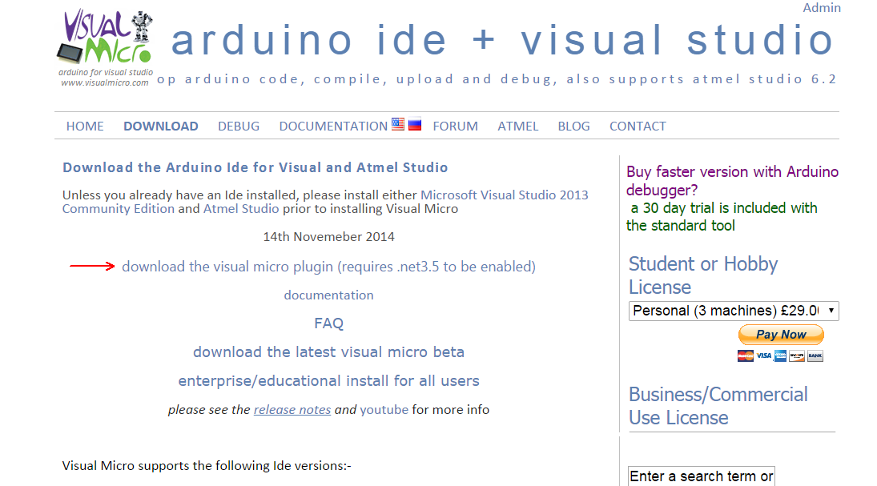

[Visual Micro](http://www.visualmicro.com/) Download Address: http://www.visualmicro.com/page/Arduino-Visual-Studio-Downloads.aspx

### Step 8 Configuration of Visual Micro

#### Start your IDE

Start Microsoft Visual Studio 2012

#### Configure Visual Micro in Visual Studio

If it is the first time after you have installed Arduino for Visual Studio (Visual Micro), the window ‘Configure Visual Micro’ will pop up wherever you can configure your system.

You can also open the window ‘Configure Visual Micro’ at any time later by clicking on "Configuration Manager" in the Visual Micro toolbar:  
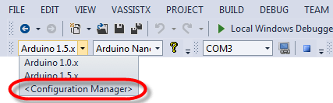

The window ‘Configure Visual Micro’  looks like this:

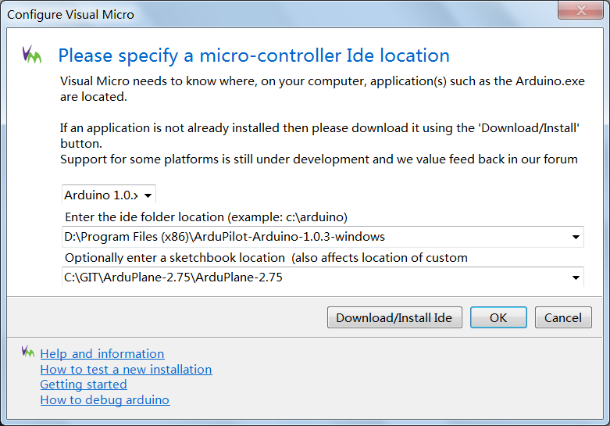

1. Choose **Arduino 1.0.x** in the first Combo.
2. The IDE folder is where you unzip ArduPilot-Arduino IDE to. For this tutorial, it is ‘**D:\Program Files (x86)\ArduPilot-Arduino-1.0.3-windows**’.
3. The sketchbook location specifies where Visual Micro will search for user libraries. As we are working on V2.75 firmware of APM now, put ‘C:\GIT\ArduPlane-2.75\ArduPlane-2.75’ in it. **In the future, if you want to change your working version of APM firmware, e.g. changing from current v. 2.75 to V 3.xx then you have to go to TOOLS >> Visual Micro (Arduino 1.0.x) >> Configure Ide Locations to open ‘Configure Visual Micro’ and change your new sketch Location.**
4. Note: sketchbook location is the folder containing folders APMover2, ArduCopter, ArduPlane, docs, FollowMe, libraries, mk and Tools.
5. Now the initial setup of your system is done. For more information, please go to http://www.visualmicro.com/page/User-Guide.aspx?doc=Your-First-Project.html

#### [Read more](http://www.visualmicro.com/page/User-Guide.aspx?doc=Board-Setup.html#BoardSelect).

Modifying Existing Configurations

The .pde file is an old version of Arduino code file. New code file for Arduino IDE is .uno file. (From: http://arduino.cc/en/guide/Environment)

### Step 9 Download and install the APM board information.

1. This is a key requirement to build and upload the APM code. Download Board Information from here <http://www.visualmicro.com/downloads/APM_Sketchbook_Hardware.zip>
2. Put the file “boards.txt” into a folder “APM” within the folder “Arduino folder /hardware”.
3. Your Arduino folder (in this case D:\Program Files (x86)\ArduPilot-Arduino-1.0.3-windows) should look like this:

[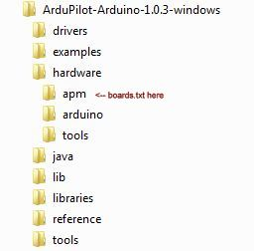](http://dev.ardupilot.com/wp-content/uploads/sites/6/2014/04/VisualMicroHardware.jpg)

1. If Visual Studio was already open when you unzipped the file then click "Tools>Arduino>Reload Tool Chain"

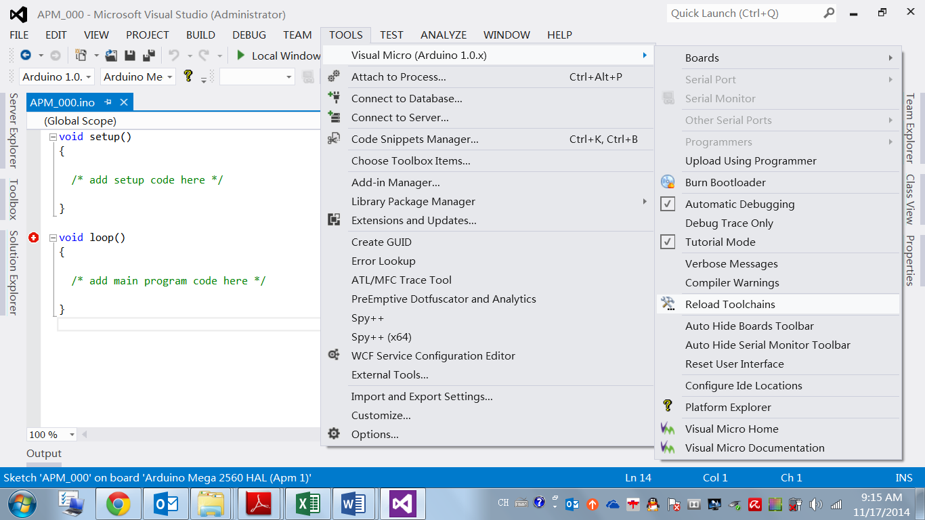

1. Run Visual Studio and set up for APM as follows:  (APM2 is used in this example.)
2. Tools>>Visual Micro>>Boards:  Select  Arduino Mega 2560 HAL (APM 2) (Only by putting the .txt file and TOOLS-> Visual Micro (Arduino 1.0.x) -> Reload Toolchains can you see real Arduino Mega 2560 HAL (APM 2))

### Step 10 Add an file from Alec to Arduino IDE

### Please contact Alec and add an indispensable file to Arduino IDE.

### Step 11 Verify your work

The following are a few ways to test your Arduino for Visual Studio installation (similar to getting started guide)

### Build your APM project:

1. Tools>>Visual Micro>>Boards:  Select ‘Arduino Mega 2560 HAL (APM 2)’

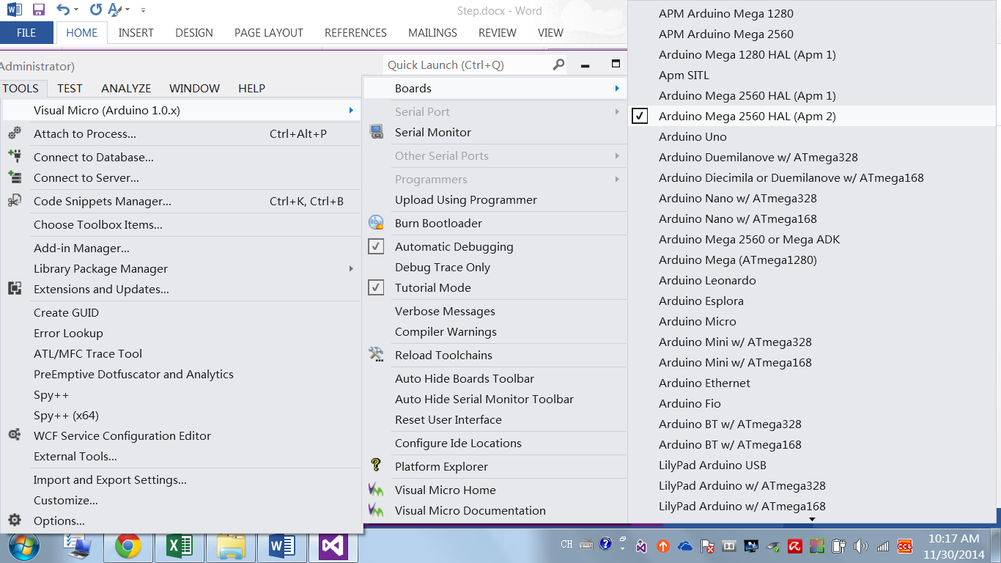

1. Open the ArduPlane.pde sketch:  File>>Open>>Sketch Project: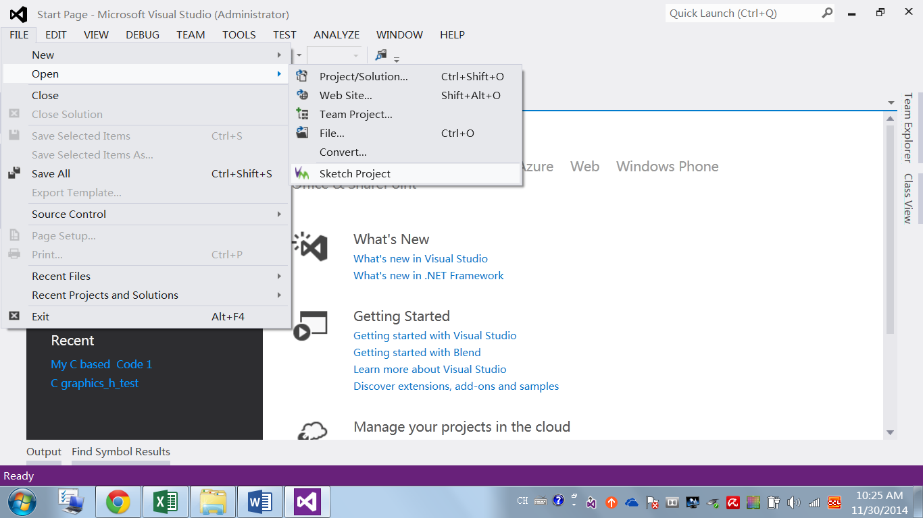
2. Select ArduPlane \ ArduPlane.pde  (or ArduPlane .pde file in you code folder.)

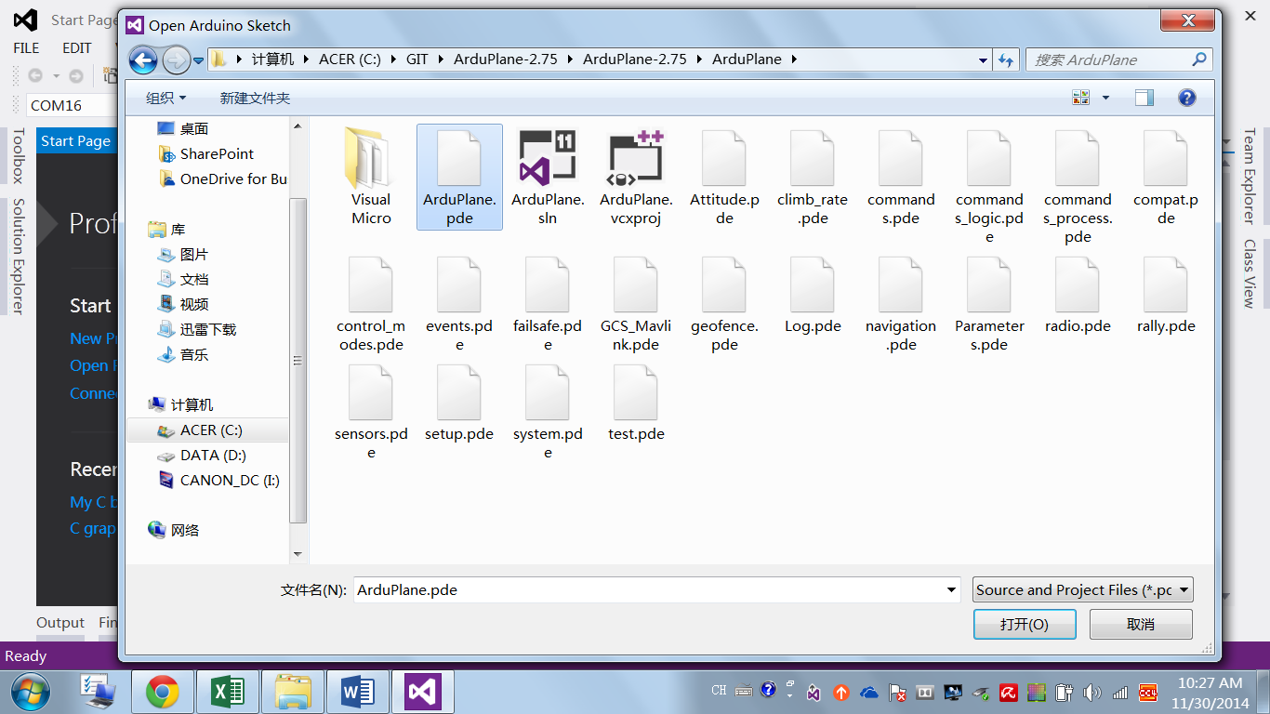

1. Build the code:

4.1 Build>>Clean Solution: After clean, you should see output in picture below.

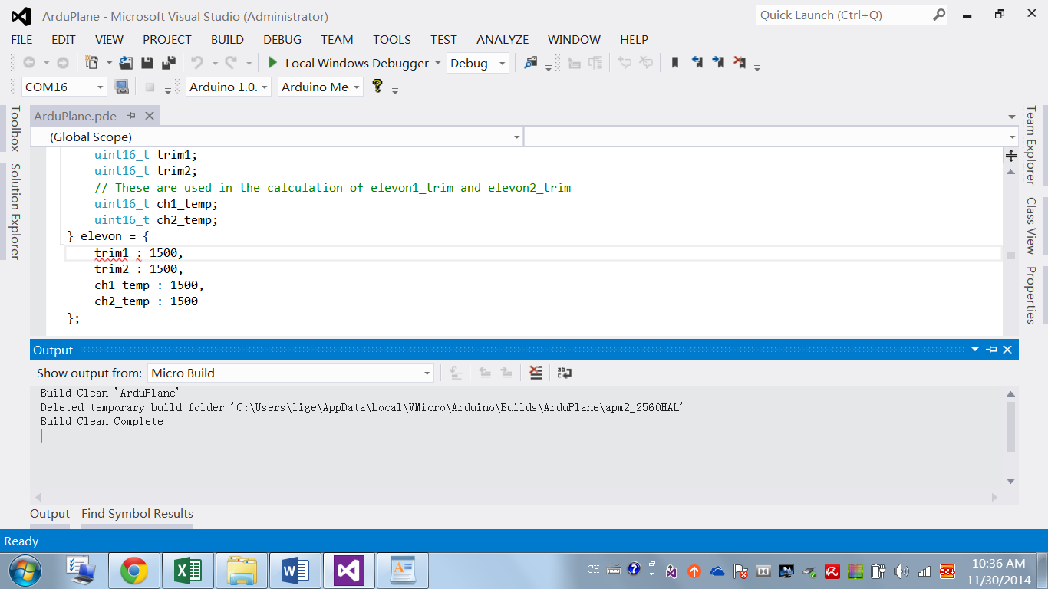

4.2 then Build>>Build Solution.

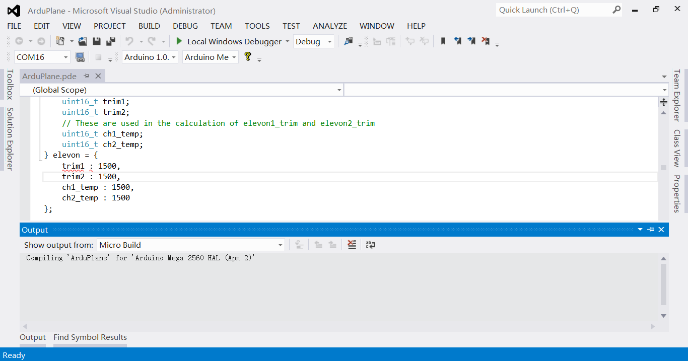

1. The code should be built without error.

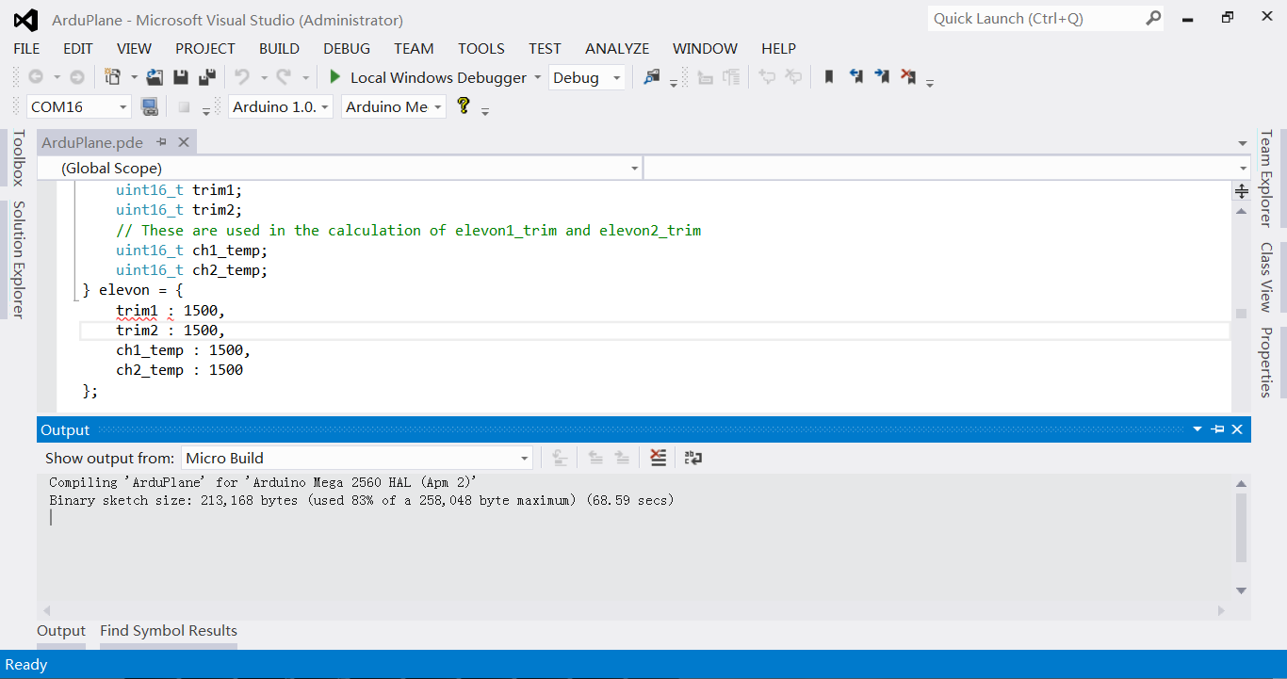

Depending on what source code your are using, you may get the message “Sketch too big …”. You can reduce the size by un-commenting some of the compile options in APM_Config.h.  
Important**:** Each time you change a #define statement (or comment one or un-comment one) you must do Build>>Clean Solution followed by Build>>Rebuild Solution.  Details are below in the Hints and Notes section.

#### Uploading the code to APM

After your code builds without errors you can upload the firmware to the APM.

1. Connect your APM via the USB cable.
2. Tools>>Visual Micro>>Serial Port. Set to the USB port detected for your APM. If the USB port is not detected, follow the Arduino installation instructions for adding the proper drivers.  If the Arduino IDE works, then Visual Studio / Visual Micro should also work.
3. To upload to the APM board, just press Ctrl + F5 (Start Without Debugging).

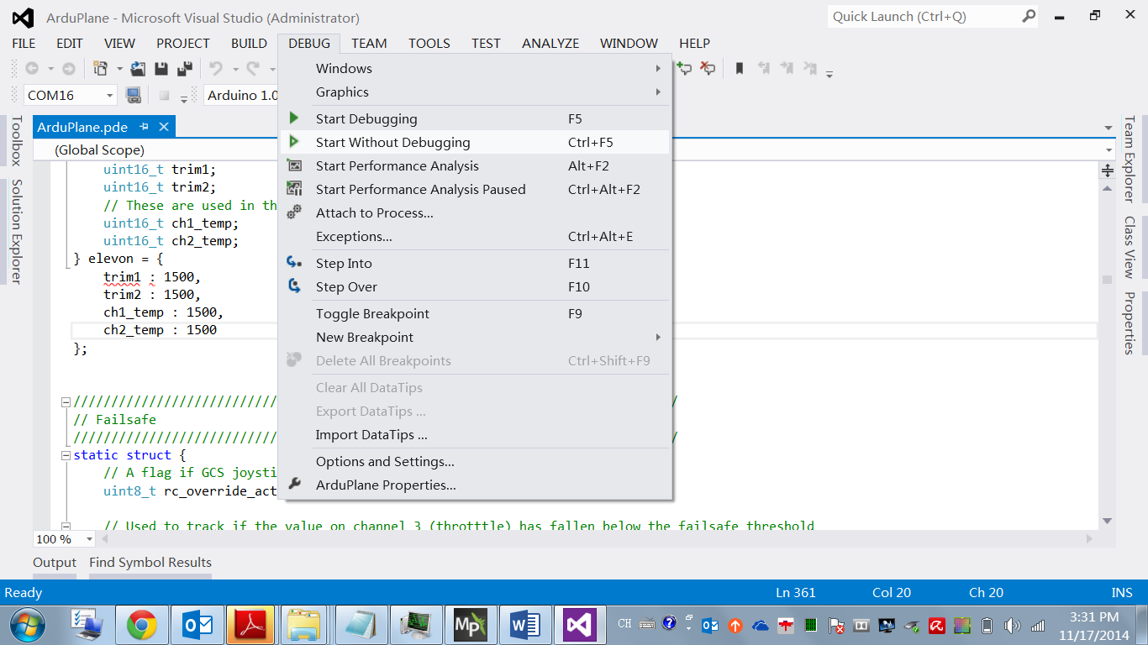

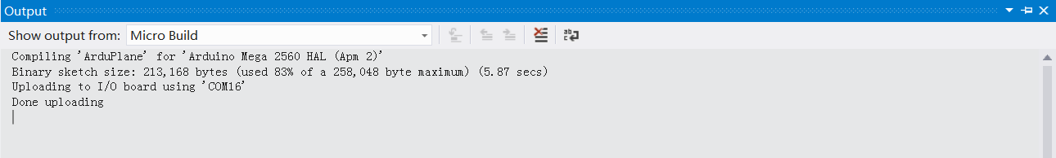

1. The build, and upload to the APM was flight tested by the author for the code release 2.7.5. The flight modes stabilize, altitude hold and loiter were all tested and behaved the same as upload of the same revision using Mission Planner.  However, be aware that building your own upload from the source can result in unexpected results. You must configure all the options defines and other code correctly. Be careful, have fun and enjoy Visual Studio with Visual Micro.

## Reference

1. http://dev.ardupilot.com/wiki/building-ardupilot-with-arduino-windows/