**Aircraft Construction Standards Manual**

This document provides instructions, warnings, and tips for the construction and maintenance of fixed-wing aircrafts.

# Record of Revisions

Table : Record of manual revisions

|  |  |  |  |  |  |  |
| --- | --- | --- | --- | --- | --- | --- |
| **Revision** | **Date** | **Pages Affected** | **Revisions** | **Author** | **Check** | **Approved** |
| 1 | 03/28/18 | All | Created document | Helen Kuni |  | Hannah Rotta |
| 2 | 08/16/18 |  | Added troubleshooting instructions for binding TX | Helen Kuni |  | Helen Kuni |

# FAQ

Click the links below to be directed to the part of the manual you need.

What materials need to be purchased?

How do I wire this thing?

I’m about to try to solder onto the switches, and I haven’t realized this is a bad idea yet

I need to remove epoxy and the internet told me I can use acetone

# Initial Considerations

Before you start working on your aircraft, look at the list of standard components below, and plan out where major components such as the Pixhawk, the switches, the ESC, and the battery are going to go. Keep in mind what the aircraft is going to be used for.

* Does the project this aircraft is for involve a large payload?
* Will anything need to be placed on the exterior of the airframe?
* Does any part of the payload create a lot of interference that could mess with the Pixhawk?
* Is any part of the payload especially susceptible to interference from other components in the plane?
* Are there any modifications to the fuselage that need to be made before the plane is glued together?
* Think about future troubleshooting. It’s sort of inevitable that at some point, something on this plane is going to break, and someone – likely you – will have to go in and fix it. Take care not to bury all of your important components in inaccessible places, or create a rat’s nest of wires that’s impossible to wade through.

As you work, update the component tracker (FlightOperations/UAS/ComponentTracker.xlsx on Perforce) to reflect any parts you have added to the plane. Also record any work you do in the aircraft’s Construction and Maintenance log (you’ll have to create this document; put it on Perforce under your UAS’s file, for example: FlightOperations/UAS/Anakin/ConstructionandMaintanenceLog.docx).

# Standard Components & Supplies

Below is a list of standard components required for all fixed-wing aircrafts, regardless of special applications.

Table 2: Standard components required for fixed wing aircraft assembly

|  |  |  |
| --- | --- | --- |
| **Component** | **Recommended Type** | **Notes** |
| Pixhawk |  |  |
| Receiver | TGY-iA10B |  |
| Telemetry radio | Holybro 915MHz 500MW |  |
| Propeller | 9” diameter |  |
| Power module |  |  |
| Motor | Turnigy 1250 kV |  |
| ESC | Turnigy 45A SBEC |  |
| I2C splitter |  |  |
| I2C/Buzzer/Arming button/USB/LED all-in-one unit |  | Can also be installed as individual components |
| GPS/compass | Holybro (round, not square) |  |
| Servos, x6 | Turnigy 50090M Analog Servo |  |
| Airspeed sensor |  | Consists of a pitot tube, two clear tubes, a pressure transducer on a small circuit board, and a 4-pin DF13 wire from the transducer to the I2C splitter. |

The following table shows additional supplies you will need for building your aircraft:

Table 3: Additional tools and supplies required for aircraft assembly

|  |  |
| --- | --- |
| **Name** | **Notes** |
| 15 minute epoxy | For large jobs, such as gluing the whole airframe together. |
| 5 minute epoxy | For smaller jobs, such as securing servos, and the safety tab between switch connections. |
| CA glue | For connections that could need removal for maintenance purposes, and where the glue is at least partially exposed (not purely between two connecting surfaces), such as switches and pitot tubes. |
| Tape | For holding the airframe together tightly while the glue sets. |
| Velcro (NOT BLUE) | For securing components within the airframe. Note that the blue Velcro does not have good adhesive. Glue should be used to strengthen the adhesive for most kinds of Velcro, and should be allowed to set completely before the connection is tested. |
| Velcro straps or zip ties | For bundling and organizing wires. |
| Lead-free solder wire | You will need to solder connections to XT60 connectors and bullet connectors. In total this should be 3 XT60 connectors and 5 bullet connectors. Depending on the configuration of your aircraft you may also want to extend wires to other components. |
| Flux, or alternatively flux-core (sometimes called resin-core) solder | Flux is a paste that cleans the surface you are soldering onto in order to make the solder stick better. Use of it can drastically improve the effectiveness of your soldering. Some solder wire has flux in the center, so that you don’t have to juggle a separate container of paste. |

# Wiring

A schematic showing the standard wiring of fixed-wing aircrafts is located on Perforce at AFSL/HowToDocumentation/FixedWingWiringSchematic.pptx.

* Use only 12-gauge wire or thicker on connections between the battery, ESC, switches, and motor.
* Wires should be color coded so that the positive and negative terminals are clearly marked. The standard is black = negative/ground, red = positive. If the correct color of wire is not available, positive and negative may be marked using colored shrink tube.
* Keep wire management in mind when designing the interior layout of your plane. Wires should be well organized and not tangled, power wires should be kept away from compasses and the Pixhawk, and it should be easy to tell what connects to what and to access all connections.

#### Plum’s Wires: A Cautionary Tale

14-gauge wire was originally used in several places on Plum. The high current through these wires caused the connections to the switches to corrode and come undone. Luckily the problem was spotted while the plane was on the ground between flights, when the motor failed to start for the throttle checks. Had the connection failed while the plane was in the air, Plum would have needed some very extensive cosmetic surgery.

## A note about soldering

* Do not attempt to solder directly onto the switches. 10-12 gage (yellow) Spade Terminal Connectors (in RC Parts Small) that can be crimped onto the wires and screwed onto the switches are kept in RC Parts Small. These are shown in Figure 1 below. Use threadlocker (small blue and red tube in the Glues box) to secure the screws.
* Solder bullet connectors (3.5 mm) or XT60 connectors between components wherever possible (both of these are in RC Parts Small). Never permanently connect any components to the plane, or to each other. It should be possible to switch out any component independently of any other components, without unsoldering, and with a minimum of cutting through styrofoam and/or glue.

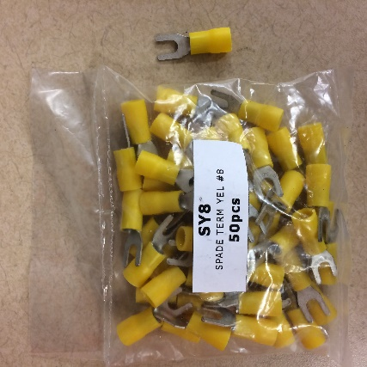

Figure : Spade Terminal Connectors, 10-12 Gauge

## Switch safety

Safety tabs made of electrical tape, shown in Figure 2, should be installed on all switches prior to any connections being made. The tabs in the figures are made by folding electrical tape on itself until it fits snuggly between the two slanted connectors, then fixing into place with 5-minute epoxy. Take care that the screws are not glued into place, that screw holes are not clogged or blocked such that current cannot flow or the screw cannot fit. Check thoroughly to make sure the terminals are not connected such that it would cause a short.

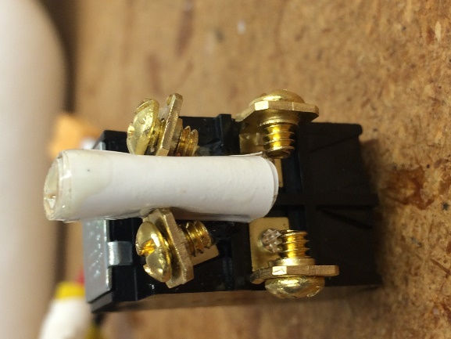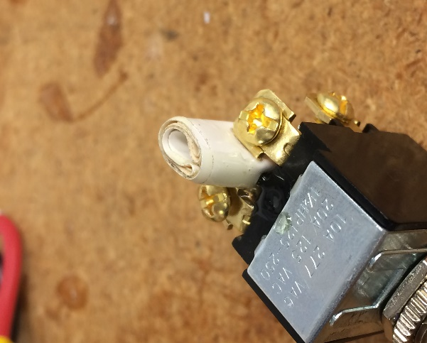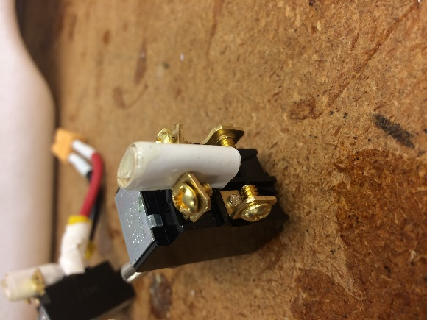

Figure 2: Switch safety tabs should be installed between the two slanted connections on all main power and motor power switches.

#### Battery Troubles: A Cautionary Tale

Failing to ensure that the two slanted connectors were well separated has resulted in damage to at least two batteries, one on Peach and one on Pear. LiPo batteries can be severely damaged by shorting, or by being drained very quickly to very low voltage. After being shorted for half a second during initial ground testing on Pear, a 3-cell LiPo remained hot to the touch for 30 minutes, swelled slightly, and had to be supervised closely until it cooled down. The lab filled up with smoke, and Pear now bears a small burn mark on the starboard interior of the cargo bay. The future of this battery is now questionable, and it has been temporarily quarantined to ground testing. LiPos are expensive, dangerous, and critical pieces of equipment. Solder tabs should always be installed for the safety of all personnel and equipment.

# Glue

Be sure you are actually ready to glue any part of your plane before you start. Most of the wiring work should be done before the fuselage is fully assembled, and the layout of all your components should be mostly finalized.

* Some wires need to be routed through the deepest darkest hidden tunnels in the tail segment before you glue. Please be sure the rudder is ACTUALLY connected to the rudder channel, and the elevator is ACTUALLY connected to the elevator channel.
* Switches should not be glued until all connections have been made and are verified as secure. They should be placed in such a way that all connections can be easily accessed using a screwdriver, to minimize the possibility of needing to remove the switch.
  + Before making any connections to the switches, or labeling them, test using a multimeter to verify which direction corresponds to on.

## Pitot tube placement

Pitot tubes have two ports: the main port, located at the front of the tube, and the static ports, which are the holes located around the sides of the tube. They work by using the difference between the pressures measured at these two ports to compute the velocity. Since the local airflow near the surface of the plane is slowed due to friction, the pitot tube should be elevated as far from the surface of the aircraft as possible in order to obtain an accurate free stream airspeed. It should also be mounted as high up as possible to prevent it being clogged with mud or filling with water during landings. Examples of good pitot tube placement are shown in Figure 3.

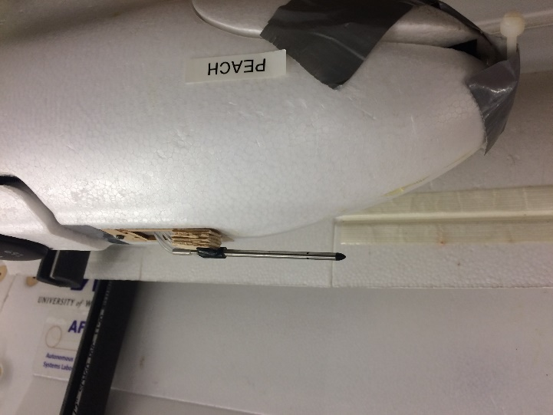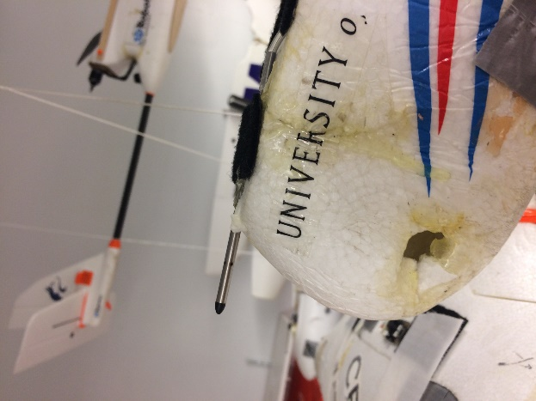

Figure 3: Effective placement of pitot tubes on a Finwing Sabre (left) and a Skywalker 1900 (right).

## Epoxy

* **DO NOT USE ACETONE TO REMOVE EPOXY FROM A STYROFOAM AIRFRAME.** Acetone melts styrofoam, and will do absolutely nothing to epoxy. It works well for getting glue off your hands, though, and will not damage metal components. Unfortunately, it also won’t really damage the epoxy. The best way to remove epoxy is to use a flathead screwdriver, needle-nose pliers, or exacto knife to peel up the edges and chip away at it and gently pry the component loose.
* Epoxy comes in two varieties: 15-minute and 5-minute. This refers to the amount of time it takes the glue to dry. Epoxy comes in two bottles, one of glue and one of hardener. To use epoxy, mix equal portions of hardener and glue using a popsicle stick on a plate or piece of cardboard, and immediately apply using popsicle sticks. The glue will begin to set as soon as the hardener is mixed in, so make sure you are ready to glue as soon as you begin mixing the two parts, and work efficiently.
* Use 15 minute epoxy for large jobs, such as gluing together two halves of a fuselage. 5 minute epoxy should be used exclusively for small connections that are easy to position precisely and are unlikely to require adjustment during the drying process.

#### Peach’s Switches: A Cautionary Tale

Peach’s switches were originally fixed into place with epoxy. Due to wiring issues, by the time the plane had had two flights, the motor power switch had had to be removed twice, and the main power switch once. Removing the epoxy originally used was extremely difficult, because the exactos had a hard time cutting through the epoxy. CA glue, which was used on the motor power switch after the first incident, was much easier to cut through. Always keep in mind when building a new plane that anything you do, someone else may someday have to undo. Probably you.

## CA Glue

* CA glue comes in two parts: the glue and a hardener spray. After you put the spray on, the glue will harden IMMEDIATELY. Make sure the thing you’re gluing is exactly where you want it before you spray hardener.
* After the hardener is applied, the glue will get hot as it cures. Use caution.
* CA glue has remover (in the glues box), but it has never been shown to work. It is however easier to cut through than epoxy and more appropriate for switches and pitot tubes, which require a very solid fix but which may need to be removed down the line.
* Legend has it that CA glue melts styrofoam. It has been used successfully to mount several pitot tubes and switches (notably on the Finwing Sabre fleet) directly to styrofoam surfaces without damage to the airframe, but proceed with caution nonetheless.

## Mounting Components

Internal components such as the pixhawk, the power module, the ESC, etc. should **NEVER** be glued into place. Velcro should be used to fix components in place and minimize problems caused by vibration. The adhesive on some types of Velcro (notably the blue Velcro) has a history of coming loose, and it is acceptable to use glue to fix Velcro to the components themselves.

# I put it together – now what?

## Software Setup

* Set your plane’s radio ID. This is done by connecting the radio that is on the plane to Mission Planner via a USB. Go to Config/Tuning > Optional Hardware > Sik Radio and click Load Settings. Wait a small eternity. The status of the connection can be seen in the lower left corner. It will say “Connecting” or “Doing command ATT” while it’s working, and “Done” when it’s finished. After the status changes to “Done”, use the dropdown menu to change the Net ID. The default ID for a new radio is 25. Never use this ID. Check on the Telemetry Radio Notes document to make sure no other plane in the lab is using the ID you are setting, and update this document with your plane’s new ID. The telemetry radio connected to Mission Planner whenever you connect the plane will need to be set to the same Net ID as your plane in order to connect to it. The Telemetry Radio Notes document is located on Perforce at: FlightOperations/UAS/CommonDocuments/TelemetryRadios/TelemetryRadioNotes.docx
  + Label the radio that is on the plane with the Net ID, using either the label maker or a piece of masking tape.
* You will need to load firmware onto the Pixhawk. Double check with a senior lab member to make sure you are loading the appropriate firmware. The most recent firmware stored on Perforce under /FlightOperations/UAS/CommonDocuments/MissionPlanner/binaries_and_installers/firmware/ should be loaded onto the plane. This is done on Mission Planner by going to Initial Setup > Firmware > Load Custom Firmware. Make sure your plane is plugged into the computer, but not connected to Mission Planner.
* All planes should at least start out with the standard parameters, which are located on Perforce at /FlightOperations/UAS/Excelsior/Subsystems/Autopilot/17_09_07B.param
* Two standard calibrations must be performed on all aircraft: accelerometer and compass. Occasionally Mission Planner will ask you to do a mag calibration before the compass calibration. This usually indicates that the plane needs to be moved away from sources of magnetic interference. Compass calibrations should always be performed outside of AERB to minimize this interference and increase the accuracy of the calibration. The accelerometer calibration can be performed indoors. These calibrations may need to be redone if the pixhawk or external compass is moved at all.
  + Instructions and documentation on the accelerometer calibration can be found here: <http://ardupilot.org/plane/docs/common-accelerometer-calibration.html>
  + Instructions and documentation on the compass calibration can be found here: <http://ardupilot.org/plane/docs/common-compass-calibration-in-mission-planner.html>

#### That’s Not Our Plane: A Cautionary Tale

Once upon a flight test, a glider club was flying in a neighboring field while Anakin was in the air. At the time, Anakin’s radio ID was set to 25. As it turned out, one of the gliders flying nearby was also set to Net ID 25, and halfway through the flight, Mission Planner became confused and began switching between the two planes. The track showing the motion of the plane on Mission Planner began zig-zagging all over the field, and out of nowhere, the GCS noted a low battery warning – 13%. An emergency landing was performed and a frantic battery check revealed that the plane was happily sitting at around 45%. As soon as Anakin was turned off, Mission Planner connected completely to the glider across the field, and the GCS was momentarily in control of someone else’s plane, completely unbeknownst to its pilot. From this experience we learned to never leave a plane’s Net ID set to 25, as it increases the risk of inadvertently giving control of the plane to another ground station – potentially, given the range of our radios, up to 2 miles away. Anakin’s radio ID is now set to 26.

## Transmitter Setup

* For instructions on how to set up and bind a transmitter, see FlightOperations/UAS/CommonDocuments/Transmitters/TransmitterNotes.docx on Perforce.
  + Be sure to update the table at the top of that document once the transmitter is bound, so that there is a record of which transmitter goes with which plane.
* Think carefully about your choice of transmitter. There is a tendency for many aircraft to get lumped onto the same transmitter, which causes problems if the transmitter breaks, or if multiple groups need it for ground testing at the same time.
* If the transmitter goes into binding mode but never actually binds, check that the binding plug is inserted correctly (the side with exposed metal should face toward the PPM/RC port), and restart the aircraft so that it initializes with the binding plug inserted.
* Be sure to remove the binding plug after binding is complete, and then restart the aircraft. If the transmitter binds successfully, but then control surfaces fail to respond, neglecting this step is often the cause.

## Ground & Flight Testing

* Once the firmware, parameters, and transmitter for your plane are configured properly, and calibrations have been completed, the following tests should be performed at AFSL prior to flight testing.
  + GPS/compass functionality – Ensure that a good GPS lock can be obtained, and that the compass heading is accurate on Mission Planner. This test needs to be performed outside the lab, since it is impossible to get a GPS lock inside AERB.
  + Surface checks – Turn on the plane with the wings connected and arm the servos. Ensure that they are all zeroed, and perform necessary adjustments. In **both Manual and Stabilize modes,** ensure control surfaces all deflect in the correct direction, and if not, reverse the appropriate RC channel (this can be done either on the transmitter or on Mission Planner). Reversed servos in auto modes can be fixed with parameters in Mission Planner, and reversed servos in manual modes can be fixed on the transmitter. Be sure to save the parameters after making any changes to them!
  + Throttle checks – Proceed through the normal pre-flight checklist to the throttle check. **Do not attach the propeller inside the lab. Do not attach the propeller at all without proper safety gear. This test does require the propeller to be attached, so use extreme caution.** Have one person hold the plane firmly, keeping their hands well away from the propeller, and SLOWLY increase the throttle. Check that the motor is operational in all flight modes that are mapped to the transmitter, and that the propeller spins the correct direction (the plane should be pushing forward on the person holding it, not pulling backward). If it spins backwards, swap the two wires from the ESC to the motor power switch**. Be sure the plane is completely powered down before making any changes to the wiring.**
* Before the plane’s first flight test, you will need to write a test card and add it to the mission document. A test card contains instructions for running a given test, and should be concise enough for the ground control operator to be able to refer to during the test and figure out what needs to happen without reading through a giant paragraph. Below is an example of the test cards that were used for Peach’s initial flights. Note that the auto modes (Auto, Guided, and RTL) were not validated in the first flight test due to issues with the GPS, and a third test was performed to validate these modes later on. All three test cards have been included here to give a good idea of the different options for how to set up your plane’s initial flight testing. Just make sure that all modes (both manual and autonomous) have been validated prior to the plane being used in regular testing.

### Run 1 – Peach Airworthiness Flight

**Before test**

1. Ensure all preflight checks thoroughly completed per aircraft checklist

**During test**

1. Takeoff Peach in manual or stabilize mode
2. Reach altitude of 200 ft
3. Perform basic turns and climbs
4. Switch to manual mode
5. Trim aircraft transmitter for level flight
6. Verify GPS and all other signals are behaving as expected
7. Switch Peach to guided mode and verify autonomous flight works well
8. Engage RTL and verify it returns to home and loiters
9. Re-enter stabilize/manual mode and perform further maneuvers as deemed necessary to verify system is fully functional
10. Determine if airspeed calibration is necessary. If so, continue to Run 2 – Peach Airspeed Calibration, either as part of this flight, or as a separate flight depending on battery
11. Land aircraft in stabilize mode.

**After Test**

1. Ensure the tlogs and data flash logs are saved

**Comments/Results**

### Run 2 – Peach Airspeed Calibration*

*Only perform if necessary

**Procedural Notes**

**Before Flight**

1. Ensure that all Skywalker 1900 normal preflight checks are completed per 1900 AFM
2. Validate GPS accuracy
   1. Observe no GPS interference in the Map
3. Validate accelerometer and compass calibration
   1. Observe no EKF, bad AHRS or Compass variance errors

**During Flight**

1. Before launch, change ARSPD_AUTOCAL to 1 and write params
2. Manually takeoff using a hand launch and climb to an altitude of 350 feet AGL
3. Fly the aircraft in a right-hand pattern using manual mode and ensure that the aircraft is fully controllable

*Perform airspeed calibration through MP*

1. Perform an airspeed calibration
   1. PIC will climb to safe altitude and engage loiter mode
   2. Loiter for 5 minutes
   3. GCS notes Airspeed Ratio
   4. Land
   5. Change ARSPD_AUTOCAL to 0
2. Recover the aircraft in manual mode once airspeed calibration is complete

**Before Landing**

1. Ensure that the aircraft remains in stabilize mode for the landing phase of the flight
2. Land the aircraft

**Comments/Results**

Run 3 – Peach Finwing Sabre Tuning

**Before Test**

1. Ensure that all of the Peach preflight checks are complete per the aircraft checklist
2. Load \FlightOperations\Operations\Missions\18_01_26_carnation\Peach\Flight002\Waypoints\ Plum_Tuning.waypoints

**During Test**

1. Takeoff in stabilize mode
2. Test RTL and guided modes
3. Upon reaching 200 ft, switch into auto mode
4. Observe flight behavior and switch into guided mode to tweak the tuning
5. Continue to tune until aircraft can either fly provided waypoints reliably or minimum safe waypoint specifications can be determined
6. Land the aircraft in stabilize mode

**After Test**

1. Ensure the tlogs and data flash logs are saved

**Comments/Results**