# Title Page

**Installing PhoenixRC**

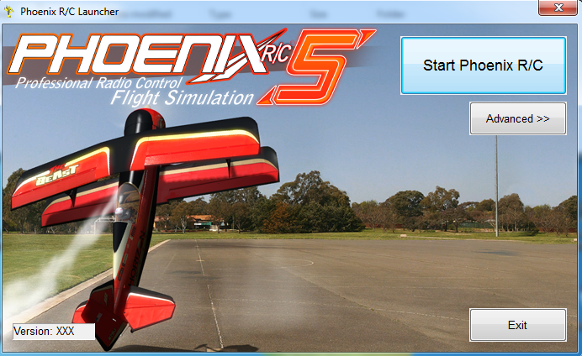

## Publication Number

AFSL-2018-06

## System Name

PhoenixRC

## Model Number

5.5

## Date of Issue

May 1, 2018

# Record of Manual Revisions

Table : Record of manual revisions

|  |  |  |  |  |  |  |
| --- | --- | --- | --- | --- | --- | --- |
| **Revision** | **Date** | **Pages Affected** | **Revisions** | **Author** | **Check** | **Approved** |
| 1 | 5/1/18 | All | Created document | Mason Guiste and Cory Cantey |  |  |

# Table of Contents

Contents

1. Title Page 1

1. Publication Number 1

2. System Name 1

3. Model Number 1

4. Date of Issue 2

2. Record of Manual Revisions 2

3. Table of Contents 3

4. Nomenclature & Glossary 4

5. Introduction 5

1. List of Standards Used for Design and Construction 5

2. Operator Contact Info 5

6. General Information and System Description 6

# Nomenclature & Glossary

Table : Nomenclature and glossary of terms

|  |  |  |
| --- | --- | --- |
| **Term** | **Definition** | **Comment** |
| AFSL | Autonomous Flight Systems Laboratory |  |
| C2 | Command and Control |  |
| ESC | Electronic Speed Control | Component used to connect a battery to a motor and to simultaneously transform battery voltage to lower levels to be used by other components. |
| FPV | First Person View | Typically used in the context of a video signal that is transmitted from the UAV to the GCS to allow a bystander to view video from the aircraft in real time. |
| GCS | Ground Control Station | Computer and associated support and communication equipment necessary for the PIC to control that UAV from the ground |
| LOS | Line of Sight |  |
| MFOC | Mobile Flight Operations Center |  |
| NOTAM | Notice to Airmen |  |
| PIC | Pilot in Command |  |
| RC | Radio Controlled |  |
| Rx | Receiver | This is typically used in the context of a radio transmitter (Tx) and receiver (Rx) |
| TFR | Temporary Flight Restriction |  |
| Tx | Transmitter | This is typically used in the context of a radio transmitter (Tx) and receiver (Rx) |
| UAV | Unmanned Aerial Vehicle | The aircraft and systems carried onboard the aircraft only. This is one component of the entire UAS. |
| UAS | Unmanned Aerial System | The entire system of UAV, GCS, and other associated equipment/entities necessary to operate the aircraft. |
| UW | University of Washington |  |
| VO | Visual Observer |  |

# Introduction

This document describes how to install PhoenixRC from the AFSL network drive and add the AFSL_SKYWALKER model.

## List of Standards Used for Design and Construction

The structure of this manual does not follow a specified standard.

## Operator Contact Info

Contact information for the operator of this system is:

Autonomous Flight Systems Laboratory

University of Washington

AERB Room 139, Box 352250

Seattle, WA

(206) 543-0539

lum@u.washington.edu

# General Information and System Description

1. Insure the AFSL network drive is mapped to your computer.
2. Check the robocopy file at \\AFSL\ComputingInfo\PhoenixRC\CopyKDriveToCDrive_Data.cmd
3. If the file path is correct execute the CopyKDriveToCDrive_Data.cmd file.
4. Navigate to C:\KDriveCopy\AFSL\Software\PhoenicRC and unzip “Phoenix DVD V5.5.zip” in place.
5. Open the “Phoenix DVD V5.5” folder and run the setup.exe to install PhoenixRC.
6. Follow the install wizard to completion.
7. Copy the folder \\AFSL\ComputingInfo\PhoenicRC\Airplanes to C:\Users\<YOUR USERNAME>\Documents\PhoenixRC\Variants\
8. Run PhoenixRC with a transmitter plugged in.
9. Follow the calibration instructions.