# LiPo Battery Charging Instruction

|  |  |
| --- | --- |
| http://www.certifiedmagiciansnetwork.com/images/MagiciansWarningLogo.png | **Batteries must be stored and charged in Lipo bags as well as within the mason cinder blocks.** |

Listed below are basic instructions on handling LiPo batteries.

* Wrong setting on the battery charger can lead to the destruction of the battery.
* Batteries should be charged inside Lipo-safe bag.
* Never charge Lipo unattended.
* Do not charge around flammable materials i.e. wood, plastic, and flammable liquids.

Listed below are basic instruction of charging a LiPo battery with imax B6 charger.

1. Inspect battery visually for any defects or “ballooning” before charging.
2. Connect the output charge lead as shown in Fig. 1.

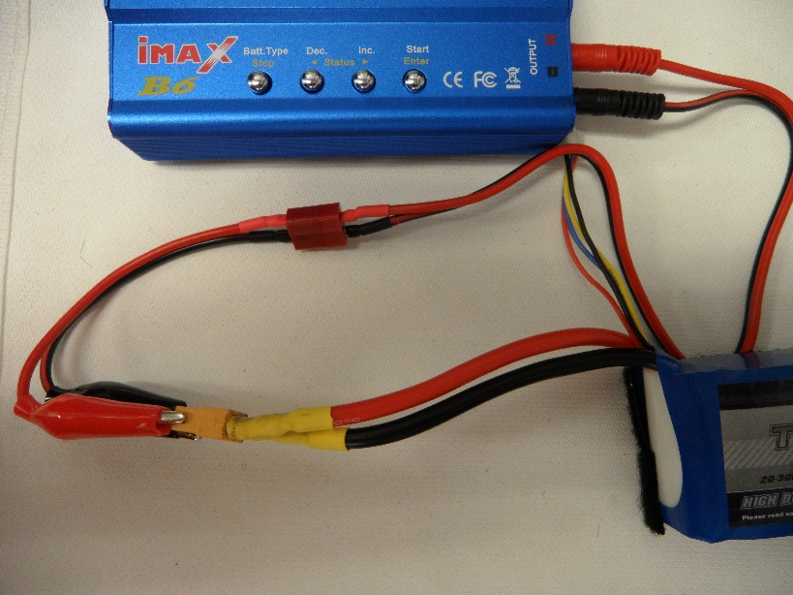

Figure 1: Connecting battery leads to the charger.

1. Connect balance leads as shown in Fig.2. Make sure to plug into the correct balance lead outlet depending on the number of cells in your battery.

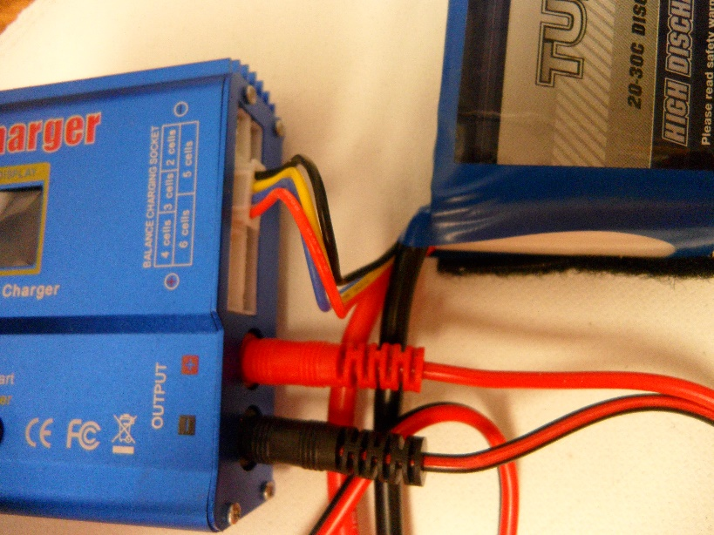

Figure 2: Connecting balance leads.

1. Turn on the power supply as show in Fig. 3.

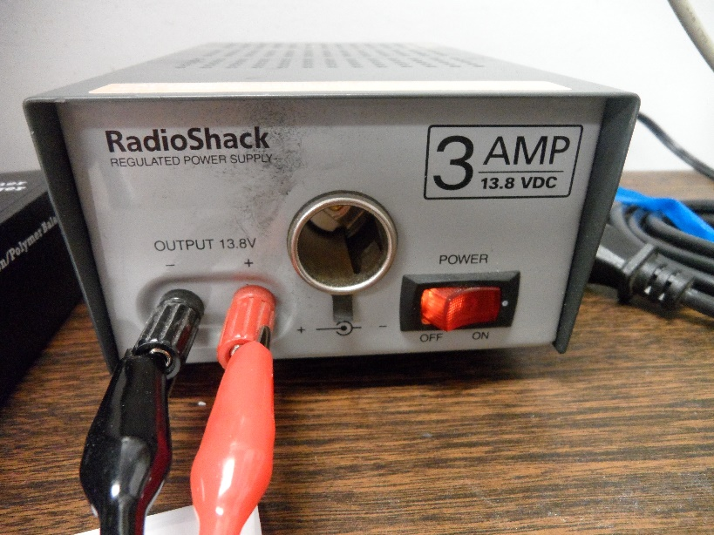

Figure 3: Turning on the power supply.

1. Start off with selecting the correct battery by pressing Batt. Type button and go through the list until you come across LiPo BATT as show in Fig. 4. Than Press Start/Enter

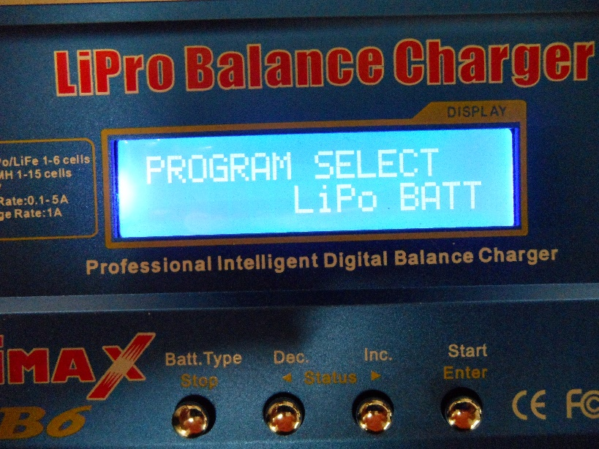

Figure 4: Selecting battery type.

1. Select LiPo BALANCE by pushing the Status button as shown in Fig. 5. You can use left or right button for this. Than push Start/Enter.

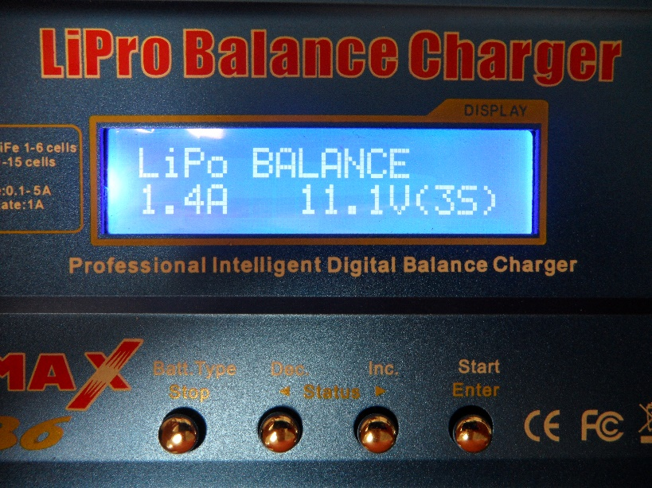

Figure 5: Selecting charging method.

1. You will see that the amps displayed on the screen will start blinking as show in Fig. 6. You want to select the correct number of Amps in, which is dependent on the size of the battery. To determine the right amperage input, you need to divide your batteries Amp hours by 1000 e.g. 1500 mAh battery should be charged at 1.5 Amps. As of right now, we are using a power supply that can output a maximum of 3 Amps as shown in Fig. 3. As a result, if you are charging a battery over 3000 mAh, charge it at 3.0 Amps. This is perfectly fine, the battery will just be charged slower. Once correct amperage input is selected, push Start/Enter.

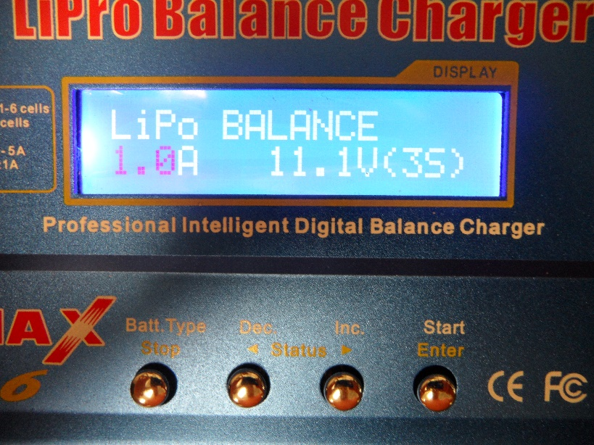

Figure 6: Selecting input amperage.

1. The number of cells on the screen will start blinking as shown in Fig. 7. You want to select the correct number of cells depending on your battery by using the Dec./Inc. buttons.

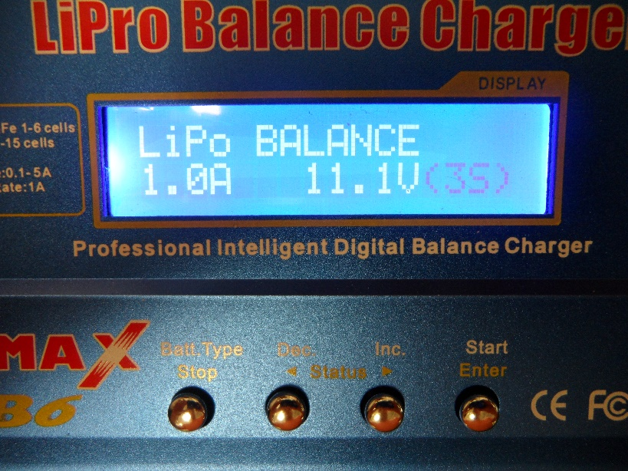

Figure 7: Selecting number of cells.

1. Press and hold the Start/Enter button. The charger will check if the battery is safe to charge. If the charger does not allow you to charge the battery, disconnect everything and ask an experience member of the team for assistance. If everything is good, the charger will ask you to press Enter or Stop to confirm or cancel charging, this is show in Fig. 8.

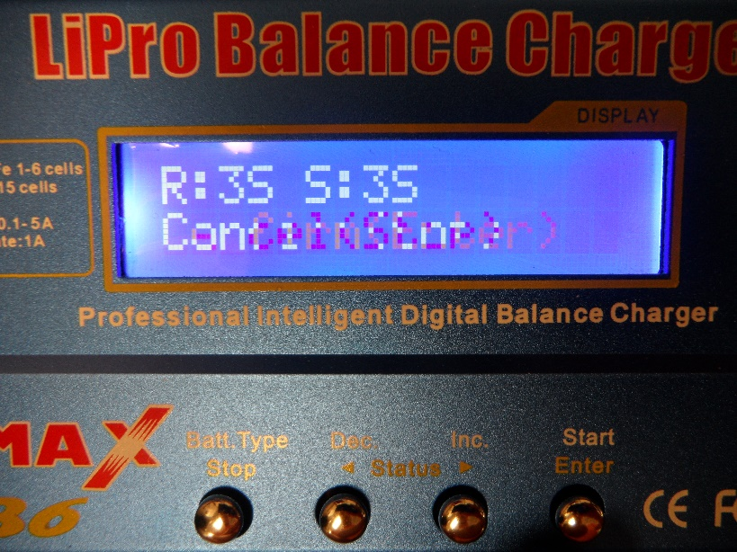

Figure 8: Confirming or canceling

1. After you pushed Enter to start charging the battery, tuck the battery away in the LiPo Safe-Bag and place it away from any flammable material as show in Fig. 9.

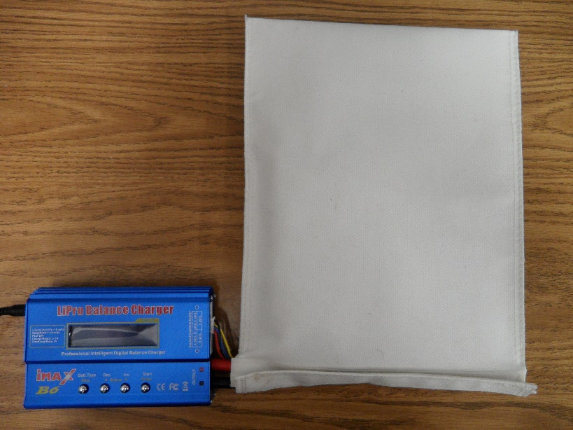

Figure 9: Battery placed in the LiPo Safe-Bag.

1. Do not leave the battery unattended while it is charging. Make sure there is someone in the lab that can stop the charging process if needed.

The charger manual is located in the charger box for any additional information.