# Title Page

**Pix4D Notes**

[](https://www.google.com/url?sa=i&rct=j&q=&esrc=s&source=images&cd=&cad=rja&uact=8&ved=0ahUKEwjI_L7LnO_SAhVE8mMKHWBgDzQQjRwIBw&url=https://pix4d.com/&psig=AFQjCNFwMVCWjAGtr9zt6mgBrlLC_ScOjA&ust=1490447718363391)

Figure 1: Pix4D Logo

## Publication Number

AFSL-2017-07

See \\AFSL\TechnicalDataPackage\AFSLPublicationNumbers.docx for list of publication numbers.

## Date of Issue

May 24, 2018

# Record of Manual Revisions

Table 1: Record of manual revisions

|  |  |  |  |  |  |  |
| --- | --- | --- | --- | --- | --- | --- |
| **Revision** | **Date** | **Pages Affected** | **Revisions** | **Author** | **Check** | **Approved** |
| 1 | 03/24/17 | All | Created document | Christopher Lum |  | Christopher Lum |
| 2 | 04/14/17 | 6-7 | Added info about UW STF license | Christopher Lum |  | Christopher Lum |
| 3 | 04/17/17 | Various | Updating document on how to manipulate point clouds | Shida Xu |  |  |
| 4 | 05/24/18 | Various | Update document with notes on the various outputs of Pix4D and what they mean | Bryson Bruno |  |  |
| 5 | 07/26/18 | Various | Added info about how to create an .stl file for 3D printing | Bryson Bruno |  |  |

# Nomenclature & Glossary

Table 2: Nomenclature and glossary of terms

|  |  |  |
| --- | --- | --- |
| **Term** | **Definition** | **Comment** |
| AFSL | Autonomous Flight Systems Laboratory |  |
| UAV | Unmanned Aerial Vehicle | The aircraft and systems carried onboard the aircraft only. This is one component of the entire UAS. |
| UAS | Unmanned Aerial System | The entire system of UAV, GCS, and other associated equipment/entities necessary to operate the aircraft. |
| UW | University of Washington |  |

# Table of Contents

Contents

1. Title Page 1

1. Publication Number 1

2. System Name 1

3. Model Number 1

4. Date of Issue 2

2. Record of Manual Revisions 2

3. Table of Contents 3

4. Nomenclature & Glossary 4

5. Introduction 5

1. List of Standards Used for Design and Construction 5

2. Operator Contact Info 5

3. Other Documentation 5

6. General Information and System Description 6

1. Introduction to the MFOC 6

7. Bibliography 7

# Introduction

This document records notes regarding how to use Pix4D. This also captures notes and “pearls of wisdom” related to the system.

## Contact Info

Contact information for the author of this document is:

Autonomous Flight Systems Laboratory

University of Washington

AERB Room 139, Box 352250

Seattle, WA

(206) 543-0539

lum@u.washington.edu

## Other Documentation

* Pix4D website ([link](https://pix4d.com/))

# Pix4D Workflow

This section describes an abbreviated set of notes on how to utilize Pix4D to process aerial imagery to generate various pertinent outputs.

**Watch the Pix4D Video Academy for additional help:** [**https://www.youtube.com/watch?v=ZNKOWP8qAMY&list=PL8ZbncaV3f_anQs_DoyKUxmNDApxM0HT8**](https://www.youtube.com/watch?v=ZNKOWP8qAMY&list=PL8ZbncaV3f_anQs_DoyKUxmNDApxM0HT8)

## Preparing the Input Data

### Before starting the first Project

1. Design Image Acquisition plan
   * Design of the image acquisition plan consists of: selecting image acquisition plan type, computing the required flight height for a given GSD, and computing the rate at which images are taken for a specific frontal overlap
     + For a flat terrain, the following steps are recommended
       - Have at least 85% frontal overlap and 70% side overlap
       - Fly higher
       - Use the agricultural template and have high accurate image geolocation
     + Flight height to obtain a given GSD
 $H \left[m\right]=(imW×GSD×F_{R})/(S_{W}×100)$

 $H=Flight height$

 $F_{R}=real focal length [mm]$

 $S_{W}=real sensor width [mm]$

 $imW=image width [pixel]$

  - * GSD [cm/pixel]

Ground Sampling Distance; means the actual, physical distance between points that are at the centers of adjacent pixels in an image

The GSD calculator can be found here: <https://support.pix4d.com/hc/en-us/articles/202560249>

* + - The rate at which images should be taken
      * + GSD [cm/pixel]
 $v=flight speed [\frac{m}{s}]$

       + overlap = percentage of desired frontal overlap between two images

1. Configure the camera settings
2. Georeference the images (optional but highly recommended)
   * Recommended to know the position of camera for at least of 80% of the images
   * Some cameras save the GPS coordinates in the EXIF of images, which Pix4D `mapper then reads to automatically import the image geolocation
   * GPS loggers placed on UAVs can collect the position information of the images, information which is then saved to a file that can be imported into the Pix4D software if the file has the correct format.
3. Getting GCPs on the field (optional but highly recommended)
   * Significantly increase the accuracy of a project
   * GCPs can be defined from other sources
     + GCPs can be extracted from existing maps or laser scanning outputs of the testing area. These GCPs can be highly accurate if these sources are up to date
     + GCPs can be extracted from Web Map Services like Google Maps or Bing Maps, but these GCPs might not be highly accurate.
   * GCPs can be measured in the field
     + The following must be defined to measure GCPs in the field
       - GCP Coordinate System
         * Global coordinate systems: defined using 3D ellipsoid coordinates (latitude, longitude, altitude)
         * National coordinate systems: Usually defined using a projection for a specific country (X, Y, altitude)
         * Local coordinate systems: Defined using a projection. User sets the origin and orientation (X, Y, altitude)
       - GCP accuracy
         * The GCP accuracy should be somewhat better than the desired accuracy of the results
         * The GCP accuracy should not be more accurate than 1/10 of the GSD

If the GSD is 20 cm, then the GCP accuracy should not be less than 2 cm

* + - * Topographic equipment
        + Total station accuracy: can be accurate to millimeters
        + GPS system accuracy: can be accurate to several centimeters

1. Picking the camera angle and flight path is dependent on the future purpose of the data
   * More defined point cloud (.ply file)
     + Flight path: double grid
     + Camera angle: 80 degrees
     + Altitude: 45 feet
   * More defined triangle mesh (3D .stl file)
     + Flight path: circular
     + Altitude: 45 feet

## Setting Up the Pix4D Project

Add some notes about how to setup the Pix4D project. This does not need to be an exhaustive discussion, just include important parameters.

* What settings are appropriate and what do they do?
* What are the different outputs (LAS, LAZ, PLY, XYZ, KML, etc.)
* After a flight, record the camera angle, flight path, and altitude
* Store all photos in one accessible location\
* Title the Pix4D project including the date of flight, flight path, and camera angle
* Create new Project and Upload photos
* Generate a 3D Model
* Begin by Processing Steps 1 and 2
  + Most of what will be needed from Pix4D can be extracted from these steps
  + If you need the DSM/Volumes, that can be done later on
* Once Project has been processed the following functions can be done:
  + Exporting the Point Cloud
  + Exporting the 3D Mesh
  + Refining the Processing Area
  + Export that specific, smaller Processing Area
  + Add GCPs to improve accuracy
  + Add MTPs for a Merge
  + Merging two projects

### Creating a new project

* Project name doesn’t utilize special character(s)
* Path where the project will be created doesn’t utilize special character(s)
* Project name and path together possess less than 128 characters

### Adding images

* The images shouldn’t have any symbols like time and data stamps or else they won’t be processed.
* Images shouldn’t be edited manually
* Images that are taken during takeoff or landing should not be utilized

### Processing options template

* Standard 3D Map: Photo is taken with the camera pointing straight down.
  + Processing speed: slow
* Standard 3D Models: Imagery that is oblique or terrestrial projects.
  + Processing speed: slow

### Manual Tie Points

* You mark the same feature in different images, which improves the reconstruction of the model because the mapper knows that the marks on all the different images should project on the same feature.

### GCPs

* Using GCPs improves georeference (highly recommended to utilize when processing images without image geolocation)
* A minimum of 3 GCPs is required
  + 5-8 GCPs are recommended
* Should be placed homogenously in area being surveyed (well spread out)
  + Do not place GCPs in a straight line
* If no GCPs are used and image has no geolocation, the results are not scaled, oriented or georeferenced, can produce an inverted 3D model in rayCloud and the final 3D model can be shifted

### Check Points

* Points with measured coordinates, and you will also need to mark these points in the images.
* Used to check the accuracy
  + When you create a GCP you are providing the mapper with extra information, which it then utilizes during the optimization process to ensure that the model is reconstructed correctly. In contrast, with checkpoints, the mapper will ignore the extra information provided, which gives you a way to check the accuracy of the project in an unbiased manner and helps you determine whether the project is well reconstructed in a given area.

## Post Processing and Interpreting Pix4D Outputs

Add some notes on how to load, view, manipulate, etc. the various Pix4D outputs. Some software to consider includes but is not limited to:

* Matlab (look at \\UWMatlab\UWMatlab\Mapping\DEMVolumeAnalysis.m)
* ArcGIS
* QGIS (see \\Mapping\TechnicalDataPackage\QGIS)
* Any other relevant software

### Volume Measurements in Pix4D

Requirements:

* Reconstruction is of good quality
  + Click on a few of the 3D points and check if the reprojection is accurate in comparison to the images, and is always at the same point
* GCPs
  + Well spread out
  + Around the point of interest

Or

* Scale Constraints
  + Around the point of interest
  + Have 2 or 3 scale constraints to average the clicking error

To measure volume:

* Select the **Volumes** tab
* Add a volume
  + Left click to mark the vertices of the base of the volume, and then right click to add the last vertex to create the base of the volume.
* Then click **Compute**
  + You will be given the terrain 3D area, the cut volume, the fill volume, and the total volume.
  + If you want to change the base plane, click on **Settings** (the Settingstab is in the same box in which the above information is given), and then you could change the base surface (default base surface is triangulated)

**Volume measurements are based on the DSM.**

**You will need to have the DSM generated before you can calculate the volume.**

**If you modify the point cloud, then you will have to run the DSM again and then compute the volume again so that the modifications are considered.**

### Specifying a Smaller Processing Area

If you are interested in only a sub region of your project, then you should utilize this tool because it aids in reducing the processing time.

1. This is done after the *Initial Processing* is completed in the rayCloud
2. On Menu Bar, select **View** and then click on **rayCloud**
3. Click the leftmost icon, in the **Create** section on the left sidebar
4. In the map, left click to mark the vertices of the *Processing area* and then right click to add the last vertex to complete creating the *Processing area*
5. Save the changes by selecting **Project** and then clicking on **Save Project** in the Menu toolbar

### Exporting Multiple Processing Areas from One Project

After the *Initial Processing* is completed and your first processing area has completed *Step 2:*

1. Export the desired file type (.obj/.ply/.las)
2. Right click on the *Processing Area* tab and select **Delete**
3. From there you can follow the steps above to select your new processing area and load *Step 2*
   1. *Key Tip*: Make sure to never reprocess *Step 1*, when loading *Step 2* for each of your processing areas make sure only the *Step 2* box is checked

### Editing Objects in rayCloud

We can accomplish this in two ways: by using 3D view (less accurate) or using the right sidebar (more accurate). By editing objects in rayCloud we can achieve very accurate measurements.

When you move a vertex that is common to multiple objects, the new position will affect all the objects that include that vertex

3D View

1. In the 3D view, click the vertex of the object to select it
2. Click the vertex again, and drag and drop it to its new position

Right Sidebar

Once a vertex is edited using this method, it is not possible to edit the vertex again utilizing the 3D view method.

1. In the 3D view, click the vertex of the object to select it
2. In the *Images* section of the right sidebar, zoom in/out by scrolling the wheel of the mouse forwards/backwards to obtain a better visual of the position of the vertex
3. Left click to mark the vertex on the images, and mark the vertex on a minimum of two images
   1. Green cross represents the projection of the corresponding 3D vertex
   2. Yellow cross represents the marked vertex in the image
4. Click on **Apply**
5. The 3D position of the associated MTP is corrected in the 3D view
   1. An MTP is associated to each vertex of the object. Each vertex that is marked on a minimum of two images is taken into account if reconstruction is reoptimized or *Initial Processing* is conducted again

### Editing Point Cloud

1. Load the point cloud
   1. All you need to do to load the point cloud is select the **Point Cloud**box under the **Layers**tab in Pix4Dmapper
2. After you load the point cloud, unselect **Cameras**, **Rays***,* and **Tie Points**under the **Layers**tab to get a better visualization of the densified point cloud
3. Suppose you want to remove noise from an area, click on the **Edit Densified Point Cloud** tool
4. Draw a polygon around that area or polygons around the areas (if there is more than one area from which you want to remove noise)
   1. In order to draw a polygon, left click to mark the vertices of the polygon, and then right click to add the last vertex.
      1. To make life easier, select the **Edit Clipping Box***,* a clipping box will appear, and you can adjust the dimensions of it, as you desire
      2. Click **Clip Point Cloud***.* Now, only the area within your clipping box is visualized
      3. Draw the polygon(s)
5. If you want to classify the points you have selected to a different group, navigate to where it says **Unclassified**in the toolbar, if you click on the down error, you will see you have the following groups available to assign the points to: **Deleted, Terrain, Objects** and **New Point Group**
   1. If you select **Deleted***,* and then click **Assign***,* when you regenerate your mesh, the points you assigned to the group **Deleted** will not be included in your result.
   2. If you do not want to remove those points, you can just create a new point group and then click **Assign**. The points will be assigned to the group you just created.
6. If you are done editing, inactivate the editing mode.
7. If you desire the export your point groups, right click on your point cloud under **Point Clouds**in the **Layers**tab, and select **Export Point Cloud**
   1. Select **Save** in the pop-up window that appears to save your changes
   2. In the following window that appears, you can select which group(s) to export, and in what file format
      1. Once you have made your selection, select **OK**

### Adding/Marking Manual Tie Points in Basic GCP/MTP Manager

1. On Menu bar click on **Project**, and then click on **GCP/MTP Manager**
2. On the *GCP/MTP Manager*, under the *GCP/MTP Table* section, click on **Add Point**
3. Repeat the above two steps for the remaining MTPs
4. To mark the MTPs, on the *GCP/MTP Manager*, under the *GCP/MTP Editor* section, click on **Basic Editor**
5. In the table that appears, click on the MTP that is to be marked
6. Under the Images section, chose the image in which the MTP needs to be marked. This image should be displayed in the *Preview* section
7. Left click on the image to mark the point
8. In the *Images* section, select the next image on which the MTP needs to be marked
   1. An MTP only needs to be marked in at least two images, ideally it should be marked in 3-8 images.
   2. The *Quality Report*, which is available after the *Initial Processing* is complete will indicate whether the MTP needs to be marked on more images
9. Repeat steps 4-8 to mark the remaining MTPs
10. Click **OK**

### Adding MTPs in rayCloud

If the reprojection of a 3D point of the model is not precise enough, you can add a Manual Tie Point to improve the reconstruction

1. On the Menu bar, click on **View** and then click on **rayCloud**
2. In the 3D view, select a point in the area where the MTP is to be inserted
   1. On the right sidebar, under the *Images* section, all the images in which the point selected above is visible are shown
   2. The green cross in the images represents the projected position of the selected point. Some images also have an orange cross which indicates the position at which the point was found to compute its 3D position
3. Click on **New Tie Point**
4. A new MTP and its information is added to the right sidebar under the *Selection* section
5. Mark the MTP on at least two images by left clicking
   1. The clicked position appears with a yellow cross and circle. The size of the circle is representative of the zoom level in which the marking has been done; the points that are marked on a high zoom level are taken more into consideration
   2. After clicking on two images, a green cross will show that represents the reprojection of the estimated 3D point on all the images
   3. After clicking on two images, an outlier is represented by a pink circle. The outliers do not impact the resulted construction
6. Verify the following on the images that have not been marked
   1. Whether the green cross corresponds to the correct Manual Tie Point position.
      1. If so, then there is no need to mark the point on more images
      2. If not, then click on more images because every time you click on image the green cross approaches the correct location
7. When the green cross is at the correct location in a majority of the images, click **Apply**
8. Repeat steps 2-7 to add more MTPs
9. When all the MTPs are marked on the images, click on **Process** and then click on **Reoptimize (**the reconstruction will be reoptimized using the MTPs)

### Importing GCPs

**All GCPs need to have the same coordinate system**

1. Obtain the GCPs measurements with the methods described previously
2. Add all the GCPs with the *GCP/MTP Manager*
   1. On the Menu bar, click on **Project,** and then click on **GCP/MTP Manager**
   2. Select the GCP coordinate system (default setting the GCP coordinate system is the same as the Output Coordinate System)
   3. Import the GCPs coordinates. This can be done in the following two ways:
      1. Manually (importing the GCPs one at a time)
         1. On the *GCP/MTP Manager* click **Add Point**
         2. Edit the properties of the GCP
            1. Change the *Type* cell of the GCP

Double click the *Type* cell of the point

From the list choose

2D GCP

3D GCP

Check point

* + - * 1. Insert the GCP coordinates

Double click the coordinate cells of the point

Type in the coordinates for the point

* + - 1. Repeat the above two steps for the remaining GCPs
      2. On the *GCP/MTP Manager* window click **OK**
    1. From File (importing all the GCPs together from a GCP file accepted by Pix4Dmapper)
       1. Make a text file with this structure:

GCP1, x,y,z

GCP2,x,y,z

* + - 1. On *the GCP/MTP Manager* window, on the *GCP/MTP Table*, click **Import GCPs**
      2. An *Import Ground Control Points* window will appear, click **Browse**
      3. Select the GCP text file
      4. Click **Open**
      5. On the GCP/MTP manager window, click **OK**

### Marking GCPs - Basic VS Ray Cloud

**All GCPs must have the same coordinate system**

1. Mark the GCPs on the images with the *Basic GCP/MTP Editor.* This is a much slower method, but will always work.
   1. On the Menu Bar, click **Project,** then click **GCP/MTP Manager**
   2. On the *GCP/MTP Manager*, click **Basic Editor**, and the **Basic GCP/MTP Point** **Editor** window will pop up
   3. On the *GCP/MTP Table*, select the GCP that needs to be marked
   4. In the *Images* section, the mages can be sorted:
      1. Alphabetically
      2. By Distance to GCP (this sorting can only be utilized if both the images and the GCPs are geolocated using a known coordinate system. This is also the default setting)
      3. By Distance to the Marked Image (this sorting can only be utilized if the images are geolocated)
   5. In the *Images* section, choose the image on which the GCP is to be marked. This image will be displayed in the *Preview* section
      1. If there are too many photos to filter through, write down the name of a few of the images that show GCPs and find them from the alphabetical list
   6. Left click on the image to mark the point
      1. You can
         1. Zoom in by moving the mouse scroll wheel forwards
         2. Zoom out by moving the mouse scroll wheel backwards
         3. Pan by using the mouse left click
   7. In the *Images* section, select the next image on which the GCP is to be marked
   8. Repeat steps for all remaining GCPs
   9. Click **OK** once finished
   10. Once all the GCPs are marked click on **Process** and then click on **Reoptimize** (the reconstruction is reoptimized using the GCPs)
2. GCPs can be marked in rayCloud post the *Initial Processing.* It aids in improving accuracy of project by allowing user to detect errors in the reprojection of GCPs and correcting them. It is also the faster method.
   1. Click on **View** and then click on **rayCloud**
   2. On the left sidebar, under the section labelled **Layer,** click on **Tie Points** and then click on **GCPs/MTPs**
   3. Select a GCP from the layer *GCPs/MTPs*
   4. On the right sidebar, under the *Images* section, all images in which the selected GCP is visible are shown
      1. The estimated GCP position appears as a blue circle with a dot in the middle in the images. This position corresponds to the projection of the 3D coordinates of that GCP in the image
         1. If the images provided do not show the GCP, you need to use the *Basic GCP editor*
   5. Mark the exact position of the GCP in at least two images
      1. Clicked position appears with a yellow cross and circle
      2. After marking the GCP on two images, a green cross will be evident in all the images. The green cross is representative of the reprojection of the estimated 3D point
      3. After marking the GCP on two images, a pink circle will appear if the point is incorrectly marked on the other images and are referred to as outliers. Outliers do no influence the calibration results
   6. Click on **Automatic Marking**
   7. Verify the following for the images in which no yellow cross is evident
      1. Whether the green cross indicates the correct location of the GCP
   8. If so, then there is no need to mark the point on more images
   9. If not, then mark the GCP on more images because every time the GCP is marked the green cross gets closer the accurate location
   10. Once the green cross is at the correct location in the majority of the images, click **Apply**
   11. Repeat for the remaining GCPs
   12. Once all the GCPs are marked click on **Process** and then click on **Reoptimize** (the reconstruction is reoptimized using the GCPs)

### Merging Projects

If you have two flights that seem to have holes in the model, or are inaccurate, merging projects can be a great solution.

1. Ensure that the projects that will be merged have matching GCPs and MTPs
   1. This means on each of the projects the same objects have been title the **exact** same name.
2. Open Pix4Dmapper.
3. On the Menu bar, click **Project > New Project...**
4. In Name, type a name for the merged project.
5. Selected the option **Project Merged from Existing Projects**.
6. Click **Next**.
7. On the Merge Projects page, the **Duplicate camera parameters**option is activated by default. If the camera model of the different projects is the same, it is duplicated by adding the name of the project at the end of the original camera model name.
8. Click **Add projects...**
9. On the Select Projects pop-up that opens, browse to the project files. Select the projects to be merge (multiple selection is possible) and click **Open**.
10. Repeat step 9 and 10 to add more projects (if the processing resources can handle multiple projects)
11. Click **Next**
12. If asked if the tie points titled the same name should be treated as identical, say yes.
13. Click **Finish** to create the merged project.

# Pix4D Cloud

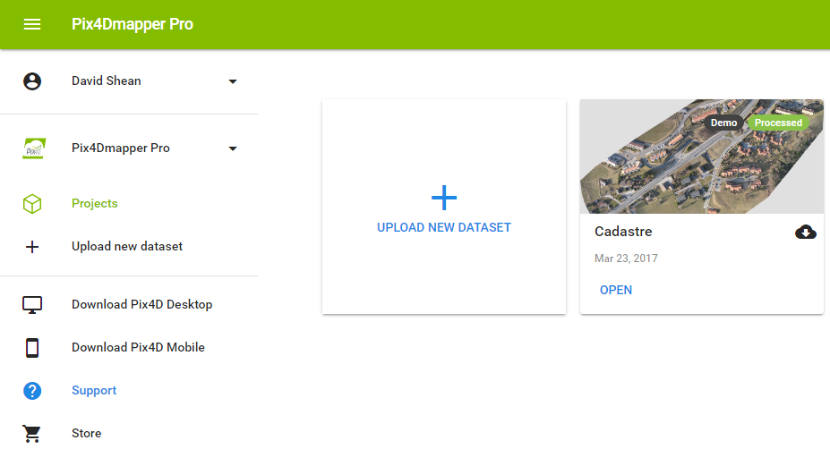

Figure 2: Interface for cloud processing.

# Manipulating Point Clouds in Other Applications

WHAT IS THE POINT CLOUD AND WHERE DOES IT COME FROM? IS THIS A .PLY, .XYZ?

## ArcGIS

### Importing Roster Data

Following steps are for importing roster data (Orthomosaic, DSM, Index Map)

1. Create a folder connection: Click on **Connect to Folder** and create a new folder and subfolder under that folder. Then click **OK**
   * The folder connection you have just created should be present under *Folder Connections* (on the left side of the screen)
2. Right click on the folder connection you have just created, select **New** and then select **File Geodatabase**
3. Load roster files into your geodatabase
   * + Right click on the geodatabase, select **Import** and then select **Roster Datasets**
       - A window will open and locate the files to be loaded and then click **OK**.
4. To visualize the roster dataset loaded, open up ArcMap
   * The *Catalog* is on the right side of the screen
   * In the *Catalog* under the *Folder Connections*, under the geodatabase you created you will find all the files you loaded.
5. Drag and drop your file
6. You can play around with the visualization.
   * If you want to change the color scheme, under the **Layers** tab (left side of the screen), right click on the name of the file you just dragged and dropped, select **Properties**, and then select the *Symbology* tab, and you can choose a different color pallet

### Importing Vector Data

Following steps are for importing vector data (Point Cloud, Contour Lines, Polylines/Surface)

1. Go into your *Catalog*
2. Right click on **Point Cloud**
   1. Select **New**
   2. Select **LAS Dataset**
3. Double click on the LAS Dataset you have just created
   1. Click on **Add Files**
      1. Locate the .las file
   2. Click **OK**
4. To visualize the point cloud, you need to open ArcScene
   1. Find the .las dataset you have just created in the *Catalog* (on the right side of the screen)
5. Drag and drop the file into the main map
6. At the top of the screen you have a toolbar called *LAS Dataset*

## AutoCad

### Importing an Orthomosaic

1. Create a layer
   1. Click on **Layer Properties**
   2. Then select **New Layer**
   3. Name the layer
2. Double click on the layer to activate the layer
   1. Layer is activated when you see the green check
3. Find the Orthomosaic that Pix4d has generated. Just drag and drop it into AutoCad
4. A box will appear asking you where you want to place it
   1. If it doesn’t really matter where you place it, just click the **Enter**key three times
5. Type in the command ID
   1. This allows you to see the coordinates as you move the cursor along the Orthomosaic
   2. You will notice that they are random coordinates
6. To place the Orthomosaic at correct coordinates, type in command GEOREFIMG
   1. Note: You might have to import this command into AutoCAD
   2. Then select the image that need to be repositioned and click **Enter**
   3. The Orthomosaic will no longer be visible on your screen because it has gone to its correct location. To see the Orthomosaic, call the command Z and E or Zoom and Extent
7. Now call command ID and as you move the cursor along the Orthomosaic you will notice that you have real coordinates

### Importing a Point Cloud

1. Click on **ToolSpace**
2. Click on **Point Cloud** and then select create **Point Cloud**
   1. Name the **Point Cloud**and then click **Next**
3. Click the button right above the red cross
   1. Find the Point Cloud you want to import into AutoCAD
   2. Then click **Next**
4. Click **Finish**
   1. It will take some time for AutoCAD to load the Point Cloud
5. To play around, go to the *ToolSpace*, click on **Point Cloud**, right click on the point cloud you just created and select **Point Cloud Properties**
   1. You can change the color of your point cloud
6. To create a surface out of your point cloud, right click on your point cloud and select **Add Points to Surface**
   1. Name the surface
   2. Chose the style of the surface and click **Next**
   3. Click **Next**
   4. Click **Finish**
   5. You can change the style of your surface by clicking **Surfaces** under the *ToolSpace,* find the surface you just created, right click on it and select **Surface Properties**
      1. Chose the new style
      2. Click on the **Analysis** tab and change the style there as well and choose the number of ranges wanted/needed
      3. Save the changes
      4. Click **Okay**

## PCL

How to we import point clouds into a C++ or C# application?

## Matlab

1) Import into matlab using .ply file

2) When using the function [k v] = boundary(….) to calculate the volume of the pointCloud the units of measurement for the volume are the same as the ones used in pix4d

## 3D Printing

The following steps are for creating an .stl file for 3D printing.

From Pix4D you can’t directly export an .stl file. We first must export the 3D triangle mesh as an .obj file. Ensure that the item intended to be printed is in the processing area and that both steps 1 and 2 have been processed

1. Open the RayCloud and check the following boxes:
   1. Triangle Meshes
   2. Mesh “Project Name”
2. Right Click on **Mesh [project name]** and select **Export Mesh…**
3. Select OBJunder **Format**
4. Check **Generate LOD Mesh and Export**
   1. SetTexture Quality to **High**
      1. Save file to desired location
   2. Once the .obj file has been exported we must import it into the application **Blender**
5. Open **Blender** and delete all example objects in the workspace
6. Open the previously generated .obj file
   1. **File** > **Import** > **Wavefront** **(.obj)**
   2. Click **Import OBJ**
7. Use the **Translate** and **Rotate** tools under **Transform** to place the object on the center grid in the correct orientation.
   1. The thickness or shape can be edited in Blender prior to printing
8. Export the project by going to **File** > **Export** > **STL (.stl)**
   1. Adjust name and location of the new .stl file
   2. Send to printer

# Troubleshooting

# License Management

Some details for this process can be found at <https://support.pix4d.com/hc/en-us/articles/202559999-How-to-move-a-Pix4D-Desktop-license-to-another-computer> .

The UW STF licenses for Pix4D are managed by ESS (Figure 2). See email from David Shean on 04/10/17 for login and password info.

## Deactivating a License

TBD

## Activating a License

After a trial license expires, you may need to activate a license.

1. Start Pix4D. You will be presented with a dialog similar to that shown below.

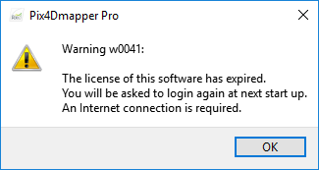

1. Dismiss the dialog and restart Pix4D again.
2. Ensure that one of the STF licenses is available.
3. Login with ‘dshean@uw.edu’ and enter the password (see Chris Lum). If you login to the Pix4D account using ‘dshean@uw.edu’ you should now be able to see the license activated (Figure 2).

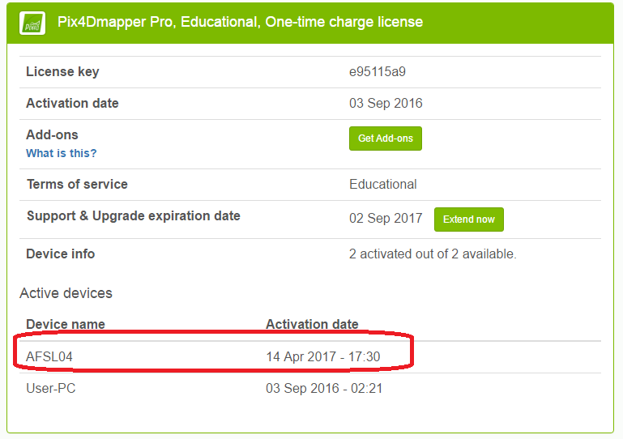

Figure 3: Showing successful activation of license on AFSL machine.

# Appendix A – Nvidia Quadro Graphics Card Settings

Some machines with Nvidia Quadro GPUs experience long processing times for Step 3. Details on how to fix the problem are located at <https://support.pix4d.com/hc/en-us/articles/218195063#gsc.tab=0>

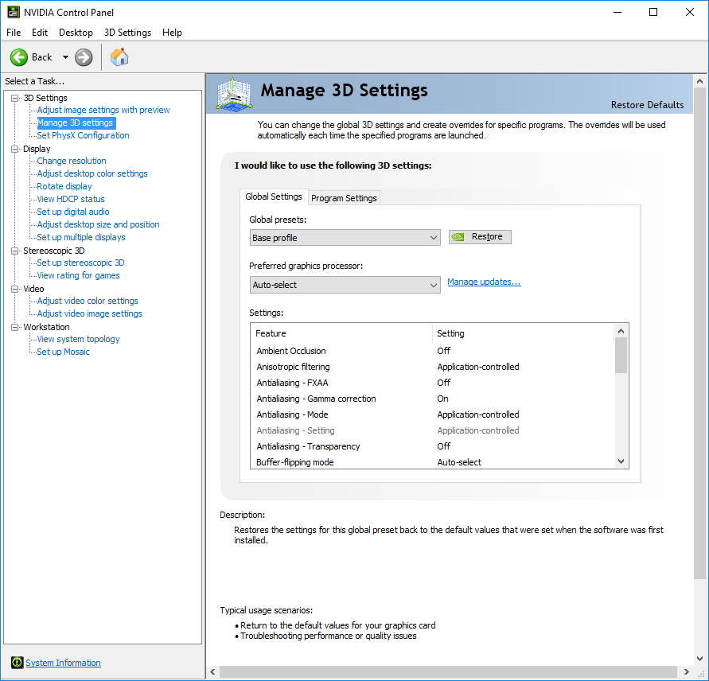

Figure 4: Settings before making a change.

# Bibliography

|  |  |
| --- | --- |
| [1] | M. Oborne, "Mission Planner Home," 2015. [Online]. Available: http://planner.ardupilot.com/. [Accessed 28 December 2015]. |