**UW OneDrive**

This document describes how to :

* Access OneDrive for Business accounts that the UW has setup
* Sync OneDrive to your local machine so you have local copies of the files on your machine

# Accessing UW OneDrive

Follow in instructions below to access the OneDrive files through a web interface.

## Important Links

Click on the link below to be taken to Christopher Lum’s AFSL OneDrive folder

Go to [AFSL](https://uwnetid-my.sharepoint.com/personal/lum_uw_edu/Documents/Shared%20with%20Everyone/AFSL)

## Accessing OneDrive

1. Go to OneDrive for business located at <https://onedrive.live.com/about/en-us/business/>
2. At the resulting page, click on “Sign In” (Figure 1)

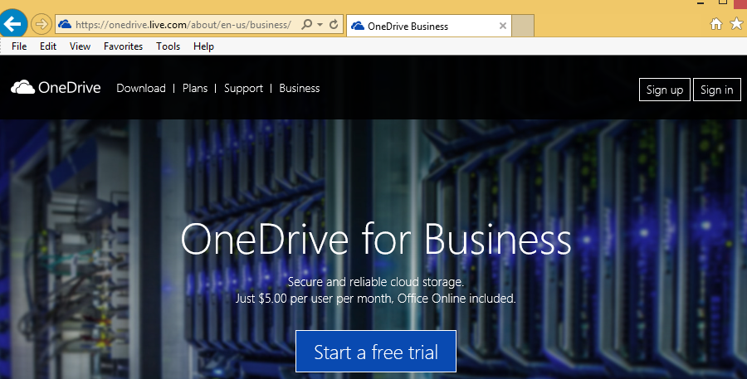

Figure 1: Sign in to OneDrive for business

1. At the sign in page, enter your UW email address (for example, lum@uw.edu).
2. You should then be redirected to the UW Net ID sign in page (Figure 2)

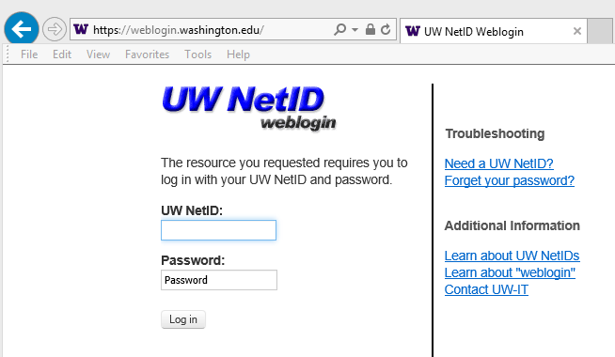

Figure 2: UW Net ID sign in page

1. Sign in using your UW Net ID information.
2. You should now see your OneDrive dashboard (Figure 3)

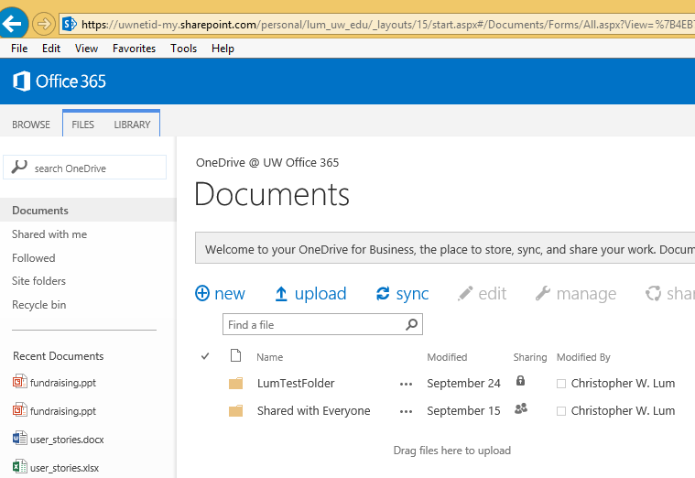

Figure 3: OneDrive dashboard

Additional information about the UW OneDrive system is located at <http://www.washington.edu/itconnect/wares/online-storage/onedrive/> .

# Sync OneDrive for Business to Your Local Machine

Follow the instructions below to sync the OneDrive files to your local machine. Note these instructions are for a Windows 8 machine.

1. Sign into your OneDrive for Business account. For instructions on this, see the section of this document entitled ‘Accessing UW OneDrive’.
2. Click on the ‘LIBRARY’ tab and then select ‘E-mail a Link’ as shown in Figure 4. This yields a URL of the library. Save this URL as you will need it later.

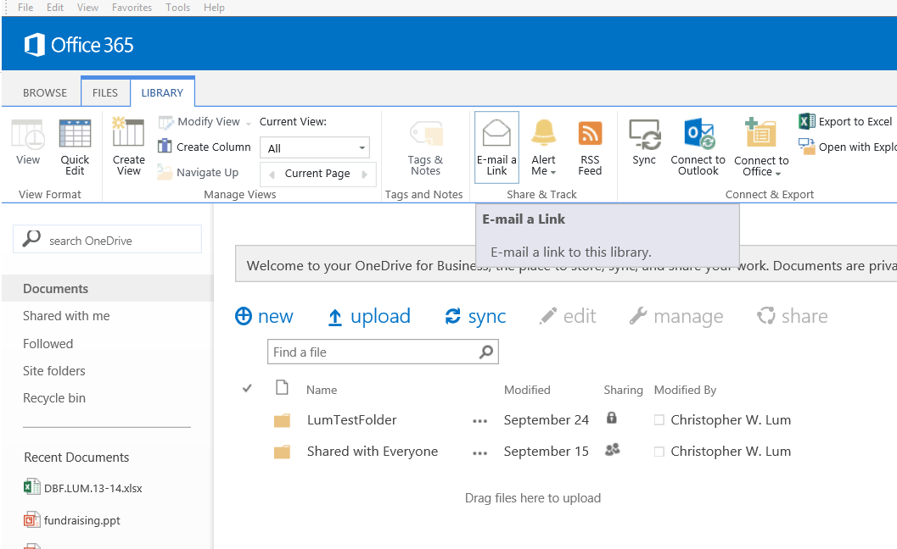

Figure : Obtaining the URL of the library.

1. Create a folder on your local machine that will house the local files. In this example, we use D:\lum\onedrive_for_business (Figure 5).

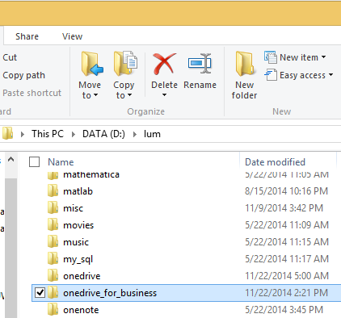

Figure : Creating a local folder on your machine to house the ‘OneDrive for Business’ files. Again, notice that this is a different folder from one that houses normal ‘OneDrive’ files.

1. Search for the ‘OneDrive for Business’ application on your machine (Figure 4). Note that this is different that ‘OneDrive’.

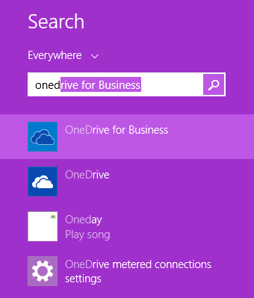

Figure : Find ‘OneDrive for Business’, not ‘OneDrive’

1. On the resulting dialog box perform the following actions:
   1. Enter in the URL you obtained previously
   2. Change the location where the library is saved to as the location of the folder created earlier.
   3. Click on ‘Sync Now’ to being syncing files.

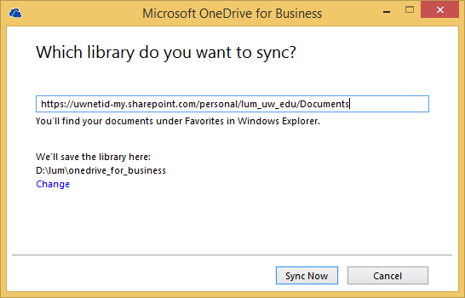

Figure : Setting up the sync settings.

1. You may need to provide UW identification information to complete the sync (Figure 8).

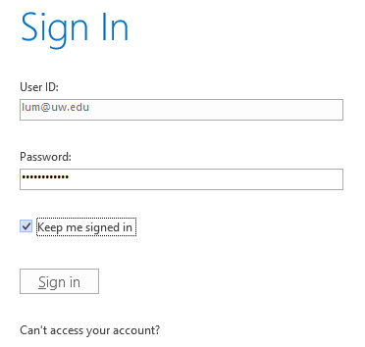

Figure : Providing UW sign in information

1. Files will begin synching to your local machine at this point.

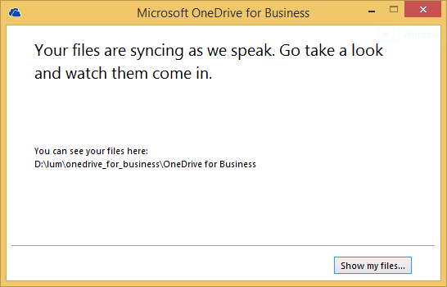

Figure : Files beginning to sync to the local machine.

1. The various icons on the files will show the status of the file (up to date, synching, etc.). Be careful at this point as any modifications on the local machine will be reflected on the cloud and there is not version control so it is easy to delete files.