**AFSL Lab Safety Information**

This document was created to educate members of the AFSL on potential hazards that they could encounter when working with the UAS. The hazards and policies described in this document focus on dangers that pose a serious threat to personal safety.

**In the case of any emergency, call 911**

## Publication Number

AFSL-2015-26

See \\AFSL\TechnicalDataPackage\AFSLPublicationNumbers.docx for list of publication numbers.

## Date of Issue

May 1, 2018

# Record of Manual Revisions

Table 1: Record of manual revisions

|  |  |  |  |  |  |  |
| --- | --- | --- | --- | --- | --- | --- |
| **Revision** | **Date** | **Pages Affected** | **Revisions** | **Author** | **Check** | **Approved** |
| 1 | 08/10/15 | All | Created document | Christopher Lum | Christopher Lum | Christopher Lum |
| 2 - 24 | Various |  |  |  |  |  |
| 25 | 05/01/18 | Various | Updated notes about hi-viz vests. Fixed table formatting | Christopher Lum |  | Christopher Lum |
| 26 | 07/16/18 | 9 (Miscellaneous section) | Added link for accessing Safety Data Sheets on MyChem | Helen Kuni |  |  |
| 27 | 3/2/19 | 9 (Misc.) | Added info about JHAs | Helen Kuni |  |  |
| 28 | 04/15 | 5,9 | Added section on OARS, updated link for uw safety manual, added info on prop guard | Nicholas  Price |  |  |

Table 2 outlines the risks associated with working in the lab and during flight excursions. Many of these hazards are discussed in greater detail in subsequent sections.

Table 2: Possible hazards and PPE and notes to mitigate risks.

|  |  |  |  |
| --- | --- | --- | --- |
| **Task Description** | **Potential Hazards** | **PPE Designated For Lab Tasks** | **Notes** |
| Spinning Propellers | Cuts, lacerations, amputations | Safety glasses  Protective chainmail glove (during launch only)  Protective rubber glove (during launch only)  Motorcycle helmet (during launch only) | * Props should only on during flight tests. * Do NOT approach a propeller unless it is confirmed that the motors are disarmed. * Physically disarm as soon as you get close enough. |
| LiPo Batteries | Electric shock, fire, toxic fumes | **In case of fire:**  Fire extinguisher  Sand  Protective gloves | * Follow all available procedures for charging, handling and disposal. |
| Exacto knives and other cutting equipment | Cuts, lacerations | Safety glasses  Protective gloves |  |
| Rotating equipment (drill, weed whacker, etc) | Injury from being struck. Getting caught in moving parts. | Safety glasses  Protective gloves | * Restrain hair, remove jewelry and no loose clothing. |
| Adhesives (epoxy, CA glue, etc) | Exposure to toxic fumes. | Disposable gloves | * Keep body and clothing away from adhesives. |
| Working with machines or equipment that produce more than 85 dBA | Exposure to hazardous noise levels. | Hearing protection (ear plugs or muffs) | * Anakin was measured to be ~100 dB at 1ft distance when at full throttle. * Hearing protection is required when within 10ft. |
| Working on ladders or stools to reach high places | Fall hazard | Sturdy ladder or stool | * Do not stand on swivel chairs or other unstable objects. |
| Working with and around the propane heater (used during field excursions) | Burns, fire, carbon monoxide exposure | CO detector | * Leave the propane tank in a well ventilated area. * No loose clothes or other flammable materials should be in the vicinity of the heater. * Ensure that CO detector is function in the vicinity of the heater. |
| Soldering, heat gun | Burns, toxic fumes | Safety glasses  Ventilation fan | * Restrain hair and loose clothing * Using clamps to hold wires. * Do not hold heat gun too close to wires, to avoid melting. * Use in a well ventilated area. * Use lead-free solder |
| Hot-wire cutter | Burns, toxic fumes, electric shock | Safety glasses  Ventilation fan  Rubber gloves  CO detector | * Use in a well ventilated area. |

# Spinning Propeller Hazards

Spinning propellers can cause severe damage to an individual or property. Listed below are some of the things to keep in mind when working with or near a propeller.

* Any necessary modifications to the motor and propeller should be done before connecting the battery.
* When the battery is plugged in, treat the motor as a loaded gun.
* Malfunction in hardware can cause the motor to rotate at any time when battery is engaged.
* Prior to approaching a vehicle, confirm that the motor is disarmed via the GCS.
* While remaining clear of the props, before picking up or moving a UAV, ensure that the Motor Power switch is turned to off as shown in Figure 1. This disconnects the motor/propeller from the battery to prevent an inadvertent spin-up.
* Propellers must be removed from the motor at all times, except during flight.[1]
* Add a prop guard whenever prop is attached but not in use.

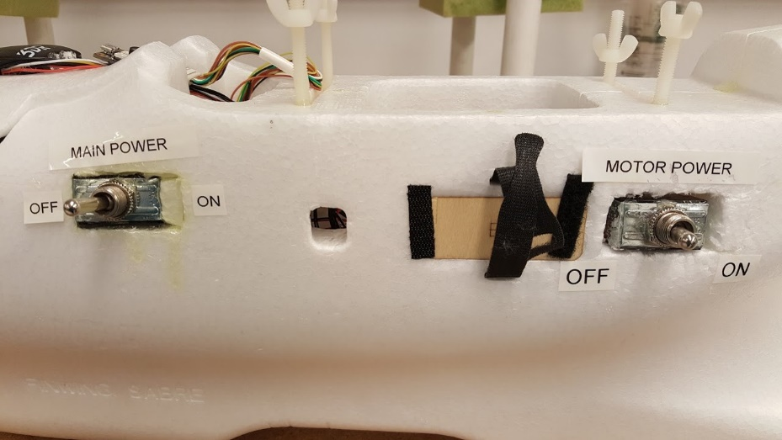

*Figure 1: Main and battery On/Off switches on a lab UAV.*

# Lithium Polymer Battery Safety

Lithium Polymer batteries are capable of storing high charges which presents a certain danger. Battery charging instructions are located on the Perforce Server in "\\AFSL\HowToDocumentation\LiPoBatteryChargingInstruction.docx."

**Policies & Procedures**

* ALL batteries must be stored:
  + in individual LiPo bags
  + in metal cart
  + with connector caps
* Do not over charge, or over discharge batteries.
  + recharge when voltage drops below ~3.3V/cell
* Batteries must be charged:
  + in a LiPo bag within the ceramic jar (see Figure 2)
  + within visual line of sight of a team member
* Any battery that has visible damage or bulging will be disposed of as soon as possible.

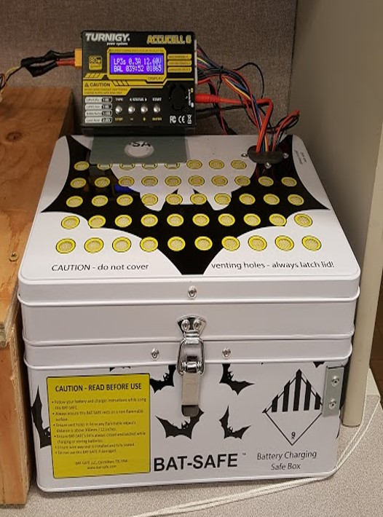

*Figure 2: Proper LiPo charging setup.*

**General Safety**

* Inspect battery visually for any defects or “ballooning” before use.
* Puncturing battery can cause fire.
* Soldering must be done properly without causing a short.
* If battery is shorted, let it sit in a safe place for 15 minutes to see if it blows up.
* Do not discharge battery below 3.3V/cell, this reduces battery life.
* Batteries need to be stored in the right temperature conditions, 40°F to 80°F recommended, 170°F is the maximum limit.
* Old batteries have to be disposed in a proper manner. Please read instructions online or consult a senior lab member.
* Don’t forget to remove batteries from aircraft when you are done.

**Charging**

* Follow procedures posted above battery charging station.
* Do not charge around flammable materials i.e. wood, plastic, and flammable liquids.

Batteries gone wrong:

<https://youtu.be/X75Lwhrgqcg>

<https://youtu.be/gz3hCqjk4yc?t=42s>

Additional information can be found at the following links:

<http://www.horizonhobby.com/pdf/EFL-LiPoSafetyWarnings.pdf>

<http://modelaviation.com/lipo-battery-basics>

**Disposal**

* Batteries can be disposed of at eMedia bins on the UW main campus (<http://www.ehs.washington.edu/eporecycle/batteries.shtm>) ([map](https://green.uw.edu/map/sustainability#type:E.MediaCollection))

# Construction Tools Hazards

Hand tools can cause damage to individuals or objects when not used properly.

* Always use safety glasses when doing any soldering, cutting, gluing, or any other potentially hazardous activities. See Figure 3 for helpful soldering equipment.
* Pay special attention when using power tools.
* Some substances can produce fumes (e.g. epoxy, paint), make sure to have good ventilation.
* Do not use spray paint inside buildings. Painting should be done outside without getting other things painted such as concrete.
* If you do not know how to use a particular tool, ask for assistance.
* Never leave soldering irons or other hot tools plugged in or unattended.
* Always work in pairs or ensure others are present when working in the lab or on any other potentially dangerous task.

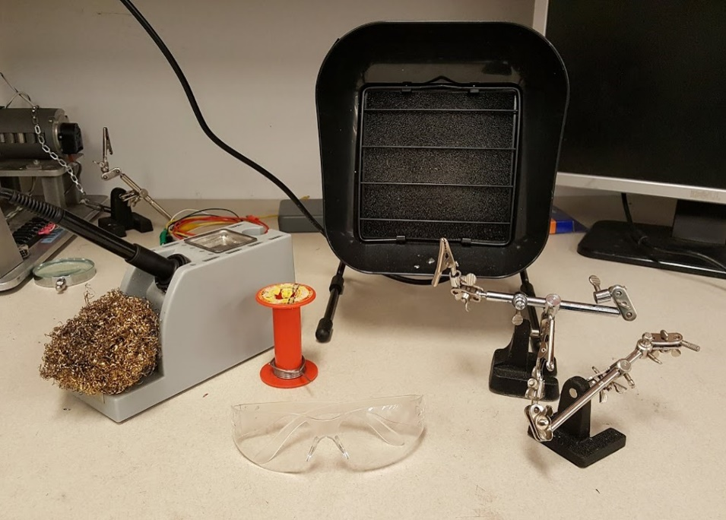

*Figure 3: Appropriate tools to use when soldering. Includes: safety glasses, clamps and ventilation fan.*

# Field Experiment Hazards

When flying UAS, there is an added danger of crashing into people or personal property. All of the above safety protocol applies and in addition, below are rules and regulations that create a safe field operating environment.

* Do not cross the flight line unless you are involved with the operation. Any personnel past the flight line must be wearing high-visibility vests (Figure 4).

## Launch

* Wear appropriate personal protective equipment (PPE) whenever you pick up an aircraft (see Figure 4). This includes a minimum of:
  + Chain mail glove
  + Rubber glove
  + Full helmet

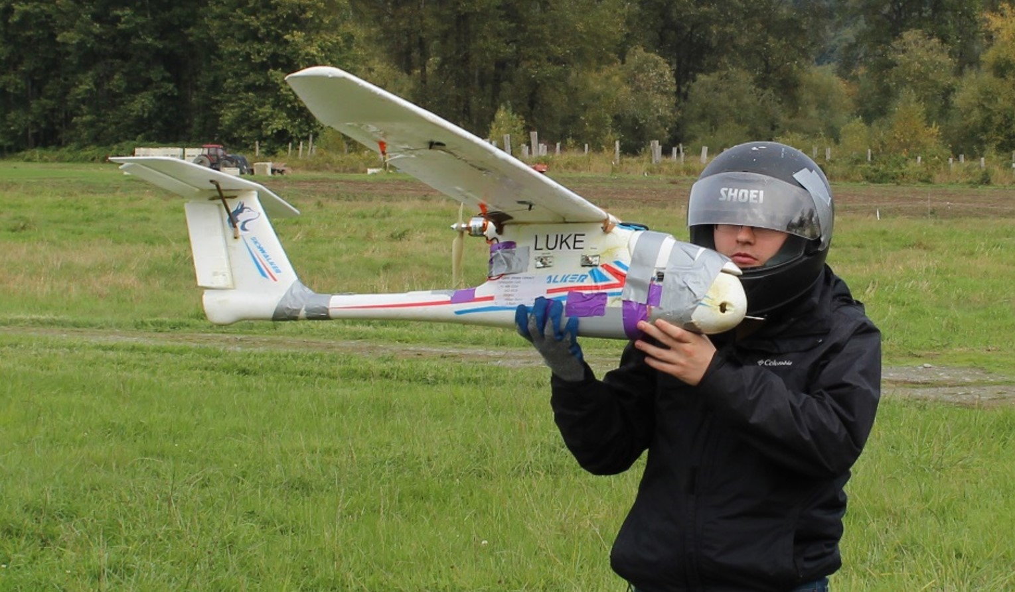

Figure 4: Researcher demonstrating minimum PPE for UAV hand launch.

## Recovery

* Ensure that all participants remain behind the safety line and do not approach a vehicle without confirming it has been disarmed via the GCS, or without immediately turning off the Motor Power switch.
* Bring fire extinguisher to landing/crash sites.

For additional information, visit AMA general rules: <http://www.modelaircraft.org/files/105.pdf>.

# Safety Training

The UW offers free, online safety courses here: <http://www.ehs.washington.edu/psotrain/corsdesc.shtm#esbo>. Below are mandatory trainings for the lab:

* Fire Extinguisher Safety – Online
* Electrical Safety, Basic – Online

Complete these trainings then update \\AFSL\LabInfo\MemberInfo.xlsx.

# Reporting Injury to Online Accident Reporting System (OARS)

* When to submit a report? Report any near misses, hazardous conditions, accidents or injuries involving employees, students, UW volunteers (on or off campus), or members of the public visiting campus.
* Who can submit? The affected employee, their supervisor, or a university representative.
* Submit a report within 24 hours of the incident to OARS at <https://www.ehs.washington.edu/workplace/accident-and-injury-reporting>
* Call EH&S immediately at (206) 543 7262 if the incident involves in-patient hospitalization, recombinant/synthetic DNA exposure or spill, or fatalities. Do not move any equipment involved in the incident until EH&S gives clearance to do so.

# Miscellaneous

* Previous lab safety scores - <https://depts.washington.edu/ehas/pubcookie/prod/labsurvey/index.php>
* The general UW Lab Safety Manual is here: <https://www.ehs.washington.edu/resource/laboratory-safety-manual-510>
* Safety Data Sheets for chemicals (i.e. glues) used in the lab can be accessed through MyChem: https://cspc.admin.uw.edu/mychem/uwnetid/inventory/InvChemSearch.aspx
  + The quickest way to find a chemical is by selecting “advanced search options” and putting in the brand name under “Supplier” (for example, Chemical name: epoxy, Supplier: Bob Smith brings up only one chemical: the type of epoxy we use)
* Job Hazard Analyses (JHAs) for various lab tasks are located on Perforce under \\AFSL\LabInfo\LabSafety. All lab members should read through these documents and sign their names in the table at the end, indicating that they have read them.

1. Detached props can be left inside the payload bay, attached to the tail of the aircraft or inside the vehicle box if it has one.