# Title Page

**New Team Member Orientation Document**



Figure 1: Banner for the Autonomous Flight Systems Laboratory

## Publication Number

AFSL-2014-01

See \\AFSL\TechnicalDataPackage\AFSLPublicationNumbers.docx for list of publication numbers.

## Date of Issue

March 17, 2019

# Record of Manual Revisions

Table 1: Record of manual revisions

|  |  |  |  |  |  |  |
| --- | --- | --- | --- | --- | --- | --- |
| **Revision** | **Date** | **Pages Affected** | **Revisions** | **Author** | **Check** | **Approved** |
| 1 | ??/??/14 | All | Created document | Christopher Lum | Christopher Lum | Christopher Lum |
| 2 | 06/13/16 | All | Updated template | Christopher Lum | Christopher Lum | Christopher Lum |
| 3 | 06/30/16 | 8 | Added notes about network drive | Christopher Lum | Christopher Lum | Christopher Lum |
| 4 | 07/18/16 | 8, 18 | Added more notes about network drive | Christopher Lum | Christopher Lum | Christopher Lum |
| 5 | 07/27/16 | Various | Added notes about AFSL publications | Christopher Lum | Christopher Lum | Christopher Lum |
| 6 | 08/18/16 | Various | Added Facebook info | Christopher Lum | Christopher Lum | Christopher Lum |
| 7 | 10/26/16 | Various | Added inventory info | Hannah Rotta |  |  |
| 8 | 11/02/16 | 14, 18 | Added printer info | Aaron Goldfogel |  |  |
| 9 | 02/24/17 | 18, 21 | Changed contact info doc | Christopher Lum | Christopher Lum | Christopher Lum |
| 10 | 01/12/18 | 10 | Updated K drive notes | Christopher Lum | Christopher Lum | Christopher Lum |
| 11 | 02/01/18 | 16 | Updated safety notes | Christopher Lum | Christopher Lum | Christopher Lum |
| 12 | 06/04/18 | Various | Readded lab calendar information | Christopher Lum |  | Christopher Lum |
| 13 | 06/19/18 | Various | Added calendar info | Christopher Lum |  | Christopher Lum |
| 14 | 10/02/18 | Various | Updated checklist | Christopher Lum |  | Christopher Lum |
| 15 | 10/18/18 | Various | Added slack info | Christopher Lum |  | Christopher Lum |
| 16 | 11/26/18 | 29 | Added Perforce04 | Christopher Lum |  | Christopher Lum |
| 17 | 03/02/19 | 16, 29 | Added info about JHAs | Helen Kuni |  |  |
| 18 | 03/17/19 |  | Fixed Slack link | Christopher Lum |  | Christopher Lum |
| 19 | 6/25/19 | Various | Updated network drive info and persons to contact | Liam Mortell |  |  |

# Table of Contents

Contents

1. Title Page 1

1. Publication Number 1

2. Date of Issue 1

2. Record of Manual Revisions 2

3. Table of Contents 3

4. Nomenclature & Glossary 5

5. Introduction 6

1. Contact Info 6

2. Other Documentation 6

6. Perforce 7

7. AFSL Network Drive 8

1. Mapping the AFSL Network Drive 8

2. Using a Web Browser to Access the AFSL Network Drive 10

8. User Stories 12

9. Inventory 14

10. Lab Spaces 14

1. AERB139 14

1. Access/Facilities 14

2. Security 14

2. AERB138 15

3. Mobile Flight Operations Center (MFOC) 15

11. Safety 16

12. UAS 17

13. Administrative Logistics 18

1. Chris Lum Schedule 18

2. Website 18

3. Email List 18

4. Contact Information 18

5. Printer Network Information 18

6. Lab Calendar 18

1. Web Browser 18

2. Outlook (Desktop Application) 19

3. Google Calendar 22

4. Outlook.com 24

14. General Lab Notes and Policies 26

1. External Communications 26

2. Time Commitments and Contributions to the Lab 26

1. Pre-Majors 26

2. Undergraduates in a Major 26

3. Graduate Students 26

15. New Member Checklist 28

16. Appendix A: Old/Deprecated Information 29

3. OneDrive 29

4. Lab Calendar 31

17. Bibliography 34

# Nomenclature & Glossary

Table 2: Nomenclature and glossary of terms

|  |  |  |
| --- | --- | --- |
| **Term** | **Definition** | **Comment** |
| AFSL | Autonomous Flight Systems Laboratory |  |
| UAV | Unmanned Aerial Vehicle | The aircraft and systems carried onboard the aircraft only. This is one component of the entire UAS. |
| UAS | Unmanned Aerial System | The entire system of UAV, GCS, and other associated equipment/entities necessary to operate the aircraft. |
| UW | University of Washington |  |

# Introduction

Welcome to the Autonomous Flight Systems Laboratory (AFSL). This document describes some of the first steps to get started and get integrated into the lab.

## Contact Info

Contact information for the lab is:

Autonomous Flight Systems Laboratory

University of Washington

AERB Room 117, Box 352250

Seattle, WA

(206) 543-0539

lum@u.washington.edu

## Other Documentation

* User stories are located at \\AFSL\UserStories
* General “how to” information is located at \dev\AFSL\HowToDocumentation
* Major/significant AFSL publications/documents are located at \\AFSL\TechnicalDataPackage\AFSLPublicationNumbers.docx

# Perforce

1. Read the document \\AFSL\ComputingInfo\Perforce\PerforceNotes.docx. This document contains links to YouTube videos to help get started with Perforce quickly.
   1. Watch each video and then like and leave a small comment as proof of completion.
   2. Subscribe to [this](https://www.youtube.com/c/ChristopherLum) YouTube channel as videos related to lab activities are regularly published here.
2. Ensure you are assigned the user story related to getting started with Perforce.

# Slack

The lab uses Slack to communicate between project teams. You can join this workspace via [this link](https://join.slack.com/t/afslworkspace/shared_invite/enQtNTgwMDM5ODM4OTQ5LTI5NjRmYTY4YzcxMDg3MzRkYWIyMjIyOGM2NmE0NGJlM2MyNjMyN2Y1Y2U0OWU4MTQwNTllNGYzZWYwMDJhYmE).

If you would like to manually join the workspace, here is relevant information:

URL: afslworkspace.slack.com

# AFSL Network Drive

Perforce is used to store code and other files that require versioning. The amount of storage space on Perforce is limited and therefore we do not want to take up valuable storage space with large data sets or files. These large files are stored on the lab’s network drive.

|  |  |
| --- | --- |
| http://www.certifiedmagiciansnetwork.com/images/MagiciansWarningLogo.png | **WARNING! FILES ON THE NETWORK DRIVE ARE NOT VERSION CONTROLLED. DO NOT PROCEED UNLESS YOU ABSOULTELY UNDERSTAND THE IMPLICATIONS OF THIS! NEVER DELETE FILES FROM THE NETWORK DRIVE WITHOUT FIRST CONSULTING WITH Helen Kuni.** |

## Mapping the AFSL Network Drive

The preferred way to access the network drive is to map this as a drive on your machine. This will make it appear on ‘My Computer’ as a network drive.

1. Discuss this with Helen Kuni or Liam Mortell before proceeding any further. DO NOT SKIP THIS STEP!
2. Map a network drive to your machine using the following settings.
   * Drive letter: K[1]
   * Folder: \\128.95.33.15\AFSLShared
   * Username: AFSLCommon
   * Password: use the standard lab password
   * Ensure that you check “reconnect at sign in” and “remember my password”

|  |  |
| --- | --- |
| http://www.certifiedmagiciansnetwork.com/images/MagiciansWarningLogo.png | **WARNING! YOU NOW HAVE ACCESS TO THE LAB’S NETWORK DRIVE FILES. THIS IS A TWO-WAY LINK MEANING ANY CHANGES YOU MAKE ON YOUR LOCAL MACHINE WILL AFFECT EVERYONE ELSE AND THERE IS NO VERSION CONTROL FOR BACKUP!** |

1. Accessing files across the network can be slow. It is recommended that you copy files you need from the network drive to your local machine. In order to ensure that references are consistent across lab members, you should create a folder “C:\KDriveCopy” to hold copies of files from the K drive. Copy files using the same file architecture as they are on the K drive.

Some things to note about the network drive

* + The drive should now show up as a network drive on your machine (Figure 2).
  + The file structure on the network drive should mirror the file structure in Perforce. Use this as a guide when determining where to place a file.
  + Remember that these files are not version controlled so any changes you make to these files are permanent and irreversible.
  + Depending on your router/firewall settings or how your network administrator has setup your network, you may encounter trouble mapping the network drive as discussed here.
  + You should only have ‘read-only’ access to these files to prevent the inadvertent deletion of data.
  + If you are off campus, you will need to first VPN onto the UW network using the Husky OnNet VPN client (<https://itconnect.uw.edu/connect/uw-networks/about-husky-onnet/use-husky-onnet/>) before you can access the network drive via the mapped network drive technique.

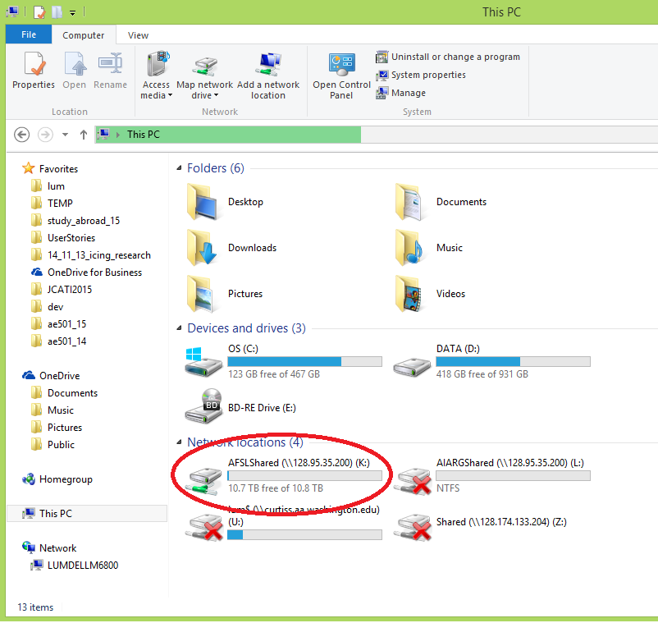

Figure 2: AFSL network drive mapped to your local machine.

## Using a Web Browser to Access the AFSL Network Drive

You can also access files on the network drive via a web interface.

1. Open a web browser (Chrome, Microsoft Edge, Firefox, etc.).
2. Type 128.95.33.15 into the address bar as shown in Figure 3.

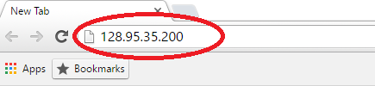

Figure 3: Using a web browser to access the network drive.

1. Hit ‘Enter’ and you should be presented with a login screen similar to that shown in Figure 4.

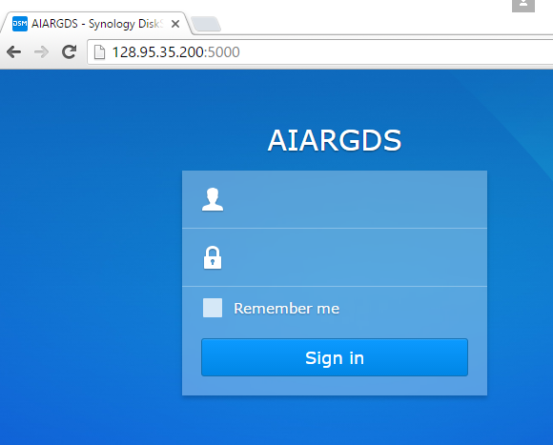

Figure 4: Web-based access to the AFSL network drive.

1. Login using your credentials.
2. Click on the ‘File Station’ icon to access files.

# User Stories

We employ the [scrum](http://en.wikipedia.org/wiki/Scrum_(development)) method of development to make progress on projects.

Each work item is encapsulated in a “user story” which is similar to a homework assignment. Researchers volunteer to be a “development champion” of a particular user story, which means they are in charge of performing all the necessary work to complete this task.

All user stories are listed in the file

\\AFSL\UserStories\user_stories.xlsx (Excel file listing all user stories and status)

The definition of each user story is documented in a sister document

\\AFSL\UserStories\user_stories.docx (Word document describing each story)

User stories are “due” approximately once per month. This month-long period of work is known as a “sprint”. The typical schedule of a sprint is as follows:

Day 1 – Planning meeting

* Group meets to discuss upcoming user stories. Stories are assigned a size by a voting process.
* Researchers are given a day to look at user stories and determine which ones they would like to work on.

Day 2 – Commitment

* Researchers email Helen Kuni or Liam Mortell to tell him which stories they would like to work on. This is called committing to a user story and is effectively promising to get this work done during the sprint.
* User stories can also be set as a “stretch goal”. For more information on user story status see Table 3.

Day 3 – 29 – In Sprint

* Researchers work on stories.
* Attend weekly research meetings to discuss progress with the entire group.
* Present relevant material to the research group as necessary.

Day 30 – Acceptance Meeting and Internal Demo

* Research group meetings and any stories that are finished will be accepted (researcher is awarded story points if their story is accepted).
* Researcher performs an “internal demo” by demonstrating their user story and any important findings.

Day 31 – External Demo

* If this work is being funded or involved external parties (companies, funding agencies, etc.) the last day of the sprint is a formal, professional demonstration of the relevant work completed over the past sprint.

Each user story can have one of the following status as shown in Table 3.

Table 3: Status of user stories and their meanings.

|  |  |
| --- | --- |
| **Status** | **Meaning** |
| In backlog | User story is not currently being worked on |
| In progress | A researcher has committed to this user story and it is being actively worked on in the current sprint. |
| stretch goal | A researcher would like to work on this user story but does not promise that this will be completed within the current sprint. |
| finished | Researcher has indicated that this story is completed and ready to be accepted at the end of the sprint. |
| accepted | Helen Kuni or Liam Mortell determines that this story is indeed complete and we accept the story as finished. Only Helen Kuni or Liam Mortell should change stories to the “accepted” status. |
| descoped | Researcher was unable to complete this user story. This is an undesirable status as it indicated that you were unable to meet your goal and missed the deadline. |
| blocked | Researcher is unable to make progress on the user story due to unforeseen circumstances or elements outside their control (for example a part they need was delayed shipment). |
| dropped | User story was deemed irrelevant or otherwise unimportant and can be dropped from consideration. |

# Inventory

In order to maintain an accurate lab inventory, all RC components are given a unique tracking number and added to our inventory database:

\\FlightOperations\UAS\ComponentTracker.xlsx

The tracking number is written directly onto each part with sharpie and recorded on this excel sheet. The goal is to track which airframes the parts have been attached to, and how much flight time each has seen. Flight time will be updated after each flight test.

Another goal is to use this to track maintenance on the planes, relating this to how much use each part has had, if it has been part of a significant crash, or if the component itself has been identified to have a noteworthy defect. We can also track if the part has been thrown away (disposed).

# Lab Spaces

## AERB117

### Access/Facilities

* Lab phone number – (206) 685-1531
* Printing:
  + The desktop computers all have the lab printer mapped as “AFSL Color” and you can print from them.
  + If you connect to the network **via Ethernet** in the lab, you should be able to map the printer to your own computer. It is at IP Address 172.25.35.11, and is a Brother HL-3170 CDW. Printing via USB cable also works. Wi-Fi printing is not available.
* The lab has 1 or 2 “floater” desks. Feel free to do work in the lab or temporarily camp out at these desks.
* If you would like access (keys) or a permanent desk in AERB 117, contact Juris Vagners.

### Security

There have been several thefts from AERB so we need to be vigilant.

* If you are the last person to leave on our side of the lab, please ensure that **both doors of the lab are closed and locked**.
* Be careful about the lab door lock as it is easy to permanently unlock the door.  Be sure that the door is locked when you remove your key.
* If you lock your bike up near the lab, please use a U-lock. Multiple lab member’s bikes have been stolen in broad daylight even when they are locked with heavier duty cable locks.

## AERB316A

* This is Juris’ office and is located on the third floor of the AERB.

## Mobile Flight Operations Center (MFOC)

The lab has a mobile trailer used for field experiments. More information on this facility can be found in \\FlightOperations\UAS\MFOC [1].

# Safety

* Read the document \\AFSL\LabInfo\LabSafety.docx that describes things that you need to be aware of when working with the UAS or other systems.
* Create and sign a certificate for yourself located at \\FlightOperations\Operators\Certifications\AFSL_safety\AFSL_Safety_BLANK.docx
* Read and sign your name at the end of the Job Hazard Analyses (JHAs) located at:
  + \\AFSL\LabInfo\LabSafety\job-hazard-analysis-LiPo battery handling.docx
  + \\AFSL\LabInfo\LabSafety\job-hazard-analysis-soldering iron.docx

# UAS

* The lab has several, independent UAS. Do not mix parts/components from one system to another.
* We have a stockpile of spare RC components and materials. If you use a component in a project, be sure to notify Helen Kuni or Liam Mortell so we can replace these materials.
* More information about the various systems are located at \\FlightOperations\UAS.

# Administrative Logistics

## Website

* The lab website is located at <http://www.aa.washington.edu/research/afsl/>
* If you would like your information added to the lab website, update the documents located in the \\AFSL\WebsiteInfo\People folder.
* Please peruse the lab’s ‘Facilities’ page to become aware of some of the systems that are available in the lab.
* The lab’s Facebook page is located at <https://www.facebook.com/uwafsl/>
  + Please follow and like this page.

## Email List

* The lab email list is [afsl@u.washington.edu](mailto:afsl@u.washington.edu). You can write a message to this list to reach all members of the lab.

## Contact Information

The lab maintains a document with everyone’s contact information at \\AFSL\LabInfo\MemberInfo.xlsx. Please add your information to this document so others can reach you if necessary.

## Printer Network Information

IP: 172.25.35.11

Subnet: 172.25.35.0/24

Subnet Mask: 255.255.255.0

Default Gateway: 172.25.35.100

Warrantee information and driver disk are on file in AERB117.

## Lab Calendar

The lab maintains an online calendar showing all upcoming AFSL events. Lab members should add this calendar to their personal calendars so they can keep apprised of upcoming events. Follow instructions below depending on how you manage your calendar.

### Web Browser

The lab calendar can be viewed from any web browser at the following URL

<https://outlook.live.com/owa//calendar/d6f2df33-5283-4c16-a595-673b280b191c/99333f76-8545-47bc-a526-f2ff58b4d535/cid-0134F7249E2BE849/index.html>

### Outlook (Desktop Application)

If you use Outlook as a desktop application (ie as part of Microsoft Office 2010 or 2013) you can synch the lab calendar to this account.

1. Start Outlook.
2. Open the ‘Calendar’ section (Figure 5)

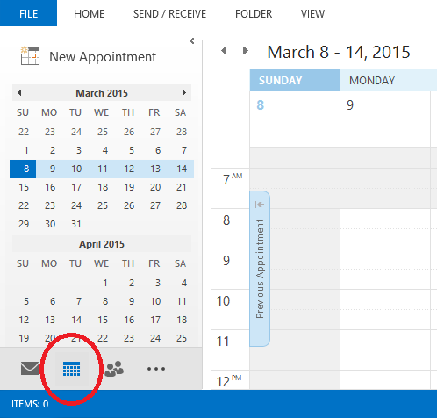

Figure 5: Open the calendar section of the applciation

1. Click “Folder” > “Open Calendar” > “From Internet…” (Figure 6).

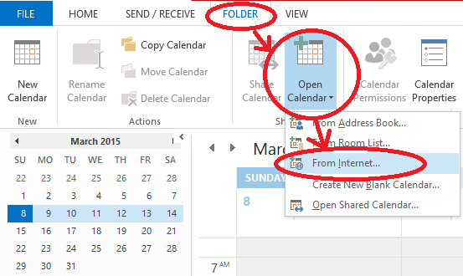

Figure 6: Opening calendar form the internet.

1. In the resulting box, add the URL

<https://outlook.live.com/owa//calendar/d6f2df33-5283-4c16-a595-673b280b191c/99333f76-8545-47bc-a526-f2ff58b4d535/cid-0134F7249E2BE849/calendar.ics>

1. If asked to add this calendar and subscribe to updates, choose “yes” (Figure 7).

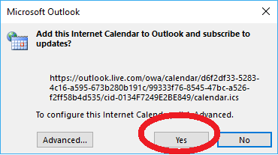

Figure 7: Adding the calendar and subscribing to updates.

1. The calendar shows up as shown in Figure 8.

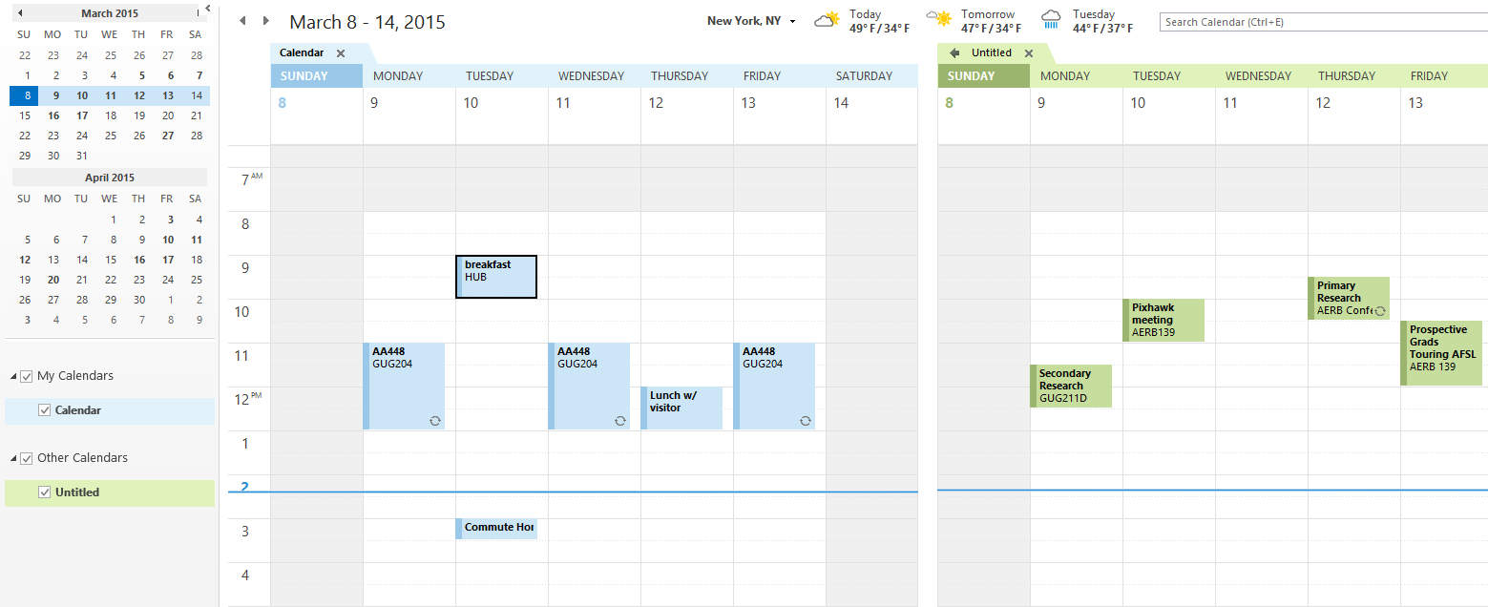

Figure 8: Your original caldenar on the left (in blue) and the added AFSL calendar on the right (in green)

1. Rename the by right clicking on the added calendar. You can also overlay the two calendars together by clicking on the left arrow near the calendar name (Figure 9)

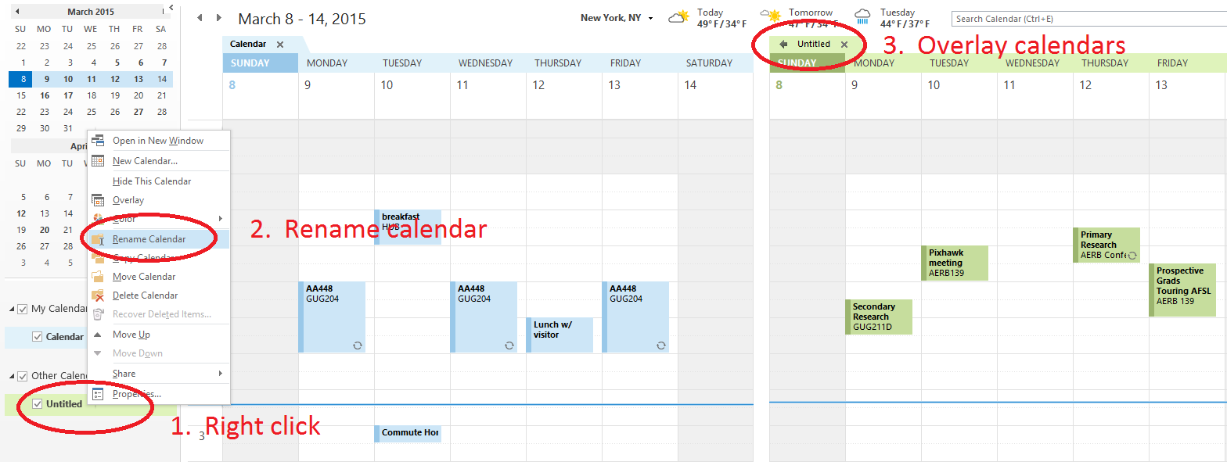

Figure 9: Renaming and overlaying the calendars.

1. The calendars should now appear as shown in Figure 10.

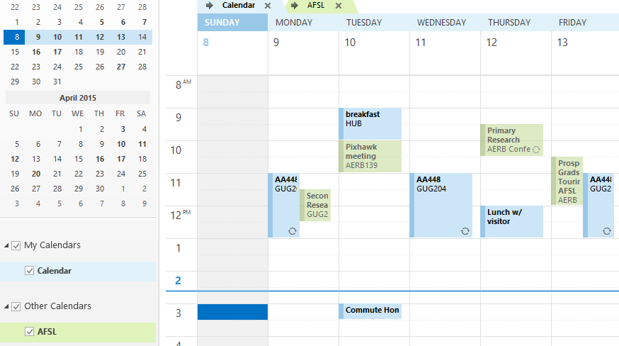

Figure 10: Original and added calendar overlaid on top of each other

### Google Calendar

If you use Google Calendar to manage your calendar, you can follow these instructions to add the lab calendar to your calendar.

1. Log into Google and launch the calendar app (Figure 11).

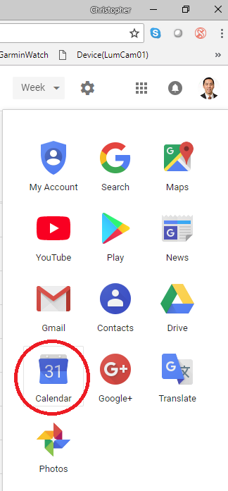

Figure 11: Selecting the calendar app.

1. Look for the ‘+’ sign to add a calendar and then select ‘From URL’

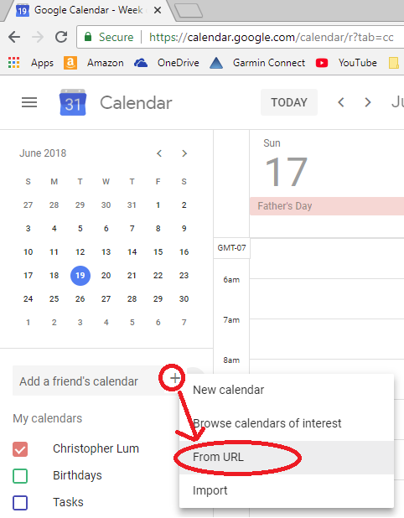

Figure 12: Adding a calendar.

1. In the resulting dialog box, use the URL of <https://outlook.live.com/owa//calendar/d6f2df33-5283-4c16-a595-673b280b191c/99333f76-8545-47bc-a526-f2ff58b4d535/cid-0134F7249E2BE849/calendar.ics> .
   1. Do not check the ‘Make the calendar publically accessible’
2. The calendar should now appear on your list of calendars. You may want to rename this.

### Outlook.com

If you use outlook.com (the web application) to manage your calendar, you can follow these instructions to add the lab calendar to your calendar.

1. Log into outlook.com and launch the calendar app (Figure 12).

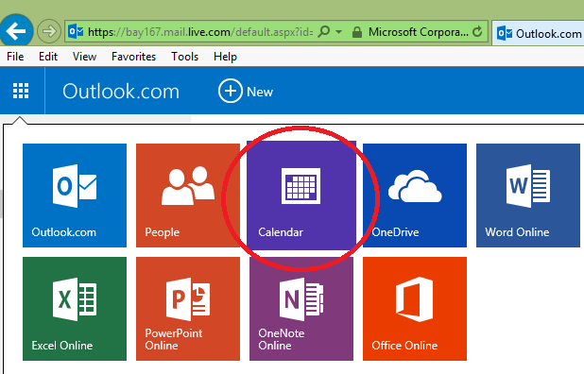

Figure 13: Selecting the calendar app.

1. Near the top, click on “Import”

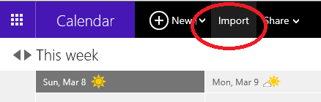

Figure 14: Impoprting a calendar

1. In the resulting page,
   1. Click on “Subscribe” on the left
   2. Enter the following Calendar URL

<https://outlook.live.com/owa//calendar/d6f2df33-5283-4c16-a595-673b280b191c/99333f76-8545-47bc-a526-f2ff58b4d535/cid-0134F7249E2BE849/calendar.ics>

* 1. Name the calendar as you see fit.
  2. Click on “Subscribe”

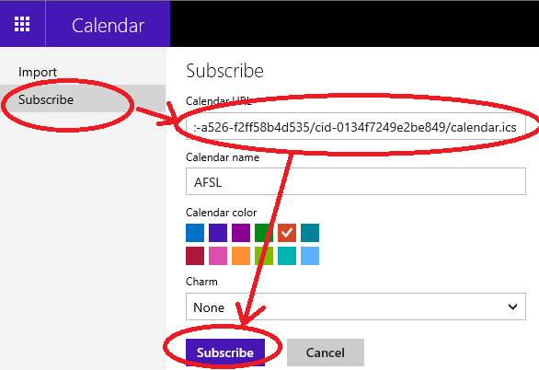

Figure 15: Importing the calendar

1. The calendar should now appear on your outlook.com calendar.

# General Lab Notes and Policies

## External Communications

Some user stories may have tasks which require contact or communications with parties outside our research group (for example contacting the FAA, other researchers in the department, UW IT, etc.).  You must discuss with Juris Vagners before making any contact or communication with anyone outside our research group.  We want to make sure that we have a consistent point of contact and discussion with these individuals.

## Time Commitments and Contributions to the Lab

In order to ensure that the lab makes measurable progress towards its goals, we expect that all lab members are able to contribute in meaningful and quantifiable ways. Depending on your class standing, we have different expectations and requirements of your time commitment. For legal and liability reasons, ALL lab members must be signed up for research credits in the lab. Refer to Table 4 for a listing of required number of story points in order to receive credit.

### Pre-Majors

We encourage pre-majors to participate in lab activities but stress that your primary focus must be getting into a department/major. If you not in a department, you should talk with the advisors of these programs as they can give you advice and information regarding departmental expectations. Many of the departments are highly competitive and value GPA very highly. Working in the AFSL lab is a good resume builder but is not a substitute for poor grades. You should work closely with these academic advisors in order to set reasonable expectations of likelihood of gaining entrance into a department. To ensure that you primarily focus on coursework, we require that you enroll in at least 1 credit of ‘AA299 – Undergraduate Research’ to satisfy legal requirements but you are not obligated to engage in significant research effort to earn this credit.

### Undergraduates in a Major

AFSL members that are already in a department or major must sign up for at least 2 credits of ‘AA499 – Undergraduate Research’ each quarter. If you are in AA, you must forgo at least one technical elective in your senior year. These credits will be replaced by research credits in the lab. Essentially we are asking you to replace one of your classes with research so you are not over burdened by classwork and can make progress in the lab.

### Graduate Students

If you are in an unfunded position, you must sign up for at least 2 credits of ‘AA600 – Independent Study or Research’ each quarter. In addition, you must only be taking two other graduate classes each quarter to ensure that you are not over burdened by classwork. Please talk with Juris Vagners if there are extenuating circumstances that require you to take more than 2 classes per quarter.

If you are in a fund position as a research assistant, you must sign up for at least 6 credits of ‘AA700 – Master’s Thesis’ each quarter. In addition, you must only be taking one other graduate class each quarter to ensure that you are not over burdened by classwork. Please talk with Juris Vagners if there are extenuating circumstances that require you to take more than 1 class per quarter.

Table 4: Mapping of required number of story points per quarter depending on the number of credits taken.

|  |  |  |
| --- | --- | --- |
| **Number of Credits** | **Expected hours/week** | **Required Story Points Per Quarter** |
| 1 | 3 | 6 |
| 2 | 6 | 12 |
| 3 | 9 | 18 |
| 4 | 12 | 24 |
| 5 | 15 | 30 |
| 6 | 18 | 36 |

To register for credits, please fill out the following form located at \\AFSL\Administrative\ResearchForms\UGandGradResearchForm031714.pdf and review it with Juris Vagners.

# New Member Checklist

All new members should complete the items listed in Table 5.

Table 5: Checklist of items for new members to perform

|  |  |
| --- | --- |
| **Item** | **Comment** |
| Read this entire document | NewLabMemberOrientation.docx |
| Contact Juris Vagners to get added to the afsl email list |  |
| Contact Helen Kuni or Liam Mortell to get a Perforce account created |  |
| Create a Perforce workspace and sync relevant files | This is outlined in the Section 6 - Perforce of this document. |
| Subscribe to YouTube channel | <https://www.youtube.com/c/ChristopherLum> |
| Like, leave a comment, and share the YouTube videos that outline Perforce operation | Go to <http://faculty.washington.edu/lum/EducationalVideos.htm> then watch videos   * Perforce01 * Perforce02 * Perforce03 * Perforce04 |
| Join the Slack workspace | Use [this link](https://join.slack.com/t/afslworkspace/shared_invite/enQtNTgwMDM5ODM4OTQ5LTI5NjRmYTY4YzcxMDg3MzRkYWIyMjIyOGM2NmE0NGJlM2MyNjMyN2Y1Y2U0OWU4MTQwNTllNGYzZWYwMDJhYmE) or manually add afslworkspace.slack.com |
| Map the lab’s network drive to your machine | AKA the “K drive” |
| Create a folder “C:\KDriveCopy” on your machine | This will hold copies of files on your local machine. |
| Obtain keys and desk space in the lab | This may not be possible if there are no free spaces |
| Complete Fire Extinguisher training | See \\AFSL\LabInfo\LabSafety.docx (Safety Training section) |
| Complete Electrical Safety training | See \\AFSL\LabInfo\LabSafety.docx (Safety Training section) |
| Sign safety agreement | See ‘Safety’ section |
| Read and sign Job Hazard Analyses | See \\AFSL\LabInfo\LabSafety |
| Add yourself to the lab contact info document | \\AFSL\LabInfo\MemberInfo.xlsx |
| Upload a photo of yourself to Perforce | Add a 150x200 pixel .jpg to \\AFSL\WebsiteInfo\People. |
| Add a brief bio of yourself to Perforce | Add a brief bio to \\AFSL\WebsiteInfo\People\People.docx. |
| Bookmark Chris Lum’s calendar | <http://faculty.washington.edu/lum/schedule.htm> |
| Follow, like, and leave a review on the lab’s Facebook page | <https://www.facebook.com/uwafsl/> |
| Sign up for research credits | See ‘Time Commitments and Contributions to the Lab’ section |
| Add the weekly lab research meeting to your schedule/calendar | Times vary each quarter, ask a lab member when the meetings take place. |
| Review the list of major/significant AFSL publications/documents. | \\AFSL\TechnicalDataPackage\AFSLPublicationNumbers.docx |
| Read through the user stories and ask to be assigned some stories | Ensure you are given a story to get started with Perforce. |

# Appendix A: Old/Deprecated Information

The following information is no longer current and is included here for historical record only.

## OneDrive

Perforce is used to store code and other files that require versioning. The amount of storage space on Perforce is limited and therefore we do not want to take up valuable storage space with large data sets or files. These large files are stored on the lab’s OneDrive account.

|  |  |
| --- | --- |
| http://www.certifiedmagiciansnetwork.com/images/MagiciansWarningLogo.png | **WARNING! ONEDRIVE FILES ARE NOT VERSION CONTROLLED. DO NOT PROCEED UNLESS YOU ABSOULTELY UNDERSTAND THE IMPLICATIONS OF THIS! NEVER DELETE FILES FROM THE ONEDRIVE OR FROM YOUR COMPUTER WITHOUT FIRST CONSULTING WITH CHRIS LUM.** |

1. Discuss this with Chris Lum before proceeding any further. DO NOT SKIP THIS STEP!
2. Go to <https://onedrive.live.com/about/en-us/business/>
3. Click on the ‘Sign In’ button
   1. If you are already logged into a personal Microsoft account, you will need to log out first.
4. At the resulting sign in page, use your official UW email address to sign in (ie [lum@uw.edu](mailto:lum@uw.edu)). Upon hitting ‘Next’ you should be redirected to a UW NetID sign in page to complete the log in.

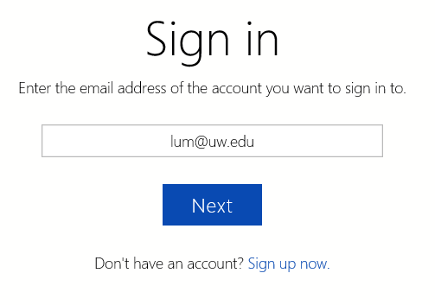

Figure 16: Sign in using your official UW Net ID.

1. Click on the link [https://uwnetid-my.sharepoint.com/personal/lum_uw_edu/Documents/Shared with Everyone/AFSL](https://uwnetid-my.sharepoint.com/personal/lum_uw_edu/Documents/Shared%20with%20Everyone/AFSL)
   1. On the resulting page, you should see all the AFSL files on the OneDrive.
2. We now would like to Sync these files to your local machine.
   1. Create a folder on your machine where you would like to store the files.
   2. On the page showing the AFSL OneDrive files, click on the ‘Sync’ button (Figure 16).
   3. Follow the instructions to sync this online OneDrive folder to your local machine.

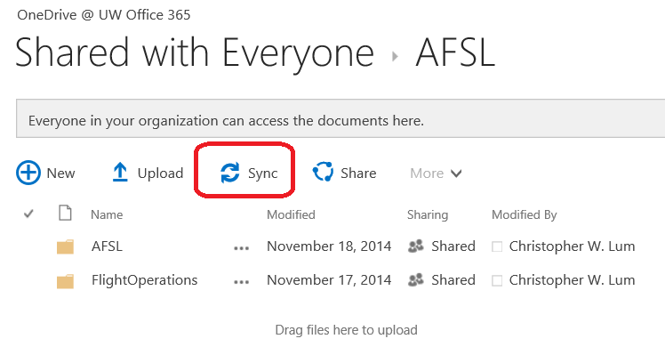

Figure 17: Synching the OneDrive files to your local machine.

|  |  |
| --- | --- |
| http://www.certifiedmagiciansnetwork.com/images/MagiciansWarningLogo.png | **WARNING! YOU NOW HAVE A COPY OF THE LAB’S ONEDRIVE FILES ON YOUR LOCAL MACHINE. THIS IS A TWO WAY LINK MEANING ANY CHANGES YOU MAKE ON YOUR LOCAL MACHINE WILL AFFECT EVERYONE ELSE AND THERE IS NO VERSION CONTROL FOR BACKUP!** |

### Lab Calendar

#### Gmail.com

|  |  |
| --- | --- |
| http://www.certifiedmagiciansnetwork.com/images/MagiciansWarningLogo.png | **THE AFSL GMAIL ACCOUNT IS NO LONGER BEING UPDATED AND AS SUCH, THE GMAIL CALENDAR WILL NOT BE UPDATED. THE BELOW INFORMATION IS PURELY FOR ARCHIVAL PURPOSES IN CASE THIS CALENDAR IS BROUGHT BACK INTO ACTIVE USAGE IN THE FUTURE.** |

If you use gmail.com (the web application) to manage your calendar, you can follow these instructions to add the lab calendar to your calendar.

1. Log into gmail.
2. Open the calendar app as shown in Figure 17.

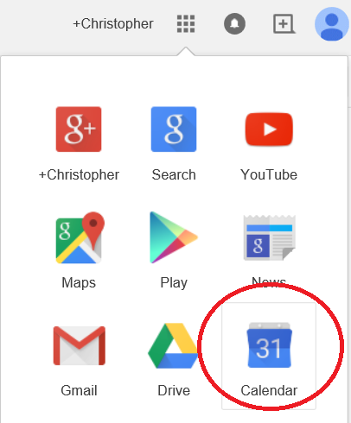

Figure 18: Selecting the Calendar

1. On the left side, click on the down arrow next to “Other calendars” then click “Add by URL” (Figure 18).

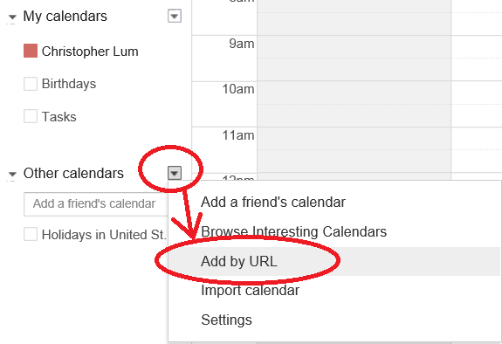

Figure 19: Adding a calendar by URL

1. In the resulting dialog box, add the following URL. Ensure the “Make the calendar publicly accessible?” option is unchecked (Figure 19)

<https://www.google.com/calendar/ical/uwafsl2%40gmail.com/public/basic.ics>

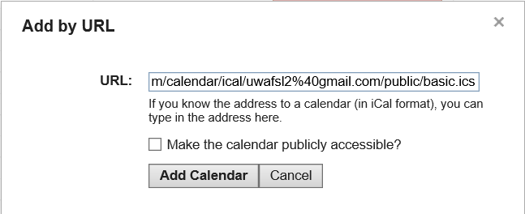

Figure 20: Adding the calendar by URL

1. Lab events should now appear on your calendar (Figure 20)

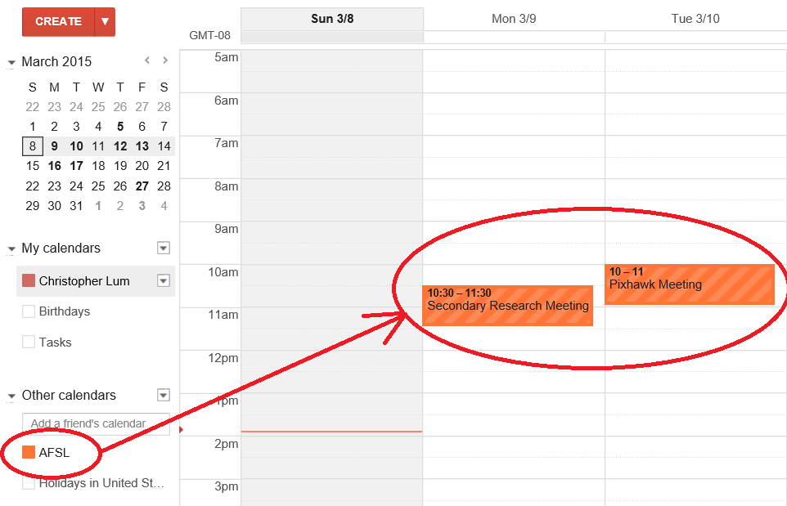

Figure 21: Lab events now appear in your calendar.

# Bibliography

|  |  |
| --- | --- |
| [1] | Autonomous Flight Systems Laboratory, "Mobile Flight Operations Center (MFOC) User Manual," Autonomous Flight Systems Laboratory, Seattle, 2015. |

1. You can usually use any drive letter but it is recommended that you use the letter K so that all references across lab members are consistent