# Title Page

**Soldering Safety Guideline**

## Publication Number

AFSL-2018-13 – not sure

See \\AFSL\TechnicalDataPackage\AFSLPublicationNumbers.docx for list of publication number

## Date of Issue

October 19, 2018

# Record of Manual Revisions

Table 1: Record of manual revisions

|  |  |  |  |  |  |  |
| --- | --- | --- | --- | --- | --- | --- |
| **Revision** | **Date** | **Pages Affected** | **Revisions** | **Author** | **Check** | **Approved** |
| 1 | 10/19/18 | All | Created document | Kelly Lee |  |  |

# Table of Contents

Contents

1. Title Page 1

1. Publication Number 1

2. Date of Issue 1

2. Record of Manual Revisions 1

3. Table of Contents 2

4. Nomenclature & Glossary 3

5. Introduction 4

1. List of Standards Used for Design and Construction 4

2. Operator Contact Info 4

3. Other Documentation 4

6. General Information and System Description 5

1. Introduction 5

2. <Laboratory procedure> 5

3. <Potential hazards and ways to reduce risk> 6

1. Inhalation of Lead solder: 6

2. Fire / Burn: 6

4. <Personal protective equipment> 6

5. <First aid for burns> 7

6. <Environmental/ventilation controls> 7

7. <Location of use in the lab> 7

8. <waste disposal procedures and locations> 7

9. <Required approval> 7

7. Bibliography 8

# Nomenclature & Glossary

Table 2: Nomenclature and glossary of terms

|  |  |  |
| --- | --- | --- |
| **Term** | **Definition** | **Comment** |
| AFSL | Autonomous Flight Systems Laboratory |  |
| UAV | Unmanned Aerial Vehicle |  |
| UAS | Unmanned Aerial System |  |
| UW | University of Washington |  |

# Introduction

This document records notes of how to use soldering workspace, potential hazard, and requirement

## List of Standards Used for Design and Construction

The structure of this manual does not follow a specified standard.

## Operator Contact Info

Contact information for the operator of this system is:

Autonomous Flight Systems Laboratory

University of Washington

AERB Room 138, Box 352240

Seattle, WA

(206) 543-0539

lum@uw.edu

## Other Documentation

* General safety guideline is in the \\AFSL\LabInfo\LabSafety.docx.

# General Information and System Description

## Introduction

This guidance document is designed as a reference for safe soldering work practices at Autonomous Flight System Lab (AFSL). Most soldering done at AFSL is electronic hand soldering, using a soldering iron. Soldering is a “metal joining process in which a low melting point, between 700F to 800F, filler metal is melted to fill the gap between two metal pieces”. It is for permanent connection between electronic components.

## <Laboratory procedure>

In AFSL soldering workplace, automatic timer is connected to the soldering iron. Press the switch on the side of timer before the usage. The timer will turn off the electrical power after certain amount of time. However, researchers should not leave soldering iron unattended. Researchers should turn off the soldering switch, which is different one from the automatic timer, whenever it is not in use. Every researcher should wear goggle during the procedure. Keep the soldering iron tip clean, by wipe excessive lead on the damp sponge. Electrostatic discharge (ESD) is the sudden flow of electricity between two objects. It could damage to the electronic components, so every researcher who are working in soldering station is required to wear static wrist strap that’s grounded to the frame of the device.

## <Potential hazards and ways to reduce risk>

### Inhalation of Lead solder:

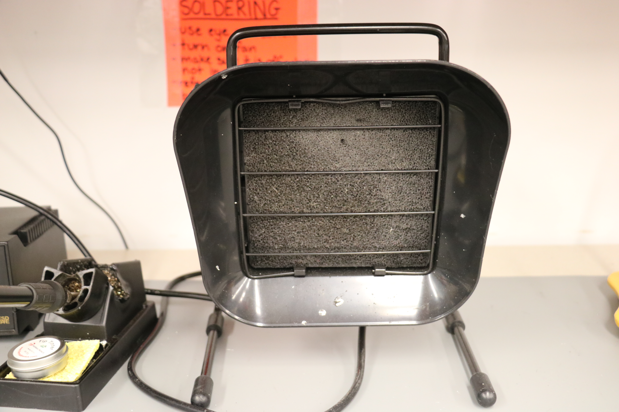The act of soldering lead, especially the one with rosin, element that helps lead to flow better, produce fumes that are hazardous. Inhalation of lead dusts and soldering fumes may cause irritation of eyes and the upper respiratory tract including asthma and pneumonia. Potential routes of exposure include inhaling soldering fume and getting lead dust on hand then introduce to digestive system.

Figure 1: Fume extraction fan

Remember to use fume extraction fan before soldering. Avoid breathing fumes by keeping your head to the side of your work. Preferably use lead free or low lead solder whenever possible. Clean the workspace and properly managing lead soldering waste. Do not eat or drink in soldering areas and wash hands after soldering work.

### Fire / Burn:

Soldering iron is approximately 700F to 800F. Researchers should be aware that it could cause fire by leaving the iron to other than its stand. Excessive flux could cause splashing lead and skin burns.

Conduct work on a fire-proof or nonflammable surface. Be sure the iron is secure in its stand. Wear protective clothing that is indicated in Personal Protective Equipment (PPE) section. Know where your fire extinguisher is and how to use it.

## <Personal protective equipment>

Wear the eye protection, glasses or goggle, that is provided in soldering workspace. Preferably wear long sleeve top and bottom to avoid possible skin burn. Long hair should be tied.

## <First aid for burns>

Immediately cool the affected area under running cold water for 15 minutes.

Do not apply any creams or ointments for the affected area.

Cover the affected area with clean cloth if you wish to protect the area from dirt.

Seek medical attention if the area is bigger than 3 inches across.

## <Environmental/ventilation controls>

The soldering workspace contains fume extraction fans. Always remember to turn on the fan before soldering.

## <Location of use in the lab>

The soldering workspace is in inner most area from the entrance AERB 117.

## <waste disposal procedures and locations>

Lead soldering waste is considered hazardous. Discard lead solder and dross in a designated container. The container will be labeled in the soldering workspace.

## <Required approval>

Every researcher who is willing to solder should have completed required safety training (check LabSafety.docx). If it is the first time working on soldering, the researcher needs approval from senior lab member.

# Bibliography

|  |  |
| --- | --- |
|  | Lead Soldering Safety Guidelines. (2018). [document] Pittsburgh: Carnegie Mellon University, pp.1-4.Available at:https://www.cmu.edu/ehs/Laboratory-Safety/chemical-safety/documents/Lead%20Soldering%20Safety%20Guidelines.pdf [Accessed 19 Oct. 2018]. |