**Title Here**

This document describes…

# General Notes

Some notes here.

## Cross Referencing Figures, Tables, Sections, etc.

All figures and tables should have captions with auto-generated figure/table numbers. To do this.

1. Insert a picture.
2. Right click on the picture and select ‘Insert Caption…’
3. Write the caption text under the figure.
4. When you would like to reference this figure in the text perform the following
   1. Insert
   2. Cross-reference
   3. Change reference type to ‘Figure’
   4. Change so it references ‘Only label and number’

For example see Figure 1.

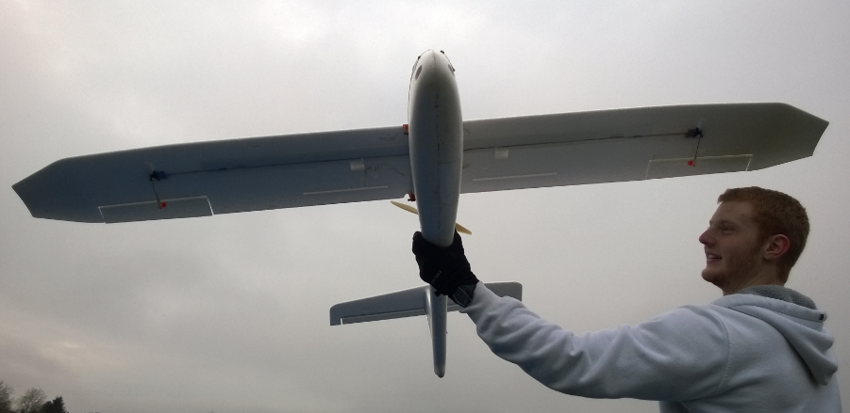

Figure : Researcher holding an aircraft during a field excursion.

## Referencing Papers

AFSL has a source of references located in \\AFSL\TechnicalDataPackage\Word\AFSLReferences.xml. To access this, go to ‘References > Manage Sources > Browse’ and select the previously mentioned file (Figure 2).

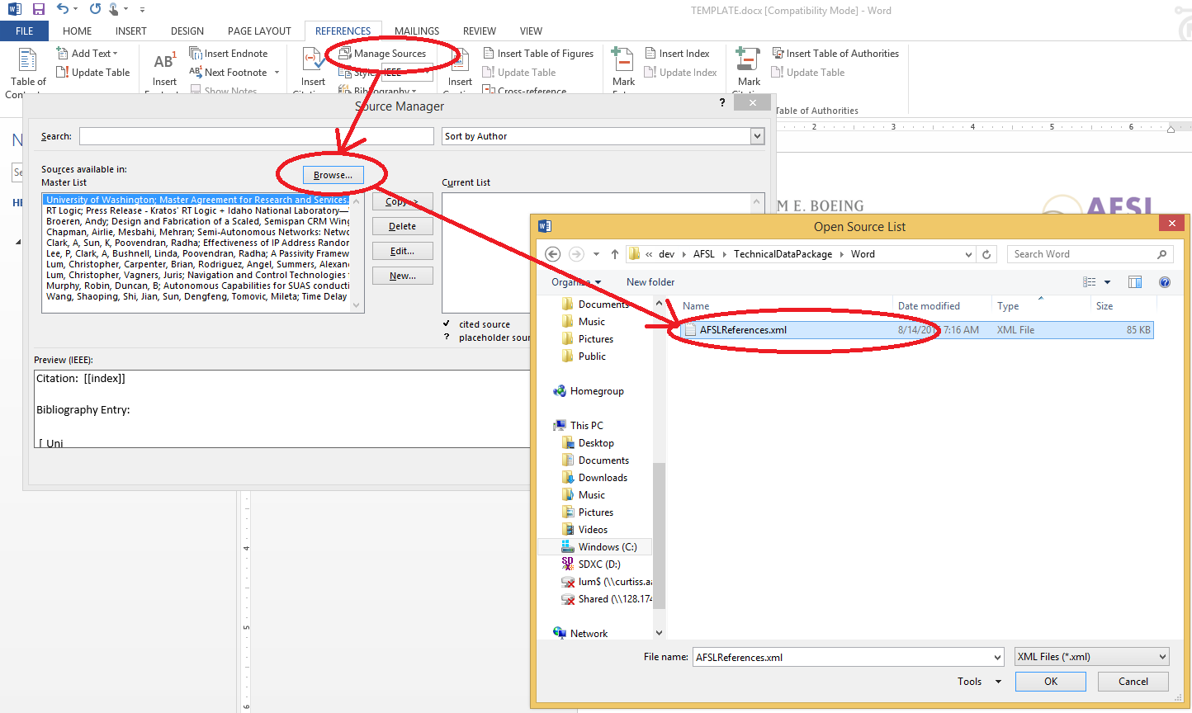

Figure : AFSL references.

You can now cite papers such as works on flight testing [1] or multi-vehicle searching [2] from this source.

### Heading 3

Yet more notes here

# Bibliography

|  |  |
| --- | --- |
| [1] | C. W. Lum, J. Vagners, J.-S. Jang and J. Vian, "Partioned Searching and Deconfliction: Analysis and Flight Tests," in *Proceedings of the IEEE American Control Conference*, Seattle, 2010. |
| [2] | C. W. Lum, J. Vagners and R. T. Rysdyk, "Search Algorithms for Teams of Heterogeneous Agents with Coverage Guarantees," *AIAA Journal of Aerospace Computing, Information, and Communication,* vol. 7, no. 1, pp. 1-31, 2010. |