**Autonomous Flight Systems Laboratory**

**WORKSPACE IN USE**

**PLEASE DO NOT DISTURB**

**Date(s):**

Summer 2014, Autumn 2014, Winter 2014, Spring 2014

**For information contact:**

Dr. Christopher Lum

lum@u.washington.edu

(206) 409-0204



**Autonomous Flight Systems Laboratory**

**These are deep storage items for the:**

**Autonomous Flight Systems Laboratory**

**If you need these moved, please contact:**

Dr. Christopher Lum

lum@u.washington.edu

(206) 409-0204

**Hello <Person I am supposed to be meeting with now>,**

**I am in the lab (AERB 139). This is the square, brick building 50 ft south of Guggenheim. Call me at (206) 409-0204 if you can’t find me, thanks!**

**-Chris Lum**

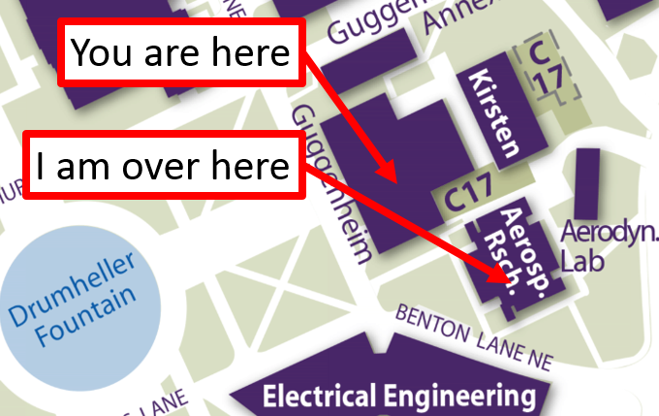

**Turnigy TGY-i10 warnings**

|  |  |
| --- | --- |
| http://www.certifiedmagiciansnetwork.com/images/MagiciansWarningLogo.png | **WARNING! USB Port is located beneath this label. Do not use the USB port to charge battery as it is prone to breaking off. Use dedicated battery charger instead.** |
|  |  |

|  |  |
| --- | --- |
| http://www.certifiedmagiciansnetwork.com/images/MagiciansWarningLogo.png | **WARNING! USB Port is located beneath this label. Do not use the USB port to charge battery as it is prone to breaking off. Use dedicated battery charger instead.** |
|  |  |

|  |  |
| --- | --- |
| http://www.certifiedmagiciansnetwork.com/images/MagiciansWarningLogo.png | **WARNING! USB Port is located beneath this label. Do not use the USB port to charge battery as it is prone to breaking off. Use dedicated battery charger instead.** |
|  |  |

|  |  |
| --- | --- |
| http://www.certifiedmagiciansnetwork.com/images/MagiciansWarningLogo.png | **WARNING! USB Port is located beneath this label. Do not use the USB port to charge battery as it is prone to breaking off. Use dedicated battery charger instead.** |
|  |  |