# Title Page

**Mobile Flight Operations Center (MFOC) User Manual**

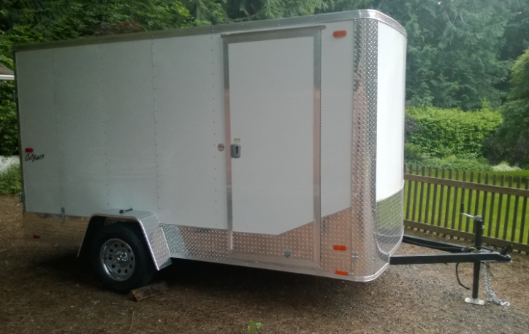

Figure : Insert a picture of the system that this document covers

## Publication Number

AFSL-2016-01

See \\AFSL\TechnicalDataPackage\AFSLPublicationNumbers.docx for list of publication numbers.

## System Name

Mobile Flight Operations Center (MFOC)

## Model Number

Pace America Outback

## Date of Issue

May 20, 2015

# Record of Manual Revisions

Table : Record of manual revisions

|  |  |  |  |  |  |  |
| --- | --- | --- | --- | --- | --- | --- |
| **Revision** | **Date** | **Pages Affected** | **Revisions** | **Author** | **Check** | **Approved** |
| 1 | 05/20/16 | All | Created document | Christopher Lum |  | Christopher Lum |

# Table of Contents

Contents

1. Title Page 1

1. Publication Number 1

2. System Name 1

3. Model Number 1

4. Date of Issue 2

2. Record of Manual Revisions 2

3. Table of Contents 3

4. Nomenclature & Glossary 4

5. Introduction 5

1. List of Standards Used for Design and Construction 5

2. Operator Contact Info 5

3. Other Documentation 5

6. General Information and System Description 6

1. Introduction to the MFOC 6

7. Bibliography 7

# Nomenclature & Glossary

Table : Nomenclature and glossary of terms

|  |  |  |
| --- | --- | --- |
| **Term** | **Definition** | **Comment** |
| AFSL | Autonomous Flight Systems Laboratory |  |
| C2 | Command and Control |  |
| ESC | Electronic Speed Control | Component used to connect a battery to a motor and to simultaneously transform battery voltage to lower levels to be used by other components. |
| FPV | First Person View | Typically used in the context of a video signal that is transmitted from the UAV to the GCS to allow a bystander to view video from the aircraft in real time. |
| GCS | Ground Control Station | Computer and associated support and communication equipment necessary for the PIC to control that UAV from the ground |
| LOS | Line of Sight |  |
| MFOC | Mobile Flight Operations Center |  |
| NOTAM | Notice to Airmen |  |
| PIC | Pilot in Command |  |
| RC | Radio Controlled |  |
| Rx | Receiver | This is typically used in the context of a radio transmitter (Tx) and receiver (Rx) |
| TFR | Temporary Flight Restriction |  |
| Tx | Transmitter | This is typically used in the context of a radio transmitter (Tx) and receiver (Rx) |
| UAV | Unmanned Aerial Vehicle | The aircraft and systems carried onboard the aircraft only. This is one component of the entire UAS. |
| UAS | Unmanned Aerial System | The entire system of UAV, GCS, and other associated equipment/entities necessary to operate the aircraft. |
| UW | University of Washington |  |
| VO | Visual Observer |  |

# Introduction

This document records notes regarding how to operate the **Mobile Flight Operations Center (MFOC)** and its various sub-systems.

## List of Standards Used for Design and Construction

The structure of this manual does not follow a specified standard.

## Operator Contact Info

Contact information for the operator of this system is:

Autonomous Flight Systems Laboratory

University of Washington

AERB Room 138, Box 352240

Seattle, WA

(206) 543-0539

lum@uw.edu

## Other Documentation

* General operational checklists and notes are located in the \\FlightOperations\UAS\MFOC folder.
* Mission Planner documentation [1]

# General Information and System Description

## Introduction to the MFOC

1. Turn on Solo transmitter and Solo aircraft
2. Connect to Sololink_UW wifi on the computer
3. Enter the password as security key instead of the default security pin
4. Go to Mission Planner and select UDP and hit connect

# Bibliography

|  |  |
| --- | --- |
| [1] | M. Oborne, "Mission Planner Home," 2015. [Online]. Available: http://planner.ardupilot.com/. [Accessed 28 December 2015]. |