# Instruction for using MATLAB scripts and Excel files

# 1. Introduction

MATLAB code will provide the latest sprint_metrics and developers’ accepted points and descoped points. It generates plots for new sprint_metrics. These data will be rewritten in several excel files and stored for each purpose. MATLAB scripts were created for reducing time-consuming in recording activity logs and Excel files are used for remaining AFSL work history, including the number of developers, and all the points.

# 2. Record of Manual Revisions

Table 1: Record of manual revisions

|  |  |  |  |  |  |  |
| --- | --- | --- | --- | --- | --- | --- |
| **Revision** | **Date** | **Pages Affected** | **Revisions** | **Author** | **Check** | **Approved** |
| 1 | 03/2/2018 | All | Created document | Taehan Kook |  |  |
| 2 | 03/17/2018 | All | Updated document | Taehan Kook |  |  |
| 3 | 03/19/2018 | All | Updated document | Taehan Kook |  |  |
| 4 | 03/21/2018 | 2 | Updated document | Taehan Kook |  |  |
| 5 | 03/21/18 | Various | Formatting changes | Christopher Lum |  |  |
| 6 | 03/28/18 | Various | Updating document | Taehan Kook |  |  |
| 7 | 03/28/18 | 2 | Updating 4.Steps | Taehan Kook |  |  |
| 8 | 08/08/18 | Various | Adding more comments | Taehan Kook |  |  |

# 3. User Manual

Note:

* Use code in MATLAB R2015b or R2016b or higher version. Recommended to use R2016b or higher version.
* This code has not been tested in lower version of MATLAB R2015b and in R2016a.
* UW MATLAB path must be set up before running the script.

Files Required:

\\AFSL\UserStories

* user_stories.xlsx

\\AFSL\UserStories\Analysis

* MAIN_UserStoriesAnalysis.m
* LoadUserStories.m
* GenerateSprintMetrics.m
* GenerateDeveloperMetrics.m
* AcceptedDevelopers.xlsm
* DescopedDevelopers.xlsm
* SprintMetrics.xlsx

# 4. Steps

1. Check out Excel files first in Perforce.

* \\AFSL\UserStories\Analysis
  + AcceptedDevelopers.xlsm
  + DescopedDevelopers.xlsm
  + SprintMetrics.xlsx

1. Open MAIN_UserStoriesAnalysis.m and Run it. (check if the script opened in the right directory folder, e.g. C:\devFlightTest)

Results:

* + - New sprint_metrics data will be created and generate plots. The sprint_metrics will be save in SprintMetrics.xlsx and operator should save the plots in one’s folder.
    - New Summary information will be created in Summary sheet in AccelptedDeveloper.xlsm and DescopedDeveloper.xlsm. (Fill out the name in Operator column who runs this MATLAB.)
    - Hyperlink will be written on Sprint column in Summary page and in a new sheet.
    - New Developers Data will be created in a New Sheet in XXXDeveloper.xlsm.
    - All the data will be displayed in MATLAB Command Window

Note:

* If there is no Descoped points, DescopedDeveloper.xlsm will not be changed.
* If Matlab script is run by R2015b, It will take longer time and sprint number will not be hyperlinked to the newly created sheet. The Link must be set manually.
* If the name of a sheet is changed, hyperlink will be no longer working, then go to step 4.

1. Open AcceptedDevelopers.xlsm, and DescopedDevelopers.xlsm. Check the updated data.
2. This step will be necessary when you rename a sheet. Remove Sprint number, already linked in but not working. Fill out Sprint number again and follow the steps in Figure 1.

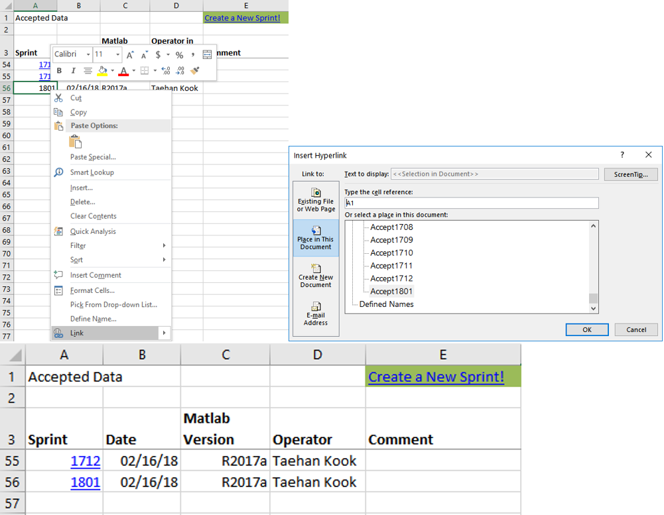  
Figure 1. New information filled out in “Summary” sheet on the 56th row and linking sheet.

*Note:

* Once a user_story of the latest sprint is accepted, all latest sprint data will be extracted.