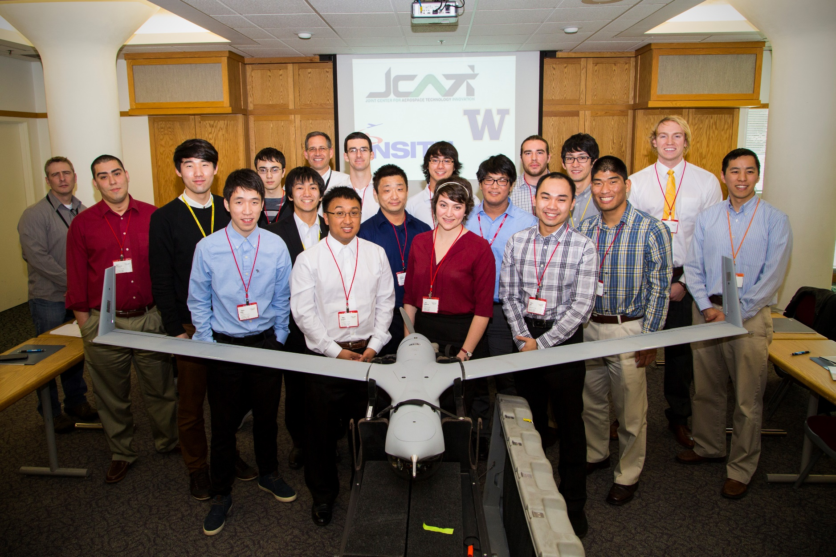

Thank You from the JCATI Team

Thank you for the demo opportunity!

It was an honor and our team looks forward to working with Insitu in the future.