Autonomous Flight Systems Laboratory

The mission of the Autonomous Flight Systems Laboratory at the University of Washington is to support advances in guidance, navigation, and control (GNC) technology relevant to autonomous vehicles and their payload. A parallel objective is to integrate this technology into the flight mechanics and controls courses in the Department of Aeronautics and Astronautics to provide students experience with realistic GNC systems.

Overview

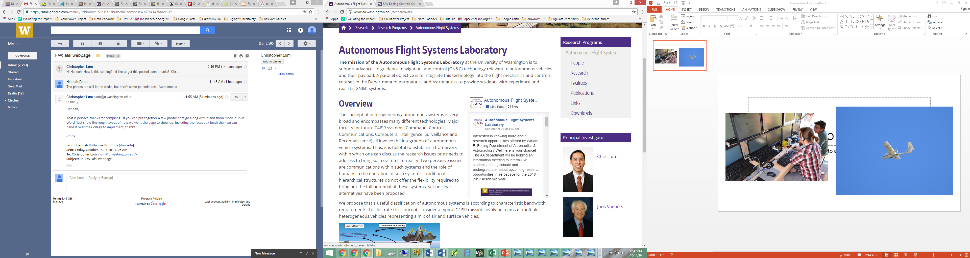

The Autonomous Flight Systems Laboratory investigates and develops technology relevant to unmanned systems. Many of the projects allow students to work closely with industry partners as they research autonomous technology and explore its future uses, leading the way as drone operations continue to increase across the globe. Investigations consist of applying advanced avionics, sensors, and other payloads to various platforms including off-the-shelf fixed wing and multi-rotor unmanned aerial systems and well as customized platforms. Each project is taken from conceptual design through actual flight testing in the field and post flight analysis.

