**The following is information from an email from Brian Leverson (dated 11/1/15) that details how to edit department websites.**

Chris,

Publishing website content is a 2-step process, in which content providers create new or edit existing web content, save these changes, after which a member of the web team examines the changes for compliance and publishes the changes, making them visible.  So you are not actually editing the live website content; you are editing a revision of the content.  In fact, you can't publish content.

You may delegate editing to a student, but I much prefer editors who will be around several years.  These designees will need to log into the website to create a profile, followed by the web team granting them edit access to specific webpages.

In order to edit content on the AA Drupal website you must authenticate yourself by logging in with your UW NetID, using the "Login" link in the footer of every webpage or by accessing the URL (<http://www.aa.washington.edu/login>).   Below is a brief summary of the steps that might be taken during an editing session.



1) Select the UW NetID option and enter your NetID username/password.  After successfully logging in you'll see a profile window, similar to the following.

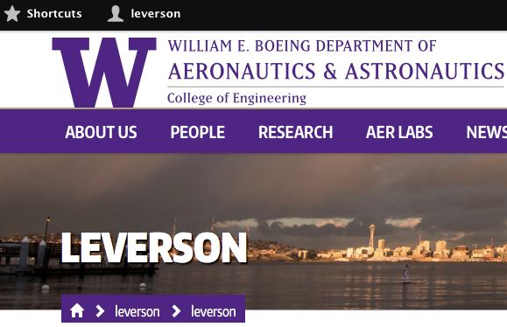

2) To access your faculty page for editing, simply navigate to it as you would normally.  The difference is that you will see a series of tabs above the body of the webpage.

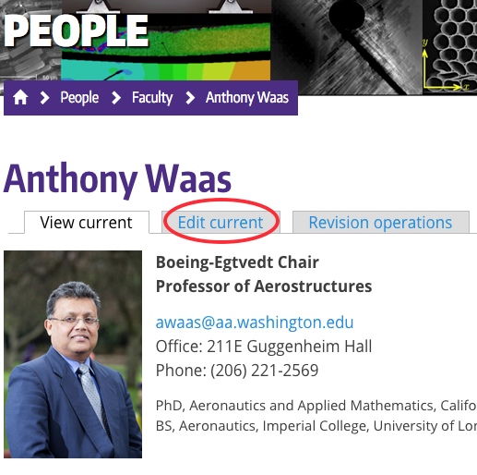

3) Select the "Edit" button and you will be presented with a WYSIWYG editor window, in which you can edit in a normal way.  Minor edits, such as simply correcting spelling errors, are straightforward.  Adding content is more involved, as you may need to format content by selecting icons.  The WYSIWYG editor is creating HTML, that can be viewed by selecting the "Source" button in the upper lefthand corner.

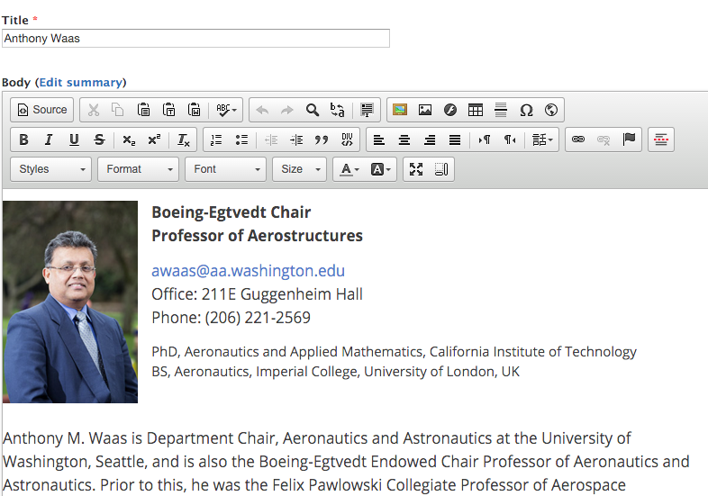

4) When you as satisfied with your changes, select the "Save" button at the bottom of the display window.  (Note the URL alias that is associated with the webpage is displayed to the right, which results in the URL (<http://www.aa.washington.edu/people/faculty/waas>).  The save button will produce a "revision" of your content, which will need to be published by a member of the web team before it becomes visible to the world.  *If you don't select "Save", nothing will be saved from your session.*

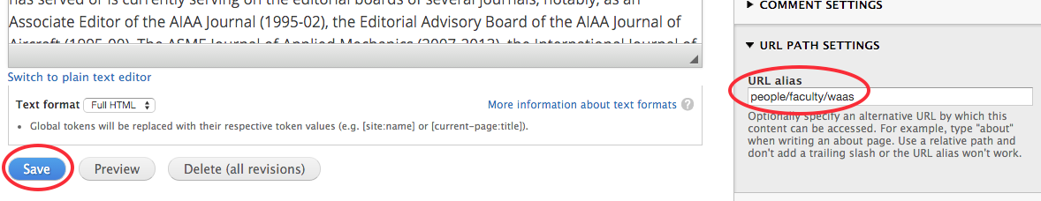

5) To end your session, simply log out or close your web browser.

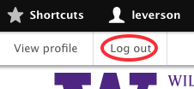

Again, this is just a brief introduction.

Let me know if you have any questions.

-Brian