Hive Assignment

Team 5:

Alex Howell

Ulrich Wartes

# Question 1

Screenshot of directories:

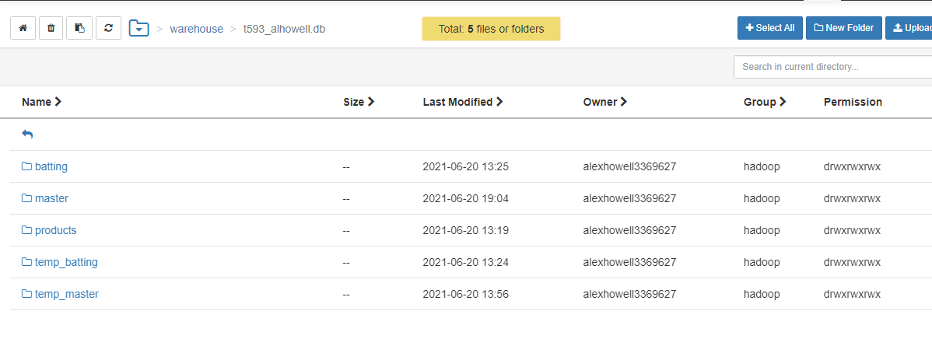

# Question 2

## 2a

Query:

SELECT year, Max(runs), Min(runs), avg(runs)

from batting

WHERE year > 2000

GROUP by year

Order by year desc;

Screenshot:

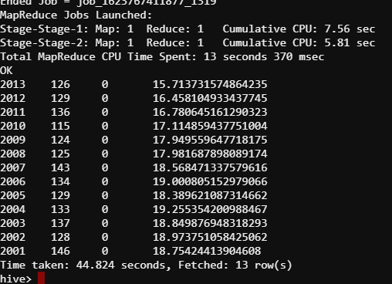

## 2b

Query:

SELECT player_id, avg(runs) as average, sum(runs) as total

From batting

group by player_id

Order by average desc

LIMIT 10;

Screenshot:  
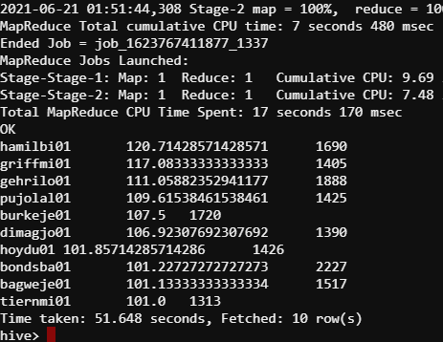

## 2c

Query:

SELECT m.fname, m.lname, avg(b.runs) as avgRuns, sum(b.runs) as sum_runs

FROM batting b

JOIN master m ON m.player_id = b.player_id

GROUP BY b.player_id, m.fname, m.lname

ORDER BY avgRuns DESC limit 10;

Screenshot:

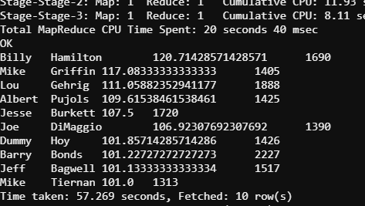

# Question 3

## 3a

Query:

CREATE EXTERNAL TABLE IF NOT EXISTS

ad_data(campaign_id STRING,

ad_date STRING,

ad_time STRING,

ad_keyword STRING,

ad_display_site STRING,

ad_placement STRING,

ad_was_clicked INT,

ad_cpc INT )

COMMENT 'hdfs ad_data'

ROW FORMAT DELIMITED

FIELDS TERMINATED BY '\t'

LOCATION '/user/alexhowell3369627/Homework_1/ad_network_data_etl/step_2';

Screenshot (of count query):

## 3b

### Question 3 from Pig Assignment:

Query:

SELECT ad_display_site, SUM(ad_cpc) as Total from ad_data

WHERE ad_was_clicked=1

Group by ad_display_site

ORDER by Total ASC

LIMIT 3;

Screenshot:

### Question 4 from Pig Assignment:

Query:

SELECT ad_keyword, SUM(ad_cpc) as total from ad_data

WHERE ad_was_clicked=1

Group by ad_keyword

ORDER by total DESC

LIMIT 5;

Screenshot:

# Question 4

## Loading the data:

### Movies (I used the fixed file so that I could verify against excel)

CREATE TABLE movies (

movieId INT,

title STRING,

genres ARRAY <STRING>)

ROW FORMAT DELIMITED

FIELDS TERMINATED BY ','

COLLECTION ITEMS TERMINATED BY '|';

LOAD DATA INPATH '/user/alexhowell3369627/movies_fixed.csv' OVERWRITE INTO TABLE movies;

### Links

CREATE TABLE links (

movieid INT,

imdbid INT,

tmdbid INT)

ROW FORMAT DELIMITED FIELDS

TERMINATED BY ',';

LOAD DATA INPATH '/user/alexhowell3369627/links.csv' INTO TABLE links;

### Ratings

CREATE TABLE ratings (

userId INT,

movieId INT,

rating INT,

times INT)

ROW FORMAT DELIMITED

FIELDS TERMINATED BY ',' ;

LOAD DATA INPATH '/user/alexhowell3369627/ratings.csv' OVERWRITE INTO TABLE ratings;

### Tags

CREATE TABLE tags (

userId INT,

movieId INT,

tag STRING,

times INT)

ROW FORMAT DELIMITED

FIELDS TERMINATED BY ',' ;

LOAD DATA INPATH '/user/alexhowell3369627/tags.csv' OVERWRITE INTO TABLE tags;

## 4-1

Query (note: I alphabetized my list):

SELECT m.title FROM movies m

LATERAL VIEW EXPLODE(m.genres) t as genre

WHERE genre='Adventure'

ORDER by m.title ASC;

Screenshot:

## 4-2

Query (I also ordered mine by most genres to fewest):

SELECT m.title, count(m.genres) as GenreCount FROM movies m

LATERAL VIEW EXPLODE(m.genres) t as genre

GROUP by m.title

HAVING GenreCount > 2

ORDER BY GenreCount DESC;

Screenshot:

## 4-3

Query:

SELECT b.title, AVG(r.rating) as AverageRating

from ratings r

INNER JOIN

(SELECT * FROM movies m

LATERAL VIEW EXPLODE(m.genres) t as genre

WHERE genre='Children') b

on r.movieid=b.movieid

GROUP by b.title

HAVING AverageRating > 3;

Screenshot:

## 4-4

Query:

SELECT r.userid, AVG(r.rating) AverageRating from ratings r

GROUP by r.userid

HAVING AverageRating > 3;

Screenshot:

## 4-5

Query:

SELECT m.title, AVG(r.rating) as AverageRating from movies m

INNER JOIN ratings r on m.movieid=r.movieid

WHERE m.title like '%Star Wars%'

GROUP BY m.title

ORDER BY AverageRating DESC

LIMIT 1;

Screenshot:

## 4-6

Query:

SELECT AVG(r.rating) as AverageRating from movies m

INNER JOIN ratings r on m.movieid=r.movieid

WHERE m.title like '%2008%';

Screenshot:

