{{Deadline}}

{{CompanyName}}
{{CompanyAddress}}
{{CompanyCity}}
{{CompanyRegion}}
{{CompanyPostCode}}
Dear {{AdminName}},
We have received your request for information regarding material changes to internal controls related to the Application Hosting Services for the Humi Software as a Service system.

Currently, Humi issues a System and Organization Controls (SOC) Type II Attestation Report for the period February 24, 2024 to February 24, 2025 by Johanson Group LLP on the America Institute of Certified Public Accountant’s Trust Services Criteria: Security Category for certain identified services (“SOC 2 Report”), which is provided through the Trust Centre (https://trust.humi.ca/).

Our next SOC 2 examination is currently planned to cover the period September 1, 2025 to February 28, 2026, with the report expected to be issued in March 2026.
Humi recognizes the need to maintain an appropriate internal control environment and report upon the effectiveness, as well as material changes to its internal controls. This letter hereby notifies that for the succeeding period from February 24, 2025 to the date of this letter, to my knowledge, there have been no significant changes to the internal controls that were described in the current Attestation Report that would adversely affect the conclusions reached which have not been disclosed to you in this letter or previously.
We continue to maintain our associated policies and procedures, and management believes these controls remain suitably designed to provide reasonable assurance that our service commitments and system requirements are achieved. You should also be aware that Humi, as a normal part of its operations, continually updates its services and technology as appropriate. In addition, Humi controls must always be evaluated in conjunction with an assessment of the strength of user controls.

Finally, to conclude upon the design and effectiveness of internal controls for Humi, you must read the current Attestation Report. This letter is not intended to be a substitute for the Attestation Report or a SOC 2 Report.

Sincerely,
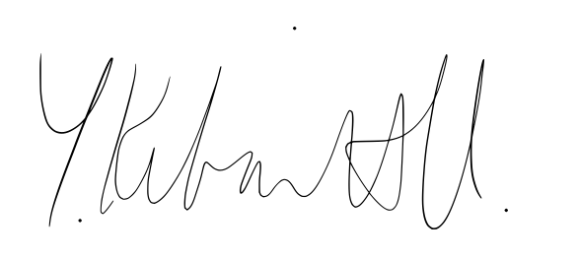
Kelvin Yip
Head of Information Security

