# **Creation Window**

The Creation Window is a Unity extension that allows for quick and easy creation of 3D assets. Instead of working with the more complex inspector tool, students should interface with the Creation Window.

## **Accessing the Creation Window**

The Creation Window should appear as a window on the Unity desktop. If it is not showing, it can be accessed through the file path: windows->[UWB] Creation Window, as displayed in figure 1.

**Figure 1: Accessing the Creation Window**

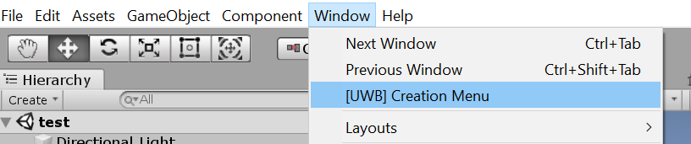

If the option to open the Creation Window is not available, it means that the program has a compiler error.

## **Creating Objects**

The Creation Window allows for a one-click creation of 3D objects that have all of the requisite components and modifications to function in the program.

To create a primitive object (e.g. basic cube, sphere) simply click the desired button, as shown in figure 2.

**Figure 2: Primitive Object Creation Buttons**

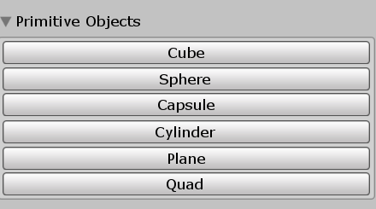

More complex objects are available, they can be found under the Custom Objects section of the Creation Window, as shown in figure 3.

**Figure 3: Custom Objects**

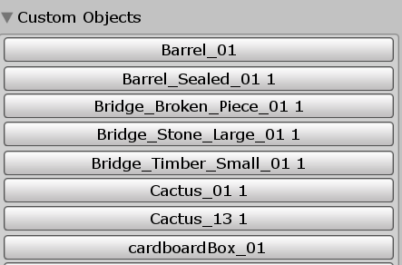

By default, when the objects are created, they do have physics characteristics. For instance, if an object is placed in the air, it will stay in the air when the game starts. Physics (gravity) can be enabled upon the object creation by checking the ‘Physics’ button (figure 4) before creating the desired object. Similarly, by default, all objects may be teleported to by the player upon creation. Unchecking the ‘Enable Teleportable’ button leave this feature off of newly created objects.

**Figure 4: Physics Option**

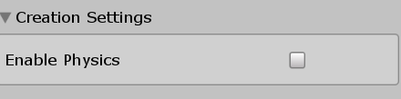

## **Using Objects**

When an object is created, it will show up in the project hierarchy, as displayed in figure 5.

**Figure 5: Project Hierarchy**

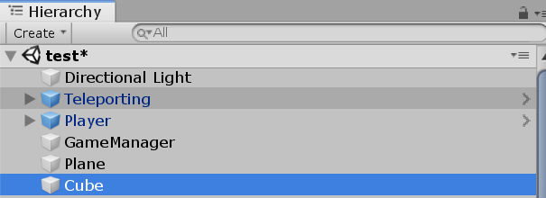

In the example in figure 5, the Plane and Cube objects were created by the creation window, the other objects displayed are for providing game functionality.

### **Scripts**

C# Scripts are used to add behavior to objects. A script may be added to an object by selecting the object in the project hierarchy, then clicking the ‘Create Script’ button in the Creation Window, as shown in figure 6.

**Figure 6: Create Script**

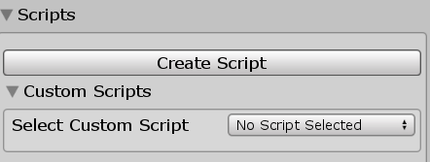

Upon creation of the script, the ‘Create Script’ button will change to ‘Open Script’. Click this to open the script in Visual Studio (figure 7).

**Figure 7: Open Script**

