[back to CSS Capstone schedule](https://uwb-stem.github.io/stem-presentation-aut20/css)



**Computer Science and Software Engineering Capstone Presentations**

Fall Quarter

December 18, 2020

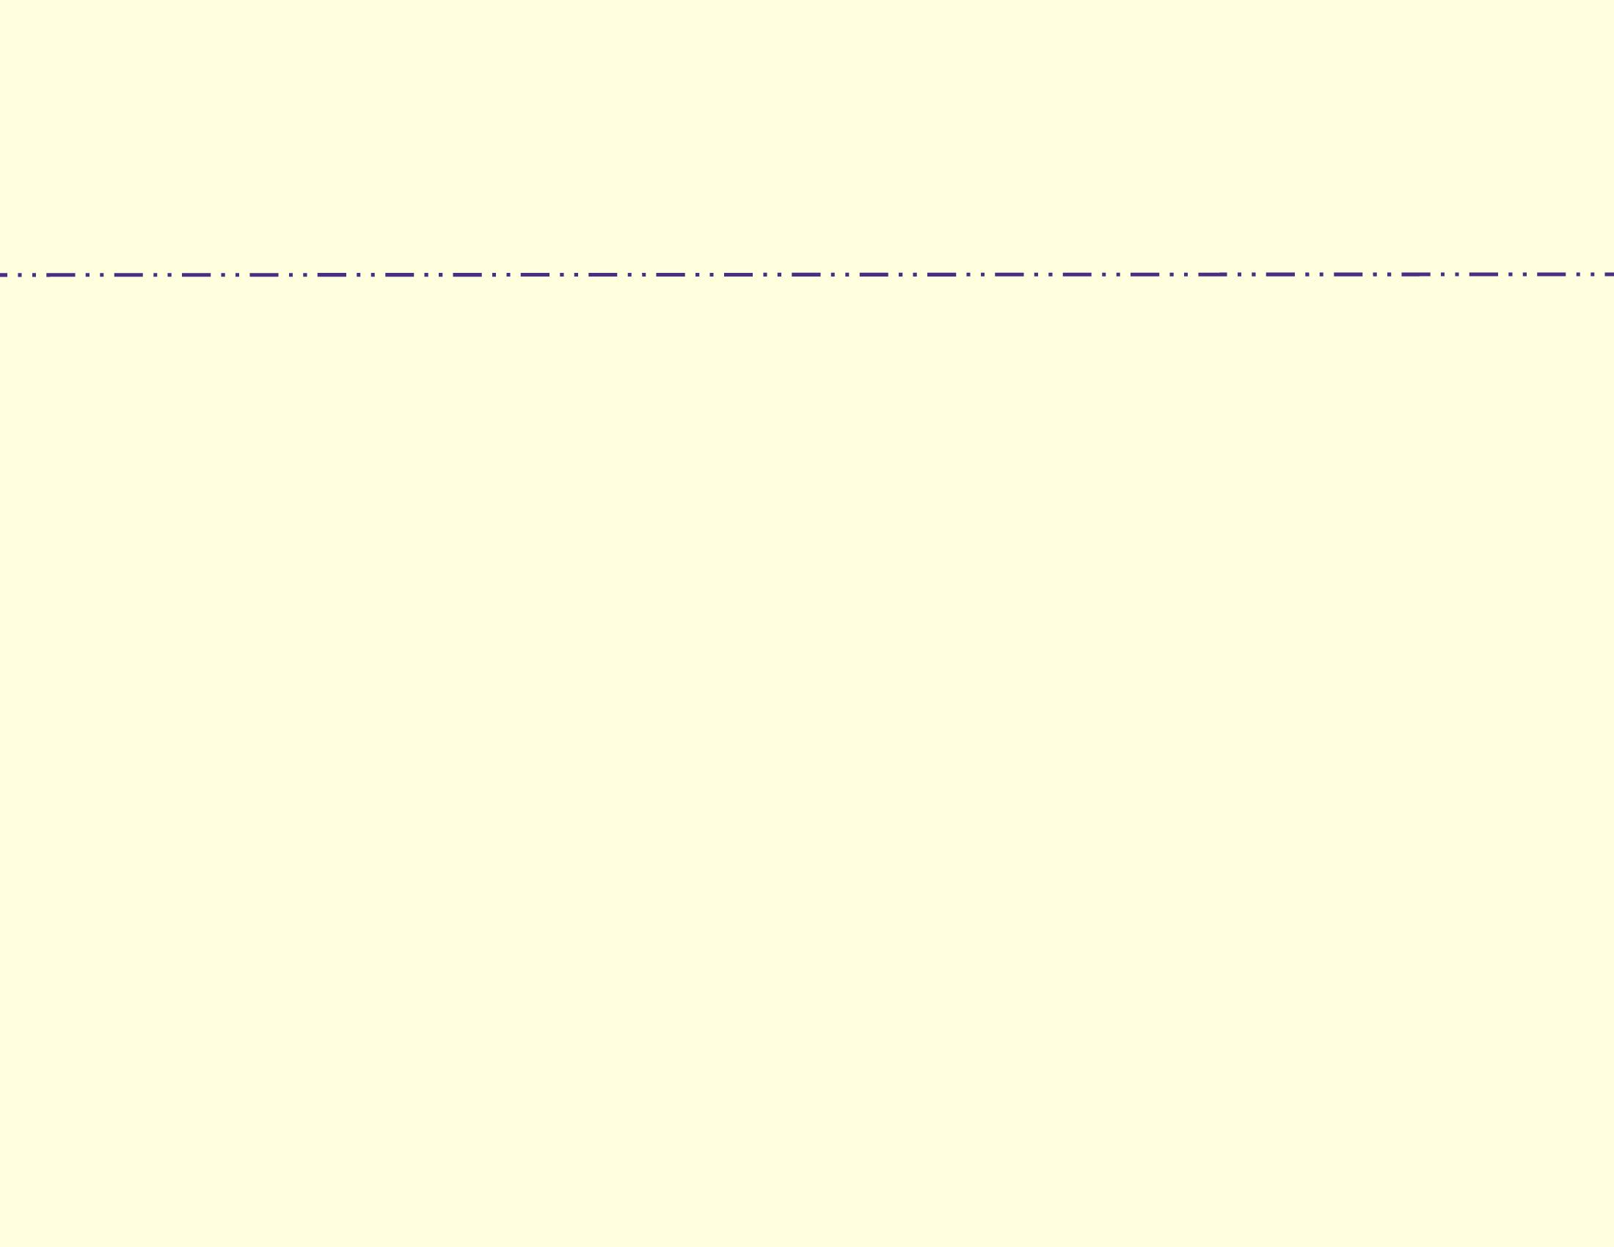

|  |
| --- |
| **Name**  "Project"  (Project type)  Faculty Advisor: Dr. |
| Abstract |
|  |
|  |

Updated 11/18/20