Cora Nelson  
Feb. 20, 2023  
IT FDN 130 A  
Assignment 06

<https://github.com/uwcora/DBFoundations>

**SQL Views, Functions and Stored Procedures**

**Introduction**  
SQL Views, Functions and Stored Procedures are all examples of database objects that allow you to write a query code once and then reuse this same code multiple times. I will be outlining how they are used as well as their similarities and differences.

**Using a SQL View**

A SQL View is used to store a SQL statement in a database and helps users retrieve that data in a quick and efficient manner and avoid having to run extra code. Example code that can be used to create a View can be found in Figure 1.

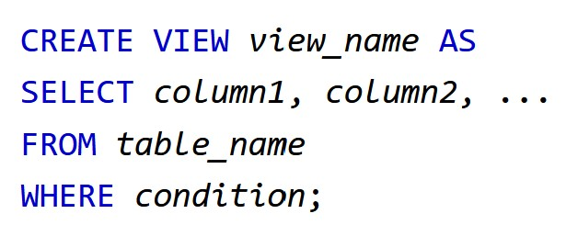

Figure 1: Create View Syntax

(W3schools Website, <https://www.w3schools.com/sql/sql_view.asp>, 2023) (External Site).

It is considered best practice to create a base view any time a new table is created, restricting access to the table while allowing access to the View.

**Differences and Similarities Between a View, Function, and Stored Procedure**

A View can be used to return only the data that a user should have access to, while restricting access to other data in the database as needed. Views are like Functions as they are considered “Named” Select statements and their code is stored in a database.Functions are often called User Defined Functions, or UDF. There are a couple of commonly used functions, one that returns a table of views and another that returns a single (scalar) value as an expression.

A Stored Procedure requires the execution of code to get results, making it different from a View or Function that uses a Select statement to show results from a table. Several statements can be included in a Stored Procedure, which is helpful when dealing with complex reporting.

**Conclusion**

Using SQL Views, Functions and Stored Procedures allow you to write query code once and then easily reuse that same code multiple times. This helps to reduce the amount of storage space being used in a database and contributes to better data integrity and database security, as limits can be put in place for how users interact with the database and access data.