# Draft K-mer processing plan

Update by D. Maier, 11 July 2016

This is the initial plan for generating and using K-mers from the Chisholm Lab sequence data.

## Global Variables

K, the length of the desired K-mers.

KMers, a list of all KMers of length K.

## Utility functions

RevComp(Seq) gets the reverse complement of a sequence. For example:

RecComp(‘ATTGCTT’) = AAGCAAT

Digest(Len, Seq) is the set of contiguous subsequences of length Len of sequence Seq .

Digest(5, ‘ATTGCTT’) = {‘ATTGC’, ‘TTGCT’, ‘TGCTT’)

## Abundance Matrix Construction

Step 0: Preprocessing (which we might try to replicate or include one day). Sequences are grouped by sample, trimmed, quality controlled and overlapped when possible. For each sample, there are two files, one for overlapped reads and one for non-overlapped reads. Example file names for sample S0445

S0445_**overlapped_qctrimmed_pairs**.fastq

S0445_**nonoverlapped_qctrimmed_pairs**.fastq

Utility functions that construct the file names for a sample.

OverlappedFile(SampleNo)

NonoverlappedFile(SampleNo)

Step 1: Ingest. Assume we have a list Samps of samples we want to include. We want to populate two tables

OLReads(SampleNo, SequenceID, JointSequence)

NOLReads(SampleNo, SequenceID, Strand, Sequence)

Here SequenceID is the sequence ID from the sequencing process. Strand is 1 or 2, to represent which end the sequence is coming from. It is the last digit of the SequenceID for non-overlapped samples.

Step 2: Digest. (Ideally, we can pipeline this step with the next.) We keep the overlapped and non-overlapped reads separate at this point.

OLKmers = unnest({(Samp,  
 flattenMap({Digest(K,OLReads[Samp, SeqID].JointSequence)})  
 |Samp ∈ Samps})

OLKmers will be a list of (SampleID, Kmer) pairs.

NOLKmers = unnest({(Samp,  
 flattenMap(union(  
 {Digest(K,  
 NOLReads[Samp, SeqID, 1].Sequence),  
 Digest(K,  
 RevComp(NOLReads[Samp, SeqID, 2].Sequence)))  
 })  
 |Samp ∈ Samps})

The output schema is the same as for OLKmers. Note that we reverse complement the second read of the pair so all sequences are read from the first strand.

Step 3. Count. Create the abundance matrices.

OLKmerCounts =

**select** SampleID, Kmer, count(*)  
 **from** OLKmers  
 **group by** SampleID, Kmer

We want to turn this into an array

OLKmerFreq(frequency: Int)[Samps, Kmers] with default value 0.

Similarly

NOLKmerCounts =

**select** SampleID, Kmer, count(*)  
 **from** NOLKmers  
 **group by** SampleID, Kmer

and is converted to the array

NOLKmerFreq(frequency: Int)[Samps, Kmers] with default value 0.

We can combined the arrays if needed:

AllKmerFreq[Samps, Kners] = OLKmerFreq + NOLKmerFreq

## Sanity Checks

Once we have these arrays, we can do some tests to see if the data is plausible. It will be useful to have a distance function to compare the frequency vectors for two samples.

An initial candidate is Bray-Curtis dissimilarity: <https://en.wikipedia.org/wiki/Bray%E2%80%93Curtis_dissimilarity>

Let FreqVect1 and FreqVect2 be of type   
 Array(frequency: Int)[Kmers]

then

BrayCurtisDissim(FreqVect1, FreqVect2) =

1 – 2*sum(min(FreqVect1, FreqVect2)/  
 (sum(FreqVect1) + sum(FreqVect2))

Here are a few tests.

Test 1: Reverse-complement comparison. The frequency of a K-mer and its reverse complement should be roughly the same in each sample.

Define RevComVec(FreqVec) to be the vector RCFreqVec such that

RCFreqVec[km] = FreqVec[RevComp(km)].

Then we can compute a vector OLRevCompDists of comparisons by sample of type Array(bcDis: Float)[Samps] where

RevCompDists[s] =

BrayCurtisDissim(  
 OLKmerFreq[s, *],  
 RevComVec(OLKmerFreq[s, *])

)

Do this also for NOLKmerFreq.

Test 2. OL-NOL comparison. Do we see the same patterns between the OL K-mers and the NOL K-mers?

OL_NOLDists[s] =

BrayCurtisDissim(  
 OLKmerFreq[s, *],  
 NOLKmerFreq[s, *]

)

This one needs work. We should probably compare relative abundances, since there might be, say, more OL sequences in general than NOL sequences. We can normalize rows in the matrix by total row counts below.

## DataSet Summaries

We need some ways to summarize the datasets to get an overall view. We can do some row (sample) and column (k-mer) summaries.

SampleSummary[s] =

(total = sum(AllKmerFreq[s, *],

avg = avg(AllKmerFreq[s, *],

spread = max(AllKmerFreq[s, *]

non-zero = count(AllKmerFreq[s, *] != 0)

We could also do a simple histogram of the values in each sample vector.

KmerSummary[km] =

(total = sum(AllKmerFreq[*, km],

avg = avg(AllKmerFreq[*, km],

spread = max(AllKmerFreq[*, km])

non-zero = count(AllKmerFreq[*, km] != 0)

KmerSummary is too big to view, so it might be further summarized with max, min, avg, top-n, histogram, etc.

We can also compute an all-pairs distance matrix PairsDists across samples of type Array(bcdis: Float)[Samps, Samps]as

PairsDists[s1, s2] =  
 BrayCurtisDissim(AllKmerFreq[s1, *] , AllKmerFreq[s2, *])

## Diversity/Richness Indexes

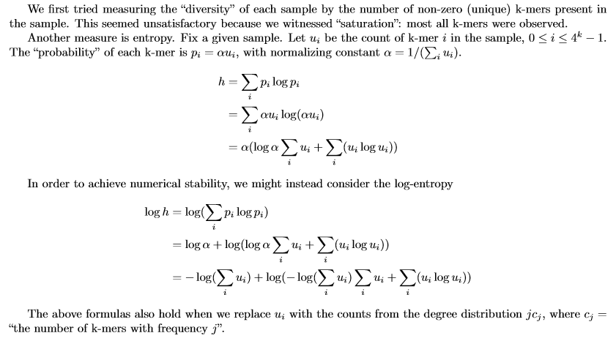

## Lookups

The Demo needs a way to poke at a sample (perhaps by clicking it on a map) and get some kind of summary of K-mer information for the sample. One possibility might be to just give the appropriate entry of SampleSummary, or show a histogram of the frequency distribution.

## Analyses

One kind of analysis will try to make sense of the distance matrix, by multidimensional scaling, say.

Bill Howe suggests the option of t-SNE (<https://lvdmaaten.github.io/tsne/>) which he says has worked well for him. It appears that t-SNE needs similarities rather than differences. In that case, we might still use the pairwise differences array to get the Sørensen similarity index, which is conveniently defined as  
   Sørensen = 1 - (Bray-Curtis)

We also want to look at analyses that consider the GeoTraces data. For example, for a particular K-mer km we could look at how its frequency varies with a particular physical variable, say via a scatterplot:

ScatterPlot(AllKmerFreq[*, km], GeoTraces.depth)

Here we’re treating GeoTraces as an array indexed on Samps.