Building an acoustics diagnostic tool to optimise Sound pressure level in event spaces

Benjamin J Smith
<22029843>

<resources links (github/onedrive)>

UXCFXK-30-3
Digital Systems Project


Abstract
In this project I hope to build a fully functional personal acoustics diagnostic tool in the aim to find the best position for a speaker system based on SPL coverage over a set area. To do this I will build a raytracing engine to begin to emulate how sound waves interact and bounce around a 3D environment. This should lead me to find the limits of this practice and shift my focus into building a true wave based acoustic simulation for a more accurate output. During this project I will build up from a very simple ray-casting engine, to hopefully an industry standard acoustics diagnostics tool. This means that I will need to be very agile in my methodology as I consistently add, edit and transform features. To make this as streamlined as possible I hope to use python as my main coding language not only to make use of its modularity, which will allow new features to be added without complete refactoring, but also to make use of its plethora of mature libraries. These include NumPy for resource intensive spectral analysis like scattering, and matplotlib for clear visualisation of acoustic data.
I am building this model in hopes to create an affordable alternative to established acoustics diagnostics tools that can not only be ran on day-to-day hardware while providing a decently accurate result but also be easy to launch and start using on the fly. This means that the project will prioritise minimalism and ease of use over advanced and resource intensive GUIs, while maintaining industry standard results.

Acknowledgements
This work is Dedicated to the spiral
Special thanks to
Pascale Florence Howson
Henry Smith
Kirsty Louise Smith
George Jacob Smith
Benjamin Alexander Joseph Webber
I couldn’t have done it without you

Table of Contents
Abstract 1
Acknowledgements 2
Table of Contents 3
Table of Figures 4
Introduction 5
Literature Review 6
Design 7
Implementation and Testing 8
Project Evaluation 9
Further Work and Conclusion 10
Glossary 11
Table of Abbreviations 12
References / Bibliography 13
Appendix A: First Appendix 14

Introduction
Acoustic modelling plays a crucial role in the analysis of any space where sound behaviour is important, including architectural acoustics, industrial noise control, bass reflex enclosures, virtual simulation systems and many more. Accurately predicting and or calculating how sound propagates through and around mediums is a complex problem involving both geometric propagation and wave-based phenomena such as diffraction or interference. Traditionally

Literature Review
This project is an exploration into ray-based acoustic simulations in enclosed spaces; it hopes to give a specialised personal acoustics diagnostic tool that is optimised for event management. To do this I will explore fully ray based, wave based and hybrid approaches, in order to differentiate which practice best suits this task.
First, we will look at the early implementation of ray tracing in acoustics, notably Kokstad A. [1968] published his seminal paper “Calculating the acoustical room response by the use of a ray tracing technique” in the “journal of sound and vibration” in 1968. They introduced a method for “simulating sound propagation by tracing a large number of discrete rays from a source to determine the impulse response and energy distribution…”. This paper is regarded as foundational in computer aided acoustics, marking a shift from purely statistical methods (like Sabine’s formula (W. B. Joyce. [1974]) to simulation-based models. This early calculation of impulse response is based on ray generation, these rays are cast in all directions inside parameters and continue until the first point of collision with an interior surface, a secondary ray is then emitted from that point (Bojičić S., Pavlović D.S. and Mijić M. [2018]). The total “reflected” sound energy of the second ray from an interior surface is the sum of both specular and diffuse vectors from reflected sound energy. This can be described by Rindel’s introduction of “vector modelling” which can be found in my appendix (Rindel J. H. [1995]). These two reflection vectors, both diffuse and specular, also define the direction of a reflected ray. The first is determined by Snell’s law, while the later is calculated by a random number generator using a probability function according to Lambert’s law or sin(20) (Rindel J. H. [2004]) diagrams from this extract can be found in the appendix. These early ray models allowed for efficient approximation of sound propagation in very complex spaces with minimal computational power.
The next noteworthy advancements in computer based acoustic simulation models was the introduction of the Image Source Method or ISM. Kirszentien pioneered this practice with his journal “An Image Source Computer Model for Room Acoustics Analysis and Electroacoustic Simulation” (Kirszenstein, J. [1984]). ISM is defined as a foundational geometrical acoustic technique simulates specular reflections, primarily by modelling the early Room impulse Response (RIR). It operates on that “When a sound field emitted by a source is reflected at an acoustically-hard infinite flat surface, the reflected field is the same as the field produced by a source that is mirrored at that plane.” (Siltanen, S., Lokki, T. and Savioja, L. [2010]). An ISM model assumes specular reflection and fails to consider diffuse reflection. However, because of this it allows for higher order reflections by creating image sources for existing image sources i.e. reflections with limited computation speed. Unfortunately, the number of image sources quickly explodes with exponentially increasing reflection order in unorthodox room shapes. However, in our use case, almost all event spaces are rectangular. This means an exact solution can be found, thus allowing for this computational model to still be applicable.
On the other hand, in a true wave-based simulation, “the governing equations of wave motion in an enclosure are solved directly… yielding highly accurate schemes, but hampered by excessive computation times” (Jörgensson, P. and Kári, F. [2020]). This method has the highly attractive property of high-order accuracies, geometric flexibility and the ability to implement phase, constructive interference, destructive interference and air absorption (refraction), but in doing so becomes more resource intensive and therefore would be impossible to implement for a large or complex space.
In short, no one model is sufficient, presently the hybrid approach is widely used. By combining the ray tracing, image source methods (ISM) and wave-based methods (Vorländer M. [2013]). This defines surfaces in a described room as two numerical parameters: the absorption coefficient which quantifies the loss of energy after reflection, and the scattering coefficient which quantifies the diffusion of reflected sound energy (Kuttruff H. [2014]). Simply put, one would build a ray based engine and assign values to each ray based on which point of their wavelength cycle they are currently in, allowing for wave-based calculation without the computational requirements for simulating actual wave reflections, simultaneously the ISM model will handle reflection whilst holding accumulative attenuation and assigning a reflection coefficient to each surface. Kuttruff states that “This method has the advantage that, once the model is at hand, many variations can be tried out with little expenditure: from the choice of various wall materials to changes in the shape of the room.” He then emphasises the use of this model by stating that “Since several properties of propagation are common to all sorts of waves, it is not absolutely necessary to use sound waves for the model tests” however he does go on to recognise that “techniques have reached a sufficiently high state… to generate and receive sound waves under the condition of propagation”. Thus, a hybrid model paints a more accurate picture within our scope. Apon further research into this hybrid approach I came across the pioneer of said technique, Jens Holger Rindel. He stated in 1995 that “…room acoustics models have matured. Hybrid methods combine the best features from ISM and ray tracing methods and have led to significantly reduced calculation times” (Rindel J. H. [1995])
In conclusion, this project should start with ray-based modelling for computational simplicity allowing for large or complex spaces, progress into ISM for deterministic reflections and higher accuracy and ultimately aim toward a full 3D acoustic model to capture the full spectrum of wave phenomena such as phase, interference and Fourier transforms.

Design

Implementation and Testing

Project Evaluation

Further Work and Conclusion

Glossary
Acoustic ray tracing - is a geometrical modelling technique that simulates sound propagation by tracing paths of energy particles (rays) from a source to a receiver
impulse response - a, typically digital, recording that captures how an acoustic environment react to a very short full frequency sound
Sabines’ formula - an empirical acoustic equation that calculates a rooms reverberation time (rT60)
specular reflection - Specular reflection is the mirror-like reflection of light (or other waves, in this case sound) from a smooth, polished surface, where rays reflect in a single direction.
diffuse reflection - the scattering of waves in many directions when striking a rough or uneven surface
Snells’ law - an equation that dictates how waves bend when crossing the boundary between media
Lamberts’ law - part of the beer lambert law is an equation to quantify the exponential loss of energy as a wave travels through a uniformly absorbing medium
Vector - a mathematical or physical quantity that has both magnitude and direction
ISM - The Image-Source Method is a geometric acoustic algorithm used to simulate sound propagation and reflections in an enclosed space by creating virtual "image sources" reflected across wall planes
RIR - the same as Impulse Response, acts as a digital fingerprint
Reflection Order - defines the number of surfaces a sound wave hits before it reaches a receiver
Scattering Coefficient - quantifies the ratio of non-specularly reflected acoustic energy to the total reflected energy from a surface, allowing us to simulate surface roughness

References / Bibliography
Krokstad, A., Strom, S. and Sørsdal, S. (1968) Calculating the Acoustical Room Response by the Use of a Ray Tracing Technique. Journal of Sound and Vibration [online]. 8 (1), pp. 118-125. [Accessed 29 March 2026].
Joyce, W.B. (1974) The Journal of the Acoustic Society of America. Sabine's Formula [online]., p. 812. [Accessed 30 March 2026].
Vorländer, M. (2013) The Journal of the Acoustic Society of America. Computer Simulations in Room Acoustics: Concepts and Uncertainties [online]. 133 (3), pp. 1203-1213. [Accessed 30 March 2026].
Kuttruff, H. (2014) 5th Edition. Room Acoustics [online]. 5, pp. 316-331. [Accessed 31 March 2026].
Rindel J. H. (1995) Computer Simulation Techniques For Acoustical Design of Rooms. [online]. 23, pp. 81-86. [Accessed 31 March 2026].
Rindel, J.H. (2004) Odeon and Scattering Coefficient. [online]. 1, pp. 1-45. [Accessed 31 March 2026].
Bojičić S., Pavlović D.S. and Mijić M. (2018) Archives of Acoustics. Formation of Scattering Characteristics For Acoustical Ray Tracing Simulation [online]. 43, p. 4. [Accessed 31 March 2026].
Kirszenstein, J. (1984) Applied Acoustics. An Image Source Computer Model For Room Acoustics Analysis and Electroacoustic Simulation [online]. 17 (4), pp. 275-290. [Accessed 31 March 2026].
Siltanen, S., Lokki, T. and Savioja, L. (2010) Proceedings of the International Symposium on Room Acoustics. Rays Or Waves? Understanding the Strengths and Weaknesses of Computational Room Acoustics Modeling Techniques [online]., pp. 1-6. [Accessed 31 March 2026].
Jörgensson, P. and Kári, F. (2020) Wave-based Virtual Acoustics. [online]., pp. 8-76. [Accessed 01 April 2026]
SynAudCon(1996). Available from: https://www.prosoundtraining.com/2024/03/15/reverberation-time-rt/ [Accessed 01 April 2026]
OnlineMathLearning(2005). Available from: https://www.onlinemathlearning.com/specular-reflection.html [Accessed 01 April 2026]
Photokonnexion(2013). Available from: https://www.photokonnexion.com/definition-diffuse-reflection/ [Accessed 01 April 2026]
PersonalMath(N/A). Available from: https://personal.math.ubc.ca/~cass/courses/m309-01a/chu/Fundamentals/snell.htm [Accessed 01 April 2026]

Appendix A: First Appendix
Diffuse Reflection diagram:
(Photokonnexion[2013])
Rindells Vector models:
https://odeon.dk/pdf/Asva97.pdf

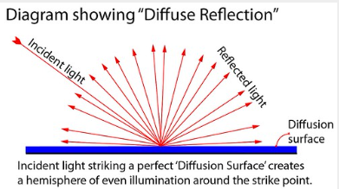

Specular Reflection diagram:
(OnlineMathLearning[2005])

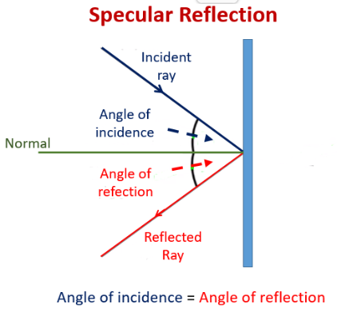
Sabines Formula:
(SynAudCon[1996])

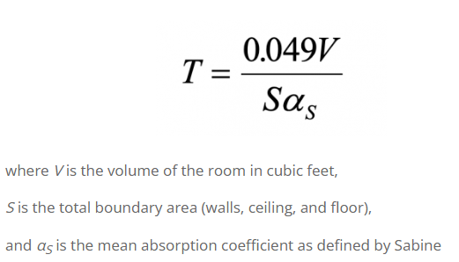

Snells Law
(PersonalMath[N/A])

