USER GUIDE

Wisconsin Irrigation
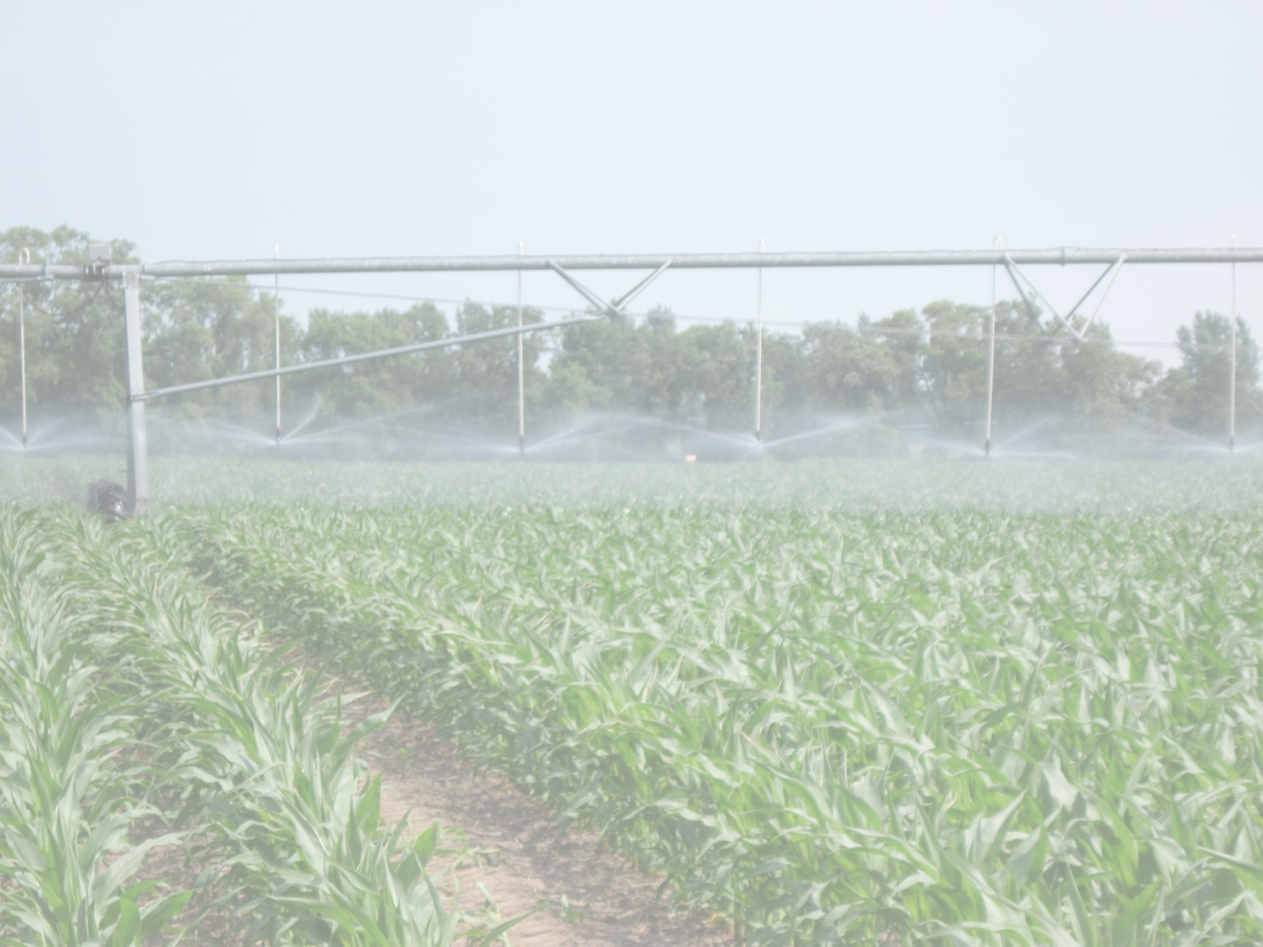

Scheduling Program

WISP 2012
Version 1.0.1
The Wisconsin Irrigation Scheduling Program (WISP 2012) is an irrigation water management tool developed by the Departments of Soil Science and Biological Systems Engineering at the Wisconsin-Madison. WISP 2012 is designed to help growers optimize crop water use efficiency by tracking the root zone water inputs and outputs (water balance). WISP 2012 incorporates several features from existing schedulers that have been used historically in Wisconsin (Curwen and Massey (1994) - UWEX Pub. No. A3600, WISDOM and the WIS Spreadsheet).

WISP 2012 uses the checkbook method to track soil moisture on a daily basis given a user defined managed root zone depth. Soil moisture losses through evapotranspiration (ET) (primarily via plant transpiration) and deep drainage (water passing through the managed root zone) are considered along with water inputs that include daily rainfall and irrigation. WISP 2012 is a soil moisture management decision support tool and is best used in combination with other information such as soil moisture monitoring and field observations when making irrigation decisions. All inputs with the exception of daily rainfall and irrigation need only be entered once during initial set up with some possible cropping season modification. Should the field crop change new inputs will be needed. The model accommodates multiple farms, pivots, fields and crops described using a hierarchal structure:

- A farm can be any set of pivots the user chooses (e.g. common ownership, location or management).

- A pivot can have one or more fields growing different crops.

- A field is typically defined by a set of common physical or management characteristics (e.g., crop type, soil water holding characteristics or irrigation management) assigned to a land area. Field characteristics can change from year to year and have multiple crops per season.

USER ACCOUNTS

Your WISP 2012 data are held for your exclusive use within a user account, accessed via OpenID authentication. WISP does not store a username or password for you; instead, an external provider (currently Google) authenticates you each time your browser accesses WISP.

If you already have a Google account, you can use it for WISP; otherwise, you can easily create one. Whenever you login to your Google account, your browser is subsequently “signed in” to Google; WISP detects this, and automatically uses that credential to hook you up to your own data. If you use your browser's “Stay logged in” and “Remember this password” features, logging in to WISP is automatic.

The first time you access any user-specific features within WISP (anything besides the home page and User Guide), you will be prompted to allow WISP to use your Google account for authentication. A new WISP user account is automatically created for you, with a single farm, pivot, and field to start with. An animated “New user account created” notice appears in the sidebar, and the “Logout” button below it displays the account's email address.

NOTE: If you have more than one Google account (or your computer is used by two people who each have their own), be sure to have your browser logged into the same one every time you use WISP! Should you access WISP with your browser logged into a different Google account, WISP will assume that you are a new user and create an entirely new account for you; your existing data will not be accessible as long as your browser is logged into a different account. Check the email address displayed in the “Logout” sidebar button if you're not sure. To log out of WISP, click the “Logout” button; to log your browser out of a Google account, go to www.google.com, click your name (displayed at the upper right), then the “Sign out” button.

MODEL INPUTS

The User Guide has been organized to take you through the scheduler setup and operation process. Initial setup includes site data such as farm ID, pivot IDs / locations, field IDs and locations and soil properties. The more dynamic daily inputs include rainfall, irrigation, percent soil moisture and possibly canopy cover, the chosen method for reference ET adjustment. The site data inputs will be retained on the server over the winter and will be available for use during the following growing season. Data displayed on the Field Status Screen will be cleared each spring in preparation for the next growing season. Initial setup data will be saved from year to year. Each user must therefore create and maintain their own backup data using the WISP report utility (see section Report in CSV Format). User access to data from the previous year is planned for future upgrades. The primary model input steps are numbered in subsequent sections 1 - 5.

Adding and Deleting Inputs

You can add farms, pivots and fields using the Add button located on the left, below the appropriate input screen and delete using the Del button to right of the row you want deleted. When adding a farm, pivot or field, simply enter data for the new feature into the boxes. You MUST press enter when data entry is complete for a row to save your data. The list of fields that appears at the bottom half of the farm inputs screen highlights those fields where the Allowable Depletion (AD) or readily available water has been depleted (e.g. negative AD). Once AD has been depleted, the crop begins to experience water stress. When AD initially reaches zero or is slightly negative, water stress impact is minimal; however as AD becomes a greater negative number, water stress is increasing. Water stress should be avoided during critical growth periods such as flowering for soybeans and tasselling for corn. As illustrated below, the currently selected row is shown with yellow fill and/or borders.

Farm Data Screen

1. Farm Inputs
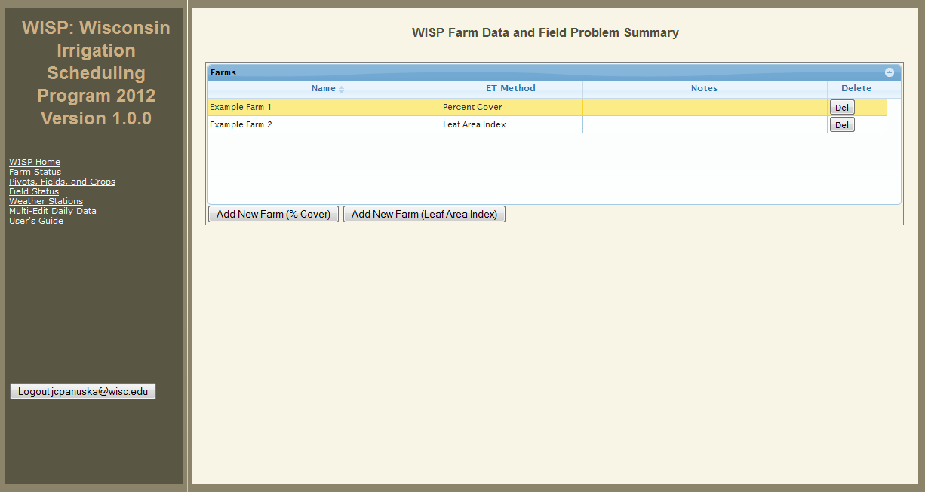

Parameter Comments / Explanation

Farm Name / ID Unique farm identifier.

ET Method 1) Determined using the Leaf Area Index (LAI) calculated via a general growth curve developed for corn with a specified emergence date (taken from the WIS spreadsheet tool).

2) Determined based on user input percent canopy cover (taken from WISP UWEX A3600 - Curwen and Massey, (1994).

Notes Descriptive notes as needed (not required).

The direct links to the various model sections are displayed at the top of the left panel and Open ID user login ID is displayed at the bottom. Use this button to log off when you have completed your WISP session.

Pivot, Field and Crops Data Screen

2. Pivot Inputs
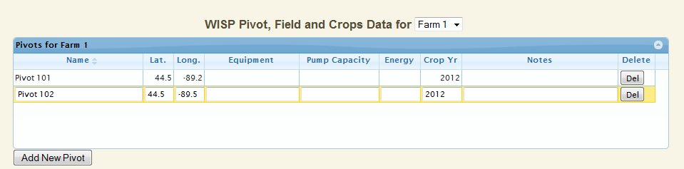

The first row is the default row created by WISP and appears automatically. Feel free to select (click) on any cell and edit the default row first or add more rows using the add button.

Parameter Comments / Explanation

Pivot Name / ID Unique pivot identifier.

Latitude & Longitude Enter as degrees and decimal degrees (e.g. 43.235). The latitude and longitude data are used in conjunction with the Agricultural Weather Observation Network (AWON) system to retrieve site specific daily evapotranspiration (ET) values. Note that the longitude must be a negative number as we are in the western hemisphere!

Equipment, Pump Capacity This input can be used for record keeping purposes, otherwise not used in this version of WISP.

Energy Use Not active at this time. Available in future upgrades.

Crop Year Current crop year (previous year access planned for future release)

Notes Descriptive notes as desired (not required).

Note that the inventory of fields and crops associated with the currently selected pivot (shown in yellow outline) are displayed in the corresponding field and crop screens located below the pivot screen. Also note that you may select a different farm using the drop down menu located to the right of the screen title.

3. Field Inputs
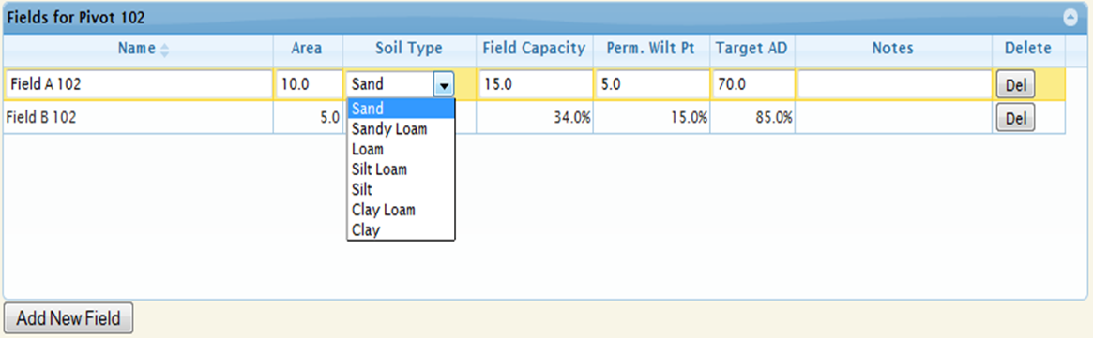

The first row is the default row created by WISP and appears automatically. The program requires at least one row of data. Additional fields can be added using the Add New Field button located at the lower left corner.

Parameter Comments / Explanation

Field Name / ID Unique field identifier, user defined.

Area Field area in acres for record keeping (not required).

Soil Type (drop down) Predominant soil type in the field for record keeping purposes. Textural class is also used to generate default initial values for field capacity (Fc), permanent wilting point (PWP) and initial soil moisture conditions (assumed to be at Fc). The Fc values are copied to the Field Status screen as initial conditions.

Field capacity is the soil moisture level where no additional water can be added without deep drainage occurring. Permanent wilt point is moisture level where there is no more plant extractable water.
Field Capacity and
Permanent Wilt Point The preferred option to using default Fc and PWP values from the Soil Type drop down menu is to select Fc and PWP values from the USDA Web Soil Survey (WSS). The WSS is the recommended soils data source for WISP. You can replace the WISP default values for Fc and PWP generated by the drop down list by directly entering the WSS values. The steps to use the WSS are as follows:

- The WSS URL is: http://websoilsurvey.nrcs.usda.gov/app/HomePage.htm After reading the four basic steps user guidance, start the WSS by pushing the green button.

- Locate your fields using the Quick Navigation menu available in the WSS (address, state and county, map, etc.).

- Select VIEW each time to retrieve the requested data.

- Zoom into your location using the magnifying glass icon on the tool bar with the + symbol.

- Use the Area of Interest (AOI) tool to select the specific field of interest.

- Select the SOIL DATA EXPLORER tab and the soil series identifications will appear.

- Select the SOIL PROPERTIES AND QUALITIES tab
and under that the SOIL PHYSICAL PROPERTIES
sub-menu.

- One at a time select WATER CONTENT, 15 BAR (PWP) and WATER CONTENT, One-Third bar (Fc).

- Under Aggregation Method be sure to select WEIGHTED AVERGE and select the correct depth units and enter your managed root zone depth (inches). The first depth is the surface (depth =0), the second depth is the managed root zone depth as shown by crop type in Table 1 at the end of this document.

- The WSS will provide a depth weighted summary of Fc and PWP along with the area and % area of each within the AOI. At this point you can select the number of individual soil groups you want to use for your field. If Fc and PWP values are within 10% of each other, you may choose to average values and lump spoil groups.

- Enter the percent moisture at 1/3rd bar (Fc) into the field capacity column and the value at 15 bar (PWP) into the Perm. Wilt Pt. column in WISP.

Field Testing for Field Capacity

The drop down soils list and WSS data are just a starting point for the Fc values. Site specific monitored soil moisture data should be used when available. The soil moisture at field capacity is the stable soil moisture level after sufficient water has been applied to satisfy the soil water holding capacity and cause deep percolation to occur. Field capacity is the constant soil moisture value observed within one to two hours of a large rainfall event or after a large volume of water has been manually applied to the soil at a single point (ex. bucket). When the water holding capacity for the surface soil layer is exceeded, the volumetric moisture content will remain constant at Fc as flow moves deeper into the soil profile.

Target AD The target AD is the desired percentage of the Allowable Depletion you want to maintain or manage for in the crop root zone. Using a full irrigation strategy you would irrigate back to field capacity (100% AD) for all irrigations. This is in contrast to a deficient strategy where you irrigate to a predetermined fraction of AD (less than Fc) allowing soil water storage capacity for rainfall. The target AD value can also be set or modified directly from the Field Status Screen.

Notes Descriptive notes as needed (not required).

4. Crop Inputs

The current version of WISP supports a single crop per growing season. Future upgrades will allow for double cropping.

Parameter Comments / Explanation

Crop Name / ID
and Variety User defined unique crop identifier.

Emergence Date The crop emergence date for annual crops is the date when approximately 50% of the crop has emerged using format YYYY- MM - DD. Use the start of growth date for perennials.

Initial Soil
Moisture (%) The root zone soil moisture should be measured on a regular basis (i.e. weekly) using a soil moisture sensor(s) and entered. WISP will automatically readjust the model’s predicted soil water content using the user input observed value. The entered value will be used in subsequent calculations. If no initial value is entered, field capacity (Fc) will be assumed.

Harvest or
Kill date The date when the crop is harvested or greater than 50% has stopped growing using format YYYY-MM-DD. This feature is to be used for double cropping (not currently active).

Root zone depth Managed crop root depth (inches) assuming no obstructing soil layer. See Table 1 located at the end of this guide for approximate root zone depths and the recommended installation depths for soil moisture sensors. Root zone depth is impacted by many things (e.g. local soil conditions, crop type, and plant hybrid) therefore the root zone depth is best determined in the field by measuring root depth at full canopy.

AD Frac. (fraction) AD Frac (0-1.0) is the total available water (TAW) that is plant extractable without limiting growth. The default value of 0.50 is recommended for most crops. A smaller value could be used for crops that are more susceptible to water stress; however the default value is appropriate in the vast majority of cases.

Field Status Screen

5. Field Status

Field Status Inputs

The field screen provides daily tracking of the root zone soil water status as well as the total water into and out of the root zone to date. Daily values can be entered directly into the field status screen or by using the Multi-Edit feature. The Multi-Edit feature can apply rainfall (in), irrigation (in), soil moisture (%) or reference ET (in) to all fields under a specified pivot by date from a single set of inputs. Refer to the Multi-Edit section below for additional detail.

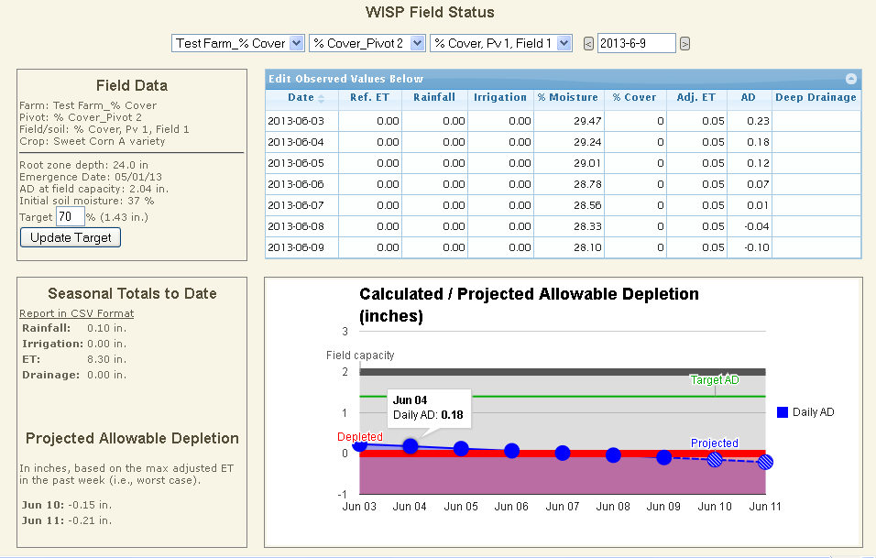
Parameter Comments / Explanation

Target AD (%) The target AD is the desired or target percentage of the AD that you want to maintain in the crop root zone. Enter the percentage of total root zone AD you want to maintain. The input target AD value is graphed using a horizontal green line with the corresponding water volume (in) displayed to the right of the input box. Deleting the target AD value removes the gray line. All entries must be followed by pressing the Update Target button or the enter key to be displayed. The target AD can also be entered on the Field Input screen.

Rainfall (in/day) Daily rainfall depth should be measured and entered into the model. Rainfall data should be collected from a location as close to the irrigated field as practical, preferably within that field.

Irrigation (in/day) Daily irrigation water application should be measured and entered into the model. If an irrigation event is greater than a day the total irrigation volume should be divided by the number of days and entered on a daily basis.

Date Click on the Date box to bring up a calendar, from which the month / week of interest can be selected. If the current week is selected, the AD time series graph displays up to five previous days in blue and two days into the future in green. Future AD projections are calculated using the maximum ET from the previous week. The right arrow displays one week later, the left arrow one week earlier.

% Moisture The observed percent soil moisture can be entered directly and WISP will use the entered value for all subsequent calculations.

% Cover / LAI If the percent cover ET option is selected from the Farm Status screen, the % cover column will appear and the user must enter the observed percent cover. The percent cover is used to adjust the daily reference ET to get an adjusted ET. If the LAI option is selected, no user input is required and the estimated leaf area index is displayed instead.

Field Status Screen Outputs

Parameter Comments / Explanation

Date Simulation date.

Ref. ET,
Adj. ET (in/day) The daily reference ET is imported from the UWEX Ag Weather site and used to calculate the ET for any given day. The adjusted ET = Ref. ET x Crop Coefficient, (between 0 and 1) is calculated from LAI or % canopy cover. Reference ET values are available state wide at a spatial resolution of approximately 25 mi. with location described by latitude and longitude

The UWEX AgWx-generated ET values can be overwritten by user inputs directly in the Field Status screen or via Multi-Edit.

% Moisture (%) The daily calculated average root zone soil moisture (%) is displayed. This value can be overwritten by observed data.

Allowable
Depletion (in/day) The allowable depletion (AD) balance for a given day is calculated as the balance from the previous day plus or minus any change in soil storage. All fields are assumed to start the growing season with the root zone at field capacity (Fc). The initial monitored soil moisture should be entered if it is available. The AD is displayed in a tabular and graphical time series format.

The AD should be monitored closely and used to determine when irrigation is necessary. A negative value indicates depletion of readily available water and the onset of plant water stress.

Deep Drainage (in/day) Deep drainage occurs when water is added to soil at field capacity thus, forcing water deeper into the soil profile. This condition should be avoided or minimized to the greatest extent practical.

Deep drainage transports nutrients and pesticides deeper into the soil profile where they have a greater potential to enter groundwater or tile drains, if present. In addition, saturated soils create conditions favorable for disease and limits soil aeration, both of which can adversely impact crop health and yields. Avoiding irrigation just prior to rainfall and managing soil moisture levels can help reduce deep drainage.

AD Time Series Graph Displays AD values (blue line and dots) for a one week time period along with a two day future projection. The future projection assumes no rainfall and uses the greatest ET value from the previous seven days.

The Field Capacity value is shown by a horizontal gray line, while the red line indicates depleted AD. The amount of water remaining in the soil profile is shades dark blue, while the degree of depletion is shaded light blue. When the daily AD drops below 0, the background is shaded purple. Hovering over any line or point displays the value.

Seasonal Totals to Date Displays the total rainfall, ET, irrigation and deep drainage in inches from the start of irrigation to the last day for which these data have been computed.

Projected AD The dashed blue line segment and cross hashed points in the time series graph is the AD projected two days into the future. Projected values are determined using the maximum ET value from the previous week, assuming no rainfall.

Weather Stations and Multi-Edit Daily Data

The Multi-Edit feature applies rainfall (in), irrigation (in), soil moisture (%) or reference ET (in) to all fields under a user specified pivot by date. Use of the Multi-Edit feature first requires that a weather station be associated with each pivot. WISP was developed with a pivot / weather station association feature to accommodate the future functionality to import weather data for each pivot from a user’s weather station. Click the Add New Weather Station link to bring up the weather station inputs shown on the right.
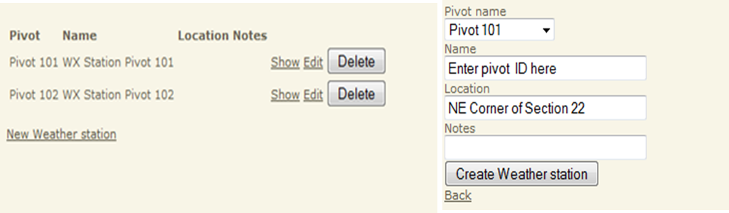

Once a pivot / weather station link has been created, it will appear on the Multi-Edit data input screen as illustrated below. Note that the fields receiving the multi-Edit data inputs are listed at the bottom of the page. After entering your multi-Edit data, you must press return to save your inputs. Entering data on the Multi-Edit screen overwrites any existing values, including zeros, for the date and variable selected for the fields listed at the bottom of the page. Multi-Edit cells left blank retain their existing values and will not be altered. Note that values entered on the Multi-Edit screen remain on the Multi-Edit screen after being copied to the Field Status screen. In addition, values will only be copied from Multi-Edit to the Field Status screen a maximum of three times. WISP currently allows multi-Edit functionality down to the pivot level however future versions will extend this functionality to the field level.

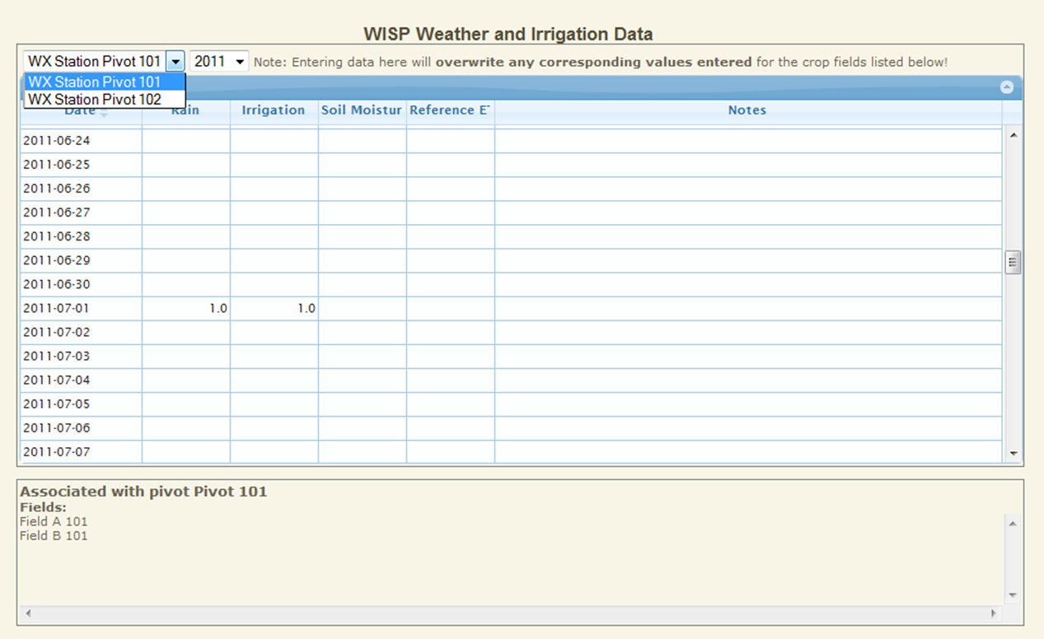

Report in CSV Format

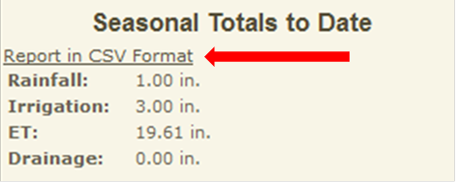
WISP allows you to export data from the Field Status page table as an electronic file. The export file format used by WISP is Comma Separated Values (CSV) format. This file format is easily imported into MS Excel for further analysis or printout. As shown below, the CSV report file is generated from the Seasonal Totals to Date Section located in the lower right hand corner of the Field Status Screen. Activating the report generation link by placing your mouse over the underlined portion and right clicking should result in a file dialog box appearing on the screen giving you the option to view or save your CSV file.

Table 1. Approximate irrigation management range and sensor placement depths by crop type.

Crop Type | Irrigation Mgmt. Depth (in) | Shallow Sensor Depth (in) @ 25% | Deep Sensor Depth (in) @ 75%
Broccoli & Cauliflower | 12 -18 | 3 - 4 | 9 - 13
Blueberry & Strawberry | 12 -18 | 3 - 4 | 9 - 13
Potato * | 16 | 4 | 12
Tomato & Cantaloupe | 12 - 24 | 3 - 6 | 9 -18
Dry, Snap and Green Bean | 18 - 24 | 4 - 6 | 13 - 18
Soy Bean | 30 - 36 | 7 - 9 | 22 - 27
Small Grains | 30 - 36 | 7 - 9 | 22 - 27
Sweet Corn & Asparagus | 24 - 30 | 6 - 7 | 18 - 22
Field Corn | 30 - 36 | 7 - 9 | 22 - 27
Established Alfalfa | 36 - 48 | 9 - 12 | 27 - 36

* Measured from the top of the hill.

