Linear Regressions for the A3600 Table

Regression Analysis: 10 % Cvr versus Ref ET

The regression equation is

10 % Cvr = -0.002263 + 0.2377 Ref ET

S = 0.00351761 R-Sq = 98.4% R-Sq(adj) = 98.3%

Analysis of Variance

Source DF SS MS F P
Regression 1 0.0128844 0.0128844 1041.28 0.000
Error 17 0.0002104 0.0000124
Total 18 0.0130947

Regression Analysis: 20 % Cvr versus Ref ET

The regression equation is

20 % Cvr = -0.002789 + 0.3956 Ref ET

S = 0.00314592 R-Sq = 99.5% R-Sq(adj) = 99.5%

Analysis of Variance

Source DF SS MS F P
Regression 1 0.0356844 0.0356844 3605.65 0.000
Error 17 0.0001682 0.0000099
Total 18 0.0358526

Regression Analysis: 30 % Cvr versus Ref ET

The regression equation is

30 % Cvr = -0.002368 + 0.5395 Ref ET

S = 0.00263931 R-Sq = 99.8% R-Sq(adj) = 99.8%

Analysis of Variance

Source DF SS MS F P
Regression 1 0.0663553 0.0663553 9525.67 0.000
Error 17 0.0001184 0.0000070
Total 18 0.0664737

Fitted Line: 30 % Cvr versus Ref ET

Regression Analysis: 40 % Cvr versus Ref ET

The regression equation is

40 % Cvr = -0.000316 + 0.6684 Ref ET

S = 0.00279318 R-Sq = 99.9% R-Sq(adj) = 99.9%

Analysis of Variance

Source DF SS MS F P
Regression 1 0.101867 0.101867 13056.81 0.000
Error 17 0.000133 0.000008
Total 18 0.102000

Fitted Line: 40 % Cvr versus Ref ET

Regression Analysis: 50 % Cvr versus Ref ET

The regression equation is

50 % Cvr = -0.000053 + 0.7781 Ref ET

S = 0.00316554 R-Sq = 99.9% R-Sq(adj) = 99.9%

Analysis of Variance

Source DF SS MS F P
Regression 1 0.138030 0.138030 13774.53 0.000
Error 17 0.000170 0.000010
Total 18 0.138200

Fitted Line: 50 % Cvr versus Ref ET

Regression Analysis: 60 % Cvr versus Ref ET

The regression equation is

60 % Cvr = 0.001053 + 0.8772 Ref ET

S = 0.00287331 R-Sq = 99.9% R-Sq(adj) = 99.9%

Analysis of Variance

Source DF SS MS F P
Regression 1 0.175439 0.175439 21250.00 0.000
Error 17 0.000140 0.000008
Total 18 0.175579

Fitted Line: 60 % Cvr versus Ref ET

Regression Analysis: 70 % Cvr versus Ref ET

The regression equation is

70 % Cvr = 0.001947 + 0.9395 Ref ET

S = 0.00290723 R-Sq = 99.9% R-Sq(adj) = 99.9%

Analysis of Variance

Source DF SS MS F P
Regression 1 0.201235 0.201235 23809.15 0.000
Error 17 0.000144 0.000008
Total 18 0.201379

Fitted Line: 70 % Cvr versus Ref ET

Regression Analysis: 80 % Cvr versus Ref ET

The regression equation is

80 % Cvr = 0.000000 + 1.000 Ref ET

S = 0 R-Sq = 100.0% R-Sq(adj) = 100.0%

Analysis of Variance

Source DF SS MS F P
Regression 1 0.228 0.228 * *
Error 17 0.000 0.000
Total 18 0.228

Fitted Line: 80 % Cvr versus Ref ET

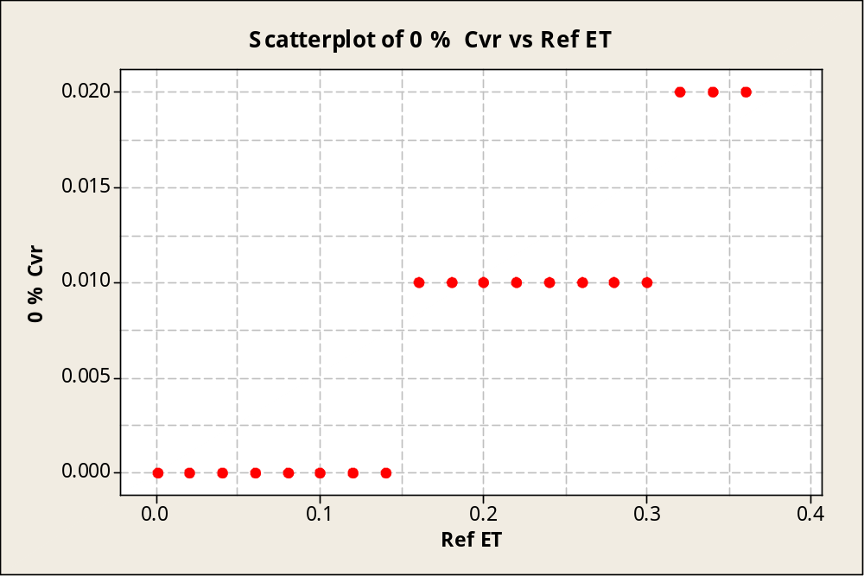

The soil evaporation at 0% cover is a step function with a range 0 to 0.010, 0.010 0.20.

