***USER GUIDE***

**W**isconsin **I**rrigation

**S**cheduling **P**rogram

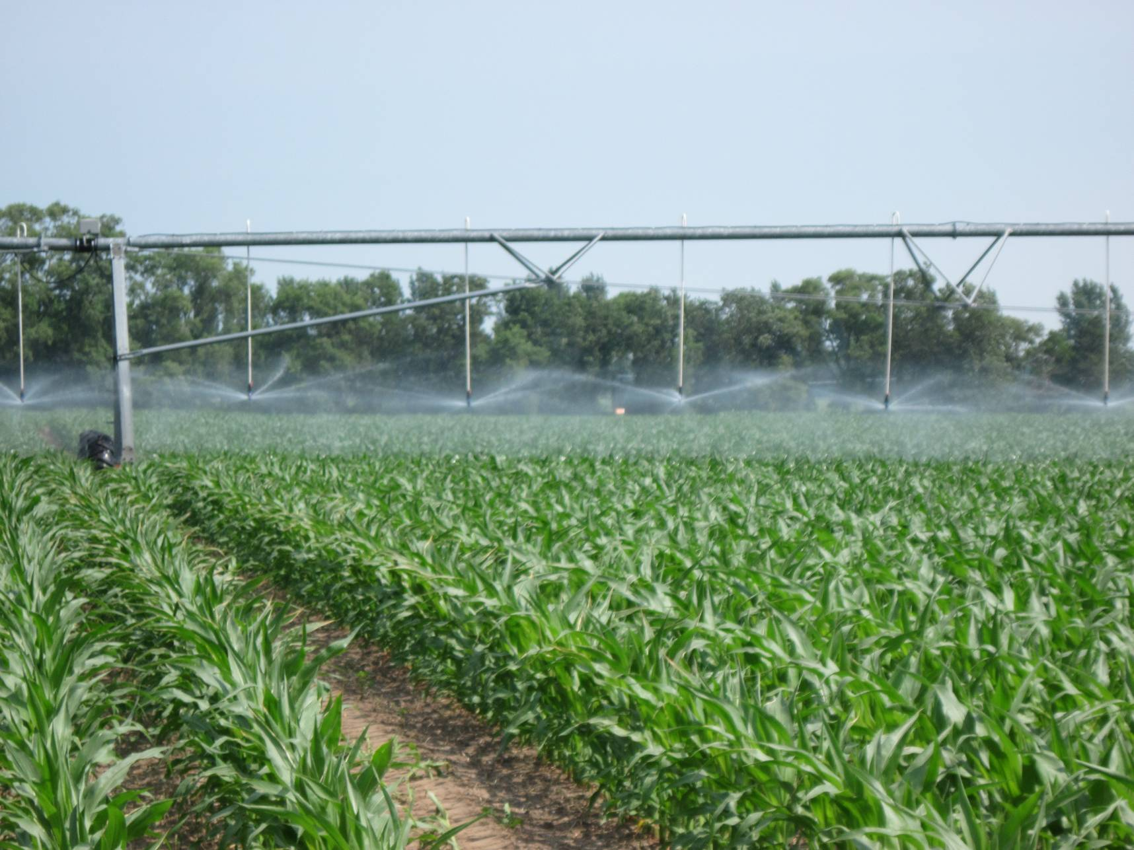

***WISP 2012***

***Version 1.1.0***

The Wisconsin Irrigation Scheduling Program (WISP 2012) is an irrigation water management tool developed by the Departments of Soil Science and Biological Systems Engineering at the Wisconsin-Madison. WISP 2012 is designed to help growers optimize crop water use efficiency by tracking the root zone water balance (water inputs and outputs). WISP 2012 incorporates several features from existing irrigation schedulers that have been used historically in Wisconsin (Curwen and Massey (1994) - UWEX Pub. No. A3600, WISDOM and the WIS Spreadsheet tool).

WISP 2012 uses the checkbook method to track soil moisture on a daily basis given a user defined managed root zone depth. Soil moisture losses through evapotranspiration (ET) (primarily via plant transpiration) and deep drainage (water passing vertically through the managed root zone) are considered along with water inputs that include daily rainfall and irrigation. WISP 2012 is a soil moisture management decision support tool and is best used in combination with other information such as soil moisture monitoring and field observations when making irrigation decisions. All inputs with the exception of daily rainfall and irrigation need only be entered once during initial set up with some possible cropping season modification. Should the field crop change new inputs will be needed. The model accommodates multiple farms, pivots (water application device), fields and crops described using a hierarchal structure:

* A farm can be any set of pivots the user chooses (e.g. common ownership, location or management).
* A pivot can have one or more fields growing different crops.
* A field is typically defined by a set of common physical and/&or management characteristics (e.g., crop type, soil water holding characteristics or irrigation management) assigned to a land area. Field characteristics can change from year to year.

**USER ACCOUNTS**

Your WISP 2012 data are held for your exclusive use within a user account, accessed via OAuth2 authentication. WISP does not store a username or password for you; instead, an external provider (currently Google) authenticates you each time your browser accesses WISP.

If you already have a Google account, you can use it for WISP; otherwise, you can easily create one. Whenever you login to your Google account, your browser is subsequently “signed in” to Google; WISP detects this, and automatically uses that credential to hook you up to your own data. If you use your browser's “Stay logged in” and “Remember this password” features, logging in to WISP takes just one click.

The first time you access any user-specific features within WISP (anything besides the home page and User Guide) you will be prompted to click through to Google, to allow WISP to use your Google account for authentication. A new WISP user account is automatically created for you, with a single farm, pivot, and field to start with.

NOTE: If you have more than one Google account (or your computer is used by two people who each have their own), be sure to have your browser logged into the same one every time you use WISP! Should you access WISP with your browser logged into a different Google account, WISP will assume that you are a new user and create an entirely new account for you; your existing data will not be accessible as long as your browser is logged into a different account. Check the email address displayed in the sidebar if you're not sure. To log out of WISP, click the “Sign out” button; to log your *browser* out of a Google account, go to [www.google.com](http://www.google.com/), click your name (displayed at the upper right), then the “Sign out” button.

**MODEL INPUTS**

The User Guide has been organized to take you through the scheduler setup and operation process. Initial setup includes site data such as farm ID, pivot IDs / locations, field IDs and locations and soil properties. The more dynamic daily inputs include rainfall, irrigation, percent soil moisture and possibly canopy cover based on the method chosen for potential ET adjustment. The site data inputs will be retained on the server over the winter and will be available for use during the following growing season. **Data displayed on the *Field Status* screen will be cleared each spring in preparation for the next growing season. Initial setup data will be saved from year to year. Each user must therefore create and maintain their own backup data using the WISP report utility (see Report in CSV Format).** User access to data from the previous year is planned for future upgrades. The primary model input steps are numbered in subsequent Sections I through V.

Adding and Deleting Inputs

You can add farms, pivots and fields using the Add button located on the left, below the appropriate input screen and delete using the Del button to right of the row you want deleted. When adding a farm, pivot or field, simply enter data for the new feature into the boxes. **You MUST press enter when data entry is complete for a row to save your data.**

The list of fields that appears at the bottom half of the *Farm Data* screen highlights those fields where the Allowable Depletion (AD) or readily available water has been depleted (i.e. negative AD). Once AD has been depleted, the crop begins to experience water stress. When AD initially reaches zero or is slightly negative, water stress impact is minimal; however as AD increases (becomes a greater negative number), water stress increases. Water stress must be avoided during critical growth periods such as flowering for soybeans and tasselling for corn. When editing, the currently selected row is highlighted with tan fill, as illustrated below.

**I. FARM DATA SCREEN**

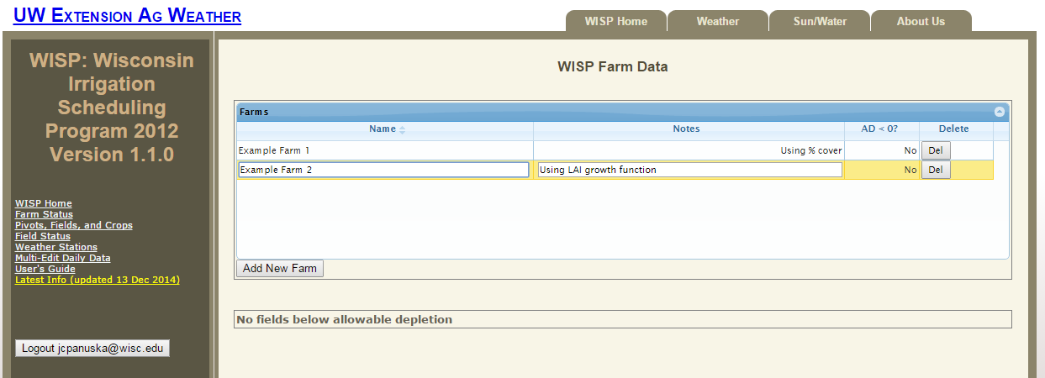

Parameter Comments / Explanation

Farm Name / ID Your unique farm identifier.

Notes Descriptive notes as needed (not required).

AD < 0 If there are any fields on this a farm where the readily available water has been depleted (AD<0), yes will be indicated and the corresponding fields will be listed below the Farm screen window. When the allowable depletion drops below 0, the crop begins to experience water stress.

Del Removes the farm from the model. This button is also used in subsequent input screens to remove the associated from the model.

A list of direct links to the various sections of the model is displayed on the left panel with the user login ID displayed at the bottom of the list. Use the “Sign out” button located on the left panel to log off or simply close the program window using the box in the upper right corner of the window when you have completed your WISP session.

**II. PIVOT, FIELD AND CROPS DATA SCREEN**

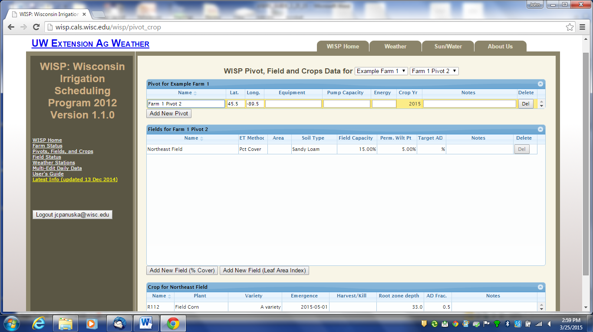

**Pivot Inputs**

The first row is the default row created by WISP and appears automatically. Edit the default row first by clicking on any cell and or add more rows using then add button. **Note that you MUST press the Enter key to save your data!**

Parameter Comments / Explanation

Pivot Name / ID Your unique pivot identifier.

Latitude & Longitude Enter as degrees and decimal degrees (e.g. 43.235). The latitude and longitude data are used in conjunction with the UWEX Agricultural Weather system (AG WX) to retrieve site specific daily evapotranspiration (ET) values. The AG WX system uses a 25 mi square grid; therefore WISP will use the same ET values for position differences less than 0.4˚ Latitude and 0.5˚ Longitude or about 25 mi2. **Note that the longitude must be a negative number for WI as we are in the western hemisphere !**

Equipment, Pump Capacity These inputs are only used for record keeping purposes in this version of WISP.

Energy Use Not active at this time. Included for future upgrades.

Crop Year Current crop year (previous year access planned for a future release)

Notes Descriptive notes as desired (not required).

ET Method

(% cover or LAI) 1) Determined based on user input percent canopy cover as calculated in UWEX A3600 - Curwen and Massey, (1994), see Appendix A or

2) Determined using the Leaf Area Index (LAI) calculated via a general growth curve developed for corn with a specified emergence date. The Leaf Area Index is the one-sided green leaf area per unit ground surface area.

Note that the inventory of fields and crops associated with the currently selected pivot (shown in yellow fill) are displayed in the corresponding *Field and Crop* screens located below the *Pivot* screen. Also note that you may select a different farm using the drop-down menu located to the right of the screen title.

**Field Inputs**

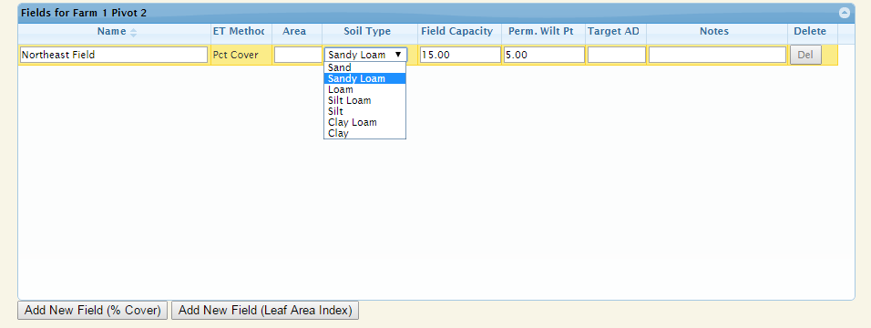

Again, the first row is the default row created by WISP and appears automatically as the program requires at least one row of data. Edit this row first and the additional fields can be added using the Add New Field button located at the bottom of the screen

.

Parameter Comments / Explanation

Field Name / ID Your unique field identifier.

Area Field area in acres for record keeping (not required).

Soil Type (drop down) Predominant soil type in the management area or field for record keeping purposes. Textural class is also used to generate default the initial values for field capacity (Fc), permanent wilting point (PWP) and the initial soil moisture conditions (**assumed to be at Fc**). The Fc values are copied to the *Field Status* screen as initial conditions.

Field capacity is the soil moisture level where no additional water can be added without deep drainage occurring. Permanent wilt point is the moisture level where there is no more plant extractable water.

Field Capacity (Fc) and

Permanent Wilt Point

(PWP) data source The preferred option over using the default Fc and PWP values from the Soil Type drop down menu is to select these data from the **USDA Web Soil Survey (WSS).** The WSS is the recommended soils data source for WISP if you don’t have measured values for your field, which is most often the case. You can replace the WISP Fc and PWP default values generated by the drop down list by directly entering the WSS or measured values into the appropriate cells. The steps to use the WSS are as follows:

1. The WSS URL is: [http://websoilsurvey.nrcs.usda.gov/app/HomePage.htm](http://websoilsurvey.nrcs.usda.gov/app/HomePage.htm%20) After reading the four basic steps user guidance, start the WSS by pushing the green button.
2. Locate your fields using the Quick Navigation menu available in the WSS (address, state and county, map, etc.).
3. Select VIEW each time to retrieve the requested data.
4. Zoom into your location using the magnifying glass icon on the tool bar with the + symbol.
5. Use the Area of Interest (AOI) tool to select the specific field of interest.
6. Select the SOIL DATA EXPLORER tab and the soil series identifications will appear.
7. Select the SOIL PROPERTIES AND QUALITIES tab

under that the SOIL PHYSICAL PROPERTIES

sub-menu.

1. One at a time select WATER CONTENT, 15 BAR (PWP) and WATER CONTENT, One-Third bar (Fc).
2. Under Aggregation Method be sure to select WEIGHTED AVERGE, select the correct depth units and enter your managed root zone depth (inches). The first depth is the surface (depth =0), the second depth is the managed root zone depth as shown by crop type in Table 1 at the end of this document.
3. The WSS will provide depth weighted Fc and PWP values along with the area and % area of each within the AOI. At this point you can select the number of individual soil groups you want to use for your field. If Fc and PWP values for the groups are within 10% of each other, you may choose to average values and lump spoil groups.
4. Enter the percent moisture at 1/3rd bar (Fc) into the field capacity column and the value at 15 bar (PWP) into the Perm. Wilt Pt. column in WISP.

Field Testing for Soil Field Capacity

The drop-down soils list and/or WSS data are good initial values to use for the Fc. However, monitored soil moisture data can also be used to determine site specific Fc values. The soil moisture at field capacity is the water held in the soil matrix against gravity. This value can be observed 24 hours after a large volume of water has been applied to the soil, such as after a large rainfall event or if water were manually applied directly to the sensor location (ex. bucket). When the water holding capacity for the surface soil layer is exceeded, the volumetric moisture content will remain constant at Fc as flow moves deeper into the soil profile. If a manual test is conducted, the test area should be free of vegetation and covered using tarp after wetting to prevent evaporation.

Target AD The target AD is the desired percentage of the Allowable Depletion you want to maintain or manage for in the crop root zone. Using a full irrigation strategy you would irrigate back to field capacity (100% AD) for all irrigations. This is in contrast to a partial strategy where you irrigate to a predetermined fraction of AD (less than Fc) maintaining some soil water storage capacity for rainfall, which can reduce leaching from rainfall. The target AD value can also be set or modified directly from the *Field Status* screen.

Notes Descriptive notes as needed (not required).

**Crop Inputs**

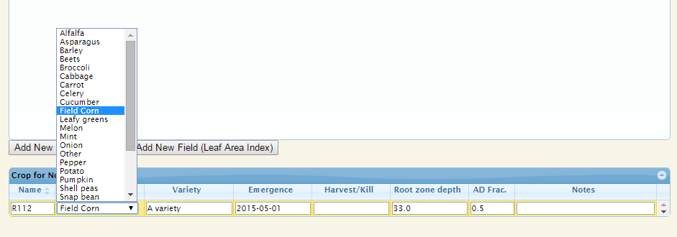

The current version of WISP supports a single crop per growing season. Future upgrades will allow for double cropping.

Parameter Comments / Explanation

Crop Name / ID

and Variety User defined unique crop identifier.

Plant (drop down) Identification of the plant type. Pressing the left mouse button while over the input box brings up a plant list. Selection of a plant type automatically enters a default root zone depth which can be over written by a user input value.

Variety Informational (not required)

Emergence Date

(Calendar pop up) **The crop emergence date for annual crops is the date when approximately 50% of the crop has emerged** using format YYYY- MM - DD. Use the start of active growth date for perennials. This date is the first date used by the when reporting seasonal water balance (irrigation, rainfall, ET and deep drainage) totals. You can right mouse click in box to bring up calendar.

Harvest /

Kill Date

(Calendar pop up) The date when the crop is harvested or greater than 50% has stopped growing using format YYYY-MM-DD. This date is used to end the seasonal water balance totals. You can right mouse click in box to bring up calendar.

Root zone depth (in) Managed crop root depth assumes no obstructing soil layer. See Table 1 located at the end of this guide for **approximate** root zone depths and the recommended installation depths for soil moisture sensors. Root zone depth can be impacted by many things (e.g. local soil conditions, timing of initial water applications, crop type, and plant hybrid) therefore the root zone depth is best confirmed in the field by measurement at full canopy. Note that selecting a plant type from the drop down menu also selects a default root zone depth.

Significant early growing season irrigation can reduce root depth development and therefore should be avoided. Plants having limiting root depth also have limited access to soil water later in the growing season.

AD Frac. (Fraction) The AD Frac. (0 - 1.0) is the total available water (TAW) that is plant extractable without causing water stress which can limit growth and yield. The default value of 0.50 is recommended for most crops. A smaller value could be used for crops that are very susceptible to water stress; however the default value is appropriate in the vast majority of cases.

**III. FIELD STATUS SCREEN**

**Field Status**

Navigating the *Field Status* screen

The three drop-down menus at the top of the *Field Status* screen allow you to select the farm, pivot, and field of interest, respectively. Located to right of these drop down menus is a calendar widget; the *Field Status* screen shows a week's worth of tabular data, nine days graphically and defaults to today's date. If a balance cannot be calculated for a given day (for instance, because it's in the future), it will be displayed as "projected" indicated by a cross-hatched symbol. Projected values are calculated using the maximum ET from the previous week, or the last-entered potential ET. A different date can be select by editing the date shown and pressing Enter twice, or by clicking on the date box and navigating the drop-down calendar. You can also move one week backward or forward by clicking the arrow buttons located to the right (forward in time) or left (back in time) of the date widget.

Field Status Inputs

The Field Status screen provides daily tracking of the root zone soil water status as well as the total water into and out of the root zone to date. Daily values can be entered directly into the field status screen or by using the Multi-Edit feature. The Multi-Edit feature can apply rainfall (in), irrigation (in), soil moisture (%) or potential ET (in) values to all fields under a specified pivot by date from a single set of inputs. Refer to the Multi-Edit section below for additional detail.

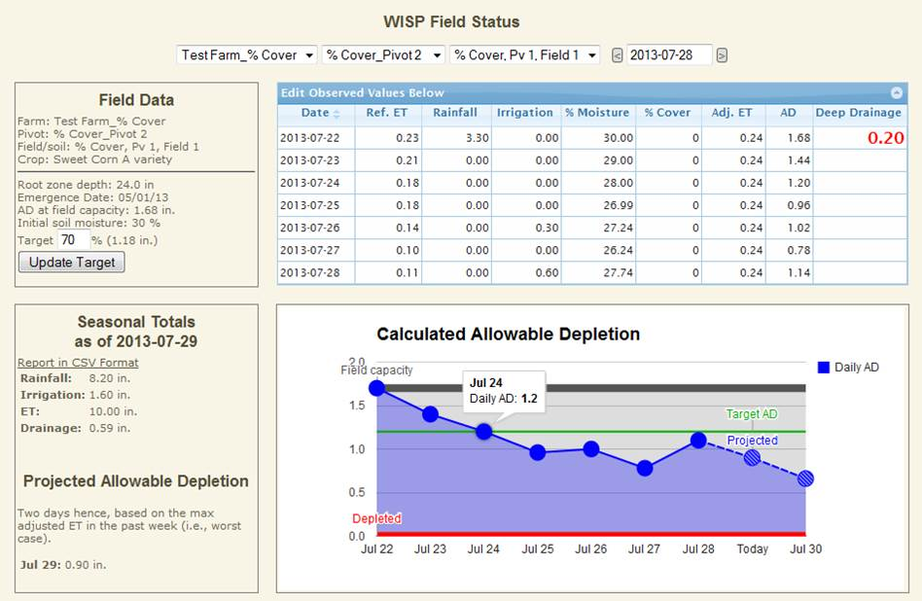

Parameter Comments / Explanation

Target AD (%) User specified desired or target percentage of the AD that you want to maintain in the crop root zone. The input target AD value is graphed using a horizontal green line with the corresponding water volume (in) displayed to the right of the input box. Deleting the target AD value removes the line. **All entries must be followed by pressing the Update Target button or the enter key to be displayed.** The target AD can also be entered on the *Field Input* screen.

Poten. ET (in/day) Potential evapotranspiration, in inches, will be imported automatically each day from the UWEX AG WX site (<http://www.soils.wisc.edu/uwex_agwx>) using latitude and longitude values which must entered for this field's pivot. Potential ET values are available state wide at a spatial resolution of approximately 25 mi. Poten. ET values can also be entered here directly or via the Multi-Edit feature.

Rainfall (in/day) Daily rainfall depth should be measured and entered into the model. Rainfall data should be collected from a location as close to the irrigated field as practical, preferably from several (3) locations within that field.

Irrigation (in/day) Daily irrigation water application should be measured and entered into the model. If an irrigation event is greater than a day the total irrigation volume should be divided by the number of days and entered on a daily basis.

% Moisture Wisp calculates the daily soil moisture, however the observed percent soil moisture can be entered directly and will used for all subsequent calculations to “ground truth” the model. These data should be entered weekly if possible. The initial default value is field capacity which can overwritten by user input.

% Cover / LAI If the percent cover ET option is selected from the *Farm Status* screen, the % cover column will appear on the *Field Status* screen and the user must enter the observed percent canopy cover. The percent canopy cover is used to adjust the daily potential ET. If the Leaf Area Index (LAI) option is selected, no user input is required and the model-estimated LAI is displayed in place of % cover. See **Appendix A** for percent cover field calculations.

Note that when the current date extends beyond the last % cover value, the last entered % cover value is used for all calculations up to the current date even though 0 is displayed in the *Field Status* Table. Therefore, when the final full canopy cover value is reached it is not necessary to continue adding % cover values as WISP will carry your last entered value forward in time to the current date.

**Field Status Screen Outputs**

Parameter Comments / Explanation

Date Simulation date.

Adj. ET (in/day) The adjusted ET (Adj. ET) = Ref. ET x Crop Coefficient, (between 0 and 1). The fraction value of percent cover is used as a crop coefficient which is entered or calculated from the LAI value.

The UWEX AG WX-generated ET values can be overwritten by user inputs directly in the *Field Status* screen or via *Multi-Edit*.

% Moisture (%) The daily calculated average root zone soil moisture (%) is displayed. As previously mentioned, this value can be replaced by observed data.

Allowable

Depletion (in/day) The allowable depletion (AD) balance for a given day is calculated as the balance from the previous day plus or minus any change in soil water storage. All fields are assumed to start the growing season with the root zone at field capacity (Fc) and the user-entered depth. The initial monitored soil moisture should be entered if it is available. The AD is displayed in a tabular and graphical time series format.

The AD should be monitored closely and used to determine when irrigation is necessary. A negative value indicates depletion of readily available water and the initial onset of plant water stress.

Deep Drainage (in/day) Deep drainage is shown in the right hand column in red and occurs when water is added to soil at field capacity thus, forcing water through the bottom of the root zone and deeper into the soil profile.

This condition needs to avoided or minimized to the greatest extent practical. Deep drainage transports nutrients and pesticides deeper into the soil profile where they have a greater potential to enter groundwater or tile drains, if present. In addition, saturated soils create conditions favorable for disease and limits soil aeration, both of which can adversely impact crop health and yields. Avoiding irrigation just prior to rainfall and managing soil moisture levels can help reduce deep drainage.

AD Time Series GraphDisplays AD values (blue line and dots) for a one week time period along with a two day future projection. The future projection assumes no rainfall and uses the greatest ET value from the previous seven days.

The Field Capacity value is shown by a horizontal dark gray line, while the red line indicates depleted AD. The amount of water remaining in the soil profile is shaded dark blue, while the degree of depletion is shaded light gray. When the daily AD drops below 0, the background turns orange as a warning. Hovering over any line or point displays its value.

Seasonal Totals to Date Displays the total rainfall, ET, irrigation and deep drainage in inches from the crop emergence date to the current date or Sept. 30th if the current date later than Sept. 30. **A crop emergence date must always be specified.**

Projected AD The dashed blue line segment and cross hashed points in the time series graph is the AD projected into the future. Projected values are determined using the maximum ET value from the previous week, assuming no rainfall. Note that when selecting days beyond the current day, WISP continues to project the AD forward in time. It is recommended that only **the first two projected values** shown at the bottom left be used. Values projected beyond two days into the future are highly uncertain.

**IV. WEATHER STATIONS AND MULTI-EDIT DAILY DATA**

**Creating a Weather Station**

The *Multi-Edit* feature applies rainfall (in), irrigation (in), soil moisture (%) or potential ET (in) values to all fields under a user specified pivot by date. Use of the *Multi-Edit* feature first requires that a weather station be associated with each pivot. To add weather stations to WISP, first select Weather Stations from the main program menu located on the left side of the main program screen, under the title. The weather station input data feature was included to allow future weather data input for each pivot from a user’s weather station, but this functionality is not available at this time. The weather station screen includes the name, location and fields associated with each weather station. To view information on an individual weather station, edit or remove it select the show, Edit or Delete links, respectively. Use the Add New Weather Station link to add another station as shown below.

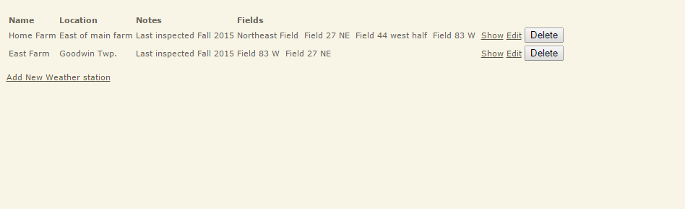

**Assigning Fields to a Weather Station**

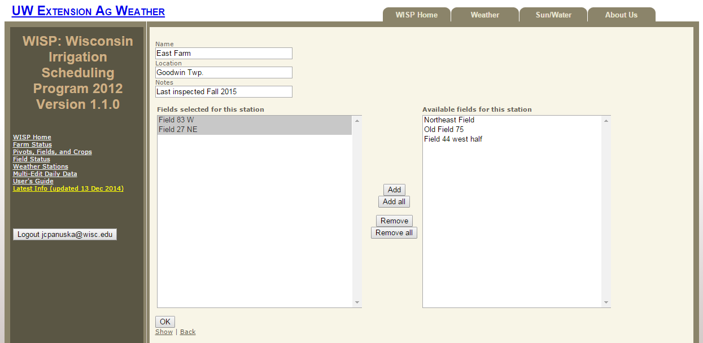After a station has been created, use the Edit link for that station to assign individual fields to that station (see figure below). Simply select the fields from the Available Fields List on the right side of the screen and use the add buttons located between the screens to make the station / field association. To remove a field / station association, select the field to be removed on the left screen Fields Selected for this Station List and press the remove button to remove the field / station connection.

**Using the Multi-Edit Feature**

The *Multi-Edit* data input screen is activated by selecting the Multi-Edit daily data input screen menu. After a pivot / weather station link has been created, it will appear on the *Multi-Edit* data input screen as shown below. Note that the fields receiving the *Multi-Edit* data inputs are listed at the bottom of the page. To save your inputs you must press return after entering each line of Multi-Edit data. Entering data on the Multi-Edit screen **overwrites the existing values of the variables selected, including zeros, for the date and fields listed at the bottom of the page.** *Multi-Edit* cells left blank retain their existing values and will not be altered. Note that values entered on the *Multi-Edit* screen will remain on the *Multi-Edit* screen after being copied to the *Field Status* screen as a record of what was entered. In addition, values for a given input cell can be re-entered / corrected and will be copied from *Multi-Edit* to the *Field Status* screen a maximum of 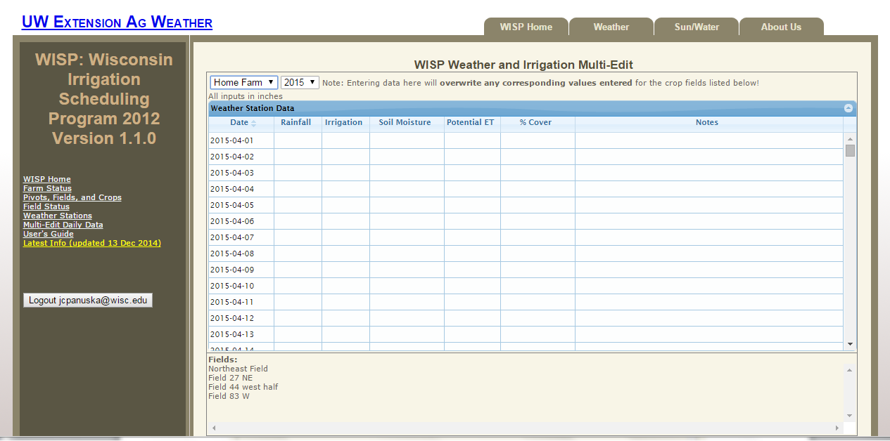three times.

**V. REPORT IN CSV FORMAT**

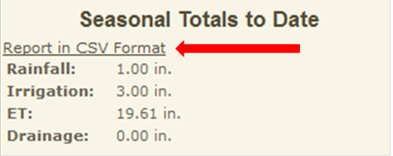WISP allows you to export data from the *Field Status* page table as an electronic file using Comma Separated Values (CSV) format. The exported file will always start on April 1st and end on Oct. 31th and thus documents the root zone water balance for the majority of the frost free period. The CSV file format is easily imported into MS Excel for further analysis, printout or archive purposes. As shown below, the CSV report link is located below Seasonal Totals to Datesection in the lower right hand corner of the *Field Status* screen. Activate the report generation link by hovering over the underlined text and right clicking downloads the file directly to your computer.

**Table 1. Approximate irrigation management range and sensor placement depths by crop type, assuming no root confining layer.**

|  |  |  |  |
| --- | --- | --- | --- |
| Crop Type | Irrigation Mgmt. Depth (in) | Shallow Sensor Depth (in) @ 25% | Deep Sensor Depth (in) @ 75% |
| Broccoli & Cauliflower | 12 -18 | 3 - 4 | 9 - 13 |
| Blueberry & Strawberry | 12 -18 | 3 - 4 | 9 - 13 |
| Potato * | 16 | 4 | 12 |
| Tomato & Cantaloupe | 12 - 24 | 3 - 6 | 9 -18 |
| Dry, Snap and Green Bean | 18 - 24 | 4 - 6 | 13 - 18 |
| Soy Bean | 30 - 36 | 7 - 9 | 22 - 27 |
| Small Grains | 30 - 36 | 7 - 9 | 22 - 27 |
| Sweet Corn & Asparagus | 24 - 30 | 6 - 7 | 18 - 22 |
| Field Corn | 30 - 36 | 7 - 9 | 22 - 27 |
| Established Alfalfa | 36 - 48 | 9 - 12 | 27 - 36 |

**\*** Measured from the top of the hill.

APPENDIX A

The following material is from:

Curwen, D. and L.R. Massie. XXXX. Irrigation management in Wisconsin – the Wisconsin irrigation scheduling program (WISP). UWEX Publication number A3600. Available on line at: <http://learningstore.uwex.edu/>

Canopy cover values are entered from emergence up until 80% of the soil surface is covered by crop canopy. Estimate the percent cover for row crops by measuring the average crop canopy width and divide this value by the between-row spacing at ground level.

Example: The percent cover equals the average crop canopy width (18”) divided by between-row width (36”) or (18/36) = 0.50 or 50%.

