NAME:ISHIMWE Patrick

2.uwimanafrancoise

3hagenimana david

4.ituze adeline raissa

5.ukundwasoleil

6.ukwishatse denyse

The **git pull** command is used to fetch and download content from a remote repository and immediately update the local repository to match that content.

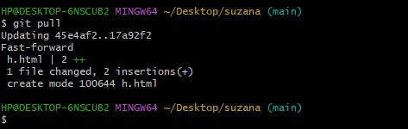

The git push command is used to upload local repository content to a remote repository.

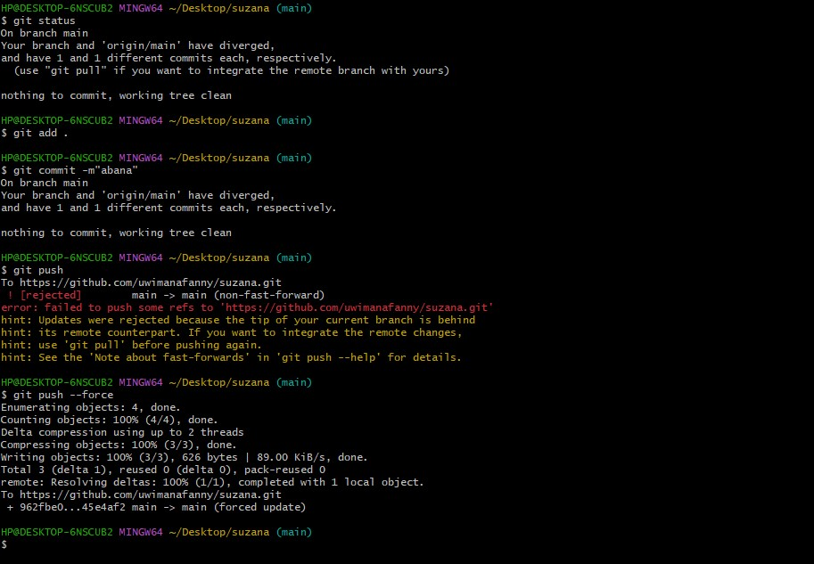

The git fetch command downloads commits, files, and refs from a remote repository into a local repo

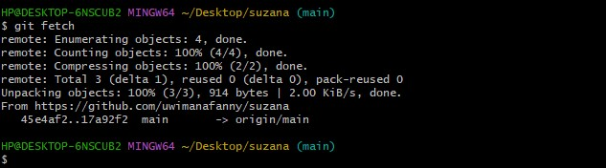

. The **git log** command includes many options for displaying diffs with each commit.

NAME:ISHIMWE Patrick

2.uwimanafrancoise

3hagenimana david

4.ituze adeline raissa

5.ukundwasoleil

6.ukwishatse denyse

