Table of Contents

[To update the table of contents, select the message below and press F9]

1. Pages 2

1.1. Page Tree 2

1.2. icuilow 3

1.2.1. User Interface 3

1.3. login 4

1.3.1. User Interface 4

1.3.2. Object Table 4

1.3.3. Login Panel 5

1.3.3.1. User Login 5

1.3.3.2. Manager Login 6

1.3.4. Login Error Panel 6

1.3.4.1. ErrorInfo 6

1.4. userhome 7

1.4.1. User Interface 7

1.4.2. Object Table 7

1.4.3. Map Panel 8

1.4.3.1. map 8

2. Masters 9

2.1. Master List 9

2.2. logo 10

2.2.1. User Interface 10

2.2.2. Object Table 10

2.3. UserInfoDialog 11

2.3.1. User Interface 11

2.3.2. Object Table 11

2.3.3. User Info Panel 12

2.3.3.1. User Info Div 12

2.4. menu 13

2.4.1. User Interface 13

2.4.2. Object Table 13

2.4.3. Menu Panel 14

2.4.3.1. Base Info 14

2.4.3.2. Store Manage 15

2.4.3.3. Inventory Decision 15

2.4.3.4. Report 16

2.4.3.5. System 16

1. Pages
   1. Page Tree
2. icuilow
3. login
4. userhome
   1. icuilow
      1. User Interface

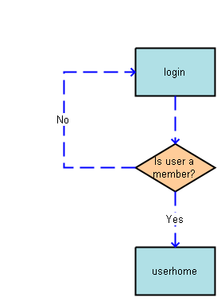

* 1. login

主页，该页提供不同角色的登录功能。

* + 1. User Interface

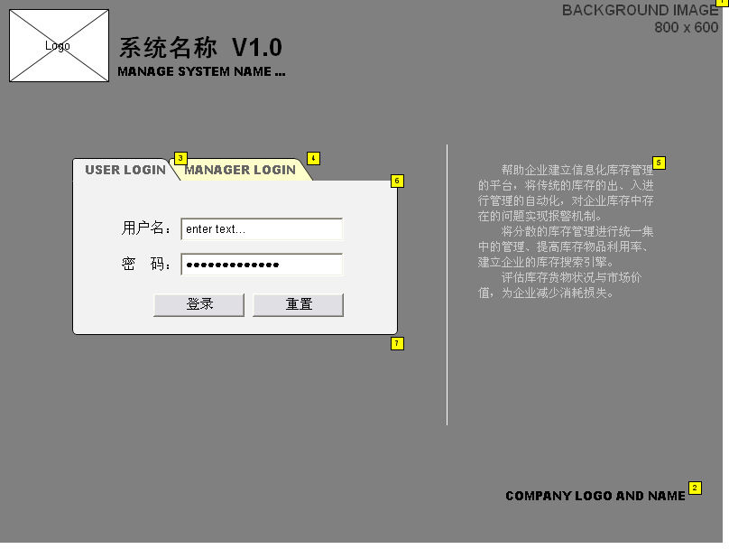

* + 1. Object Table

|  |  |  |  |  |  |  |  |  |
| --- | --- | --- | --- | --- | --- | --- | --- | --- |
| Footnote | Label | Interactions | 详细说明(specification) | 设计状态(State) | 重要度(Benefit) | 风险(Risk) | 目标版本(Target Release) | 分配给(Assigned To) |
| 1 | Page Background |  | 登录页面背景图片 | 建议的(Proposed) | 有用的(Useful) | 低(Low) |  | Zhong Lizhi |
| 2 | CopyRight Logo Name |  | 脚注，版权公司名称和标志 | 建议的(Proposed) | 有用的(Useful) | 低(Low) | 0.1 | Zhong Lizhi |
| 3 | User Login Tab | OnClick:  Case 1:  Set Login Panel state to User Login | 用户登录标签页，用户单击该标签系统打开普通用户的登录页面，单击管理员标签则打开管理员登录页面。 | 建议的(Proposed) | 必要的(Critical) | 低(Low) | 0.1 | Zhong Lizhi |
| 4 | Manager Login Tab | OnClick:  Case 1:  Set Login Panel state to Manager Login | 管理员登录标签，用户点击此标签可打开管理员登录页面。 | 建议的(Proposed) | 必要的(Critical) | 低(Low) | 0.1 | Zhong Lizhi |
| 5 | Introduce Text |  | 软件简介 | 建议的(Proposed) | 有用的(Useful) | 低(Low) | 0.1 | Zhong Lizhi |
| 6 | Login Panel |  | 登录面板，用来切换普通用户登录和管理员登录界面。 | 建议的(Proposed) | 必要的(Critical) | 低(Low) |  | Zhong Lizhi |
| 7 | Login Error Panel |  | 错误信息提示面板 | 建议的(Proposed) | 重要的(Important) | 低(Low) | 0.1 | Zhong Lizhi |

* + 1. Login Panel
       1. User Login

User Interface

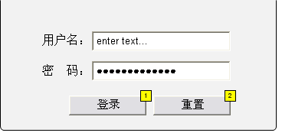

Object Table

|  |  |  |  |
| --- | --- | --- | --- |
| Footnote | Label | Interactions | 详细说明(specification) |
| 1 | User Login Button | OnClick:  Case 1 (If text on widget User Name equals "demo" and text on widget User Password equals "demo"):  Open userhome in Current Window  Case 2 (Else If True):  Show Login Error Panel | 登录按钮，当用户名为：demo，密码为：demo时点击登录按钮系统进入用户首页，否则在登录框下文会出现错误信息。 |
| 2 | User Reset Button | OnClick:  Case 1:  Set text on widget User Name equal to "" and text on widget User Password equal to ""  Hide Login Error Panel | 清空输入框中的内容 |

* + - 1. Manager Login

User Interface

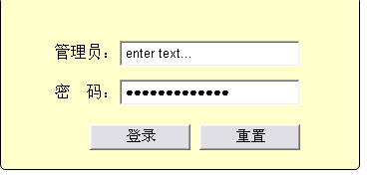

* + 1. Login Error Panel
       1. ErrorInfo

User Interface



Object Table

|  |  |  |
| --- | --- | --- |
| Footnote | Label | 详细说明(specification) |
| 1 | Login Error Div | 错误信息显示区 |

* 1. userhome
     1. User Interface

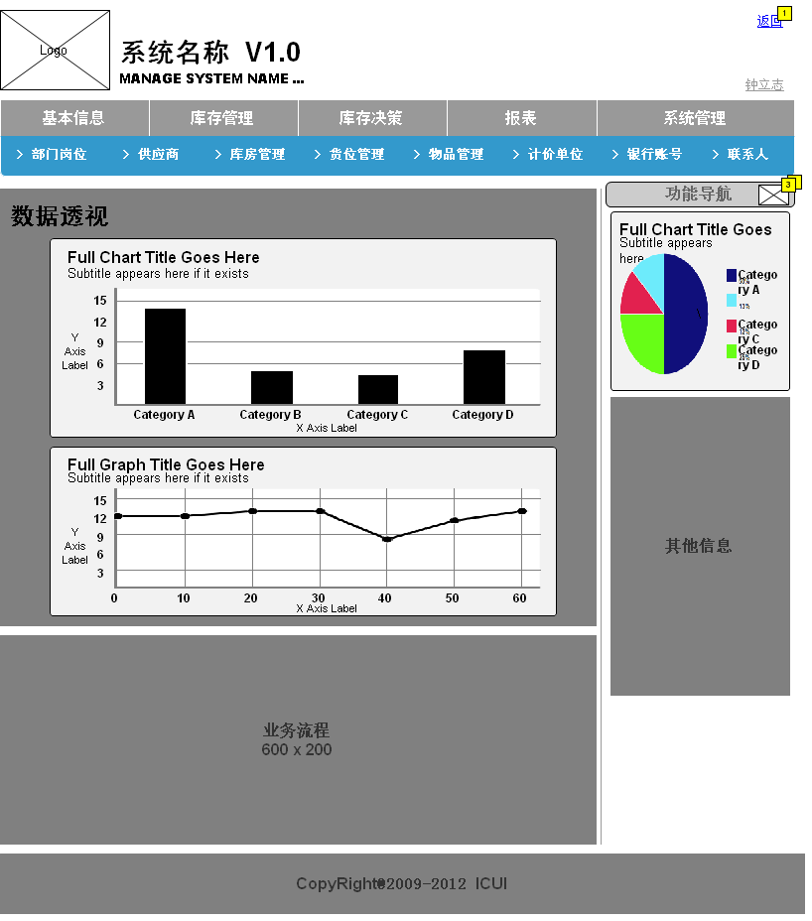

* + 1. Object Table

|  |  |  |  |
| --- | --- | --- | --- |
| Footnote | Label | Interactions | 详细说明(specification) |
| 1 |  | OnClick:  Case 1:  Open login in Current Window |  |
| 2 |  | OnClick:  Case 1:  Toggle Visibility for Map Panel |  |
| 3 | Map Image |  | 一个图片，用来表示该区域是一个按钮，可以点击下拉出菜单。 |

* + 1. Map Panel
       1. map

User Interface

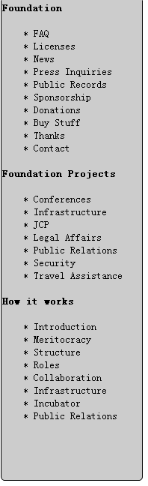

1. Masters
   1. Master List
2. logo
3. UserInfoDialog
4. menu
   1. logo
      1. User Interface

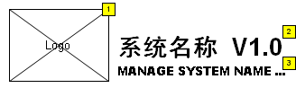

* + 1. Object Table

|  |  |  |  |  |  |  |  |
| --- | --- | --- | --- | --- | --- | --- | --- |
| Footnote | Label | 详细说明(specification) | 设计状态(State) | 重要度(Benefit) | 风险(Risk) | 目标版本(Target Release) | 分配给(Assigned To) |
| 1 | Logo | 公司LOGO | 建议的(Proposed) | 必要的(Critical) | 低(Low) | 0.1 | Zhong Lizhi |
| 2 | Chinese Name | 系统中文名 | 建议的(Proposed) | 必要的(Critical) | 低(Low) | 0.1 | Zhong Lizhi |
| 3 | English Name | 系统英文名 | 建议的(Proposed) | 重要的(Important) | 低(Low) | 0.1 | Zhong Lizhi |

* 1. UserInfoDialog
     1. User Interface



* + 1. Object Table

|  |  |  |  |  |  |  |  |
| --- | --- | --- | --- | --- | --- | --- | --- |
| Footnote | Label | Interactions | 详细说明(specification) | 设计状态(State) | 重要度(Benefit) | 风险(Risk) | 分配给(Assigned To) |
| 1 | User Name | OnClick:  Case 1:  Set User Info Panel state to User Info Div | 单击用户名可以显示详细的用户信息。 | 建议的(Proposed) | 重要的(Important) | 低(Low) | Zhong Lizhi |
| 2 | User Info Panel |  | 个人信息展示面板，单击用户名可以打开用户详细信息面板，单击上面关闭按钮可以关闭信息框。 | 建议的(Proposed) | 重要的(Important) | 低(Low) | Zhong Lizhi |

* + 1. User Info Panel
       1. User Info Div

User Interface

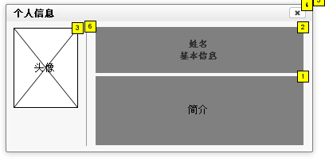

Object Table

|  |  |  |  |  |  |  |
| --- | --- | --- | --- | --- | --- | --- |
| Footnote | Label | Interactions | 详细说明(specification) | 设计状态(State) | 重要度(Benefit) | 风险(Risk) |
| 1 | User Info |  | 用户个人简介 | Proposed |  |  |
| 2 | User name |  | 显示用户姓名、职称等 | Proposed |  |  |
| 3 | User photo |  | 用户头像 | Proposed |  |  |
| 4 | User Dialog Close | OnClick:  Case 1:  Hide User Info Panel | 单击关闭个人信息对话框 | Proposed | Useful | Low |
| 5 | User Info Dialog |  | 个人信息对话框 | Proposed |  |  |
| 6 | User Info Line |  | 个人信息框中的分隔线 | Proposed |  |  |

* 1. menu

OnPageLoad:

Case 1:

Set Base Info Item to Selected

* + 1. User Interface

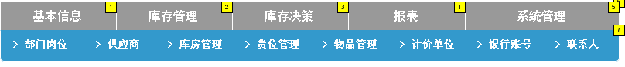

* + 1. Object Table

|  |  |  |  |  |  |  |  |  |
| --- | --- | --- | --- | --- | --- | --- | --- | --- |
| Footnote | Label | Interactions | 详细说明(specification) | 设计状态(State) | 重要度(Benefit) | 风险(Risk) | 稳定性(Stability) | 目标版本(Target Release) |
| 1 | Base Info Item | OnClick:  Case 1:  Set Menu Panel state to Base Info  Set Base Info Item to Selected, Inventory Control Item to Default, Inventory Decision Item to Default, Unidentified to Default, Report Item to Default, System Manager Item to Default | 基本信息菜单项，下有库房、货位等子项。 | 建议的(Proposed) | 必要的(Critical) | 低(Low) | 在定稿后一般不会改变。 | 0.1 |
| 2 | Inventory Control Item | OnClick:  Case 1:  Set Menu Panel state to Store Manage  Set Inventory Control Item to Selected, Base Info Item to Default, Inventory Decision Item to Default, Unidentified to Default, Report Item to Default, System Manager Item to Default | 库存管理目录项，下有入库项、出库项、盘点等子目录。 | 建议的(Proposed) | 必要的(Critical) | 低(Low) | 在定稿后一般不会改变。 | 0.1 |
| 3 | Inventory Decision Item | OnClick:  Case 1:  Set Menu Panel state to Inventory Decision  Set Inventory Decision Item to Selected, Base Info Item to Default, Inventory Control Item to Default, Unidentified to Default, Report Item to Default, System Manager Item to Default | 库存决策菜单项，该功能为以后作扩展，暂不实现。 | 建议的(Proposed) | 有用的(Useful) | 中(Medium) | 在定稿后一般不会改变。 |  |
| 4 | Report Item | OnClick:  Case 1:  Set Menu Panel state to Report  Set Report Item to Selected, System Manager Item to Default, Unidentified to Default, Inventory Decision Item to Default, Inventory Control Item to Default, Base Info Item to Default | 报表功能菜单项。 | 建议的(Proposed) | 必要的(Critical) | 低(Low) | 在定稿后一般不会改变。但其子项由于其需求的不确定性可能会有所变化。 | 0.1 |
| 5 | System Manager Item | OnClick:  Case 1:  Set Menu Panel state to System  Set System Manager Item to Selected, Report Item to Default, Unidentified to Default, Inventory Decision Item to Default, Inventory Control Item to Default, Base Info Item to Default | 系统管理菜单项。 | 建议的(Proposed) | 必要的(Critical) | 低(Low) | 在定稿后一般不会改变。 | 0.1 |
| 6 | Menu |  | 主目录面板。 | 建议的(Proposed) | 必要的(Critical) | 低(Low) | 在定稿后一般不会改变。 | 0.1 |
| 7 | Menu Panel |  | 二级目录面板。该区域用来显示不同的二级目录。 | 建议的(Proposed) | 必要的(Critical) | 低(Low) | 在定稿后一般不会改变。 | 0.1 |

* + 1. Menu Panel
       1. Base Info

User Interface



Object Table

|  |  |  |  |  |  |  |  |  |
| --- | --- | --- | --- | --- | --- | --- | --- | --- |
| Footnote | Label | 详细说明(specification) | 设计状态(State) | 重要度(Benefit) | 风险(Risk) | 稳定性(Stability) | 目标版本(Target Release) | 分配给(Assigned To) |
| 1 | Base Info Sub Menu | 基本信息管理子菜单项。 | 建议的(Proposed) | 必要的(Critical) | 低(Low) | 在定稿后一般不会改变。 | 0.1 |  |
| 2 | Dpt Job Item | 部门及岗位管理菜单项。 | 建议的(Proposed) | 必要的(Critical) | 低(Low) | 在定稿后一般不会改变。 | 0.1 | Zhong Lizhi |
| 3 | Suppliers Item | 供应商基本信息管理菜单项。 | 建议的(Proposed) | 必要的(Critical) | 低(Low) |  | 0.1 | Zhong Lizhi |
| 4 | Store Hourse Item | 库房管理菜单项。 | 建议的(Proposed) | 必要的(Critical) | 低(Low) |  | 0.1 | Zhong Lizhi |
| 5 | Cargo space Item | 货位管理菜单项。 | 建议的(Proposed) | 必要的(Critical) | 低(Low) |  | 0.1 | Zhong Lizhi |
| 6 | Materials Item | 物品管理菜单项。 | 建议的(Proposed) | 必要的(Critical) | 低(Low) |  | 0.1 | Zhong Lizhi |
| 7 | Unit Item | 计价单位管理菜单项。 | 建议的(Proposed) | 必要的(Critical) | 低(Low) |  | 0.1 | Zhong Lizhi |
| 8 | Account Item | 银行帐号管理菜单项。 | 建议的(Proposed) | 必要的(Critical) | 低(Low) |  | 0.1 | Zhong Lizhi |
| 9 | Person Item | 人员管理菜单项。 | 建议的(Proposed) | 有用的(Useful) | 低(Low) |  |  | Zhong Lizhi |

* + - 1. Store Manage

User Interface



Object Table

|  |  |  |  |  |  |  |  |
| --- | --- | --- | --- | --- | --- | --- | --- |
| Footnote | Label | 详细说明(specification) | 设计状态(State) | 重要度(Benefit) | 风险(Risk) | 目标版本(Target Release) | 分配给(Assigned To) |
| 1 | Stock Out Item | 出库单管理菜单项。 | 建议的(Proposed) | 必要的(Critical) | 低(Low) | 0.1 | Zhong Lizhi |
| 2 | Stock In Item | 入库单管理菜单项。 | 建议的(Proposed) | 必要的(Critical) | 低(Low) | 0.1 | Zhong Lizhi |
| 3 | Inventory Item | 盘点管理菜单项。 | 建议的(Proposed) | 必要的(Critical) | 低(Low) | 0.1 | Zhong Lizhi |
| 4 | Store Manage Sub Menu | 库存管理二级菜单面板。 | 建议的(Proposed) | 必要的(Critical) | 低(Low) |  | Zhong Lizhi |

* + - 1. Inventory Decision

User Interface



* + - 1. Report

User Interface



* + - 1. System

User Interface



Object Table

|  |  |  |  |  |  |  |  |
| --- | --- | --- | --- | --- | --- | --- | --- |
| Footnote | Label | 详细说明(specification) | 设计状态(State) | 重要度(Benefit) | 风险(Risk) | 目标版本(Target Release) | 分配给(Assigned To) |
| 1 | Operation Log Item | 操作记录菜单项。 | 建议的(Proposed) | 有用的(Useful) | 低(Low) | 0.1 | Zhong Lizhi |
| 2 | Online User Item | 在线用户管理菜单。 | 建议的(Proposed) | 有用的(Useful) | 低(Low) | 0.1 | Zhong Lizhi |
| 3 | System Log Item | 系统日志菜单项。 | 建议的(Proposed) | 有用的(Useful) | 低(Low) | 0.1 | Zhong Lizhi |
| 4 | System Sub Item | 系统管理子菜单面板。 | 建议的(Proposed) | 必要的(Critical) | 低(Low) |  | Zhong Lizhi |