Marie Karumuhinzi

May 11, 2021

Introduction to Programming (Python)

*Assignment 05*

**Module 05 – Lists and Dictionaries**

# Introduction

The purpose of this paper is to document step by steps taken in modifying Assignment 05 Python Script. The modified script manages a “To Do List” which contains two columns of data: “Task” and “Priority”. Additionally, the script loads the columns into a python dictionary object, each representing one row of data and these rows are added to a python list object to create a table of data.

# Python Script Creation

Below are step by step taken in creating the python script documented in this report.

## Creation of “Assignment05” Folder

I created a folder called “Assignment05” inside the _PythonClass folder that is stored in Documents on my Mac (see Figure 1).

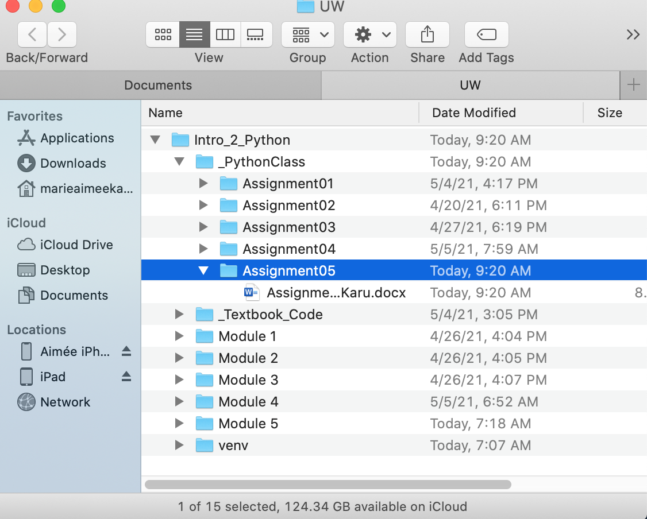

Figure 1 Assignment05 Folder

## Creation of “Assignment05” Project in PyCharm

Next, I created a new project in PyCharm (see Figure 2) based on instructions provided in \A\.

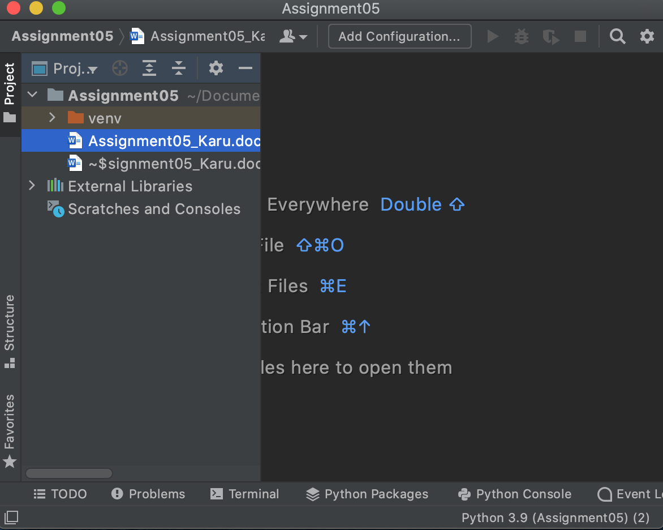

Figure 2 Assignment05 Project in PyCharm

## Modification of Python Script

Next, I opened the “Assigment05_Starter.py” script (see Figure 3) in the newly created Assignment05 project.

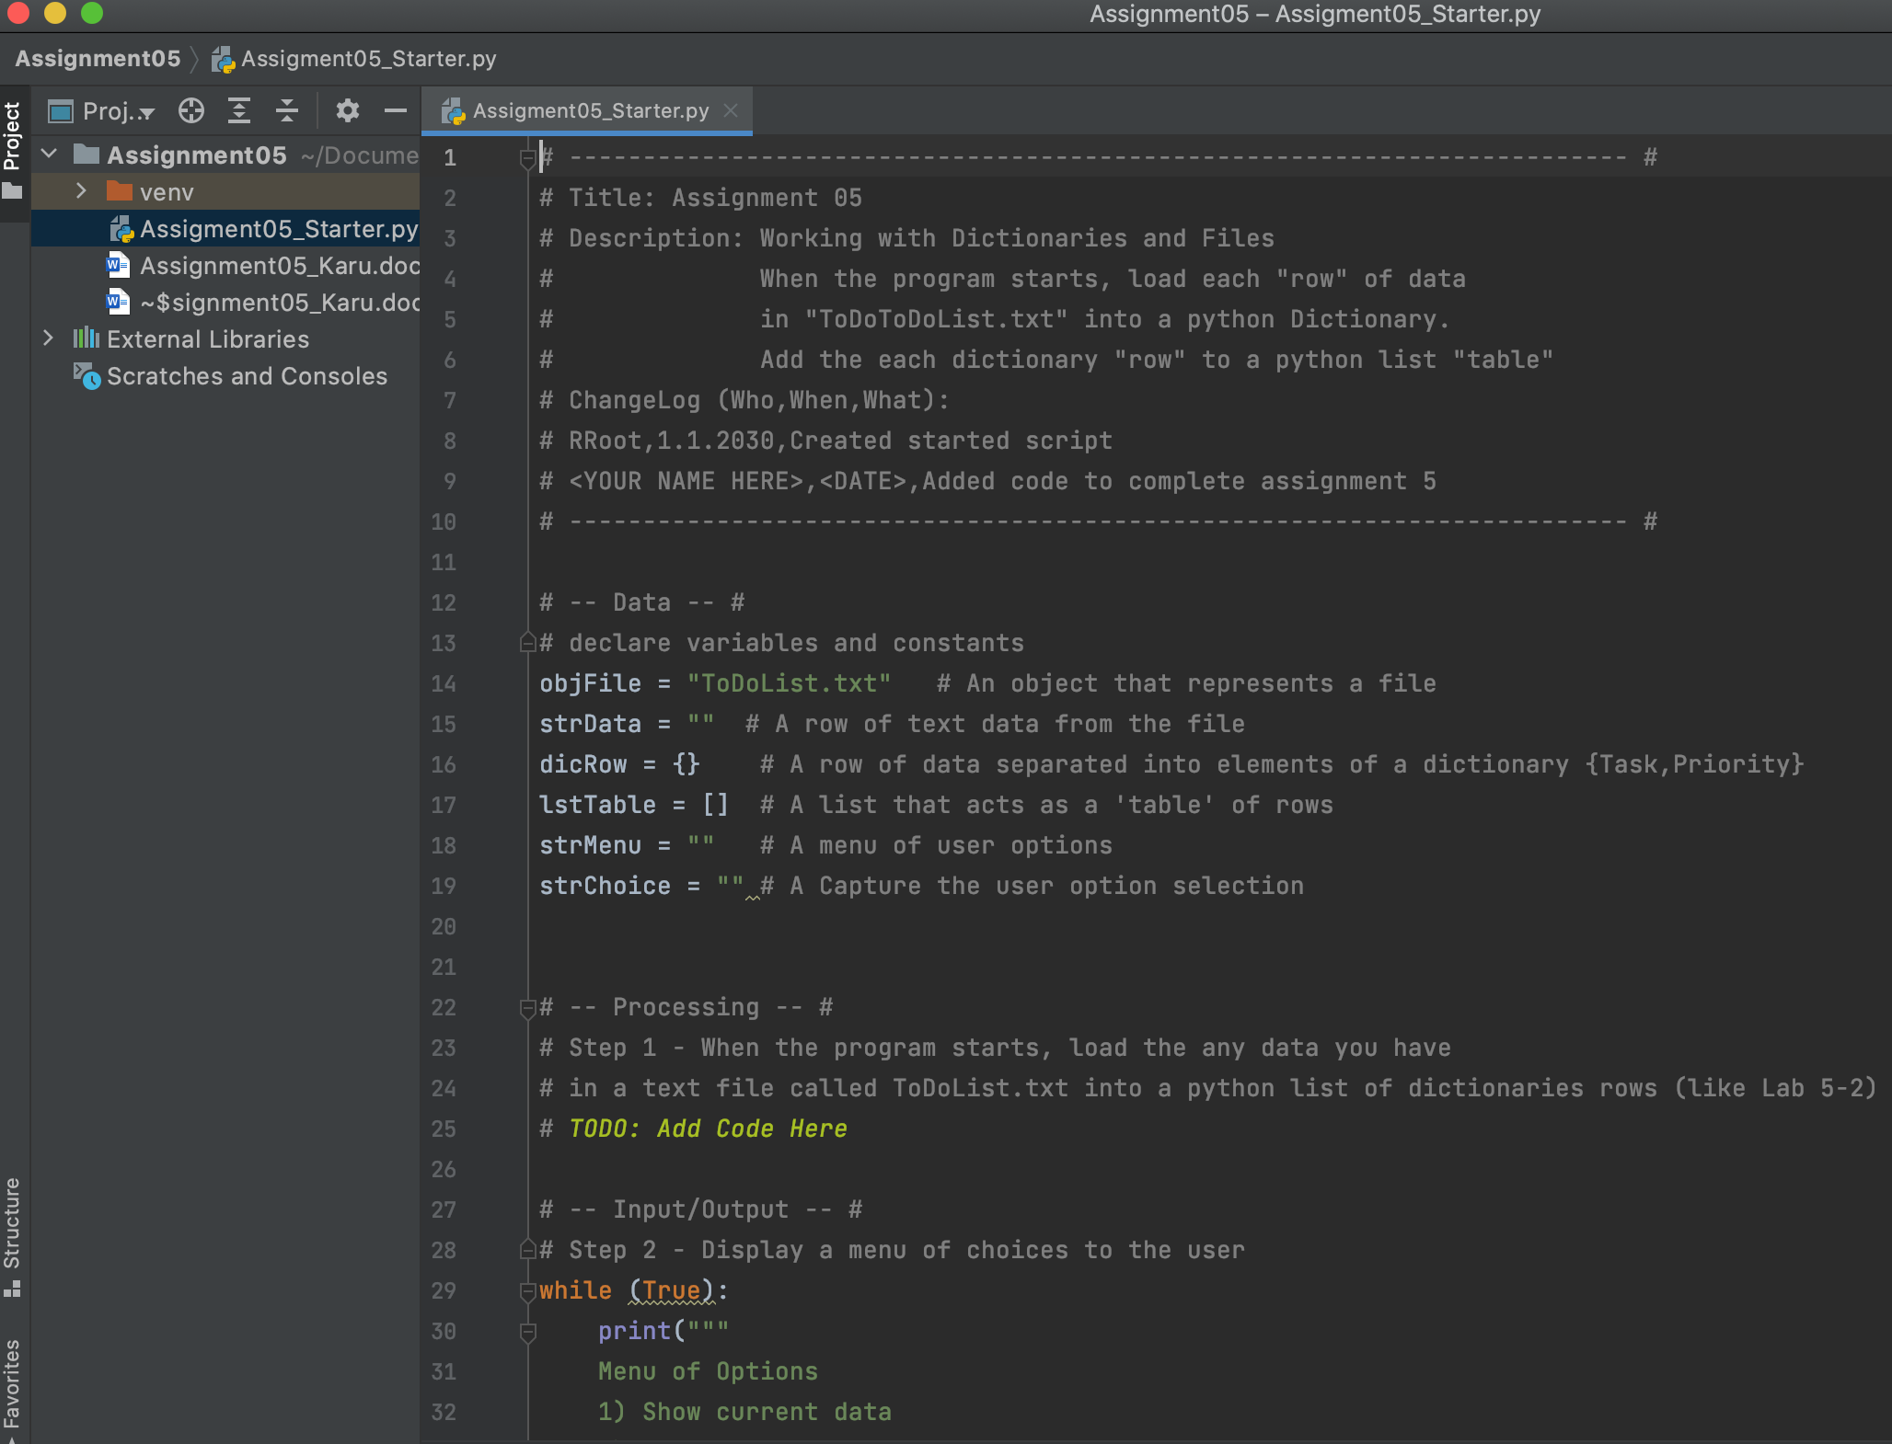

Figure 3 “Assigment05_Starter.py”Script

## Initial Script Modification

Figure 4 show the modifications made in the “Assigment05_Starter.py” script. I updated the script heading section then added the necessary code. I run the script to test it however the data weren’t being saved in the “ToDoList.txt” file (see Figure 5).

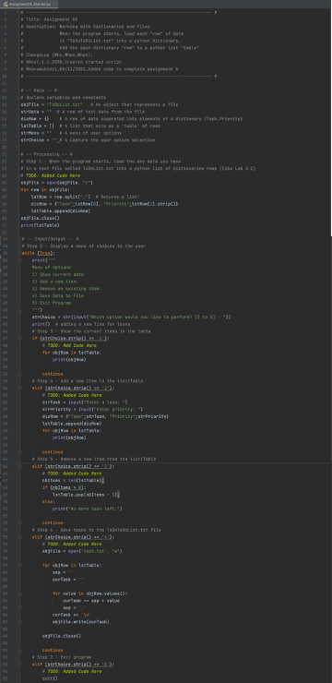

Figure 4 Initial Script Modification

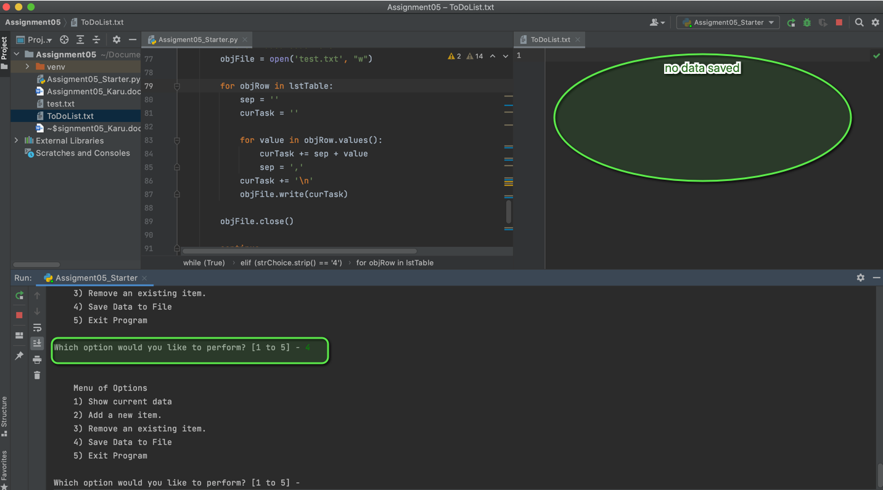

Figure Initial Script Modification Output

Next step, I modified the script as shown in Figure 6 and it fixed the problems. See **Error! Reference source not found.** for results.

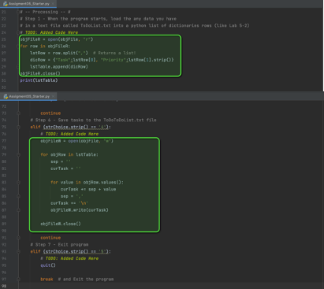

Figure Modified Script

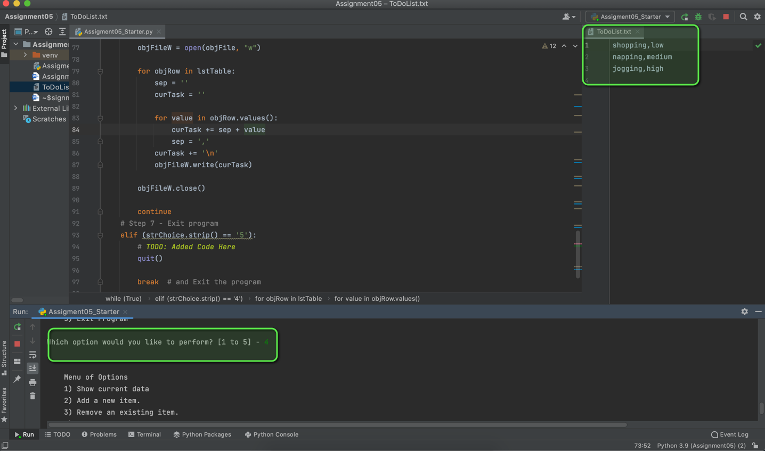

Figure 7 Modified Script Text File

## Script Testing

Since the code run perfectly in PyCharm, next step was to test it in command shell. As shown in Figure 8 and Figure 9, the script run as expected and no errors were found in the output file.

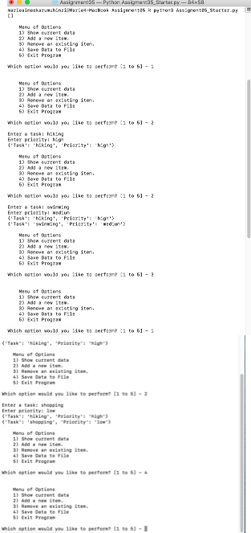

Figure 8 Assigment05_Starter.py Script Testing using Terminal

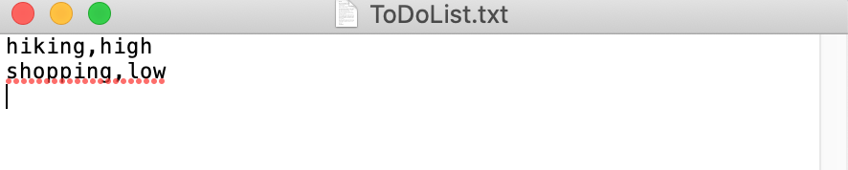

Figure Assigment05_Starter.py Script Testing Output

## Final Script

The final script is shown in Figure 12 through Figure 12 below.

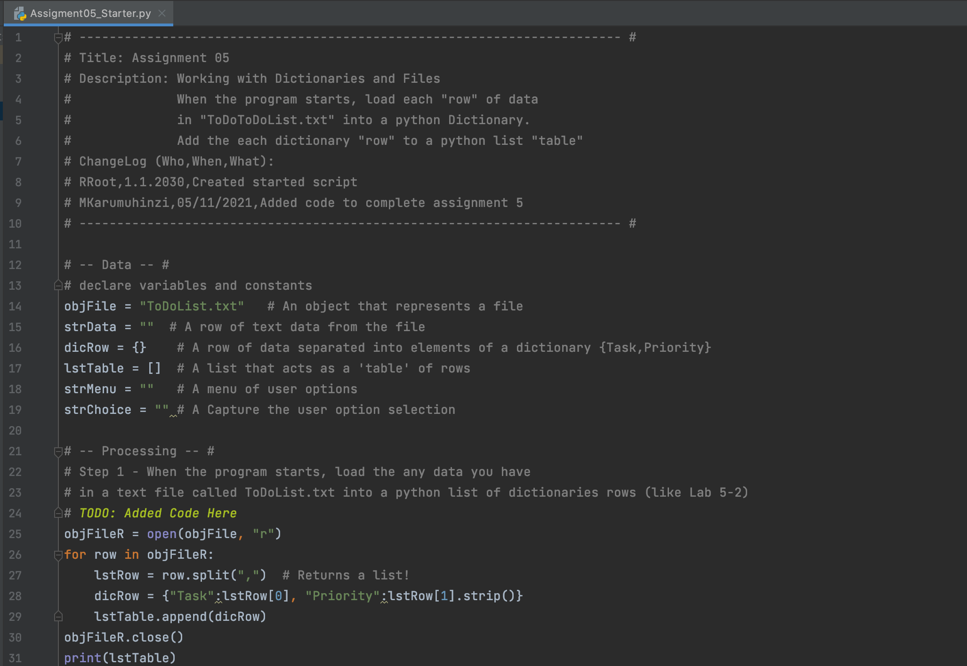

Figure Final Script (Part 1)

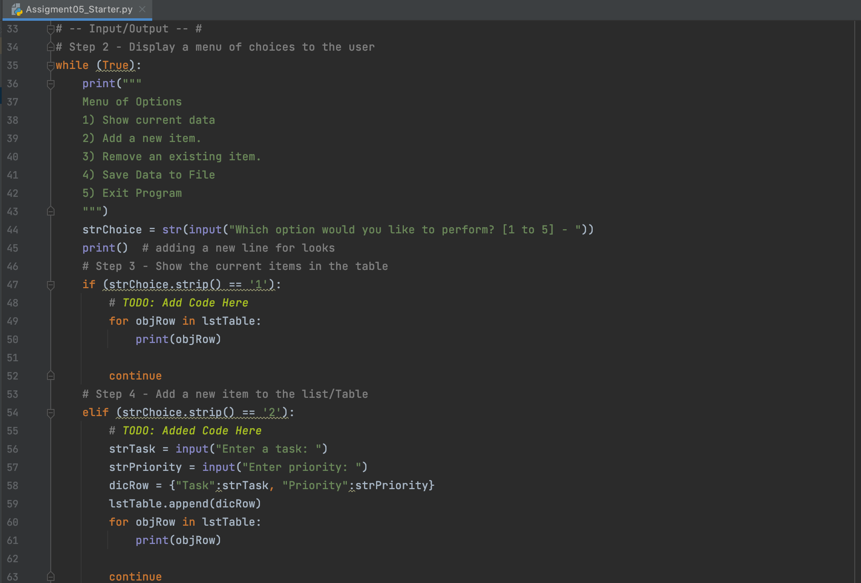

Figure Final Script (Part 2)

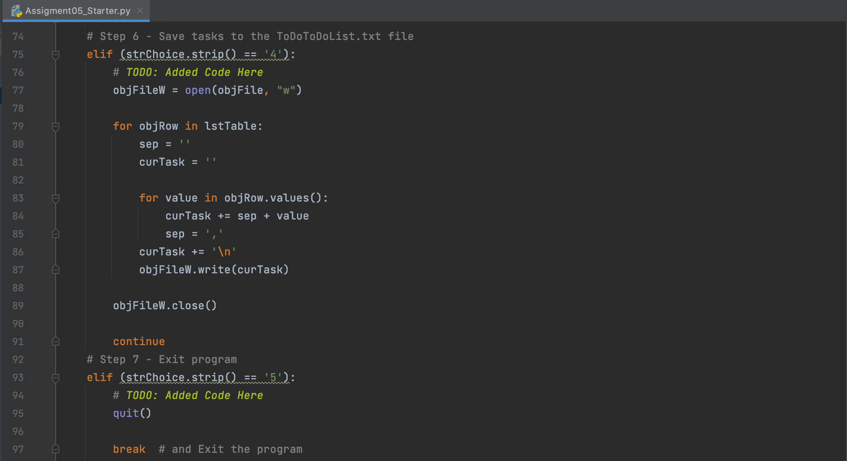

Figure 12 Final Script (Part 3)

# Summary

In this assignment, I learned how to modify existing script and add code to perform a task. I also learned how to uploaded files to GitHub.

# References

1. Module 5 Class Notes
2. Textbook
3. Google Search