Marie Karumuhinzi

May 18, 2021

Introduction to Programming (Python)

*Assignment 06*

[*TBD*](https://github.com/uwmak2021/IntorToProg-Python)

**Module 06 – Functions and Classes**

# Introduction

The purpose of this paper is to document step by steps taken in modifying “Assigment06_Starter.py” code. The code currently loads data from a file into a Python List of Dictionary objects and it uses few functions. In this assignment I will be adding more functions to organize the code. The modified script manages a “To Do List” which contains two columns of data: “Task” and “Priority”. Additionally, the script loads the columns into a python dictionary object, each representing one row of data and these rows are added to a python list object to create a table of data.

# Python Script Creation

Below are step by step taken in creating the python script documented in this report.

## Creation of “Assignment06” Folder

I created a folder called “Assignment06” inside the _PythonClass folder that is stored in Documents on my Mac (see Figure 1).



Figure 1 Assignment06 Folder

## Creation of “Assignment06” Project in PyCharm

Next, I created a new project in PyCharm (see Figure 2) based on instructions provided in \A\.

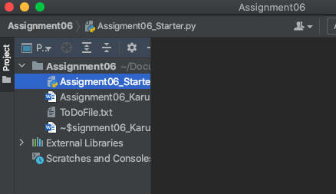

Figure 2 Assignment06 Project in PyCharm

## Modification of Python Script

Next, I opened the “Assigment06_Starter.py” script (see Figure 3) in the newly created Assignment06 project.

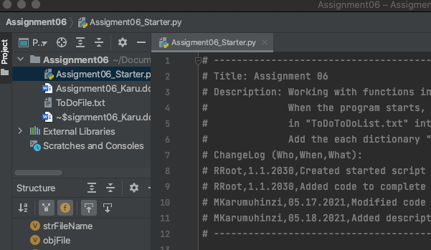

Figure 3 “Assigment06_Starter.py”Script

## Initial Script Modification

Figure 4 show the modifications made in the “Assigment06_Starter.py” script. I updated the script heading section then added the necessary code.

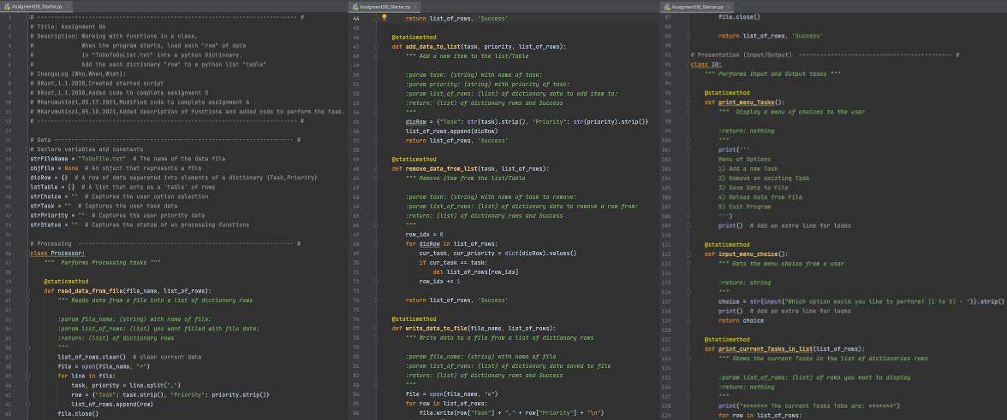

Figure 4 Initial Script Modification

Figure 5 shows the continuation of the initial script shown in Figure 4.

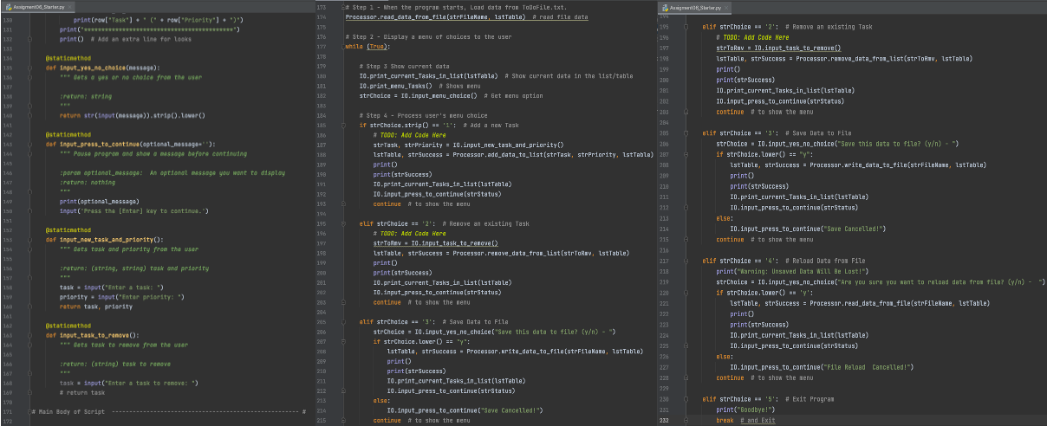

Figure Initial Script Modification (Cont’d)

The initial script did not perform Menu # 2 as expected. There was a # sign in front of the return code on line 169 as shown in Figure 6 that is removed and the code is rerun successfully.

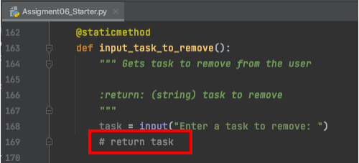

Figure Initial Script Modification Fix

## Script Testing

Since the code run perfectly in PyCharm, next step was to test it in command shell. As shown in Figure 7.

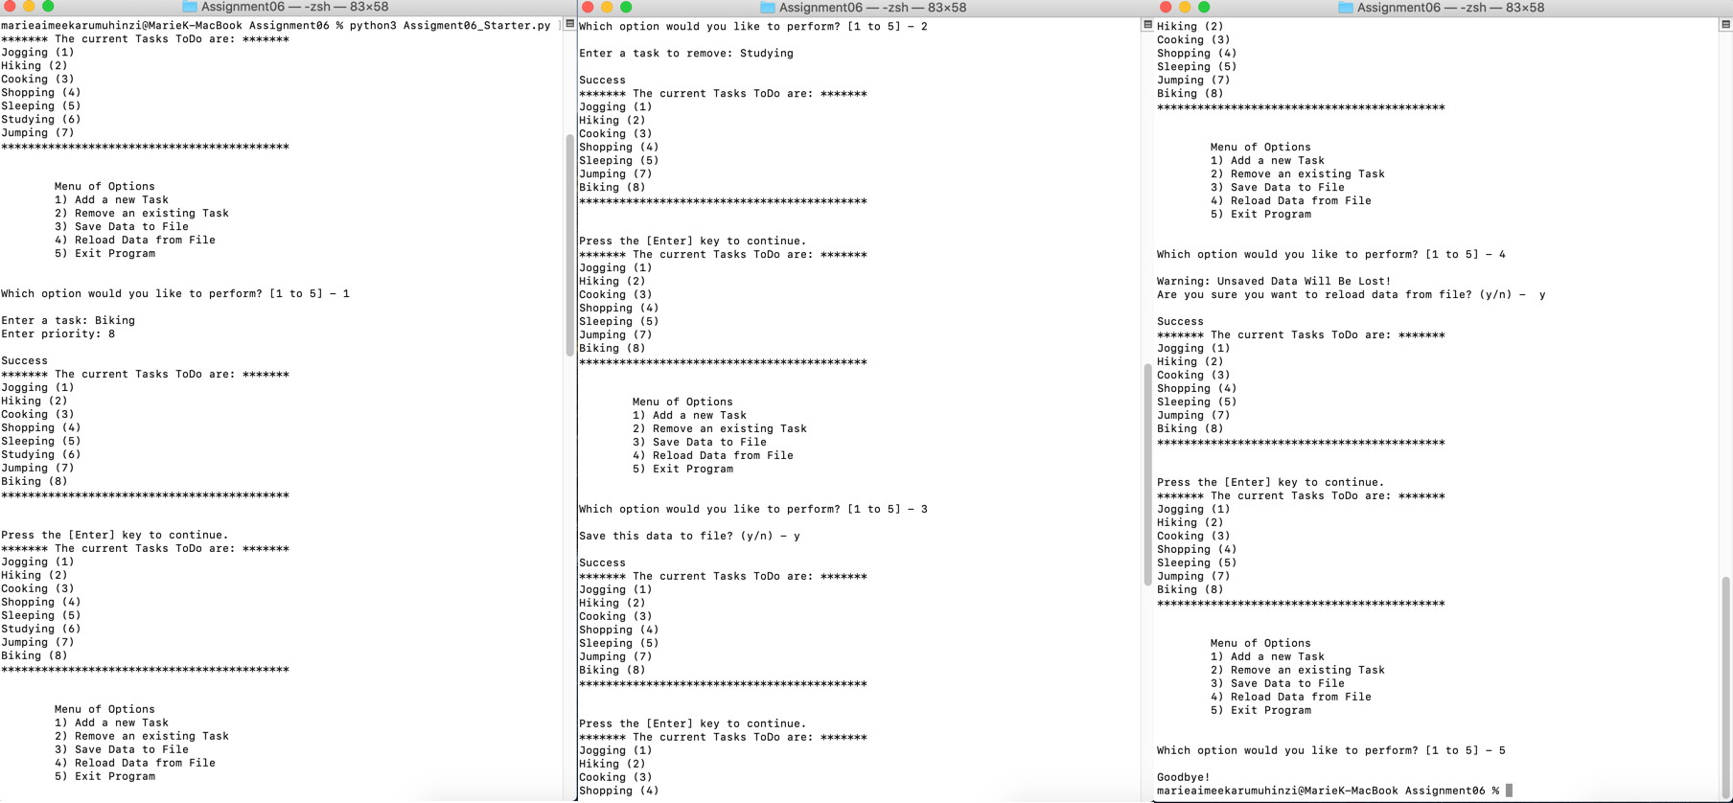

Figure 7 Assigment06_Starter.py Script Testing using Terminal

The script run as expected and no errors were found in the output file as shown in Figure 8.

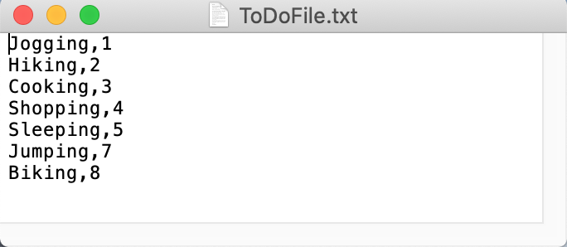

Figure Assigment06_Starter.py Script Testing Output

## Final Script

The final script is shown in Figure 9 through Figure 14.

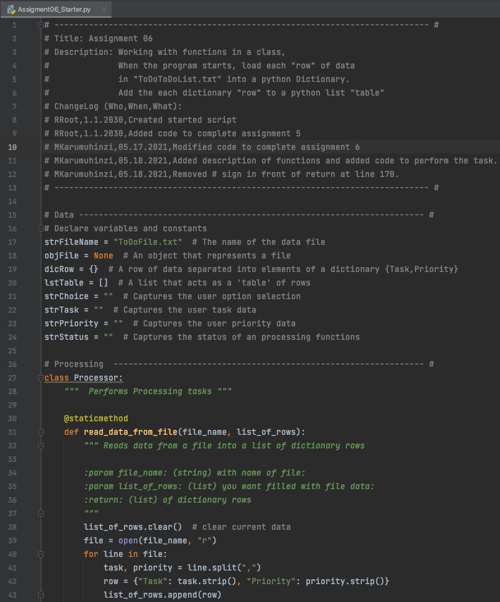

Figure Final Script (Part 1)

Figure below shows continuation of the final script shown in Figure 9 through Figure 14.

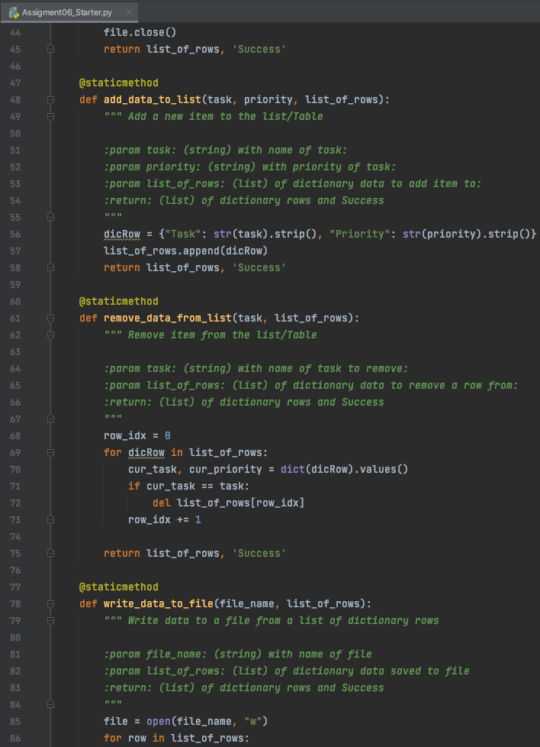

Figure Final Script (Part 2)

Figure below shows continuation of the final script shown in Figure 9 through Figure 14.

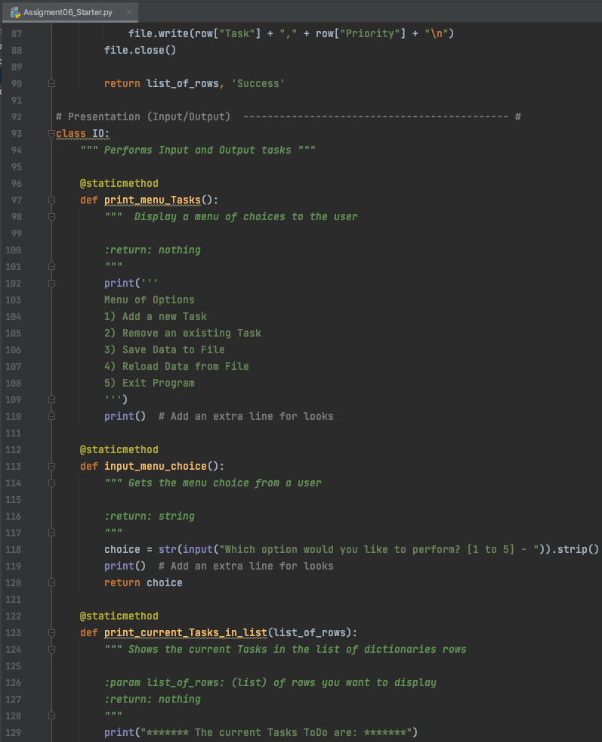

Figure 11 Final Script (Part 3)

Figure below shows continuation of the final script shown in Figure 9 through Figure 14.

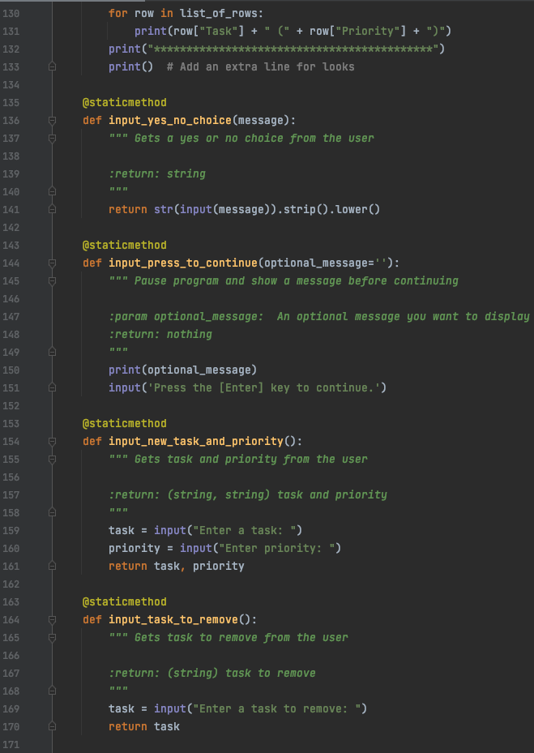

Figure Final Script (Part 4)

Figure below shows continuation of the final script shown in Figure 9 through Figure 14.

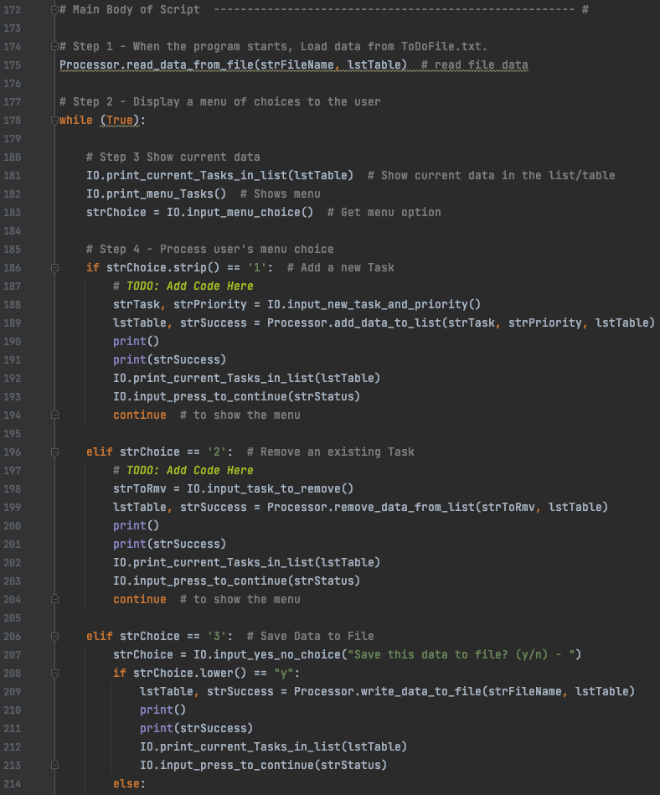

Figure Final Script (Part 5)

Figure below shows continuation of the final script shown in Figure 9 through Figure 14.

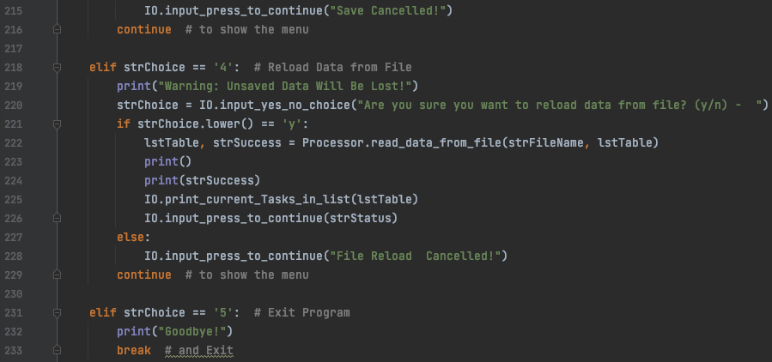

Figure Final Script (Part 6)

# Summary

In this assignment, I learned how to modify existing script and add code to perform a task.

# References

1. Module 5 Class Notes
2. Textbook
3. Google Search