Marie Karumuhinzi

May 24, 2021

Introduction to Programming (Python)

*Assignment 07*

<https://github.com/uwmak2021/IntroToProg-Python-Mod07>

<https://github.com/uwmak2021/IntroToProg-Python-Mod07/blob/main/docs/Assignment07.md>

**Module 07 – Files and Exceptions**

# Introduction

The purpose of this paper is to document step by steps taken in completing Assignment 07. The goal is to learn about exception handling, Python’s pickling module and how you use them.

# Python Exception Handling Research

The following websites were reviewed to complete this research, however the last link highlighted in bold and italic spoke to me the most because it explained this concept in simple and practical terms. The example code is relatable and as the article goes on additional information to supplement this concept is provided. If I only had few minutes to understand the exception handling concept, this will be my go to link and I will recommend it to anyone new to coding and trying to learn this concept without being overwhelmed.

<https://docs.python.org/3/tutorial/errors.html>

<https://www.programiz.com/python-programming/exception-handling>

<https://www.w3schools.com/python/python_try_except.asp>

<https://realpython.com/python-exceptions/>

<https://www.tutorialspoint.com/python/python_exceptions.htm>

[***https://www.tutorialsteacher.com/python/exception-handling-in-python***](https://www.tutorialsteacher.com/python/exception-handling-in-python)

# Python Pickling Research

The following websites were reviewed to complete this research, however the first 2 links highlighted in bold and italic spoke to me the most because they explained this concept in simple and practical terms. The example codes are relatable and easy to follow, more over it is not information overload for a beginner. If I only had few minutes to understand the pickling concept, either of those two links will be my go to and I will recommend them to anyone new to coding and trying to learn this concept without being overwhelmed.

[***https://www.tutorialspoint.com/python-pickling***](https://www.tutorialspoint.com/python-pickling)

[***https://medium.com/@lokeshsharma596/what-is-pickle-in-python-3d9f261498b4***](https://medium.com/@lokeshsharma596/what-is-pickle-in-python-3d9f261498b4)

<https://docs.python.org/3/library/pickle.html>

<https://www.geeksforgeeks.org/understanding-python-pickling-example/>

<https://realpython.com/python-pickle-module/>

<https://www.datacamp.com/community/tutorials/pickle-python-tutorial>

<https://yasoob.me/2013/08/02/what-is-pickle-in-python/>

<https://pythonprogramming.net/python-pickle-module-save-objects-serialization/>

# Python Script Creation

Below are step by step taken in creating the python script documented in this report.

## Creation of “Assignment07” Folder

I created a folder called “Assignment07” inside the _PythonClass folder that is stored in Documents on my Mac (see Figure 1).

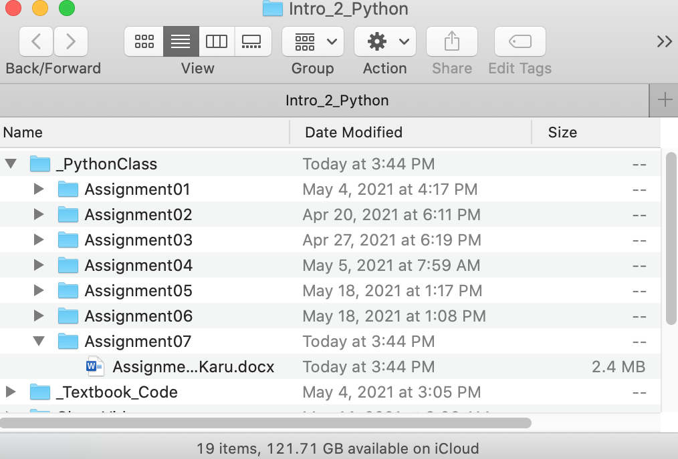

Figure 1 Assignment07 Folder

## Creation of “Assignment07” Project in PyCharm

Next, I created a new project in PyCharm (see Figure 2) based on instructions provided in \A\.

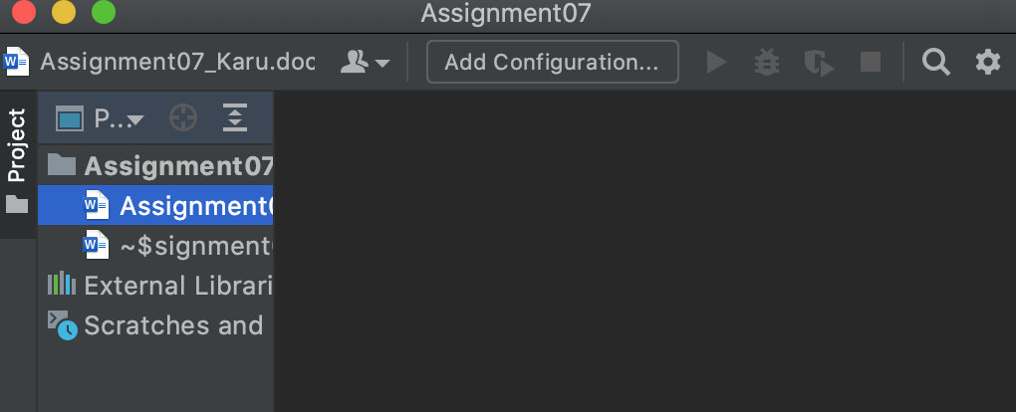

Figure 2 Assignment07 Project in PyCharm

## Creation of Python Script

To demonstrate the knowledge learned in Module 07, I reused some of the python script created in Assignment 06, modified it to calculate the quotient of two numbers instead of adding a task to a list. Additionally, I added exception handling code to warn user of any errors/typo that may occur during the execution of the code and lastly added pickling code that save data in binary file.

Figure 3 through Figure 7 show the python script created to demonstrate excepting handling and pickling python concepts.

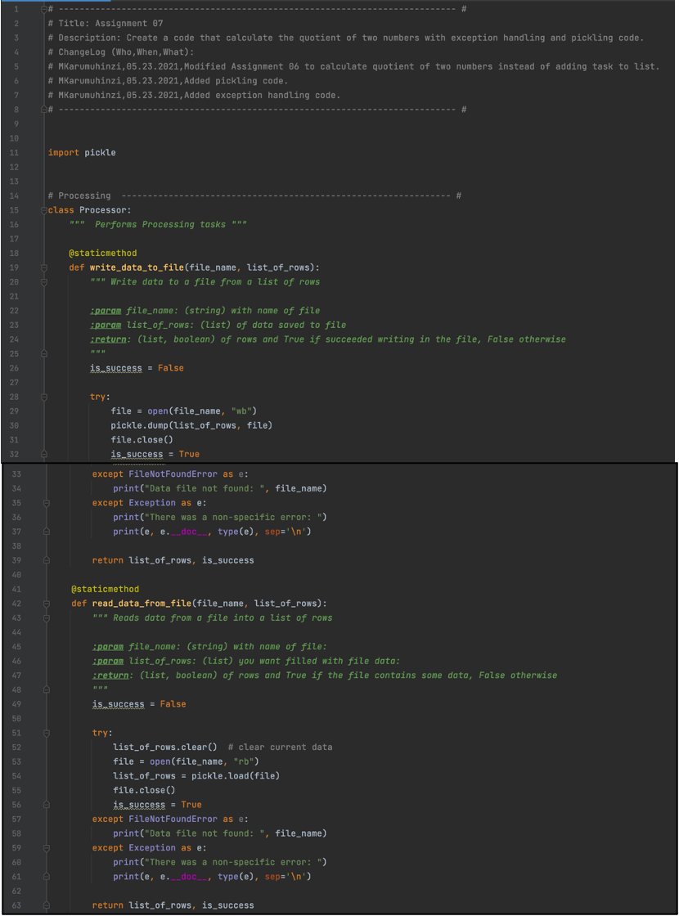

Figure  Assignment 07 Script (Part 1)

Figure below shows continuation of Assignment 07 script shown in Figure 3 through Figure 7.

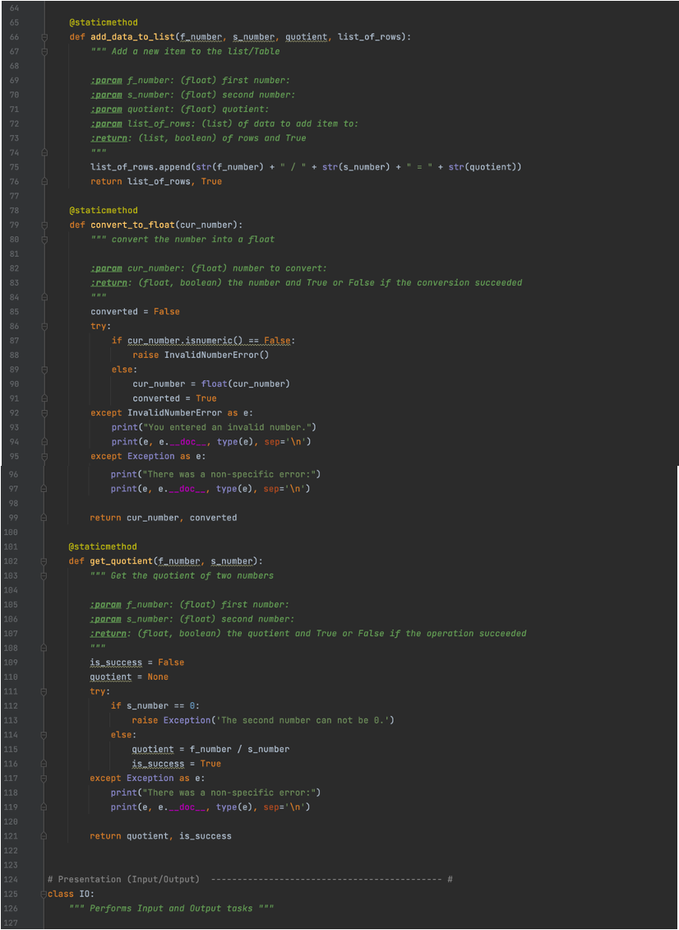

Figure 4 Assignment 07 Script (Part 2)

Figure below shows continuation of Assignment 07 script shown in Figure 3 through Figure 7.

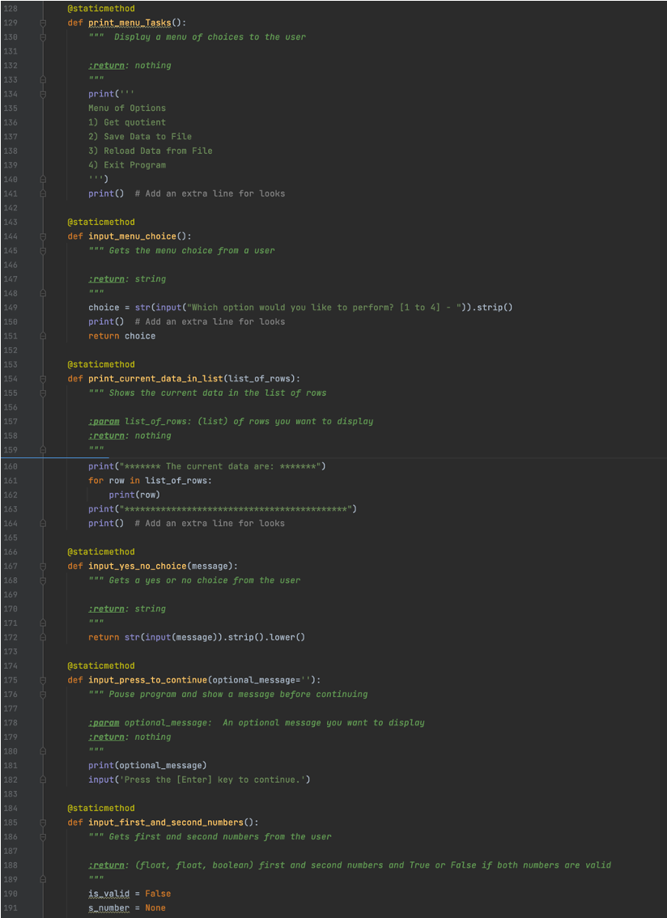

Figure  Assignment 07 Script (Part 3)

Figure below shows continuation of Assignment 07 script shown in Figure 3 through Figure 7.

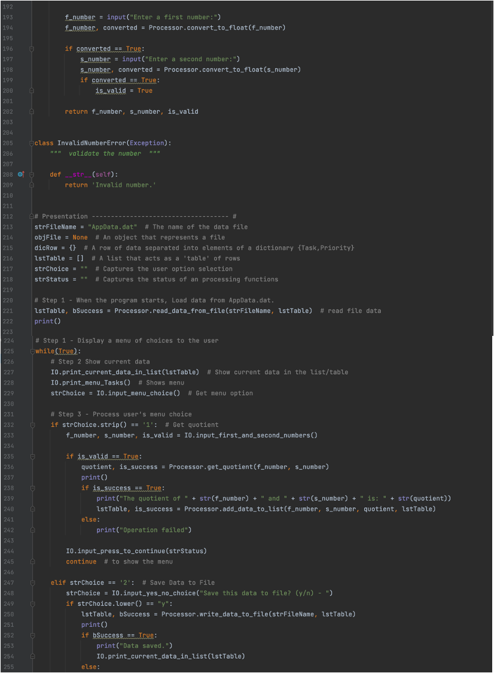

Figure Assignment 07 Script (Part 4)

Figure below shows continuation of Assignment 07 script shown in Figure 3 through Figure 7.

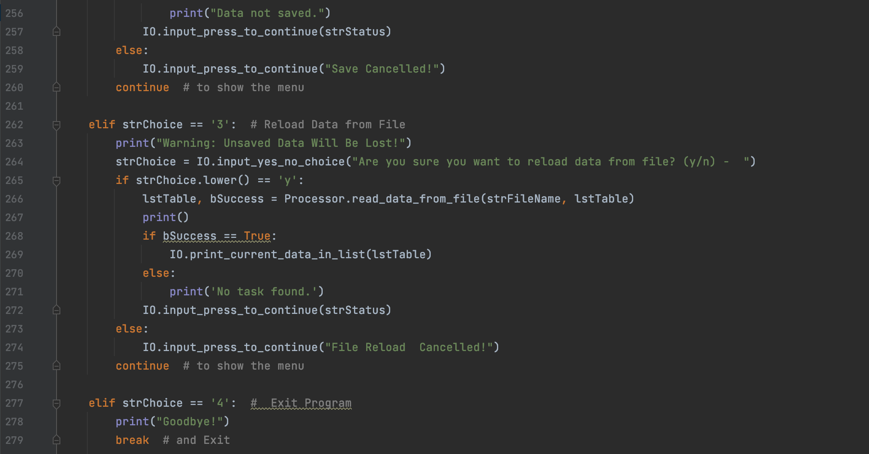

Figure 7 Assignment 07 Script (Part 5)

## Python Script Testing

Since the code run perfectly in PyCharm, next step was to test it in command shell as shown in Figure 8 and Figure 9.

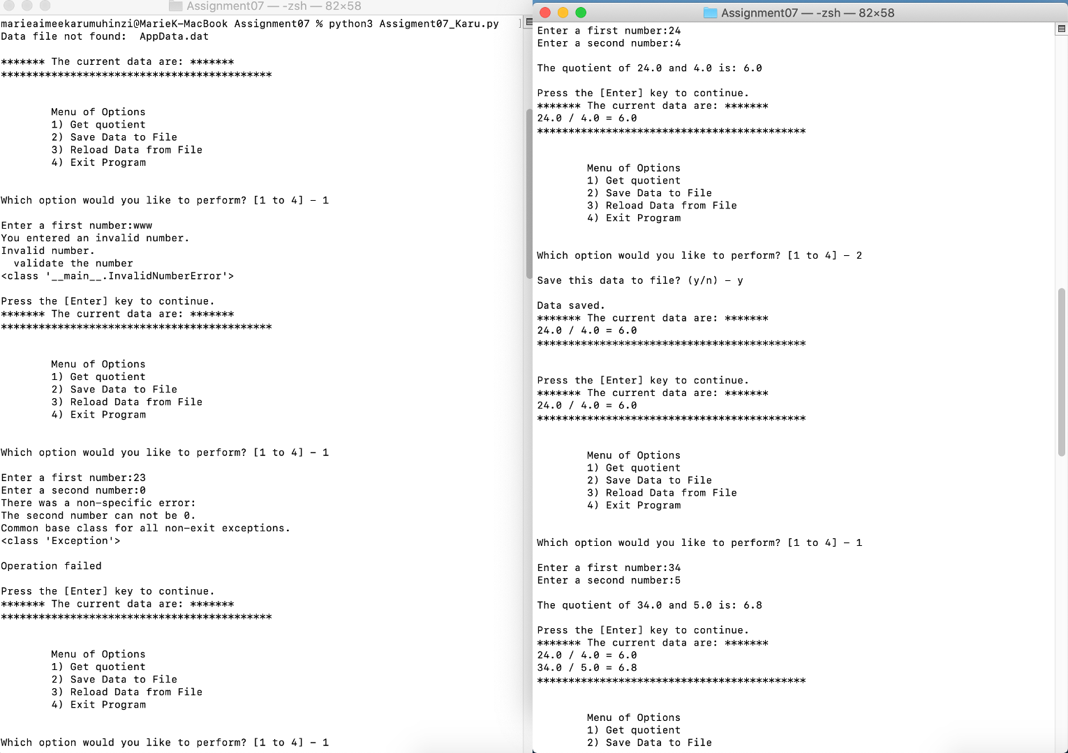

Figure 8 Assignment 07 Script Testing using Terminal (Part 1)l

Figure below shows continuation of Assignment 07 script testing using terminal.

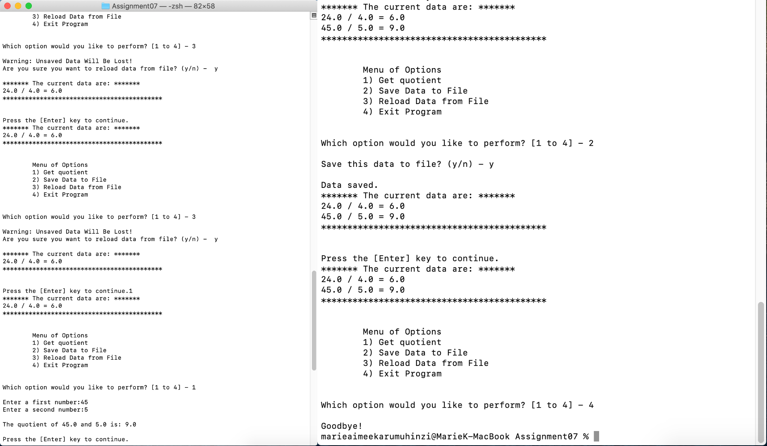

Figure 9 Assignment 07 Script Testing using Termina (Part 2)

The script run as expected and no errors were found in the output file as shown in Figure 10.

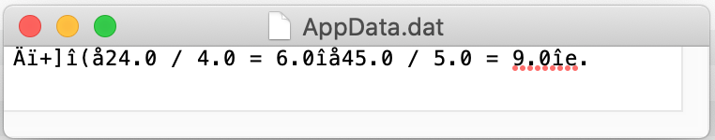

Figure Assignment 07 Script Testing Output

# Summary

In this assignment, I learned how write a python script that incorporates exception handling concepts and pickling module.

# References

1. Module 7 Class Notes
2. Textbook
3. Google Search