Marie Karumuhinzi

June 1, 2021

Introduction to Programming (Python)

*Assignment 08*

<https://github.com/uwmak2021/IntroToProg-Python-Mod08>

**Module 08 – Objects and Classes**

# Introduction

The purpose of this paper is to document step by steps taken in completing Assignment 08. The goal is to learn about objects and classes as well how to use them properly.

# Python Script Creation

Below are step by step taken in creating the python script documented in this report.

## Creation of “Assignment08” Folder

I created a folder called “Assignment08” inside the _PythonClass folder that is stored in Documents on my Mac (see Figure 1).

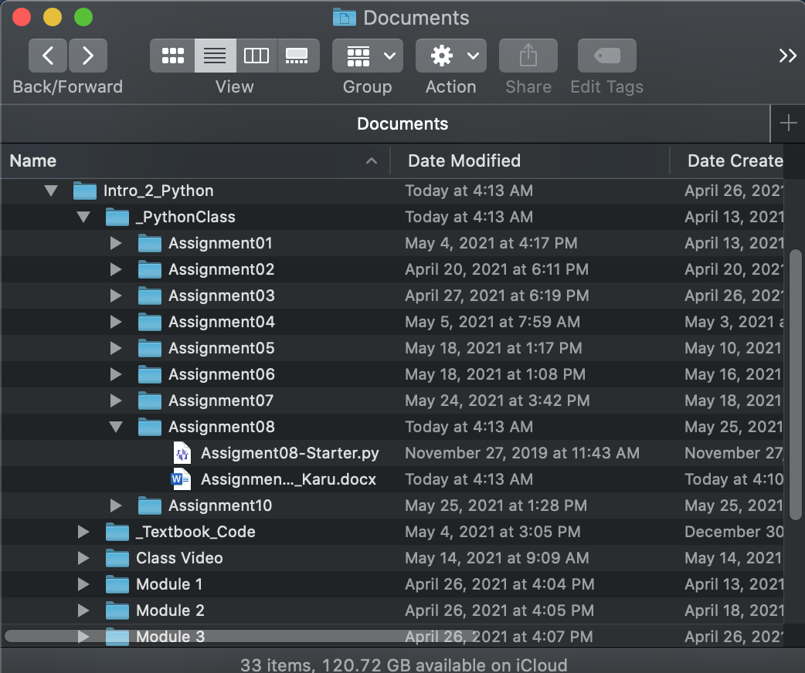

Figure Assignment08 Folder

## Creation of “Assignment08” Project in PyCharm

Next, I created a new project in PyCharm (see Figure 2) based on instructions provided in \A\.

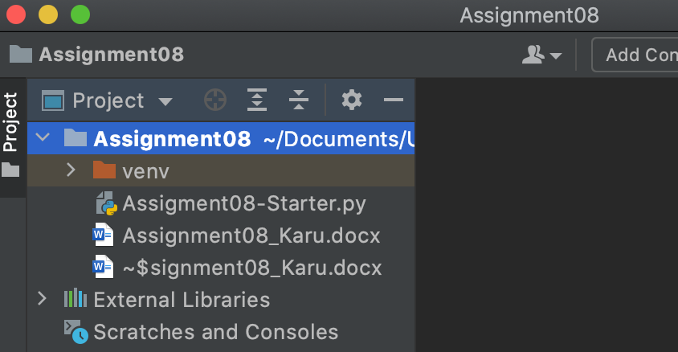

Figure Assignment08 Project in PyCharm

## Creation of Python Script

To demonstrate the knowledge learned in Module 08, I followed the instructions and p pseudo-code provided in “Assignment08-Starter.py”. Additionally, I reused some of them scripts created in previous assignments as well as used Lab8-4.py script as an example.

Figure 3 through Figure 6 show the python script created to demonstrate objects and classes knowledge learned in this module.

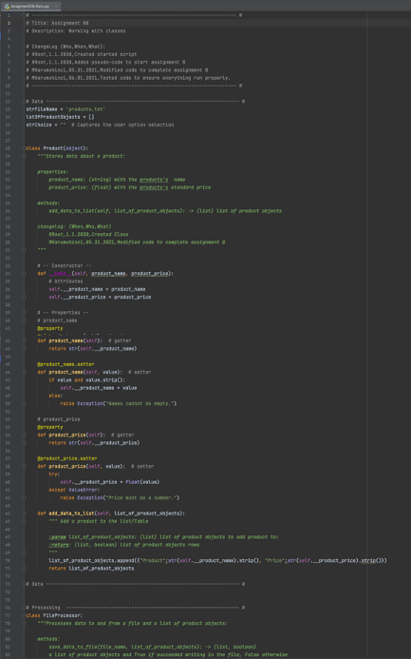

Figure 3 Assignment 08 Script (Part 1)

Figure below shows continuation of Assignment 08 script shown in Figure 3 through Figure 6.

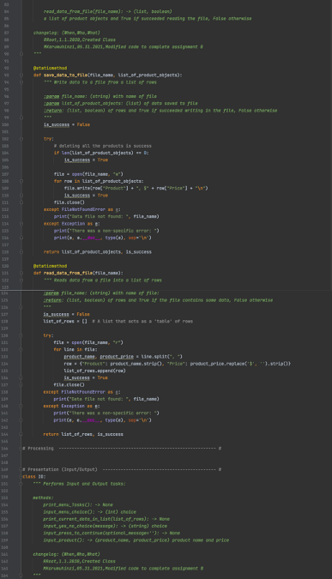

Figure Assignment 08 Script (Part 2)

Figure below shows continuation of Assignment 08 script shown in Figure 3 through Figure 6.

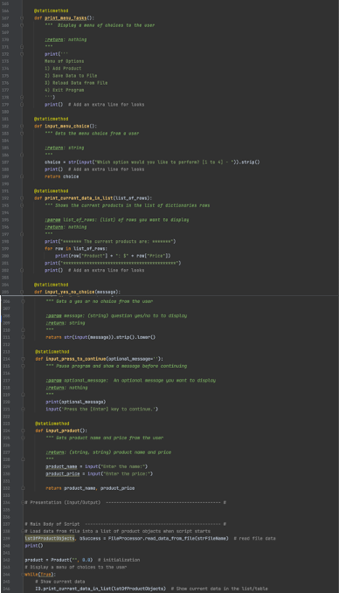

Figure 5 Assignment 08 Script (Part 3)

Figure below shows continuation of Assignment 08 script shown in Figure 3 through Figure 6.

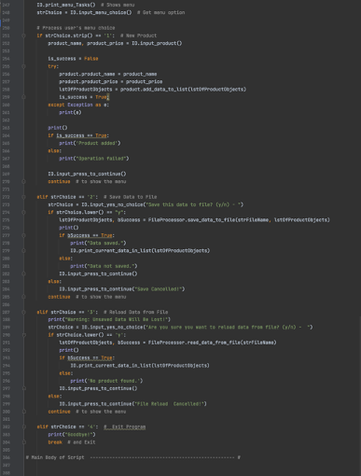

Figure Assignment 08 Script (Part 4)

## Python Script Testing

Since the code run perfectly in PyCharm, next step was to test it in command shell as shown in Figure 7 and Figure 8.

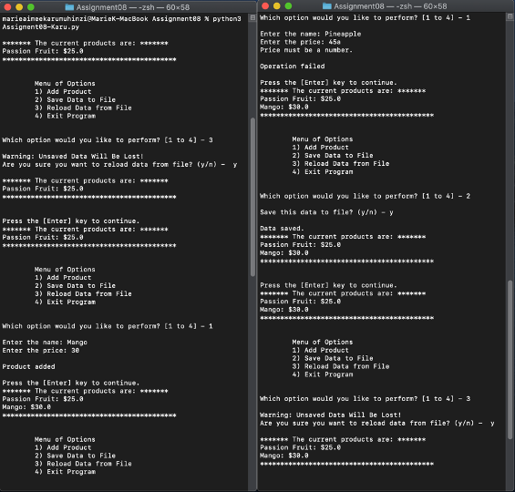

Figure Assignment 08 Script Testing using Terminal (Part 1)l

Figure below shows continuation of Assignment 08 script testing using terminal.

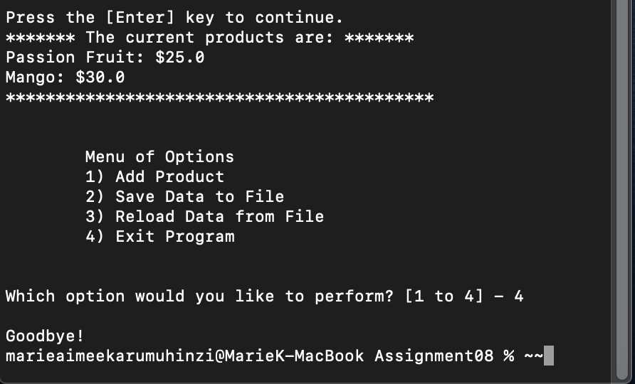

Figure Assignment 08 Script Testing using Termina (Part 2)

The script run as expected and no errors were found in the output file as shown in Figure 9.

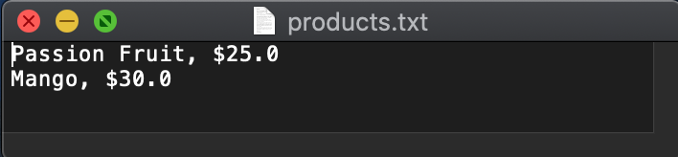

Figure 9 Assignment 08 Script Testing Output

# Summary

In this assignment, I learned how to create a python script using custom classes.

# References

1. Module 8 Class Notes
2. Textbook
3. Google Search