E-Commerce Profitability Analysis
Power BI Portfolio Case Study
Revenue conversion • value leakage • profit drivers • customer profitability
Why isn’t the business converting more of its sales into contribution margin, and where can profitability improve?
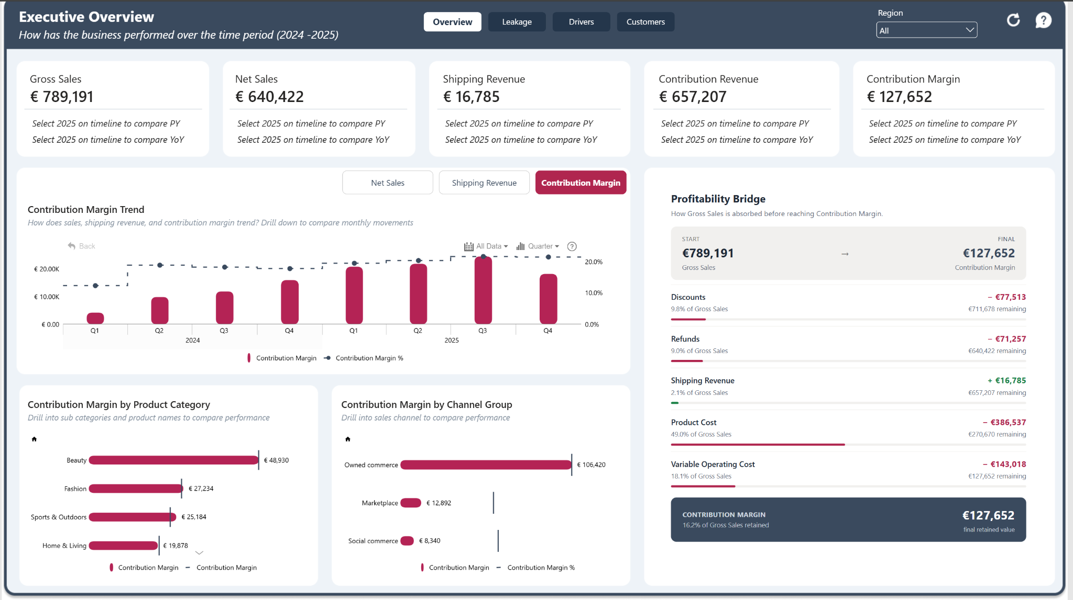
REPORT  4 pages | PERIOD  2024–2025 | TOOLS  Power BI · DAX | DESIGN  ZoomCharts · Star schema

Executive Summary
Turning sales performance into a profitability diagnosis
Project purpose
This project analyses an e-commerce business from Gross Sales through to Contribution Margin to understand why revenue is not translating into stronger profitability. Rather than treating sales performance as the end result, the report separates the problem into four management questions.
Analytical journey
How profitable is the business? → Where is value leaking? → What drives profit? → Are customers creating sustainable value?
What I delivered
- A four-page Power BI report covering Executive Overview, Value Leakage, Profit Drivers and Customer Profitability.
- A star-schema model connecting transactions with products, customers, geography, sales channels, promotions, fulfilment and return reasons.
- Reusable DAX measures covering revenue, contribution margin, returns, lost sales, discounting, fulfilment, acquisition and repeat-customer economics.
- Drill-down hierarchies, interactive navigation, dynamic time controls and contextual KPI reference labels.
- A profitability narrative that separates value creation from value leakage rather than relying on sales totals alone.
Headline results
Gross Sales | €789,191
Net Sales | €640,422
Contribution Revenue | €657,207
Contribution Margin | €127,652
Contribution Margin Rate | 19.4%
Product Cost Rate | 49.0% of Gross Sales
Discount Cost | €77,513
Return Cost | €102,898
Lost Sales Value | €36,715
Repeat Contribution Margin | €95,028 — 74.4% of total contribution margin
Portfolio summary
The analysis shows that strong sales alone do not guarantee strong profitability. Almost half of Gross Sales is absorbed by product cost, while discounts, returns, lost sales and transaction-related costs create further pressure on margin. Profitability also varies materially by product mix, sales channel and geographic market, while repeat purchasing is a major contributor to customer economics.

1. Business Context and Objectives
From revenue reporting to profitability diagnosis
The dataset captures the commercial journey from gross sales through discounts, fulfilment, refunds, product cost and operating costs to final contribution margin. The analytical challenge was therefore not simply to report what the business sold, but to understand how much value remained after the costs and losses associated with generating and fulfilling those sales.
North-star question
Why isn’t the business converting more of its sales into contribution margin, and where can profitability improve?
Primary analytical objective
Determine why the business retains only 19.4% of contribution revenue as contribution margin, identify the largest sources of value erosion, and establish which commercial and customer behaviours are associated with stronger profitability.
Analytical framework
Report page | Management question | Analytical focus
Executive Overview | How effectively are sales converting into margin? | Revenue flow, trend, product and channel sales mix
Value Leakage | Where is value being lost? | Returns, lost sales, discounts, fees and fulfilment
Profit Drivers | Where are stronger profit economics being created? | Products, categories, channels and regions
Customer Profitability | Is the customer base creating sustainable value? | Acquisition, repeat purchasing, age groups and profit at risk
Success criteria
- Follow the financial path from Gross Sales to Contribution Margin.
- Distinguish revenue scale from profitability and quantify the main sources of value leakage.
- Identify products, channels and markets associated with stronger margin performance.
- Connect acquisition and repeat purchasing to customer profitability.
- Allow users to move from executive-level results into lower-level product, city, campaign and customer detail without overcrowding the report.

2. Dataset, Preparation and Semantic Model
Connecting the full path from transaction to contribution margin
The dataset links e-commerce transactions to the commercial and operational factors that influence profitability, including products, customers, markets, promotions, sales channels, fulfilment and returns.
Core analytical areas
Area | Examples
Transactions | Orders, fulfilled units, selling price, gross sales and contribution measures
Products | Brand, brand tier, category, subcategory, product, list price and standard unit cost
Customers | Customer segment, acquisition channel, cohort and age band
Geography | Region, country, city and market attributes
Promotions | Campaign, discount type, discount rate and promotion objective
Sales channels | Channel group, sales channel, device type and payment fees
Fulfilment | Fulfilment model, carrier, service level and cost-to-serve
Returns | Return reason, return group, return loss and recovery attributes
Time / cohort | Calendar periods, cohort age and months since first purchase
Semantic model
The report uses a star-schema design centred on Fact Order Lines, supported by Product, Customer, Geography, Sales Channel, Promotion, Fulfilment, Return Reason, Date and Cohort Age dimensions. Separate helper tables hold core measures, time-intelligence measures, dynamic measures, trend parameters and waterfall steps.
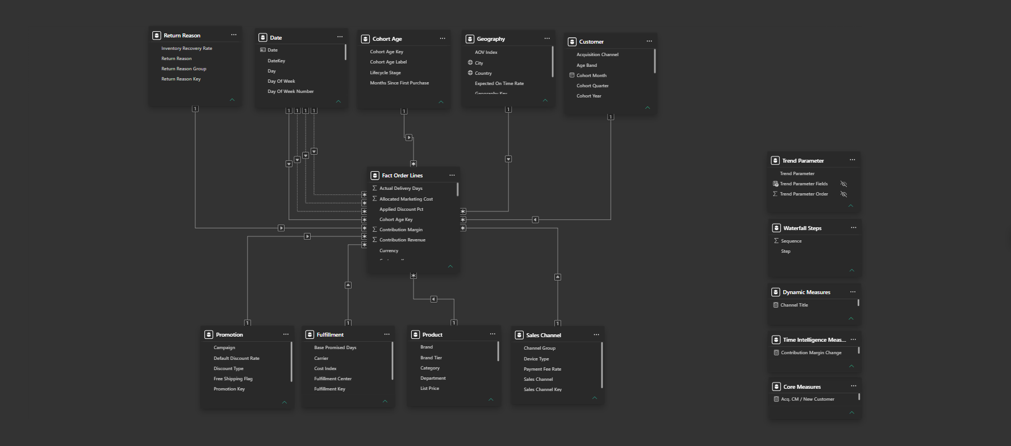
Figure 1. Power BI semantic model
Key modelling considerations
- Contribution Margin is calculated from underlying financial components rather than averaging row-level margin percentages.
- Customer profitability distinguishes acquisition-period value from contribution generated after acquisition.
- Geography used for customer analysis is aligned to the customer’s home geography where required.
- Time intelligence supports period comparison while Cohort Age supports repeat-purchase and lifecycle analysis.

3. Measure Design and Analytical Logic
Defining profitability before analysing its drivers
The report follows value from the original sale to the amount retained as contribution margin. This separates revenue leakage from the variable costs required to serve that revenue.
Profitability chain
Gross Sales − Discounts − Refunds + Shipping Revenue = Contribution Revenue → less Product Cost and Variable Operating Cost = Contribution Margin
Core measures
Measure | Purpose
Gross Sales | Original sales value before discounts and refunds
Net Sales | Sales retained after commercial deductions
Contribution Revenue | Revenue available to cover product and operating costs
Contribution Margin | Value remaining after variable costs
Contribution Margin % | Margin efficiency relative to contribution revenue
Return Loss | Financial impact associated with returned orders
Lost Sales Value | Revenue opportunity lost through unfulfilled demand
Acquisition Cost / New Customer | Cost required to acquire each new customer
Repeat Contribution Margin | Margin generated after the customer’s acquisition period
Selected DAX patterns
Contribution Margin %
Contribution Margin % =
DIVIDE ( [Contribution Margin], [Contribution Revenue] )
Repeat Contribution Margin
Repeat Contribution Margin =
CALCULATE ( [Contribution Margin], 'Cohort Age'[Months Since First Purchase] > 0 )
Company CM% Baseline
Company CM% Baseline =
CALCULATE ( [Contribution Margin %], ALL ( Geography ) )
Interaction design
- Year controls support current-period and prior-year comparison.
- Product visuals drill Brand → Category → Subcategory → Product; geography drills Region → City.
- Tooltips provide supporting measures without overcrowding the main chart.
- Page navigation follows Overview → Value Leakage → Profit Drivers → Customer Profitability.

4. Executive Overview and Value Leakage
From overall performance to the specific sources of margin erosion
Executive Overview
How effectively does sales value convert into contribution margin?
• €789.2K Gross Sales produces €127.7K Contribution Margin; 16.2% of Gross Sales is retained.  • Product Cost is the largest burden at €386.5K, equal to 49.0% of Gross Sales. | • Discounts remove €77.5K and refunds a further €71.3K before final margin.  • Variable Operating Cost absorbs €143.0K, or 18.1% of Gross Sales.
Value Leakage
Where are commercial and operational losses reducing profitability?
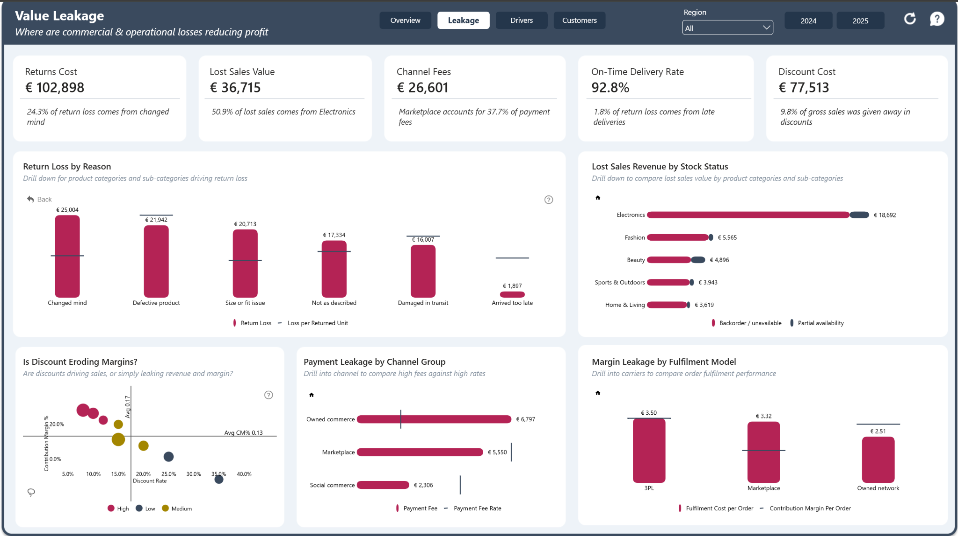
• Returns cost €102.9K; Changed Mind is the largest individual return-loss reason at €25.0K.  • Lost Sales Value totals €36.7K, with Electronics responsible for 50.9% of the total. | • Discount Cost is €77.5K, equal to 9.8% of Gross Sales.  • Channel fees total €26.6K; Marketplace accounts for 37.7% of payment fees.

5. Profit Drivers and Customer Profitability
Where stronger economics are created and whether customer value is sustainable
Profit Drivers
What factors are associated with stronger profitability across the business?
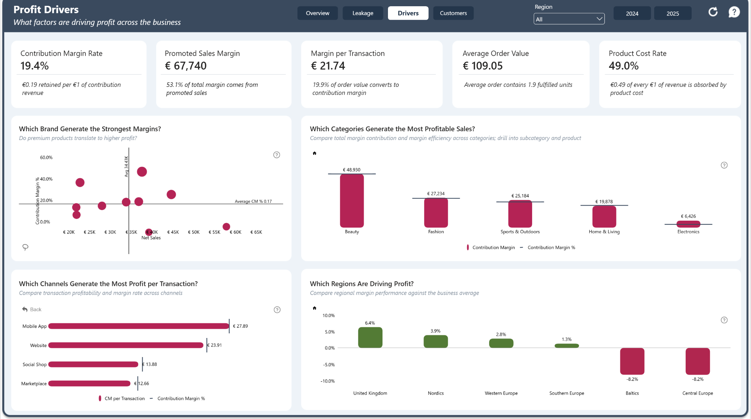
• Beauty contributes €48.9K of margin, ahead of Fashion (€27.2K) and Sports & Outdoors (€25.2K).  • Electronics contributes only €6.4K, highlighting the difference between sales scale and profitability. | • Mobile App has the strongest transaction economics at €27.89 CM per transaction.  • UK margin performance is +6.4pp above the company benchmark; Baltics and Central Europe are about -8.2pp below.
Customer Profitability
Are acquisition and repeat purchasing creating a sustainably profitable customer base?
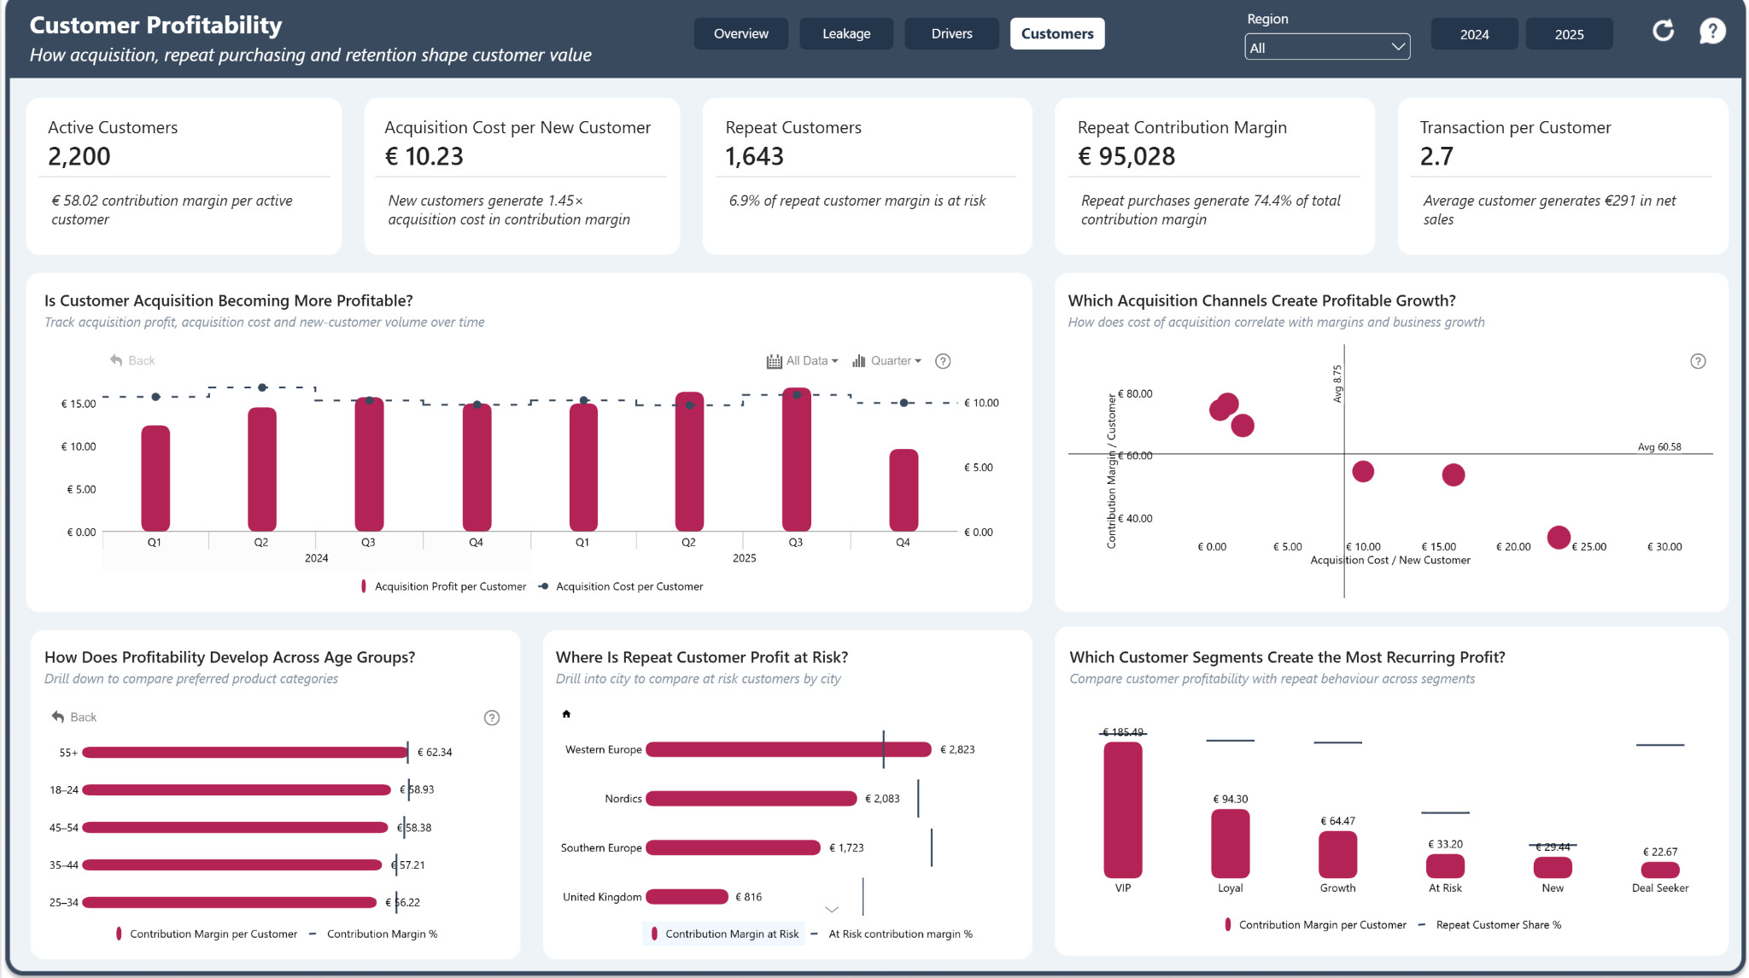
• 2,200 active customers generate €58.02 Contribution Margin per active customer.  • Repeat purchases generate €95.0K, representing 74.4% of total Contribution Margin. | • New customers generate about 1.45× acquisition cost in Contribution Margin; average CAC is €10.23.  • 6.9% of repeat-customer margin is at risk; VIP customers generate the highest margin per customer.

6. Recommendations
Evidence-led priorities for improving profitability
1. Review product economics, not sales volume alone.
Product Cost absorbs 49.0% of Gross Sales, while some commercially significant categories generate relatively weak Contribution Margin. Electronics, for example, contributes only €6.4K of margin and also accounts for 50.9% of lost sales value. Product and assortment decisions should therefore consider margin quality alongside revenue.
2. Reduce the largest sources of return-related loss.
Returns generate €102.9K in cost, with Changed Mind, Defective Product and Size/Fit issues contributing the largest losses. Drill into category, subcategory and product to identify where product information, quality or fit issues can be addressed.
3. Tighten discounting where margin does not justify the reduction in price.
Discounts remove €77.5K, equivalent to 9.8% of Gross Sales, and the campaign analysis shows weaker margin performance among some of the more heavily discounted promotions. Promotions should be judged on the Contribution Margin they retain, not only the sales they generate.
4. Address inventory-related lost sales, particularly in Electronics.
Lost Sales Value totals €36.7K, with Electronics responsible for 50.9% of the total. Availability planning should prioritise the products and categories where stock constraints are suppressing otherwise valuable demand.
5. Protect repeat-customer profitability.
Repeat purchases generate €95.0K, or 74.4% of total Contribution Margin, while 6.9% of repeat-customer margin is at risk. Retention activity should focus on high-value repeat customers and segments where the financial exposure is greatest.
6. Investigate weaker channel and regional economics before scaling growth.
Mobile App generates €27.89 Contribution Margin per transaction, while regional margin performance ranges from +6.4pp above the company benchmark in the UK to around -8.2pp in the Baltics and Central Europe. Growth decisions should consider both route-to-market economics and regional margin performance.
Decision value
Profitability improvement is unlikely to come from one intervention. The strongest opportunity is to combine better product economics, lower leakage, disciplined discounting, stronger availability and protection of repeat-customer value.

7. Limitations and Project Summary
Transparent assumptions strengthen the credibility of the analysis
Analytical limitations
- Synthetic challenge data: findings demonstrate analytical methods rather than conclusions about a live business.
- Association, not causation: the report identifies relationships and performance differences but cannot prove that one variable directly causes another.
- Contribution Margin is not net profit: fixed overheads, tax, capital costs and other non-variable expenses are outside the analysis.
- Regional variance is relative to the overall company Contribution Margin rate; it is a benchmark signal rather than a prescribed target.
- Contribution Margin at Risk represents value associated with customers classified as At Risk; it is exposure, not a prediction that the value will definitely be lost.
- Acquisition measures use the available reporting period and do not represent a complete customer lifetime-value model.
- Lost sales, return losses and fulfilment measures rely on the definitions supplied in the challenge dataset and would require production validation.
Future enhancements
- Add forecasting for sales, contribution margin and customer value.
- Extend customer analysis into formal cohort-based lifetime value.
- Introduce product-level profitability thresholds and exception reporting.
- Add scenario analysis for discount, product-cost and fulfilment-cost changes.
- Integrate inventory availability with demand forecasting to quantify preventable lost sales.
- Add automated data-quality monitoring and documented measure definitions for production deployment.
Project links
Interactive Power BI report: View the live dashboard
GitHub repository: ecommerce-profitability-analysis
Final reflection
The main analytical challenge was not calculating sales or margin individually, but organising the report around the full journey from revenue generation to retained value. Separating the analysis into Executive Overview, Value Leakage, Profit Drivers and Customer Profitability makes it possible to distinguish what the business sells from what it actually retains, where value is being eroded, and which commercial and customer behaviours support stronger profitability.
Project outcome
A concise four-page decision interface that connects financial performance, value leakage, commercial drivers and customer economics in one profitability narrative.

