College of Business Internship Site instructions

Viewing Internships

1.) Log into the website using your email username and password

2.) Click on the link at the top of the page that reads “All Applications” or follow the link given to you by email.

3.) If you clicked on the “All Applications” link, you will be looking at the most recent 20 applications. To view all the applications, click on the link at the bottom of the table that says “show all items.”

Sorting Internships

1.) Once you click on the “All Applications” link and click on the “show all items” link, you can sort the internships by clicking on the words in the column headers (“Title,” “Size,” “Modified,” or “State”).

***Clicking on “Title” will sort the internships by title from a to z
***Clicking on “Size” will sort the internships by smallest to largest size. This sort doesn't help because the internship size is irrelevant
***Clicking on “Modified” will sort the internships from the earliest dates.
***Clicking on “State” will sort the internships by state from states starting with a to z
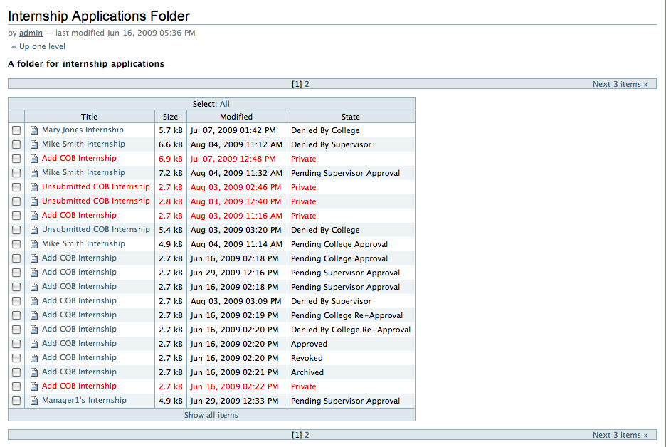
2.) One way to find a specific internship is to click on “show all items” and then hit Ctrl + F and type in the name of the student. A more simple way to find a specific student is to type in his/her name in the search bar in the upper right corner.
Sending Supervisors a Second Notification Email

1.) To send a supervisor a second notification email, the student internship must be in the Pending Supervisor Approval state. All you have to do is click the button at the bottom of the screen that reads “Send Notification Email to Supervisor.”

2.) To confirm that the message was sent, look at the top of the screen after clicking the button. The top of the screen should display a message that says “INFO Second notification email sent to supervisor.”

Archiving Internships Warning

1.) When you archive an internship, you can send it back to any state. This feature is available to give you absolute power over the internships. However, archiving a student's internship and sending it to any state should only be used in very special cases. When you archive an internship and send it back to a state, NO EMAILS OR ALERTS are sent to the Internship Director, the student, enrollment, and/or the supervisor.

***Example 1: The student's internship is approved by the College and sent to the Pending Supervisor Approval state. However, the supervisor calls you to say he/she approves the internship and he/she does not want anything to do with the application site.

Solution 1 for Example 1: You could log into the site and approve the internship from the Pending Supervisor Approval state.

Solution 2 for Example 1: You could archive the internship, send it back to the Pending College Approval state, then send it to the Shortcut state, and finally send it to the Approved state from the Shortcut state.

*****In Example 1, you cannot archive the internship and send it to the Approved state, because the student wouldn't receive an email that lets them know they have been fully approved. The Internship Director and Enrollment would also not receive the email that lets them know the student has been approved; along with all of the student's internship information.

Denying an Internship

1.) To deny an internship, go to the student's internship and scroll down to the bottom of the screen.

2.) Click on the button that reads “Internship Review.”

3.) On the new page, scroll to the bottom of the page and select a reason or many reasons under the “Reason for College Denying Internship” section. If you want to leave a comment, type out your comment in the box under the “Other Reason(s) for College Denying Internship” section.

4.) When you are finished selecting your reasoning, click the save button at the bottom of the page.

5.) You will be sent back to the original webpage, then select the “Deny by College” button at the bottom of the page.

Alerting Students of Internship News/Updates on the Internship Application Site

1.) If you want to let students know about some last second changes to the website or internships in general, talk to me and I can put up a news item on the site. This news item will display off of the homepage and it will let students know (in addition to the emails you send out already) about changes to the program. The news item would display on the right and looks like this:

