Installation:

First, make sure you have the required libraries:
- Blender 2.6x
- Python 3.x
- PyYAML

Download the /plugins/blender/plugin.py file from the bitbucket repo. You will then place the plugin.py file in the blender addons directory.

On linux blender addons go in:
/home/$user/.config/blender/$version/scripts/addons
Windows XP:
C:\Documents and Settings\%username%\Application Data\
BlenderFoundation\Blender\2.6x\scripts\addons
Windows7:
C:\Users\%username%\AppData\Roaming\Blender Foundation\Blender\2.6x\scripts\addons

Then to enable the plugin, open up blender and navigate to the User Preferences window:

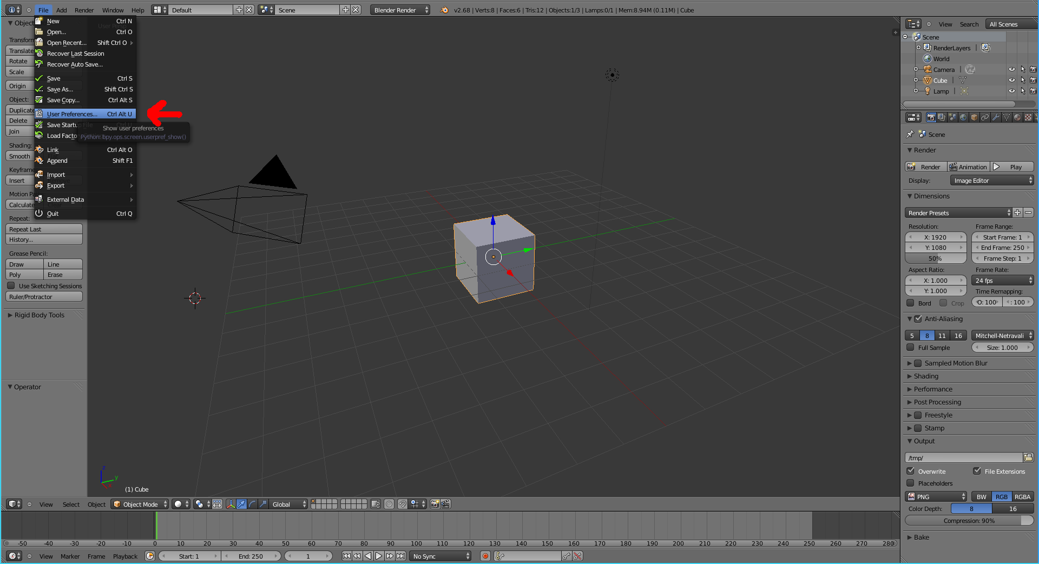
Then click the addons tab:

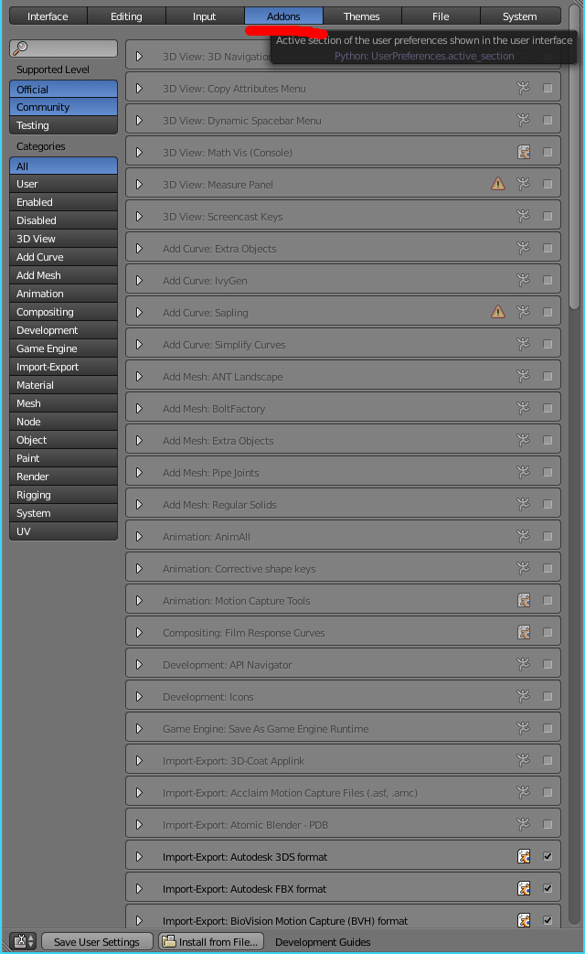
Then scroll down and click the check box next to Import-Export: Chrono::Render plugin:

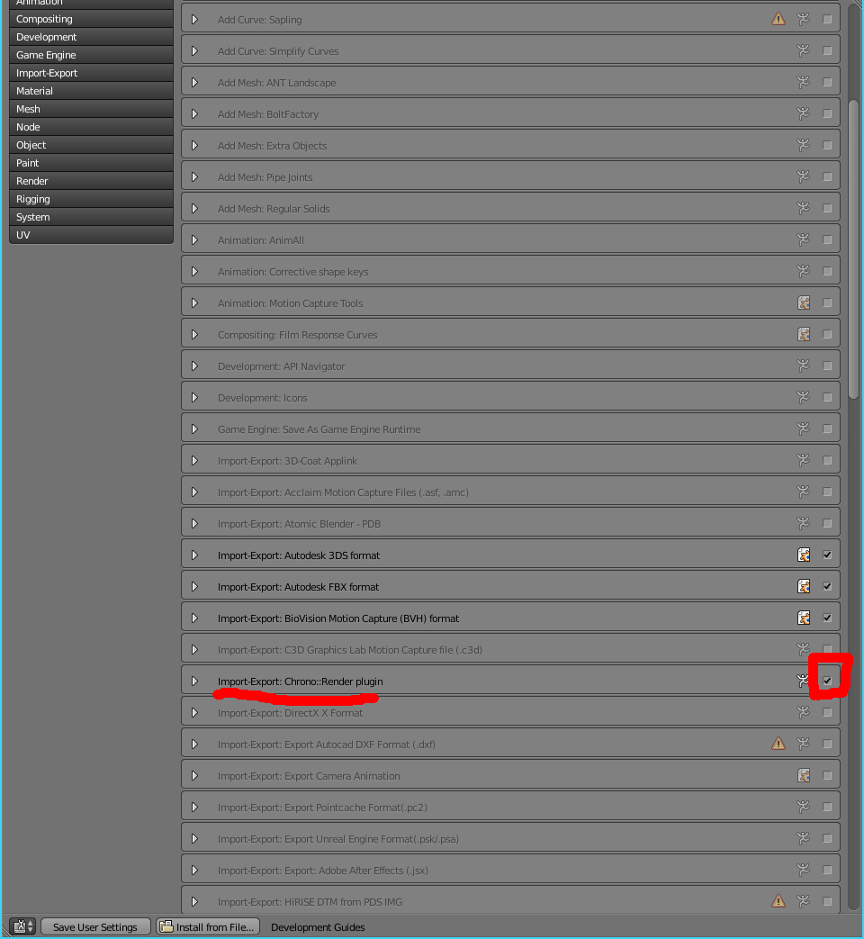
Next, click on Save User Settings to enable this plugin every time

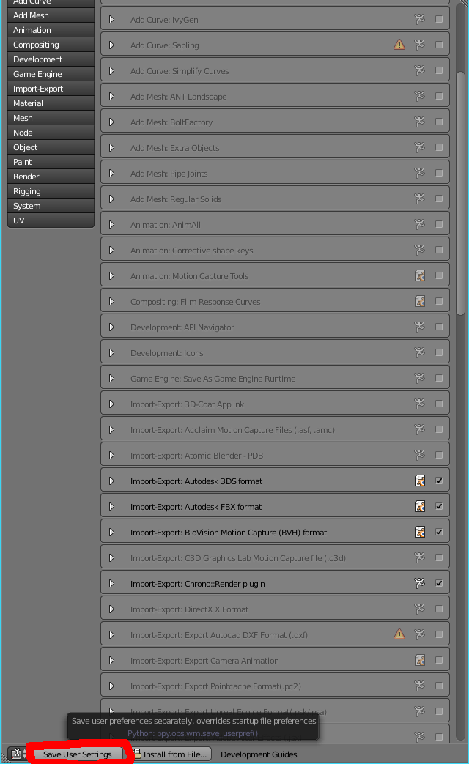

Installation is now complete and you may now begin using the plugin.

Creating a Simple Scene:

Before we create a scene, we need some data. Typically, we'd get this data from a simulation, but for this tutorial we can just create it ourselves. Save this data in a file named data_0.dat.

individual,1,0,0,0,0,0,0,0,cube,2.0
individual,2,0,0,3,0,0,0,0,sphere,1.0

First we need to get rid of the default cube. Do this by selecting it and then pressing 'x'. After the default cube is gone, we need to import our data. To do this, go to File->Import->Import ChronoRender.

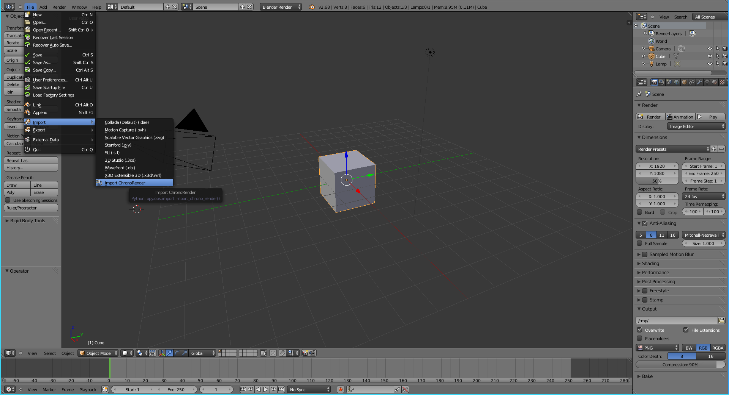
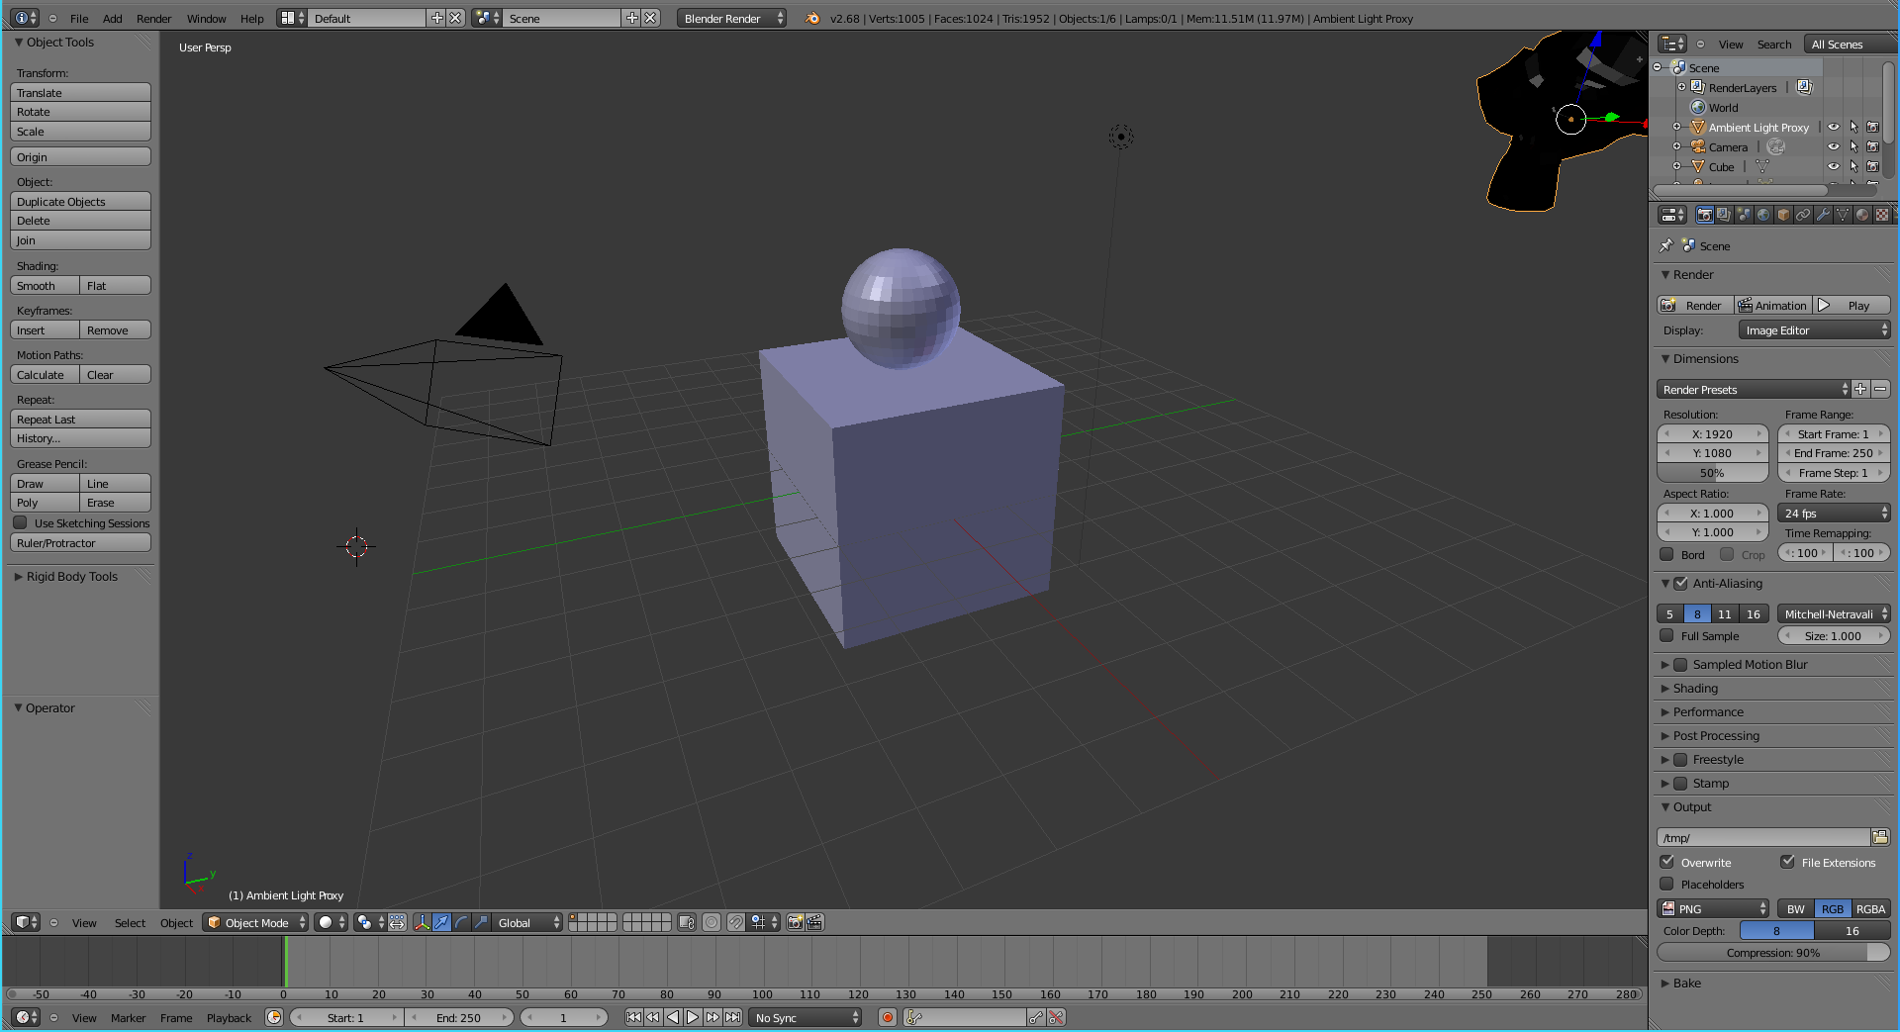
Then, select the data and hit the Import ChronoRender button to import it. You should now see our scene in the main window.

Notice blender's default camera to the left is pointed directly at our scene. Normally we would have to reposition it but not for this simple scene. The default light to the right of our objects is also in a plenty good position so we don't need to worry about it. On the far right there is a black monkey head. This can be ignored unless you desire ambient lighting. We already have lighting, so we shall ignore it.

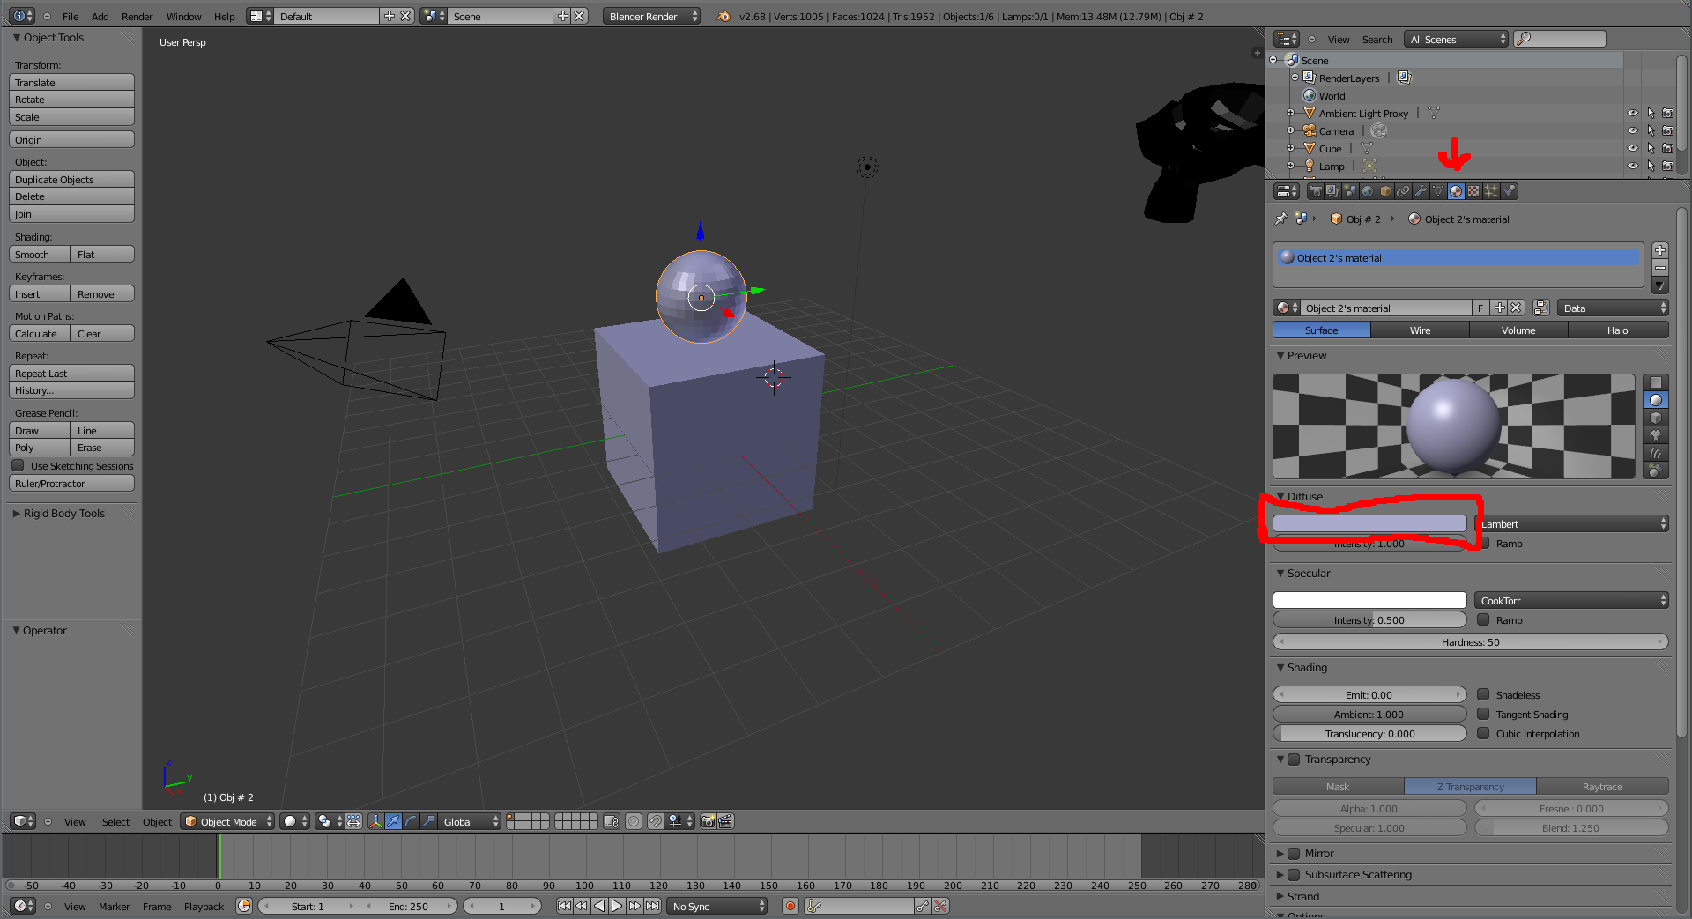
Our scene looks a bit dull right now so lets give the sphere a different color than the box. To do this right click on the sphere to select it and then click on material tab on the right hand side of the screen. To select a new color for the sphere, click the color bar under the Diffuse tab and select one from the color wheel.

Then select the box in the scene and repeat. Soon, you should have two colored objects.

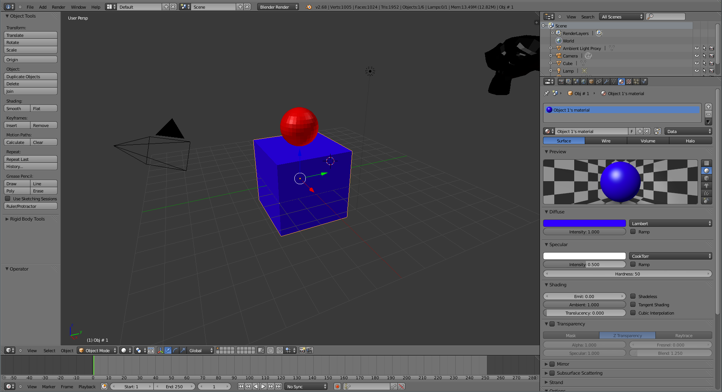
Now press F12 to get an idea of what it will look like when rendered.

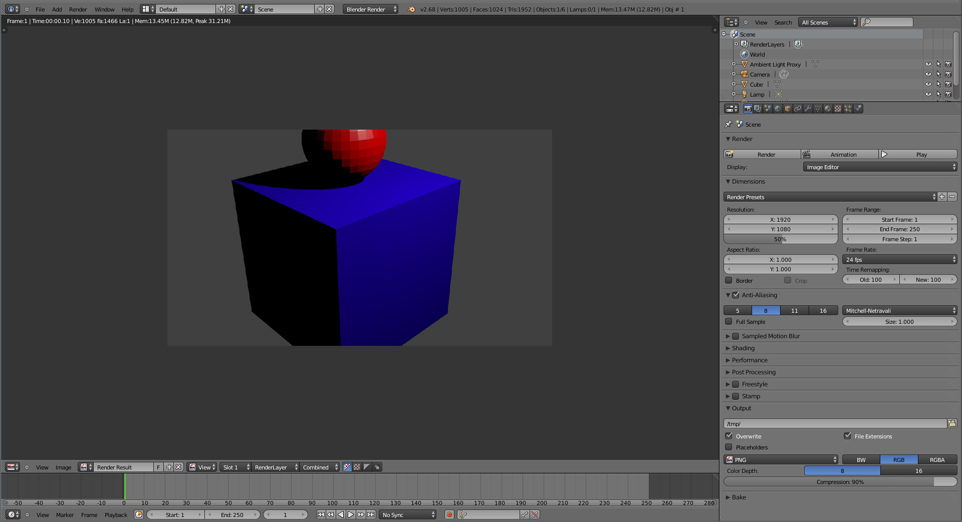
That seems good enough, lets render it using prman. First off, we need to export the scene. To do so go to File->Export->Exports to Chrono::Render. Now navigate to a clean directory, create a filename with a .yaml extension (out.yaml is customary) and hit the export button. You may now close blender. Now in the directory you saved to you will see 9 files. These files plus your original data file contain all the information necessary to render the scene.

Rendering with PRMan:

Go to some nice quiet place on euler and run:
/home/groups/sbel/rendering/chrono-render/scripts/crender.py init

This will create a RENDERMAN directory with a bunch of default files and folders. Copy all the files outputed by blender into the RENDERMAN folder. Your data should go in the RENDERMAN/job/data folder. Once that is done, execute:
/home/groups/sbel/rendering/chrono-render/scripts/crender.py render -m out.yaml -r prman

This will us prman to render your data. An image out.0.tif will appear in the RENDERMAN/job/images directory. This is your final render.

A More in Depth Look at the Pipeline:

The File Format:

Each file represents a frame, each line represents an object. The format of the lines are:
Group, Object ID, x_pos, y_pos, z_pos, quat_w, quat_x, quat_y, quat_z, object_type, extra_params

Group represents the group name and is discussed in the Proxy Object section
The Object ID is a unique identifier of the object, no two objects should have the same ID.
x_pos, y_pos, and z_pos are the coordinates of the object.
quat_w, quat_x, quat_y, and quat_z are the rotation of the object in quaternions
object type represents what kind of object it is, current options include sphere, cube, cylinder, and cone.
extra_params are specific to the object type. For example, a sphere has only one extra param: the radius while a cone requires both the radius and the height. All extra_params are comma delimited like the rest of the file. See FileFormat.txt for a full list of supported object_types and more detailed information on the file format.

The Proxy Object System:

Blender cannot handle large numbers of particles, so it is necessary to use proxy objects to represent groups of objects with identical properties. This is done by use of the Group field of the input data. Any objects that will be identical in size and color should be given the same group name. Then when the file is imported to blender, each group will appear as a floating monkey head which serves as a proxy for the group. Anything that can be done to a normal object may be done to the proxy object as well and the change will apply to all members of the group.

In order to handle individual objects, the group name must be “individual” (no quotes). This way, blender will show each object at it's correct place in the scene. This is so key objects such as walls may be dealt with separately, and so an outline of the scene may be seen.

Because the proxy object must know EVERY member of its group, the last frame of a simulation must be used for the blender import if objects are being created throughout the simulation. There is currently no way to manage objects being deleted.

Global Render Settings:

Resolution: Sets the resolution of the image to be rendered. Higher resolution means more time is required. Set in the rendering tab.

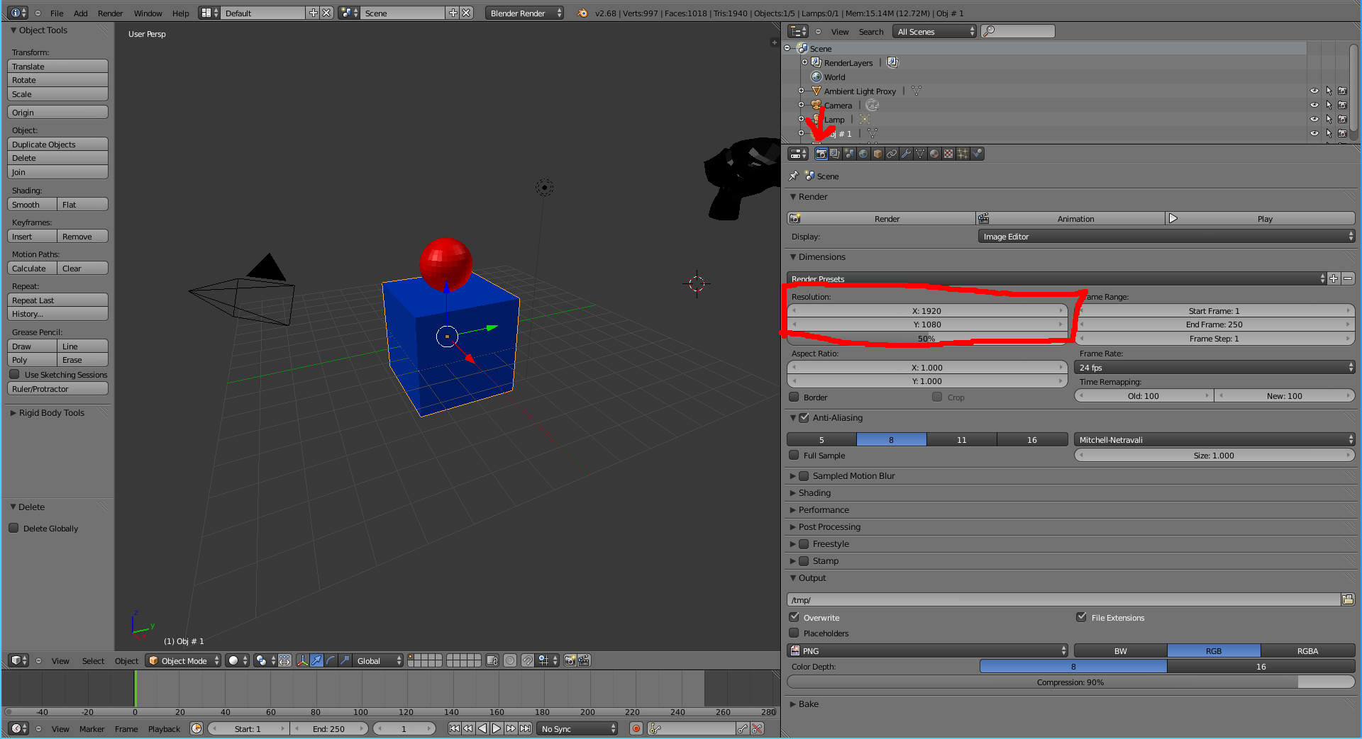

Camera:

The camera dictates the framing of the scene. Pressing the NUM0 key will show the view of the camera. Pressing it again will cancel that view.

While there are many ways to orient the camera, the two easiest seem to be flymode and snap-to-view. For flymode, go to camera view with NUM0 and press (capital) F. A small box should appear inside the view and you may now move about with the mouse using the scroll wheel to accelerate and the mouse to steer. Press enter to exit this mode while saving the camera position or ESC to exit without saving.

The other method is to press Ctrl-Alt-NUM0 to have the camera snap to the view you currently have of the screen. This plus flymode are typically the best ways to maneuver the camera.

Besides maneuvering, the one other thing that will adjust the picture is the camera's focal length, greater focal length means a smaller fov so less can be seen at one time.

In order to test the camera positioning it is advisable to simply press F12 to see blender's render and adjust accordingly.

There is currently a minor bug where the renderman render always shows a small amount more of the scene (an apparently higher fov) than blender. The current way of dealing with this is to just make the blender camera see slightly less than you want it to.

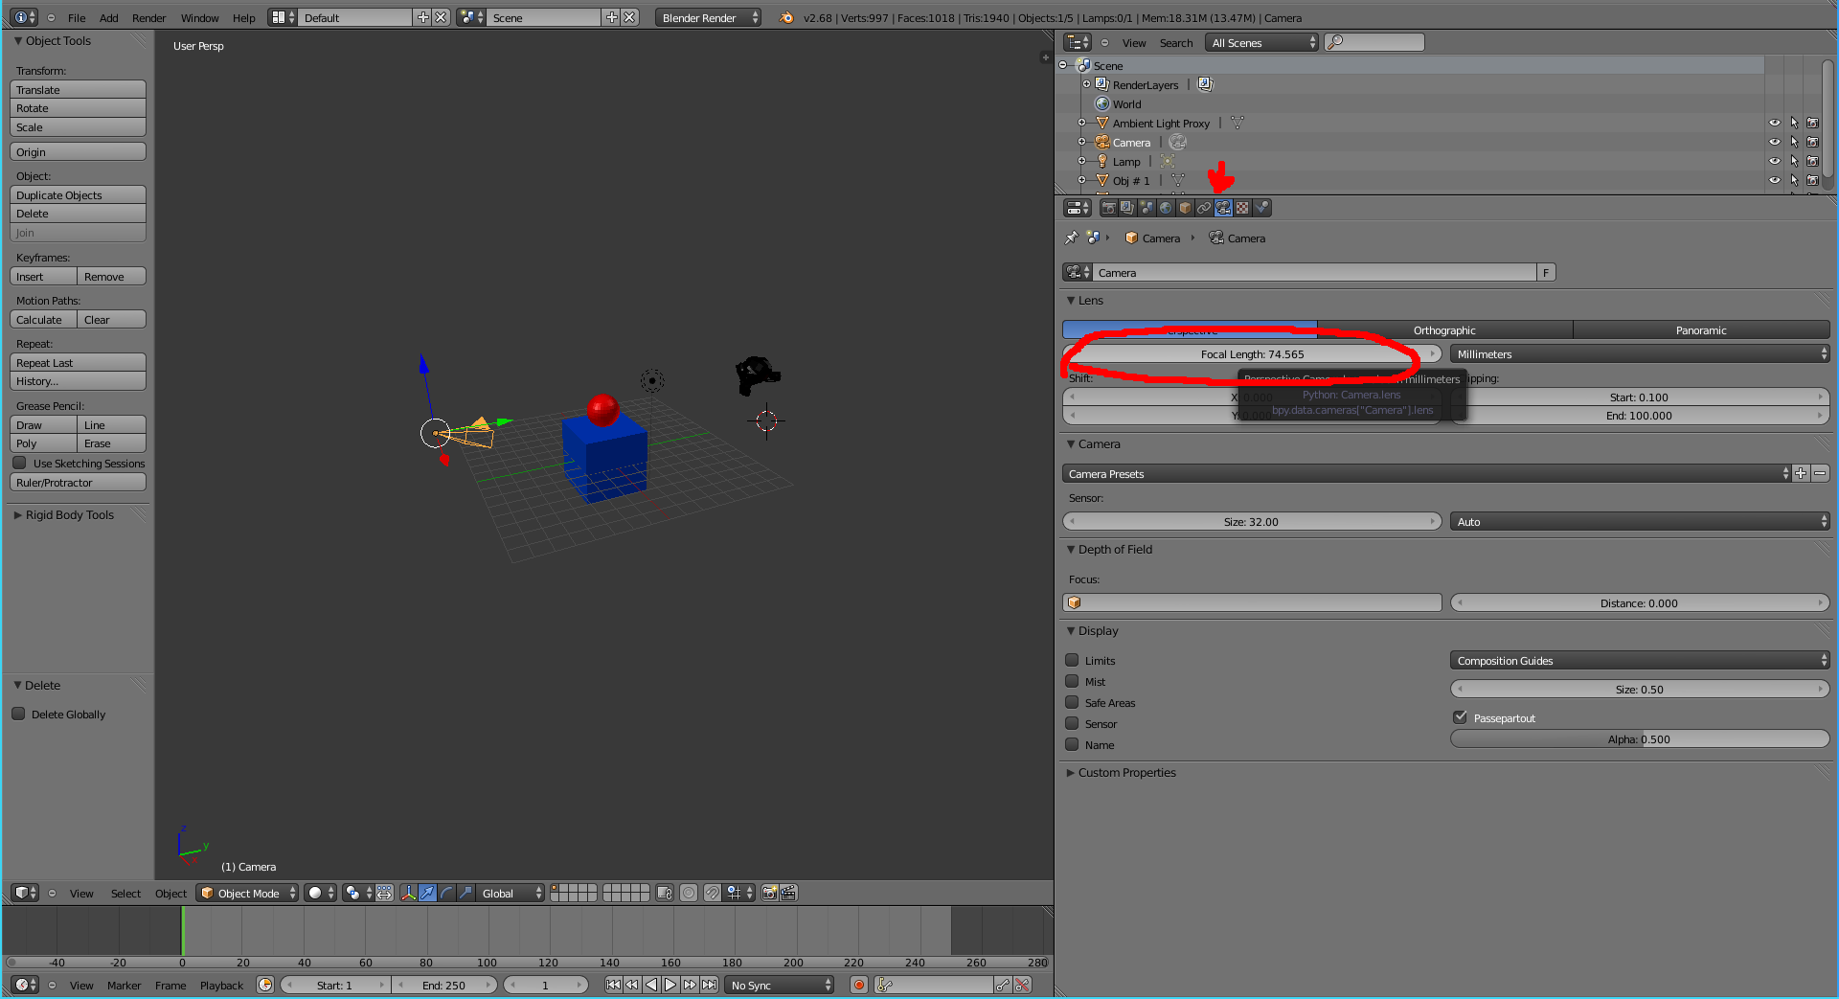

Lights:

The most useful feature of the plugin is the vast simplification of the normally onerous lighting procedure. The pipeline supports the four basic renderman light types as well as ambient occlusion and color bleeding. Shadows are also supported but come with a significant time cost.

The most basic light type conceptually is the point light. It acts like a light bulb and spews light out in every direction with the intensity diminishing as the distance increases. The intensity of the bulb is the only adjustable attribute for this light.

Unfortunately, blender and renderman use different algorithms for getting the intensity of the light that don't convert exactly. Therefore, while the light intensity may be adjusted in blender, the intensity in blender's internal renderer will not match that of the renderman one. To deal with this, one may edit the lighting file manually, or try to adjust in blender.

The sun light type functions like our own sun. The intensity of it's light comes in parallel in one direction and its intensity does not diminish with distance. The placement of this light does not matter for illuminating, but in order to be efficient at creating shadows the ray you see from the sun should pass through the origin. Again, the intensity is the only adjustable attribute of this light.

The spot light type is the most complicated of the basic lights. Its light diminishes with distance and only gives off light in a cone shape determined by the angle parameter. In addition to the angle parameter, the blend parameter controls how sharp the edge of the light is. The blend value tells what proportion of the circle the light is dimming in. Blend=0 means a very hard edge with no light drop, blend=1 means that the intensity of the light dimminishes from the center to the edge giving a softer edge. Something in between means that there is a center circle at full intensity and an outter one where the intensity gradually declines.

The location of the settings for the spotlight can be found here. Each light has the color bar and intensity slider while the spotlight also has the angle and blend sliders. All three also have a No Shadow button. If this is selected, the lights will not cast shadows (the type of shadows cast do not matter for the pipeline).

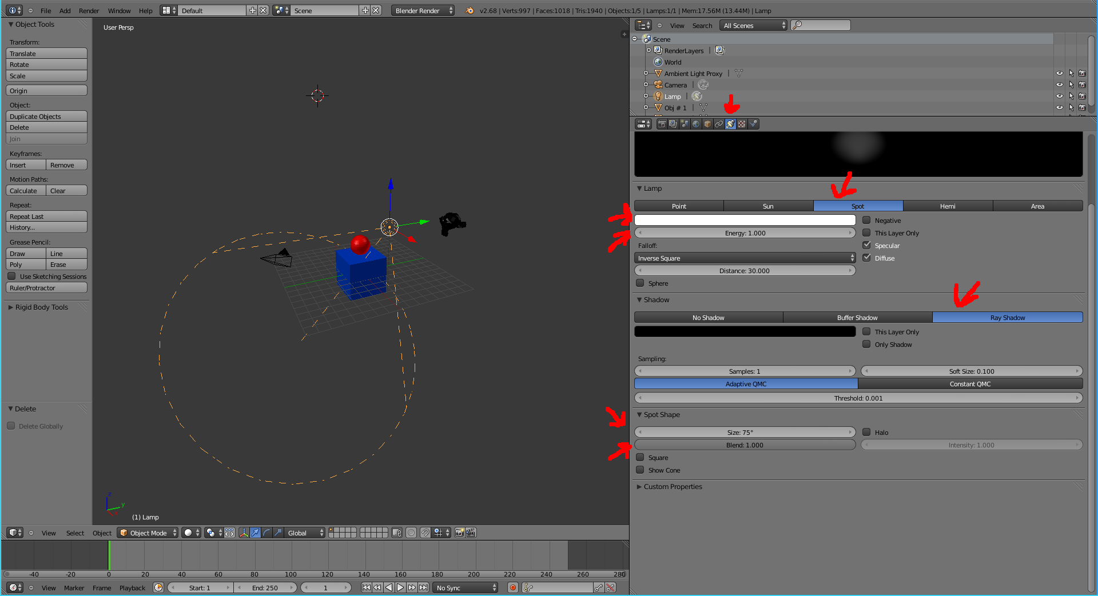
The ambient light functions differently than the other basic three because of differences in how blender and renderman handle ambient light. Blender gives individual objects different ambient intensity sliders while renderman makes one intensity and uses shaders to change the effects on individual objects. The compromise is the Ambient Light Proxy object. This object stores the ambient intensity of the whole scene in its own ambient attribute

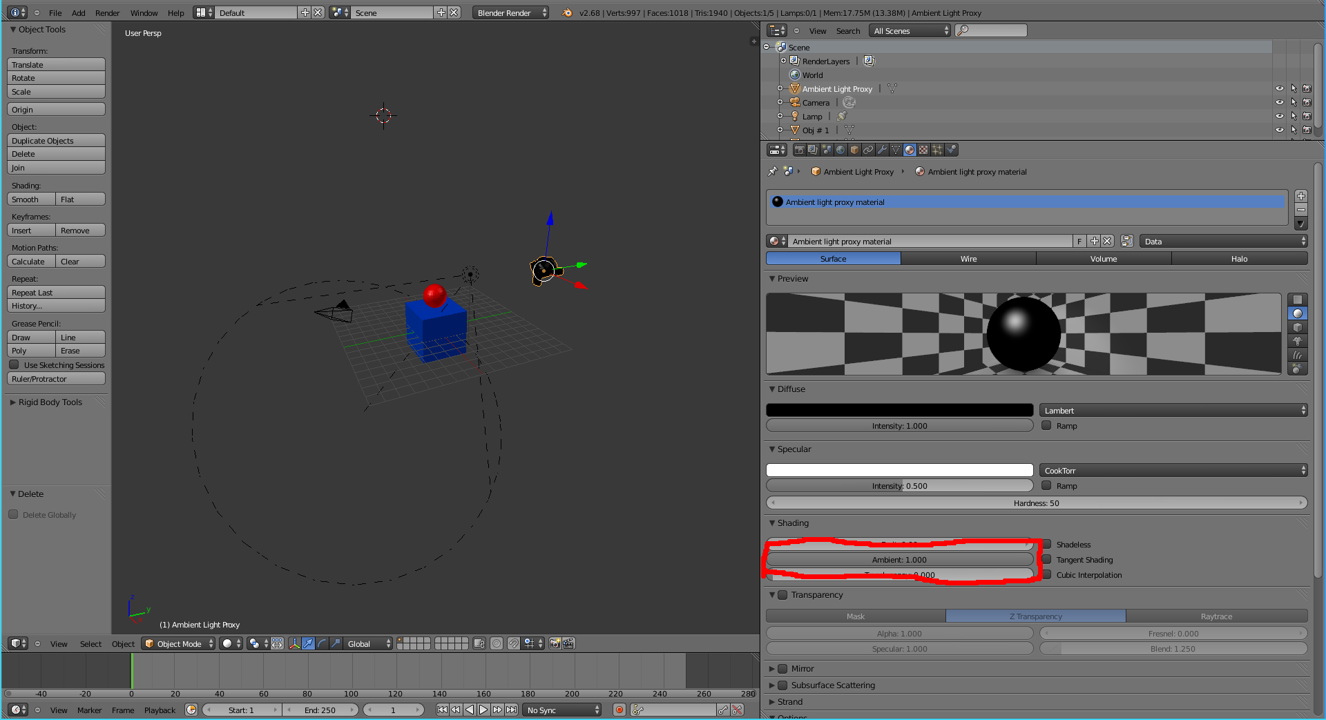

Note that the ambient attribute of the proxy object does NOT actually change the blender render. To visualize that change you will have to go to any objects you want to see the change in and set their ambient parameter.

In order to change the color of the ambient light, you must select the world tab and then the Ambient Color color bar.

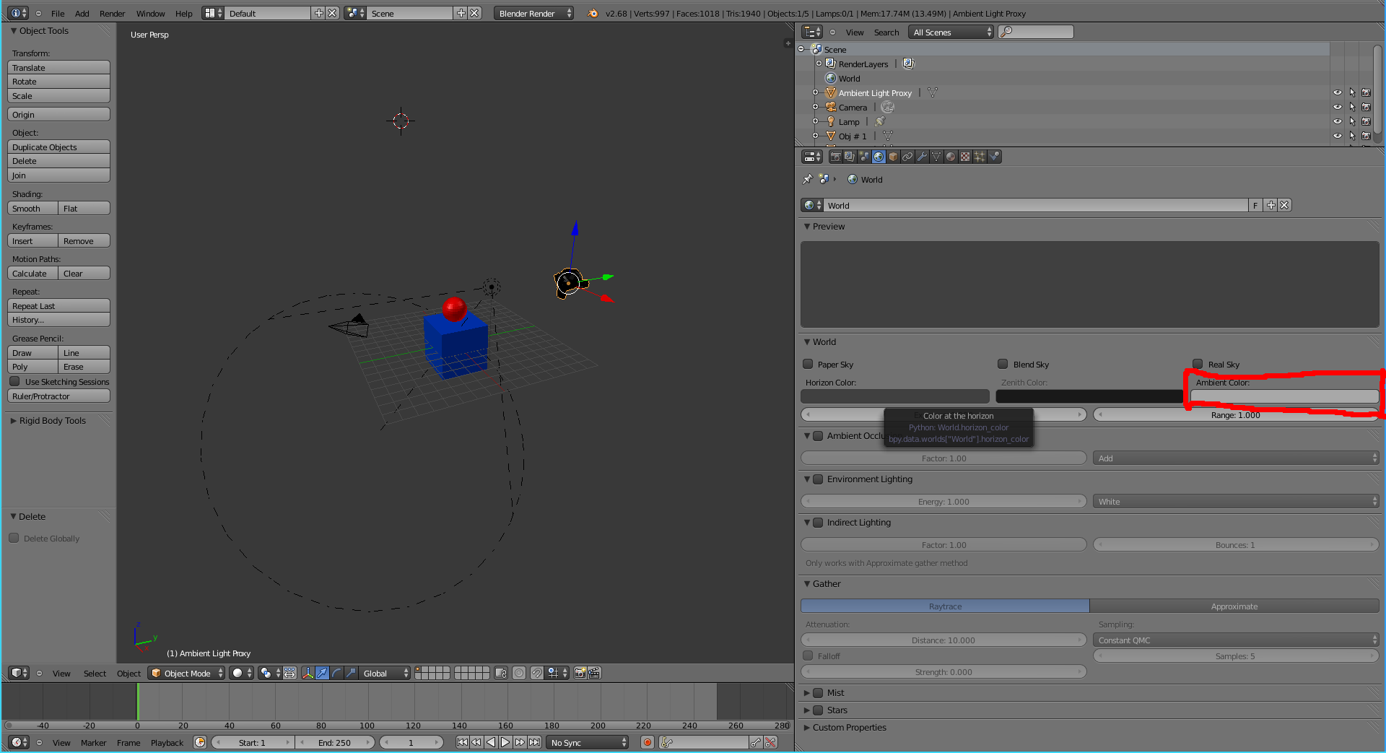
Shadows:

There are two ways to get a shadow affect from this pipeline: Use shadowmaps or using ambient occlusion.

The shadowmap method goes through a separate renderpass for each light and then uses the output from those passes to darken the areas where shadows will be in the final pass. These shadows are modeled photorealistically so they look the same in real life as on the screen. To enable these, all you have to do is make sure that for any light you want to cast shadows, the No Shadow button is NOT checked (ray shadow vs buffer shadow doesn't matter).

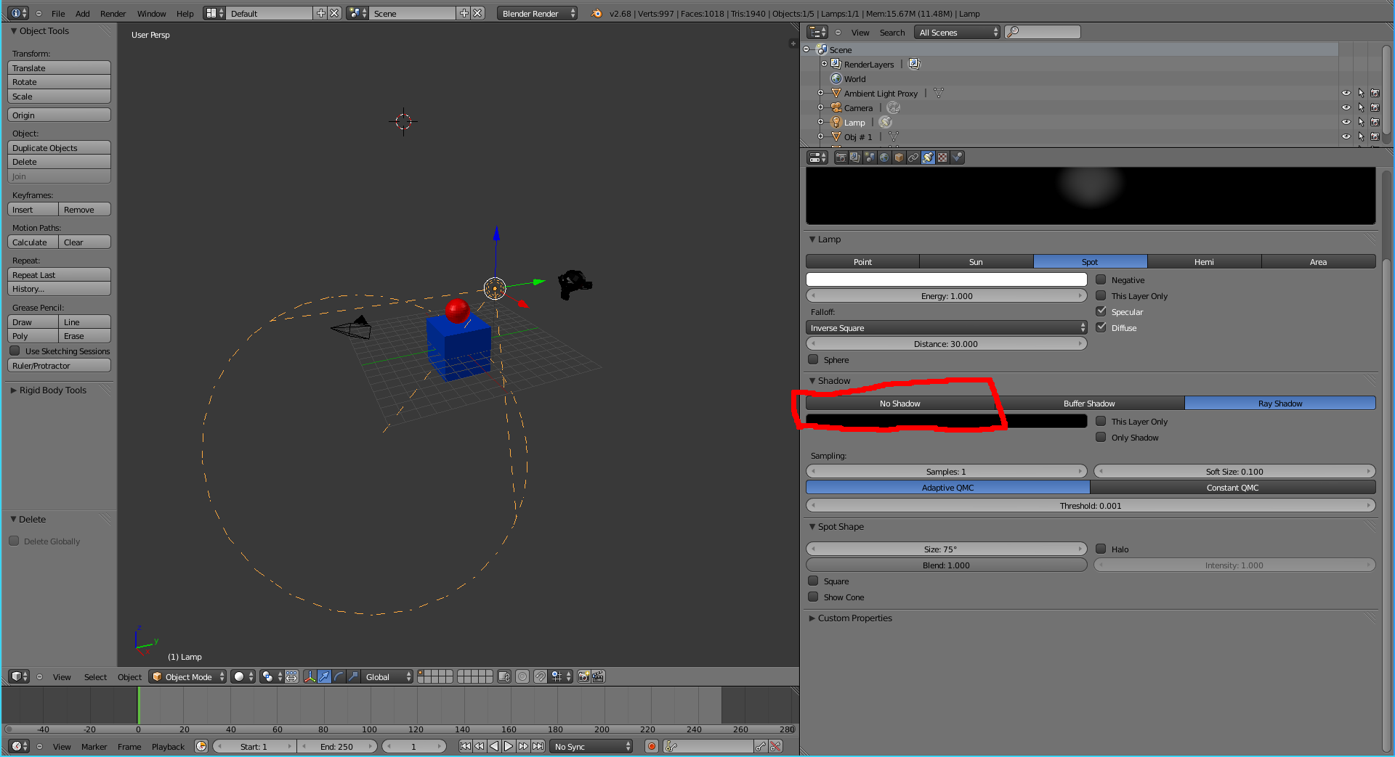

Ambient Occlusion on the other hand uses ray tracing to give a realistic approximation. It shoots out a bunch of rays from a point and sees how many intersect with another object nearby. For each ray that does, it darkens the point a little bit. This phenomena does not happen in real life but it often looks indistinguishable. This method also tends to produce softer shadows with outlines less harsh than the shadowmap method (although in the future the shadowmap method could be modified for softer shadows). This method is turned on by selecting it under the world tab.

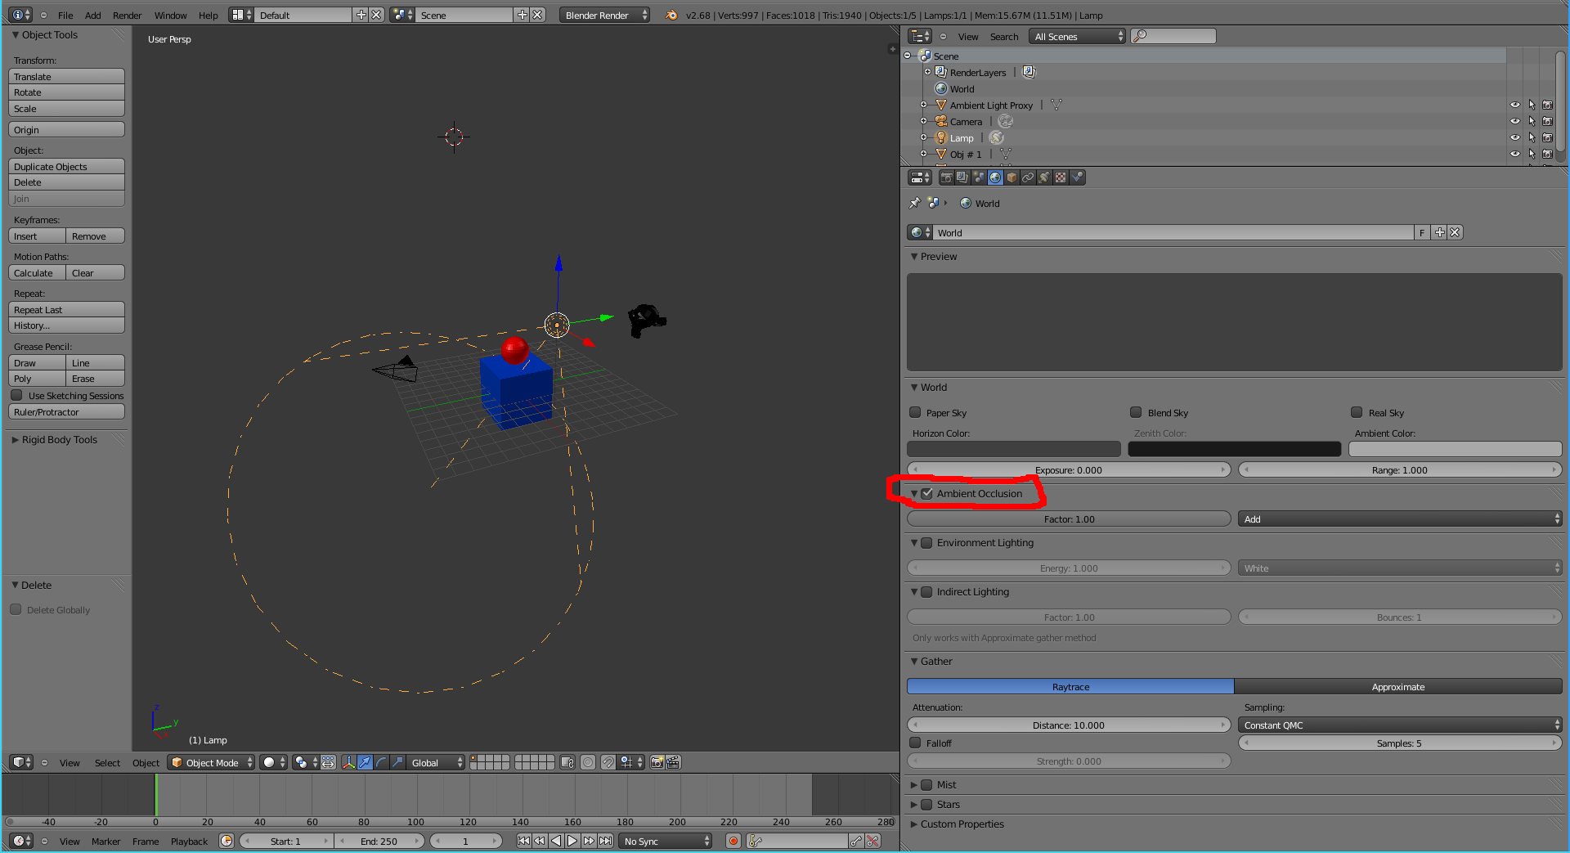

Color Bleeding works almost exactly the same as ambient occlusion except it changes the color instead of the brightness. To enable it, check the Indirect Lighting box under the world tab. In order to see its effects in blender the gather method must be set to approximate but this will not affect the renderman render.

Currently only one of color bleeding and ambient occlusion may be used at one time. This should not be a problem in practice as ambient occlusion would aggressively dull the already subtle color bleeding effect.

Also, both ambient occlusion and color bleeding rely on two parameters that control a quality/time trade-off. Blender cannot handle nearly what renderman can so these values currently must be set manually if the defaults are not satisfactory.

Hiding Objects:

Removing an object that has been imported will cause blender to crash. However, sometimes one does not want to render all the objects in the simulation. For example, for a simulation inside a closed box, one might want to remove some of the sides of the box to see in. In order to do this, select the object from the list of objects and click on the little eye. The eye makes the object invisible in blender, and the camera makes it invisible in the render. Note that lights may also be hidden in this manner.

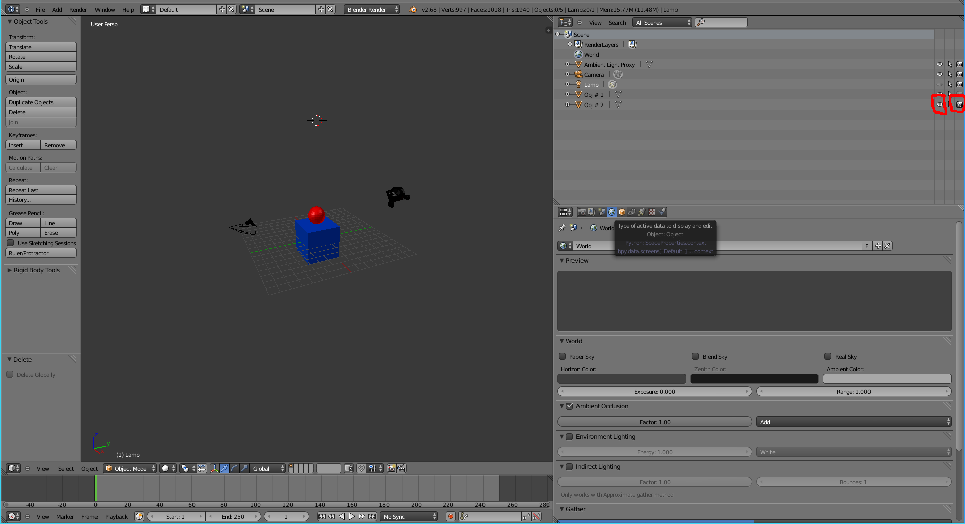

Submitting to Euler:

Submitting a job to euler uses the exact same parameters as running it locally, plus a few extra.

An example of a submission to euler,:
crender.py submit-m out.yaml -r prman -f 1 100 -q prman -w 1:00:00 -c test-render

What the flags mean:
submit The job is for euler. For a local job, replace submit with render
-m The metadata file which specifies the configuration for the render
-r Tells what render to use. PRMan is recommended, but aqsis supports most features
-f The start and end of the framerange, if not there just renders frame 0
-q The queue the job will run on. License issues means that for a prman render it MUST be in the prman queue
-w The walltime for the job. The default is very low so be sure to set this
-c what the job is (c)alled.

Currently submitting to euler creates one instance of prman for each frame to render so the -p and -n flags do not do anything but waste resources so they should not be used currently.

Importing blender lighting rigs:

While a full scene of imported data plus lights cannot be saved, the lights, camera, and global settings of a scene can be saved in a .blend file. This enables the creating of lighting rigs that can in theory be used to render different scenes with the same lighting. To create a rig, first arrange the lights, camera, and global variables (resolution, etc). Then, delete everything besides the lights and camera. Then go to File->Save As and save it as a .blend file. The next time you want to use it just go to File->Open and open the file.

Current Limitations:
When creating a shadowmap for the sun, the process involves converting the sun to a camera. Unlike the spot and point lights the sun uses an orthographic camera which requires a screen window to be set. The current solution to this is to make a square just big enough to hold the whole scene and make sure it is centered by requiring the sun's ray to pass through the origin. However, this can be inefficient if the scene is long and skinny. There is currently no easy way to fix this issue.

The lighting algorithms from blender and renderman do not match up well. The current attempt to fix it is simply multiply the intensity by a constant for the renderman render but often times it still requires manual intervention. This is done by editing the custom_lighting.rib file and changing the value after “intensity” on the light's line.

The number of samples and maxvariance parameters for ambient occlusion and color bleeding cannot be set in blender. These values affect the quality/speed tradeoff of rendering. Currently the pipeline leans toward higher quality. The value of samples can be adjusted manually by editing the yaml file. The maxvariance cannot easily be changed currently but it would be somewhat easy to add it as a parameter in the yaml file.

Color bleeding and ambient occlusion can not be used simultaneously and would require some restructuring to fix.

Optimizations:
Play around with using a spotlight instead of a pointlight. A pointlight actually makes 6 different shadowpasses that all end up roughly like a 95 degree spotlight pointed up and down each axis. It would likely be much more efficient to just use one spotlight if there is nothing behind it. Or none. Shadows are expensive, don't use them unless you would actually notice them.

