BLACKJACK

Blackjack, also known as 21, is one of the most popular and widely played card games in casinos around the world. It's a game of both skill and chance, where players compete against the dealer rather than each other.

1. Main menu

Menu screen:

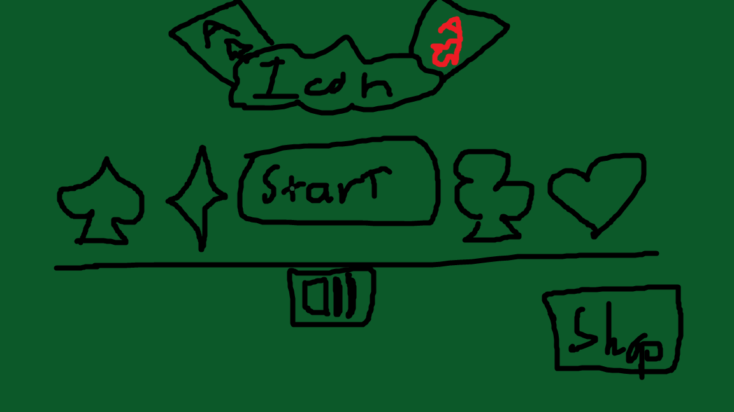

User:

-Press Start (enter Play screen)

-Press Sound (turn off Sound)

-Press Shop (enter Shop screen)

Play screen:

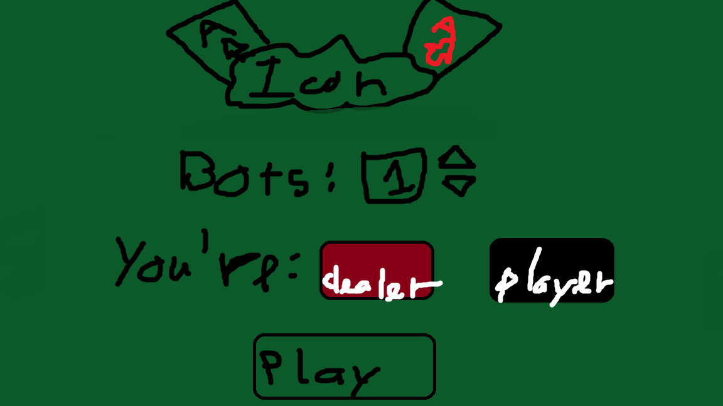

1. Shop screen

Updating…. ( I don’t know why I make this feature )

1. Rules

When start round, deal each player 2 cards:

|  |  |
| --- | --- |
| Cards | Points |
| Arrow Right with solid fill | 2🡪10 points |
|  | 10 points |
|  | 1-10-11 points |
| Top 1 | Add outline |
| Top 2 | Add outlinewith any card that have 10 points |
| Top 3 | Have 5 cards but total points still under 21 |
| Top 4 | Normal combine cards |

After that, if you still under 16(15 if you’re dealer), you should pick more cards until enough points so that you can ‘down’ and compare with another player’s cards (with Dealer if you’re player, with ALL players if you’re Dealer)

--------------------------------------------------

If you win dealer: you get x2 tbucks you have put before, if you lose, you lose them.

Otherwise, if you’re dealer, you can get tbucks, who have lower points than you, obvious pay tbucks equal they have put if you lower.