Class Design:

You are going to create your own class which is derived from an ArrayList collection. Your class will be called MyAnimalList and it can only contain classes of type Animal.

MyAnimalList MyAnimals = new MyAnimalList();

The Animal class is defined as follows:

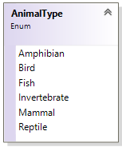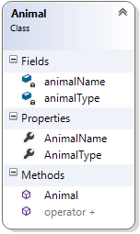

Creating a list of Animal objects**:**

Add the following Animal objects to MyAnimals using the Add() method:

MyAnimals.Add(new Animal(AnimalType.Amphibian, "Frog"));

MyAnimals.Add(new Animal(AnimalType.Bird, "Eagle"));

MyAnimals.Add(new Animal(AnimalType.Fish, "Bass"));

Add the following Animal objects to MyAnimals using the overridden + operator:

MyAnimals += new Animal(AnimalType.Invertebrate, "Worm");

MyAnimals += new Animal(AnimalType.Mammal, "Lion");

MyAnimals += new Animal(AnimalType.Reptile, "Snake");

If you try and Add() any object other than an Animal:

MyAnimals.Add("Dog");

You catch the exception and display the error:

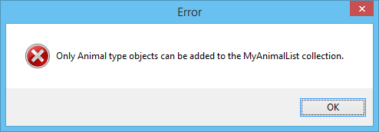

Events**:**

Your MyAnimalList class defines an event called AnimalRemoved to which you will subscribe:

MyAnimals.AnimalRemoved += MyAnimals_AnimalRemoved;

Methods used to subscribe to this event must have the following signature:

void MyAnimals_AnimalRemoved(MyAnimalList collection, Animal item)

When an Animal object is removed from MyAnimals the MyAnimals_AnimalRemoved() method is called by the AnimalRemoved event and a message box is displayed with the following information:

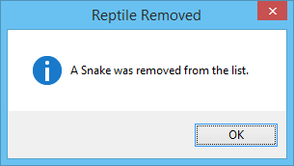

***\*\*Important Note:***

ArrayList collections allow for objects to be removed 3 different ways:

1. ArrayList.Remove Method (Object)
2. ArrayList.RemoveAt Method (Int32)
3. ArrayList.RemoveRange Method (Int32, Int32)

Testing:

Remove the Snake:

MyAnimals.Remove(5);



Remove the Worm:

MyAnimals.RemoveAt(3);

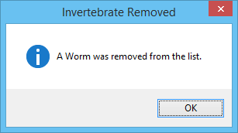

Remove the Eagle and the Bass:

MyAnimals.RemoveRange(1, 2);

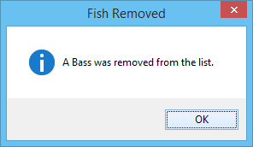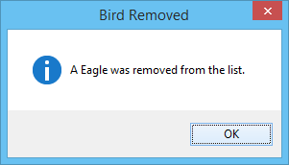

Try and remove an invalid object:

MyAnimals.Remove(5);

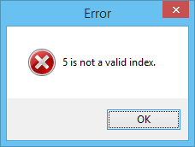

Iterate your MyAnimals collection in order to see what you have left:

foreach (Animal animal in MyAnimals)

{

MessageBox.Show(this, "You still have a " + animal.AnimalName + " (" + animal.AnimalType + ")", "CS559 - Assignment 2", MessageBoxButtons.OK, MessageBoxIcon.Information);

}

