International University of Information Technology

Department of Computer Engineering

**Project work:**

**Creating and analyzing simple block code for text.**

completed by: Kim Vladislav - IT2-2314

Checked by senior lecturer of the Department of Computer Engineering: Daurenbaeva Nurkamilya A

Almaty 2024

**Intorduction:**

Modern web development requires the creation of adaptive, user-friendly and visually appealing interfaces. The main element of web pages is text, which must be properly structured and displayed. An important task for a frontend developer is to apply the correct markup and styles to display text in accordance with the requirements of the project. In this paper, we will consider the process of creating a simple block code for text, which includes the use of HTML for structuring, CSS for styling and analysis of the grammar of the markup language used for this.

**Analysis Of The Terms Of Reference (ТЗ) (10%):**

The technical specification for creating a block code for text implies the following key points:

* Text structuring: The text should be divided into blocks using HTML elements. For example, headings, paragraphs and lists should be decorated with appropriate tags.
* Adaptability: The block code style must be adapted for different screens, which requires the use of media queries.
* Visual Styling: Using CSS to control indentation, alignment, color, and other text parameters.
* Semantics support: Using semantically correct HTML tags to improve SEO and accessibility of content.
* Cross-browser compatibility: The code must be displayed correctly in all popular browsers.

### **Description of grammar and language: The language that is used to mark up block text is HTML (HyperText Markup Language), the fundamental language of web pages. It uses elements in the form of tags to structure text and other elements on the page.**

### 

### The main HTML elements that are used for the block structure of the text:

### <h1> - <h6>: Header tags of various levels, which are used to define the structure of the document.

### <p>: A paragraph tag for formatting text blocks.

### <ul>, <ol>, <li>: Tags for creating unnumbered and numbered lists.

### <div>: A block element used to group elements and control their location on the page.

### CSS (Cascading Style Sheets) is used to style the text and control its display. The main CSS properties for block text include:

### margin, padding: Managing the external and internal margins of text blocks.

### 

### text-align: Align the text.

### color, font-family, font-size: Customize the appearance of the text.

### As a result, the grammar of HTML and CSS together allows you to create structured and stylized text blocks that can be adapted to different devices and screen resolutions.

**The theoretical part (20%):**

1. **The basics of HTML and CSS**

HTML (HyperText Markup Language) is a standard markup language for creating web pages. It serves as the basis for the structure and semantics of the document, which allows browsers to interpret and display content. HTML consists of elements that are represented as tags. These tags are used to identify various parts of a web page, such as headings, paragraphs, and lists. Proper use of these elements allows you to create a clear and accessible document structure.

CSS (Cascading Style Sheets) is a style language that allows developers to control the appearance of HTML documents. He is responsible for the design of the elements, including color, font, margins and alignment. Using CSS helps to create visually appealing and responsive interfaces, which is a key aspect of modern web development.

**2. The structure of the block code**

When creating block code for text, it is important to use the correct HTML tags to ensure the semantics and accessibility of the content. Each element must perform its own function: headings indicate the importance of information, paragraphs are used for text content, and lists help structure data. Proper structure improves the perception of information and makes it more organized.

**3. Adaptability and media requests**

Responsive web design is an approach that allows pages to be displayed correctly on various devices and screens. Adaptability is achieved through the use of media queries, which allow you to change styles depending on the characteristics of the device, for example, the width of the screen. This makes it easier for users to read and navigate, regardless of which device they access the site from.

**4. Semantics and accessibility**

The use of semantically correct HTML tags not only improves the search engine optimization of the site, but also makes it more accessible to users with disabilities. Using the right tags helps screen readers and other assistive technologies correctly interpret the page structure, which is an important aspect of accessible web design.

**Development of system architecture and algorithms (50%)**

The stage includes designing the system: defining the main components (encoding, decoding, interface), describing algorithms (building a Huffman tree, generating codes) and creating diagrams to help understand the structure and operation of the system.

**Implementation of algorithms with demonstration of functionality (70%)**

Implementation of algorithms involves writing and testing code for encoding and decoding, integration of components, testing with different data, as well as preparing a demonstration of the system.

**Code with architecture and algorithms and demonstration functionality:**

Html:

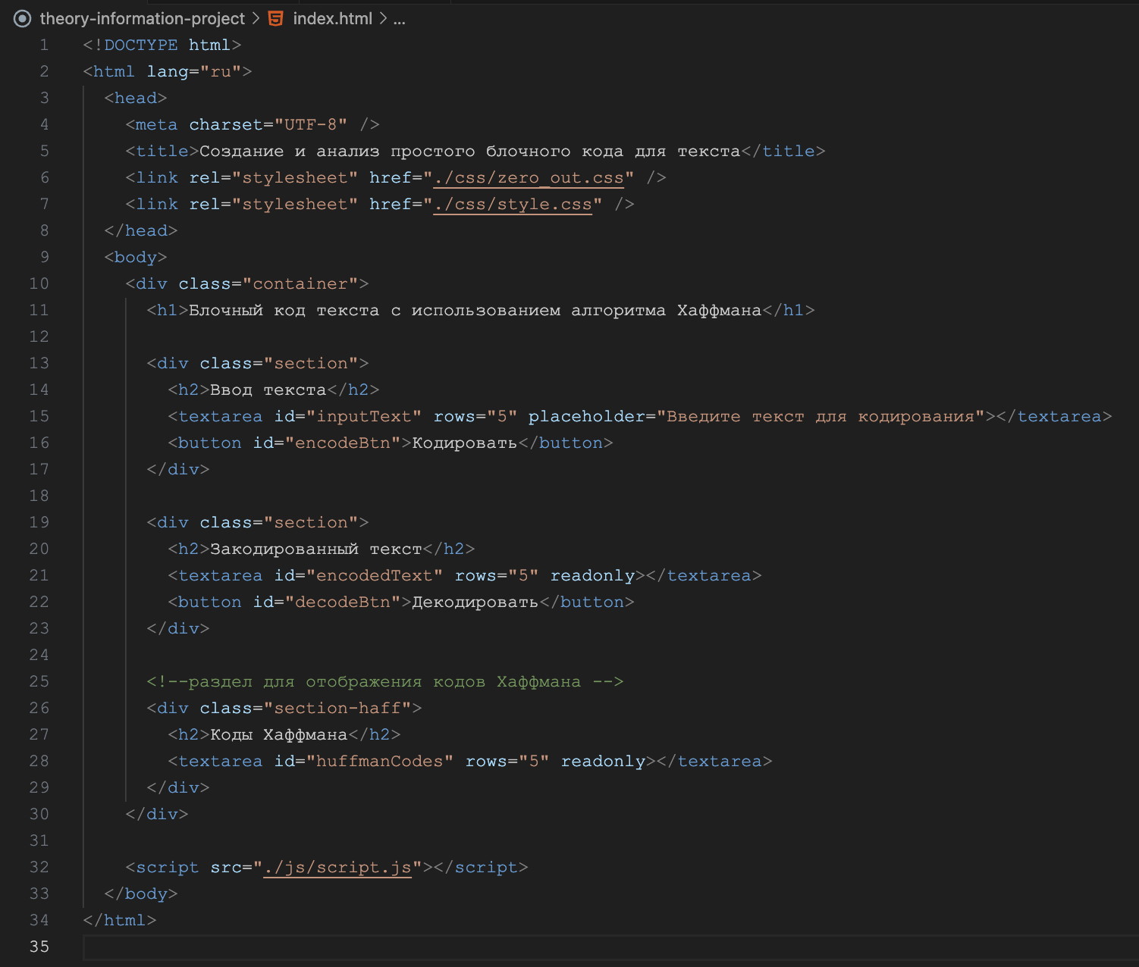

JavaScript + dom

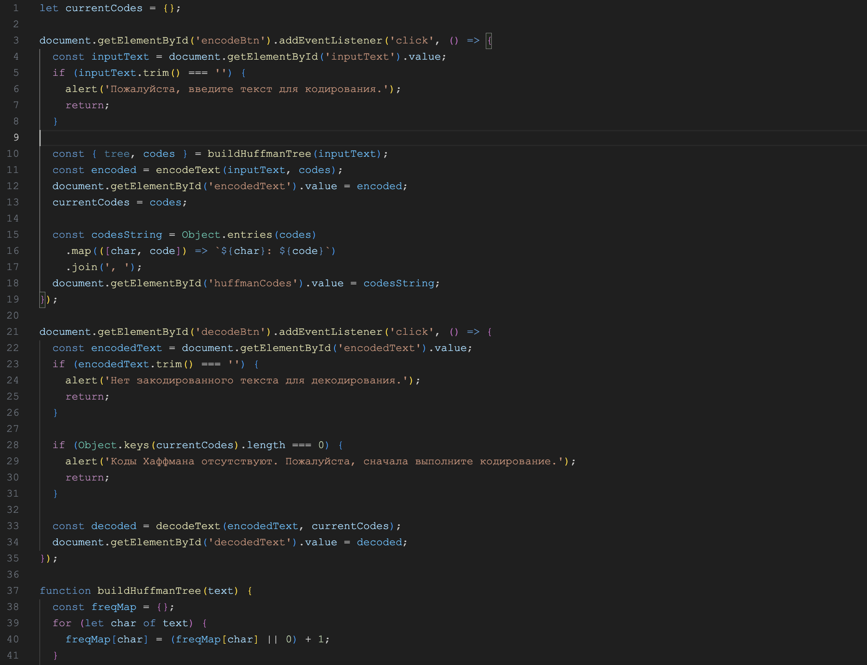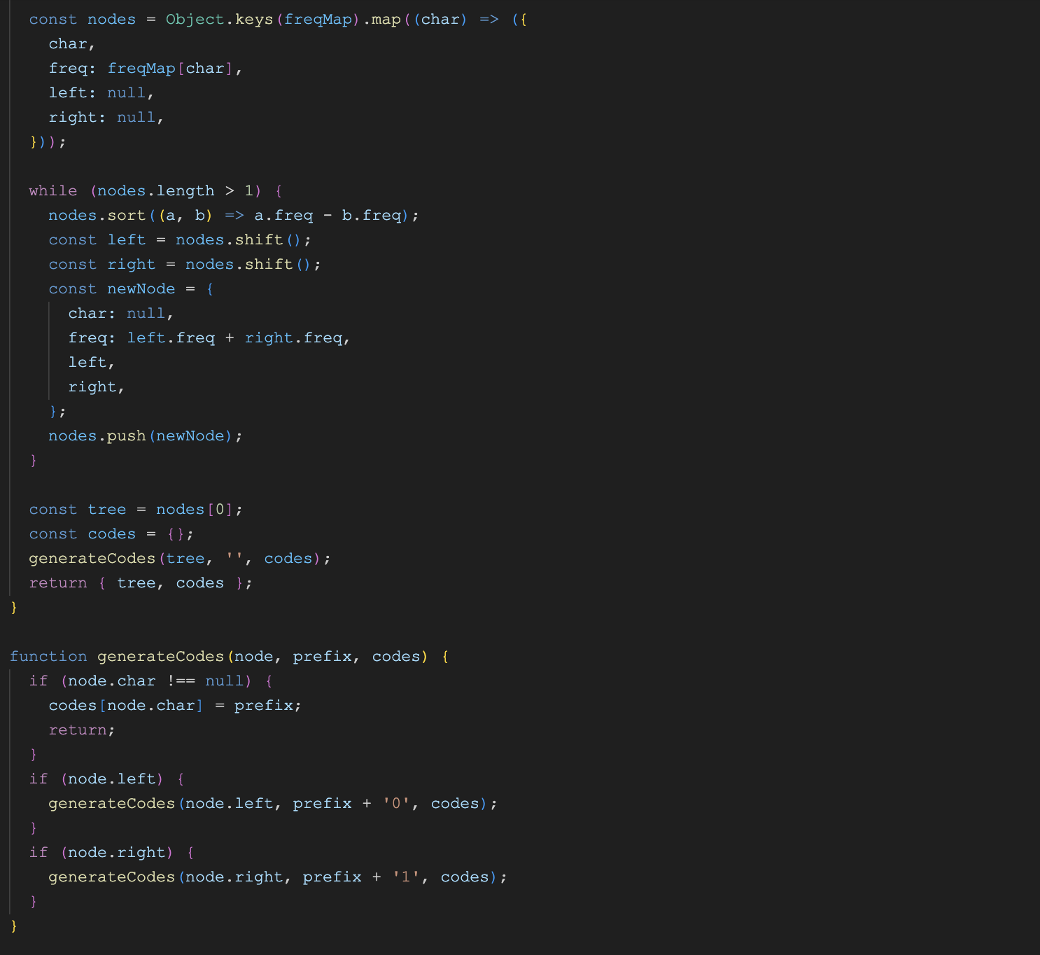 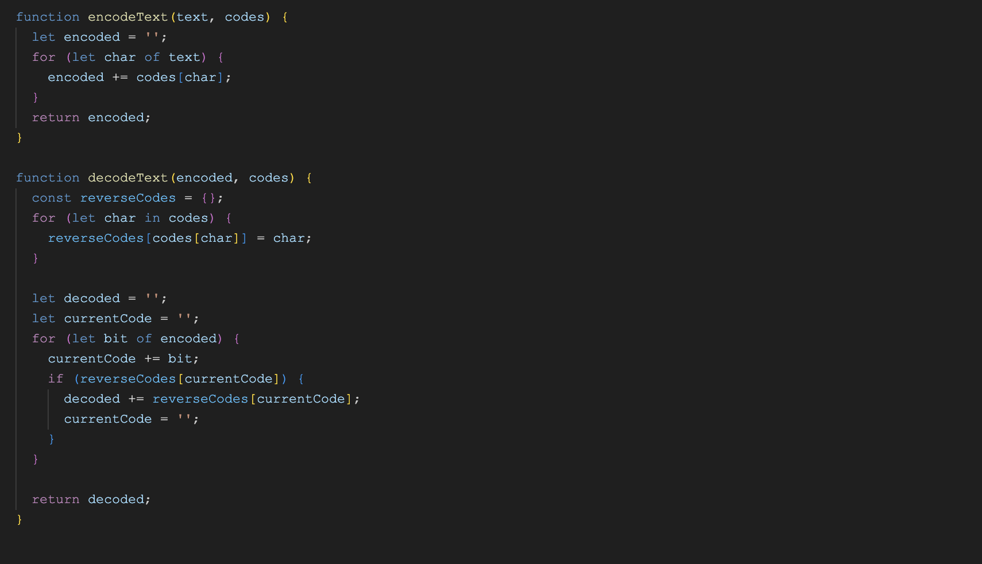

Css :

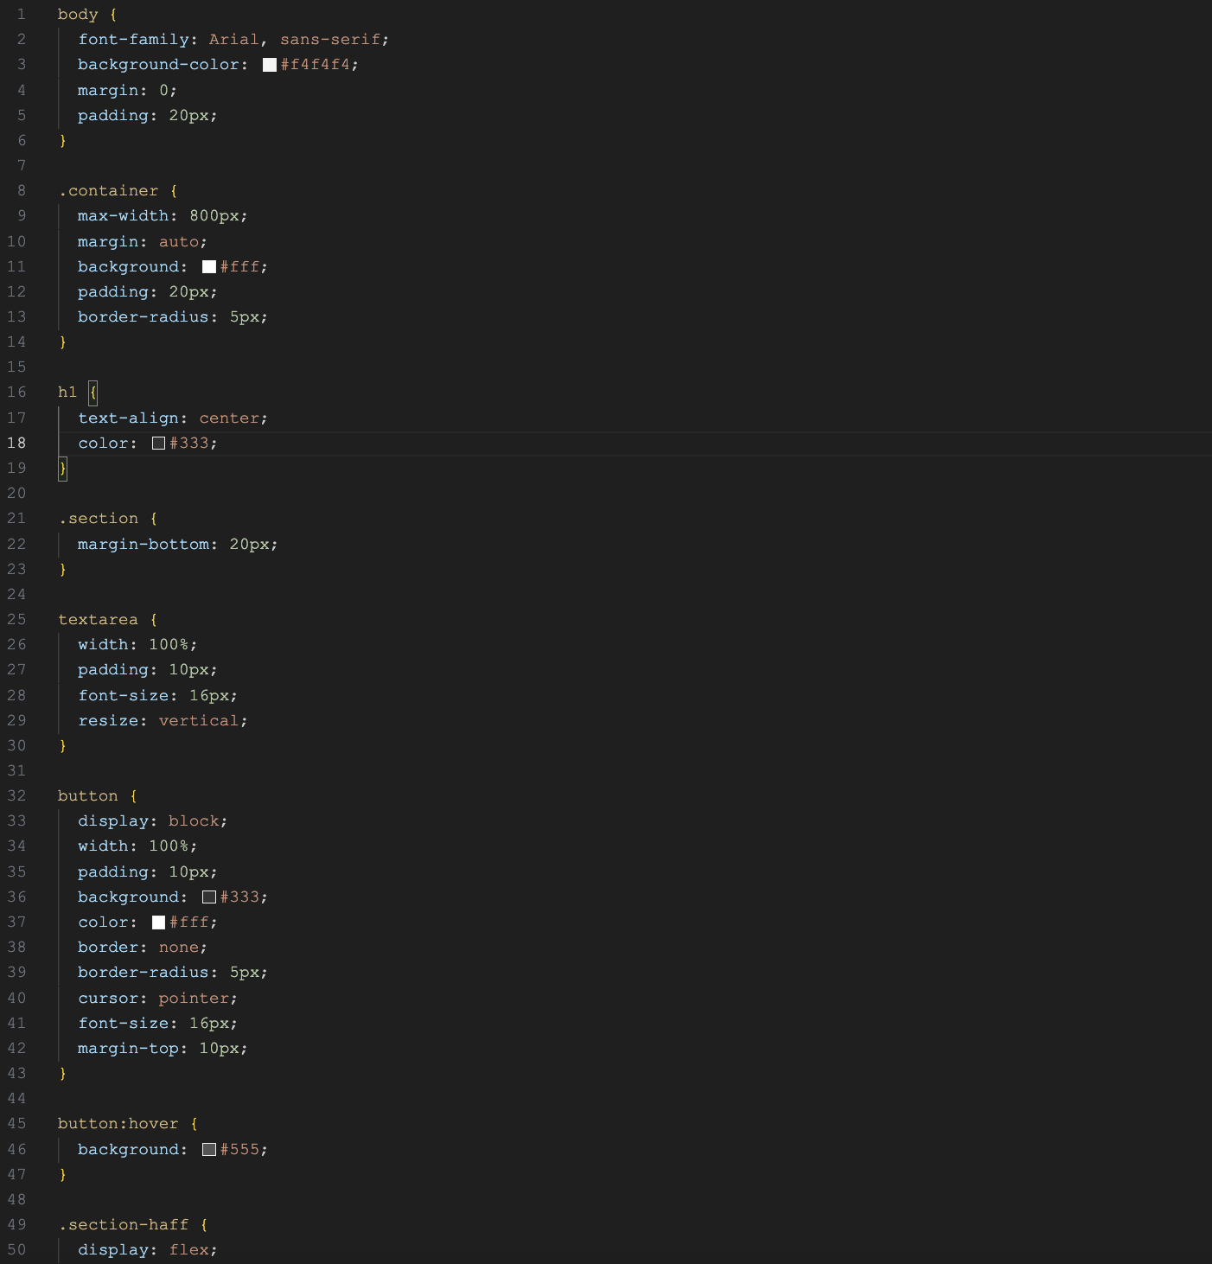

Demonstration functionality:

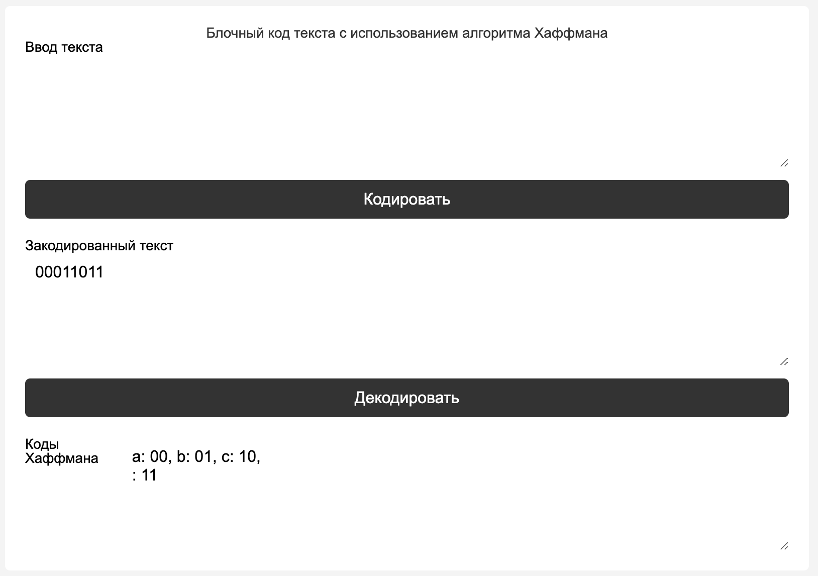

**Testing (90%)**

When you enter an empty line, a window with the inscription "please enter the text for encoding" is displayed:

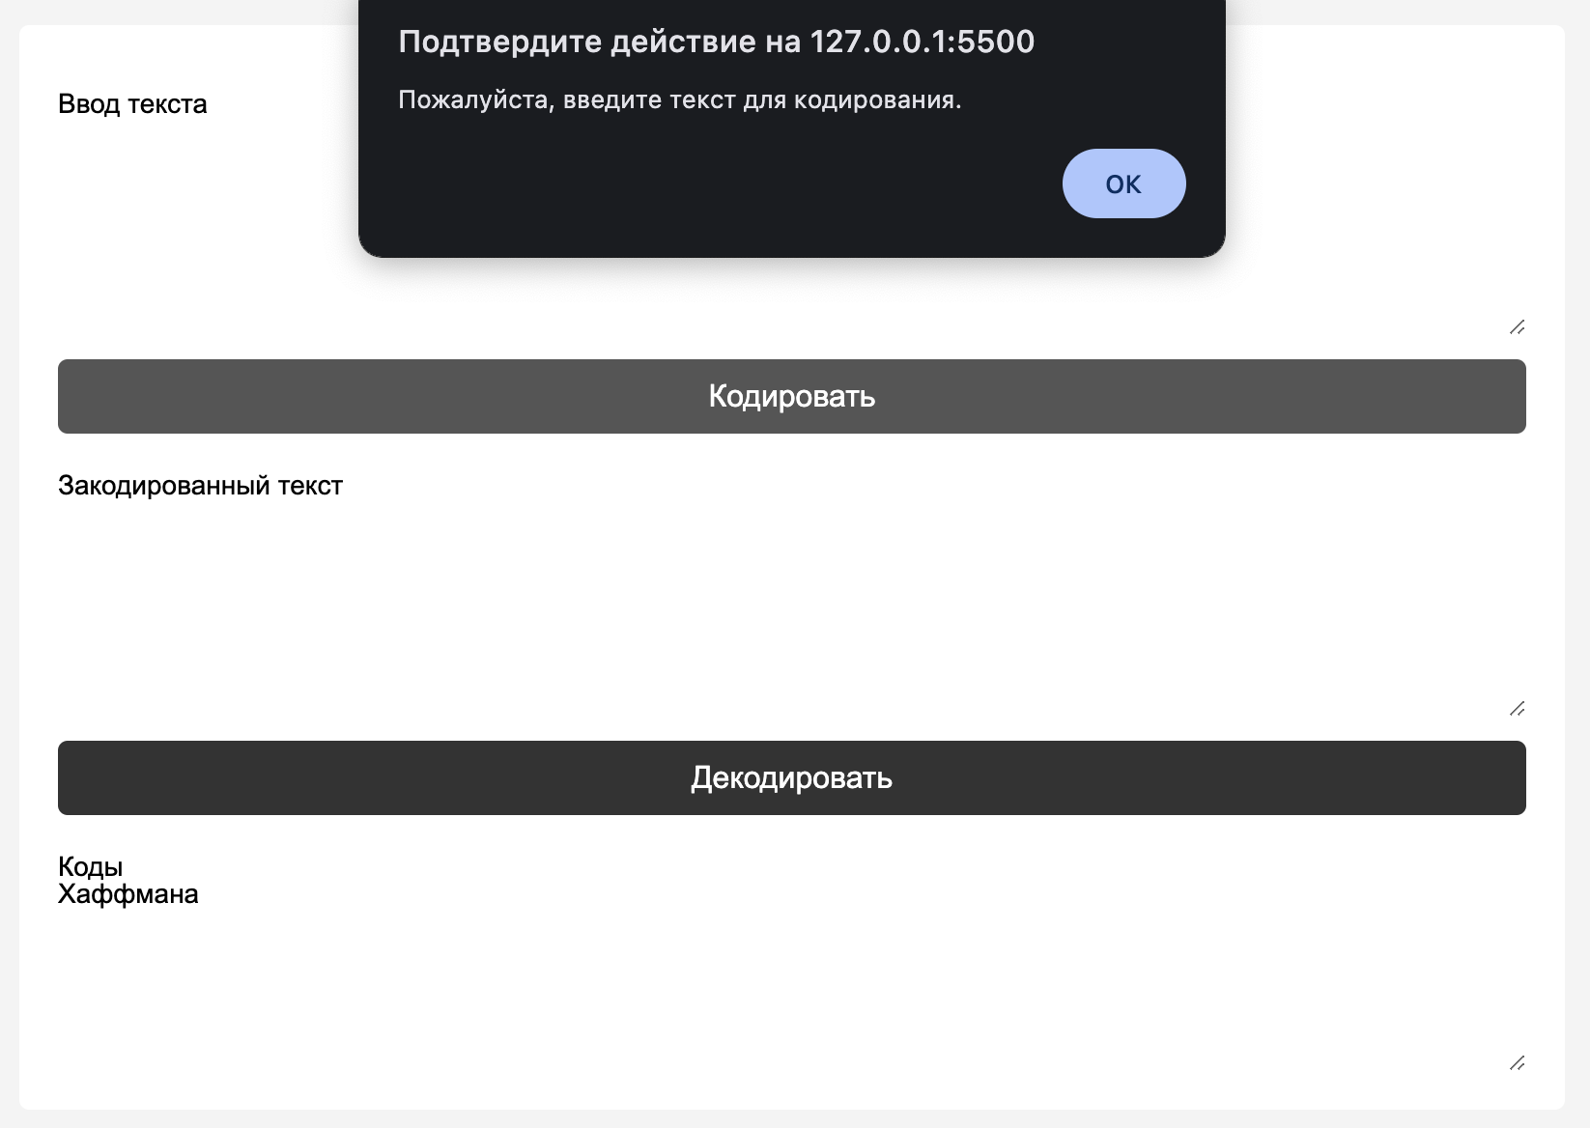

When entering numbers, the code encodes the numbers:

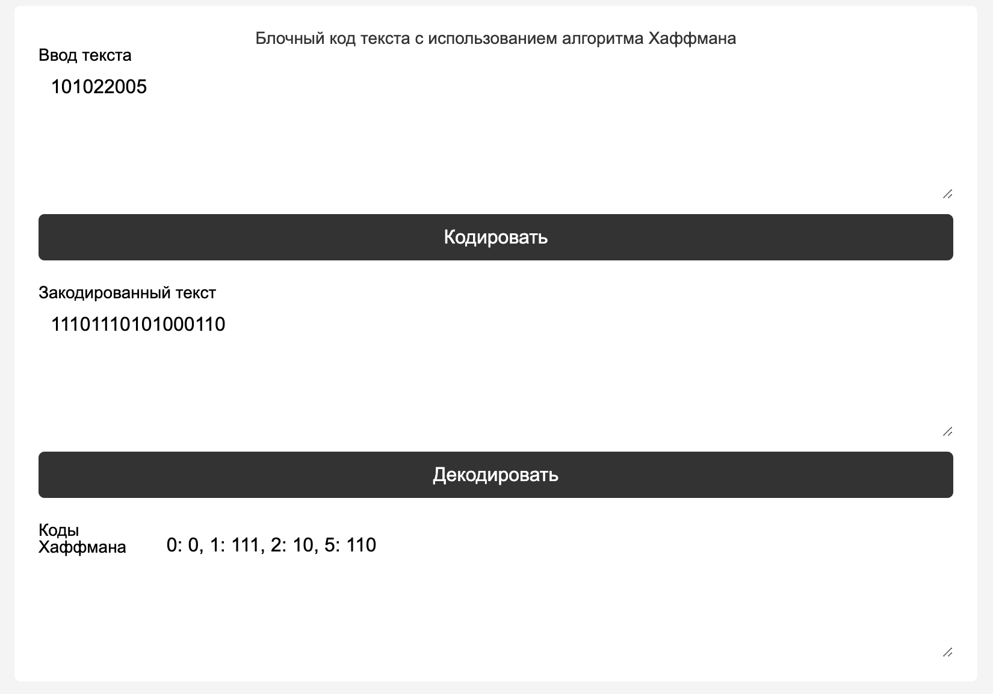

When you enter characters from the Russian alphabet, the encoding still works:

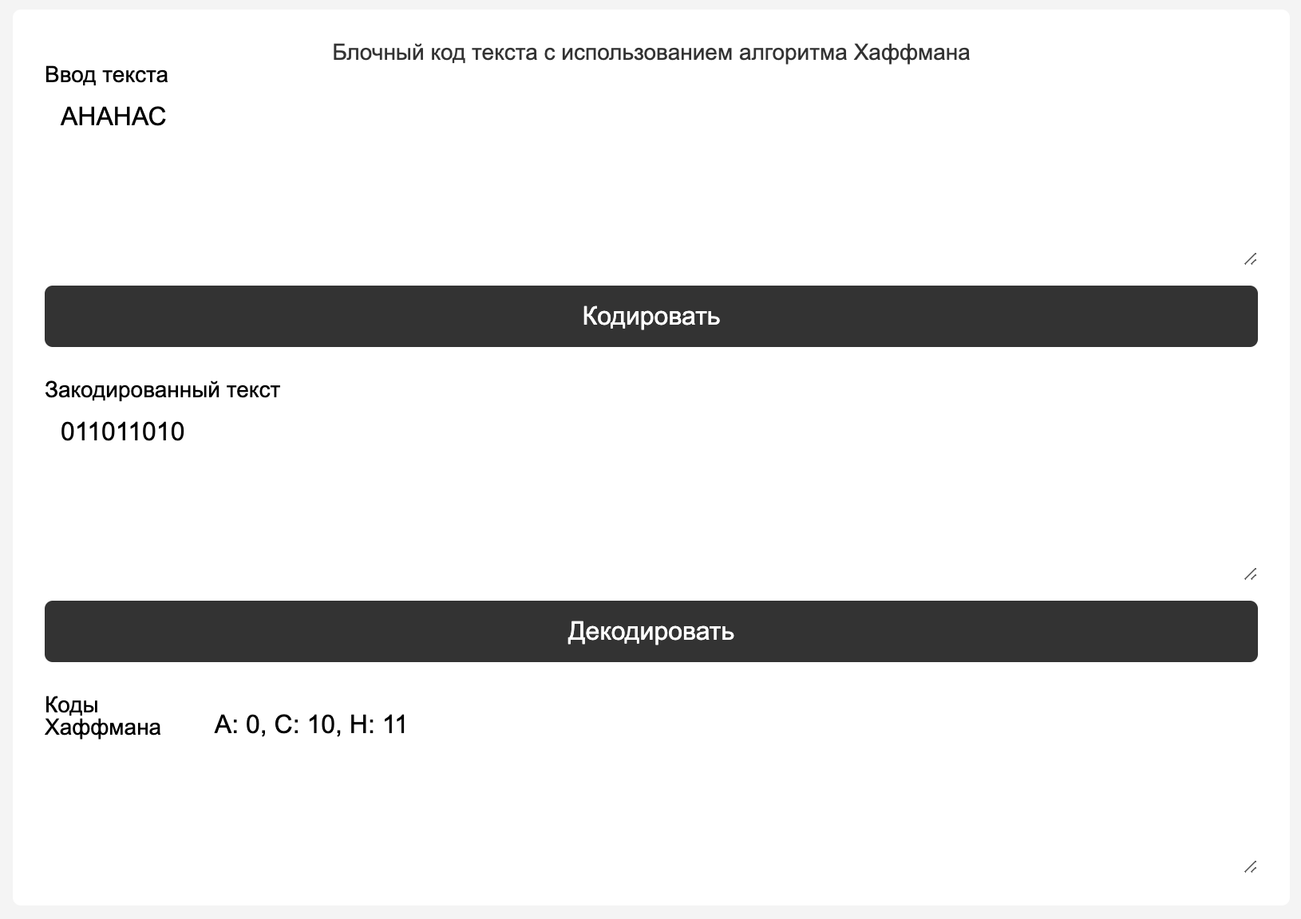

**Conclusion:**

As a result of the project, a text block encoding system using the Huffman algorithm was developed. This system allows you to efficiently encode and decode text, which reduces the amount of stored data and optimizes its transmission. The Huffman algorithm has proven to be reliable for compressing text data, which is confirmed by the results of testing on various input data.