DSF: Personal Loan Form

Personal loan - Alignment with ASB Web – already done

ID | Change | Details
1 | Loan Purpose dropdown options | Change list of options to:  - debt consolidation loan  - car loan  - travel loan  - home improvements loan  - wedding loan (New)  - personal expenses loan
2 | Sentence order | Due to 1.  I would like to borrow [$ 999999] for a [debt consolidation loan]
3 | Establishment fee to be included in calculation | The $25 establishment fee is to be included in the loan calculation.
4 | Copy change for Establishment fee | To be confirmed by legal.
5 | Accept pre-defined calculation parameters from DCMS | The following parameters will be passed from DCMS  - Display name (purpose, for display to user)  - Product request name (expected by API)  - Loan amount  - Term  - Custom repayment amount (customer-selected repayment amount).  - Repayment frequency  - Pre-calculated (if true, skip calculator page)  Note / TODO:  - Need to confirm actual parameter names (preferably no spaces, and consistent terminology – like amount & term rather than loan amount and term).
6 | Validate pre-defined calculation parameters | Parameters passed to PL from a 3rd party (DCMS) need to be validated using the same rules as applied in the calculator page.

Personal loans – other fixes
ID | Change | Details
7 | Remove True Rewards | A customers’ True Rewards accounts should not display under ASB Overdrafts in the ‘Your expenses and debt’ section.
8 | Remove Visa Business | A customers’ Visa Business card should not display under ASB Credit Cards in the ‘Your expenses and debt’ section. This is not to be confused with Visa Business Rewards, which should continue to display.
9 | Allow a customer to enter different frequencies for their income | The current income question (How much do you earn each year?) should allow the user to enter the following 4 frequencies:  - Weekly  - Fortnightly  - Monthly  - Yearly  After/Before tax will be retained and the heading needs to change to ‘How much do you earn?’, see screenshot for details.  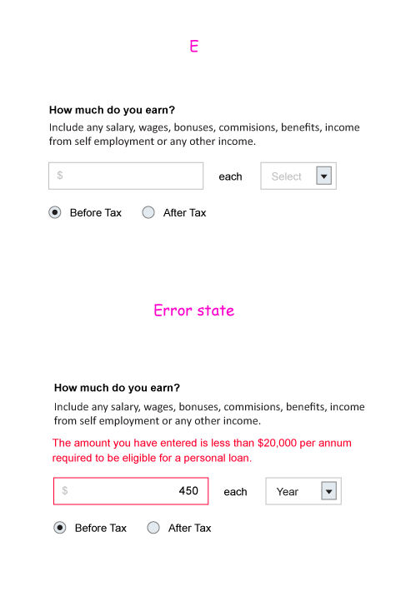
10 | Update the validation on the income field | The income field should validate that the user enters an income that is equal or larger than $20,000 (as confirmed on page 2 of the application).  The validation should be as follows:  - If frequency = weekly, multiply income by 52, must be equal/larger than 20,000  - If frequency = fortnightly, multiply income by 26, must be equal/larger than 20,000  - If frequency = monthly, multiply income by 12, must be equal/larger than 20,000  - If frequency = yearly, income must be equal/larger than 20,000  - before/after tax is disregarded for the validation  The error message should be: The amount you have entered is less than $20,000 per annum required to be eligible for a personal loan.
11 | Make the headings dynamic for Other loans, credit cards and mortgages. | As we prepopulate existing ASB information for loans, credit cards and mortgages, the headings for ‘other’ loans, credit cards and mortgages currently read: Do you have any other <product>? This sentence only makes sense, if the user has ASB products in this category, but not if they don’t.  Ideally we’d like to display separate headings for each of the categories, depending on whether the customer has existing ASB accounts or not. The headings should be:  Existing ASB accounts (as per current):  - Do you have any other <product>?  - Products are:  - credit cards  - loans or debts  - mortgages  No existing ASB accounts:  - Do you have any <product>?  - Products are:  - credit cards  - loans or debts  - mortgages
11a | Change copy on ‘do you qualify’ page ‘It's easy to apply for an individual personal…’ | Change to:  It's easy to apply for a personal loan with us and should take less than 15 minutes. Complete this form for your individual application, for joint applications please call 0800 272 662.<br>Please have the following information handy:
11b | Calculator loan purpose font | 'enter an amount' should be #999999 in all browsers, #000000 in FF and #757575 in IE.
11c | Width of loan_years dropdown is 24, width of loan_months dropdown is 35. | Introduce separate classes for loan_years and loan_months. Add padding-right of 11px to loan_years only.
11d | Calculator: Tip: Try different combinations to find the loan that suits you | Remove this copy
11e | Change the layout of the calculator – see image | - Change label on button to: Start application  - Move the button to the bottom of the page  - Move ‘An ASB personal loan can be …’ to the top of the page  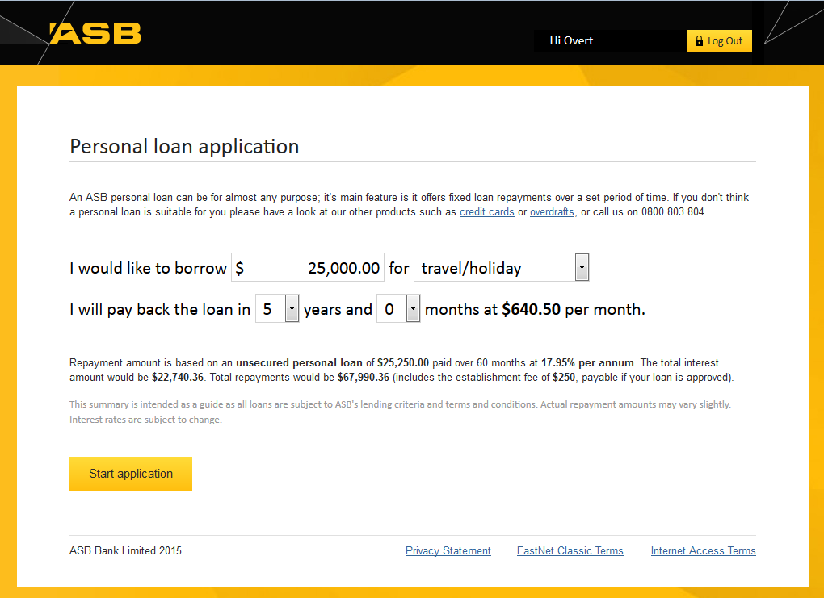
11f | Header | Add a ‘Hi’ in front of the first name
11g | "Do you have any other savings or investments?" | New logic required:  a) If customer has 0 Current ASB Accounts, show question text of "Do you have any savings or investments?"  b) If customer has 1+ Current ASB Accounts, show question text of "Do you have any other savings or investments?"
11h | Change copy for  "Do you own a vehicle(s)?" | Change to: Do you own any vehicles?
11i | Checkbox [agreeCreditCheck]  Move to page 2 (do you qualify) | - Add the agree to a credit checkbox to page 2 and remove the last page  - Progress bar should be one step less (4)  - Change "I have a regular income of $20,000 per annum" to "I have a regular income of at least $20,000 per annum"  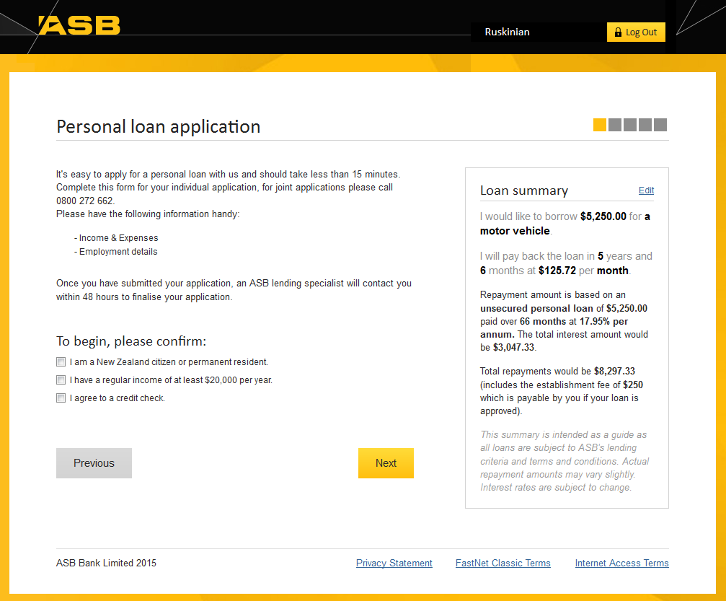
11j | Error message copy for  "The personal loans application form is currently unavailable. Please call 0800 783 724." | Change to:  "The personal loans application form is currently unavailable. Please try again later or call 0800 783 724 and we will progress your loan application over the phone."
11k | Change loan purposes | Reduce the loan purposes selectable to:  - Car loan  - Debt consolidation loan  - Personal loan
11l | Update links in footer | Privacy Statement should point to:  - https://www.asb.co.nz/fnc-privacy  Internet access should point to:  - https://www.asb.co.nz/story949.asp  FastNet Classic Terms should point to:  - https://www.asb.co.nz/story634.asp

Personal loans – SiteCat fixes
ID | Change | Details
12 | Move location of Event 5 (form viewed event) | Should be triggered on the first page of the form viewed. This is dependent on what property the customer comes from  FNC & mojo: customer’s land on calculator page  Asb.co.nz: Customer’s bypass calculator page and land on second page
13 | Serialize Events 5,6 & 9 | As per previously implemented.
14 | Update evar10 & prop10 on calculator page | Currently on evar10 & prop10 on calculator page is “personal loan:”  Please update to: “personal loan:undefined” This is the way it is done on the CALs form
15 | Validation- on error page | Can it be confirmed what happens if the thank you page displays an error message (is event 6 still firing)
16 | Move location of event 6 | To be triggered on second page of customer journey dependent on where they started.
17 | Classify source properties (evar11) that are online.asb.co.nz | Is #3 from asb mobile website? If so can we classify that seperately than asb.co.nz  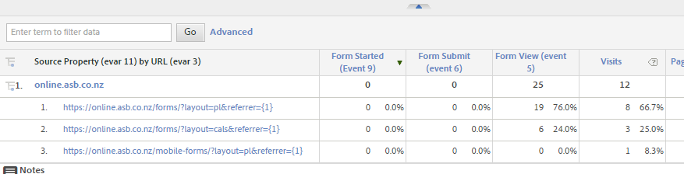  https://sc2.omniture.com/x/5hffv
18 | Add evar16 to every page | Set equal to pagename

CALs fixes
ID | Change | Details
19 | Back to FNC should be dynamic based on goto URL | Back to FNC function not working in QA as the form is hard-coding the long-form URL to /fnc/. Needs to derive the appropriate junction from the gotoURL.
20 | Header | Add a ‘Hi’ in front of the first name
20a | Update links in footer | Privacy Statement should point to:  - https://www.asb.co.nz/fnc-privacy  Internet access should point to:  - https://www.asb.co.nz/story949.asp  FastNet Classic Terms should point to:  - https://www.asb.co.nz/story634.asp

CAL – SiteCat fixes
ID | Change | Details
21 | Serialize Events 5,6 & 9 | As per previously implemented.
22 | Validation- on error page | Can it be confirmed what happens if the thank you page displays an error message (is event 6 still firing)
23 | Add evar 16 to everypage | Set to same value as pagename
24 | Classify source properties (evar11) that are online.asb.co.nz | Is #3 from asb mobile website? If so can we classify that seperately than asb.co.nz  https://sc2.omniture.com/x/5hffv

