CS7643: Deep Learning
Problem Set 0

Instructor: Zsolt Kira
Due: Jan 18th, 2026 8:00AM ET

1. We are machine learners with a slight gambling problem (very different from gamblers with a machine learning problem!). Our friend, Bob, is proposing the following payout on the roll of a dice:

$2 x = 1
payout = -$1/4 x ≠ 1

where x Ɛ 1; 2, 3, 4, 5, 6 is the outcome of the roll, (+) means payout to us and (-) means payout to Bob. Is this a good bet i.e. are we expected to make money?

Answer: True.
Expected value = (1/6)(2) + (5/6)(-0.25)
= 0.125 > 0.

2. X is a continuous random variable with the probability density function:

p(x) = 4x 0 ≤ x ≤ 1 = 2
-4x + 4 1/2 < x ≤ 1

Which of the following statements are true about equation for the corresponding cumulative
distribution function (CDF) C(x)?
[Hint: Recall that CDF is defined as C(x) = Pr(X ≤ x).]

Answer: All of the above.

3. A random variable x in standard normal distribution has the following probability density

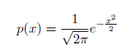
Evaluate following integral

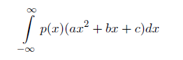

[Hint: We are not sadistic (okay, we’re a little sadistic, but not for this question). This is not
a calculus question.]

Answer: a + c

4. Consider the following function of x = (x1, x2, x3, x4, x5, x6):

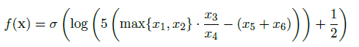

where _ is the sigmoid function

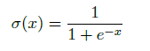

Compute the gradient and evaluate it at x̂=(-1,3,4,5,-5,7).

Answer:

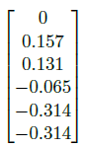

5. Suppose your machine learner friend trains two classification models A and B on the same data set. Their training routine produces the following learning curves. You are told one of the models has higher model complexity (by some sufficient definition of model complexity). Generally this would lead us to believe which of the following is True?

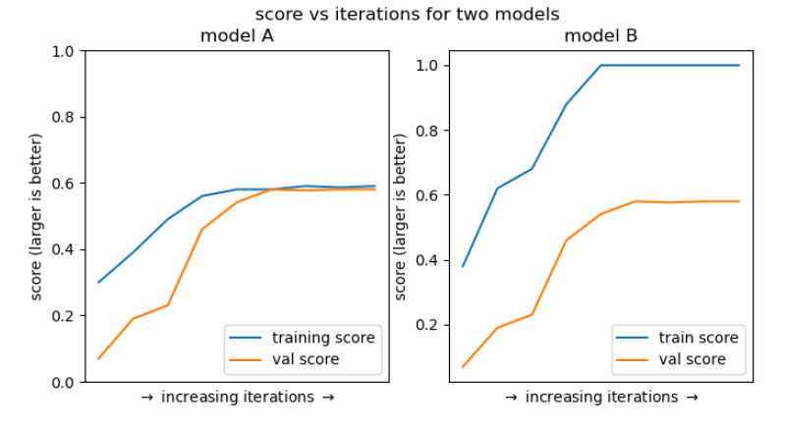

Answer: Model B complexity > Model A complexity.

6. Which of the following functions are convex?

Answer: 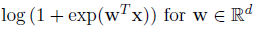

7. Suppose you want to predict an unknown value Y 2 R, but you are only given a sequence of noisy observations x1; xn of Y with i.i.d. noise (xi = Y + _i). If we assume the noise is I.I.D. Gaussian (_i _ N(0; _2)), the maximum likelihood estimate (^y) for Y can be given by:

Answer: Both A & C

PROOFS

This proof section is optional but highly encouraged.

8. Prove that

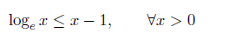

with equality if and only if x = 1.
[Hint: Consider differentiation of log(x) 􀀀 (x 􀀀 1) and think about concavity/convexity and second derivatives.]

Answer:

Let
$$f(x)=log⁡x-(x-1)$$
Then
$$f^{'}(x)=\frac{1}{x}-1$$
Set $f^{'}(x)=0$:
$$\frac{1}{x}-1=0⇒x=1$$
Also,
$$f^{''}(x)=-\frac{1}{x^{2}}<0$$
so $f(x)$is concave and $x=1$is its maximum. At $x=1$,

$$f(1)=log⁡1-(1-1)=0$$
Therefore,
$$f(x)≤0$$
which means
$$log⁡x-(x-1)≤0$$
so
$$log⁡x≤x-1$$
Equality holds only when $x=1$.

