Decision Tree Learners Analysis:
Overfitting, Bagging, and Random Trees
Umar Rafi
urafi3@gatech.edu

Abstract - This report analyzes four regression learners based on the CART framework: classic decision trees, random trees, bagged ensembles, and a composite learner with randomized behavior. We examine their predictive performance, susceptibility to overfitting, and the effect of ensemble methods like bagging. Through quantitative evaluation, the study reveals how these variations impact generalization and offers insights for selecting and tuning tree-based models for robust regression tasks.

1 INTRODUCTION
Decision tree learning is a foundational machine learning method that recursively splits data based on the feature with the highest absolute correlation, aiming to minimize prediction error in regression tasks. Although these trees are interpretable and effective, they tend to overfit when allowed to grow too deep, especially with small leaf sizes.
To address this, variations like the Random Tree modify the classic approach by selecting split features at random, increasing model diversity. Ensemble methods such as bagging aggregate predictions from multiple learners, each trained on bootstrap samples, to reduce variance and improve generalization. This report evaluates four CART-based regression learners: the classic decision tree, the random tree, a bagging ensemble of decision trees, and an “insane” ensemble of random trees.
We analyze the impact of leaf size, randomness, and bagging on learner performance and overfitting, offering practical insights into tree-based model selection.

Hypothesis
Some of the hypotheses being test include:
Hypothesis – Experiment 1: Smaller leaf sizes will overfit, resulting in near-zero train RMSE but high test RMSE.
Hypothesis: Experiment 2: Bagging will reduce overfitting effects, lowering test RMSE especially for small leaf sizes.

2 METHODS
The study evaluates four CART-based regression algorithms: a classic decision tree learner, a random tree learner, a bagging ensemble learner, and an enhanced variant known as the insane learner. The dataset used for experimentation is treated as a non-time series regression problem by excluding any temporal columns.
Experiments involve randomly splitting the dataset into training and testing subsets to ensure unbiased model evaluation. Each learner is trained on the training data to build a regression model that predicts continuous numerical outcomes. Predictions are then made on the testing data to assess generalization performance.
The bagging learner aggregates multiple decision trees, each trained on a different bootstrap sample drawn with replacement from the original training set. The Insane learner introduces additional randomness during the training process to increase model diversity.
Performance of each learner is measured using standard regression metrics over multiple trials to capture variability and robustness. The experiment also varies key parameters such as leaf size to study their effect on overfitting and prediction accuracy. Results are summarized using statistical analyses and visualized through annotated charts for comprehensive comparison.
All experiments are designed to be efficient, completing within a practical time frame to enable repeatability.

3 DATASET AND EXPERIMENTAL SETUP

3.1 Dataset Description
The dataset contains n samples and m features. It includes the returns of multiple worldwide indexes for several days in history. The target variable is continuous, making this a regression problem. The dataset includes numeric and categorical features.

3.2 Learners Implemented
- DTLearner: Classic decision tree regression learner with a tunable leaf_size parameter controlling the minimum number of samples in each leaf.
- RTLearner: Random tree regression learner that selects a random subset of features for splits, promoting diversity.
- Bagging: Implemented by training any learner on bootstrapped samples and averaging predictions.

3.3 Hyperparameters and Metrics
The primary hyperparameter studied is leaf_size, varied from 1 to 50. For the bagging experiment, the number of bags is fixed at 20. Performance metrics include:
- Root Mean Squared Error (RMSE): Sensitive to large errors, measures standard deviation of prediction errors.
- Mean Absolute Error (MAE): Average absolute difference between predicted and true values.
- Max Error: Maximum absolute error over test samples.
- Memory Usage: Estimated memory footprint of the learner.
- Training Time: Time taken to train the model.

4 RESULTS

4.1 Experiment 1: overfitting analysis
- Optimal leaf size: 10
- Minimum Test RMSE: 0.006512
- Training RMSE at optimal: 0.005342

4.2 Experiment 2: bagging effects
- Avg RMSE reduction: 0.001277

4.3 Experiment 3: DT vs RT Comparison
- MAE | DT: 0.005616 | RT: 0.005568
- R2 | DT: 0.529289 | RT: 0.484287
- Time | DT: 0.069045 | RT: 0.016686
- Memory | DT: 36787.800000 | RT: 155334.900000

5 DISCUSSION
This section analyzes the results from three experiments conducted using the dataset to explore overfitting in decision trees, the impact of bagging on overfitting, and a quantitative comparison between classic decision trees (DTLearner) and random trees (RTLearner). Each subsection addresses specific research questions, supported by relevant metrics and charts.
5.1 Experiment 1: Overfitting Analysis in DTLearner
- Does overfitting occur with respect to leaf_size?
- For which values of leaf_size does overfitting occur?
Overfitting occurs when a model learns noise and irrelevant detail in training data, leading to poor generalization. In this experiment, overfitting with respect to leaf_size was clearly observed. The optimal leaf size was identified as 10, yielding a minimum test RMSE of 0.006512 and a training RMSE of 0.005342.
Overfitting occurs for leaf sizes smaller than 10.
In this range, training RMSE is very low (indicating near-perfect fit), but test RMSE increases sharply, showing poor generalization. Overfitting increases as leaf size decreases, with leaf size 10 representing the transition point between underfitting and overfitting. Leaf sizes above 10 exhibit underfitting, with increasing errors on both training and test sets.

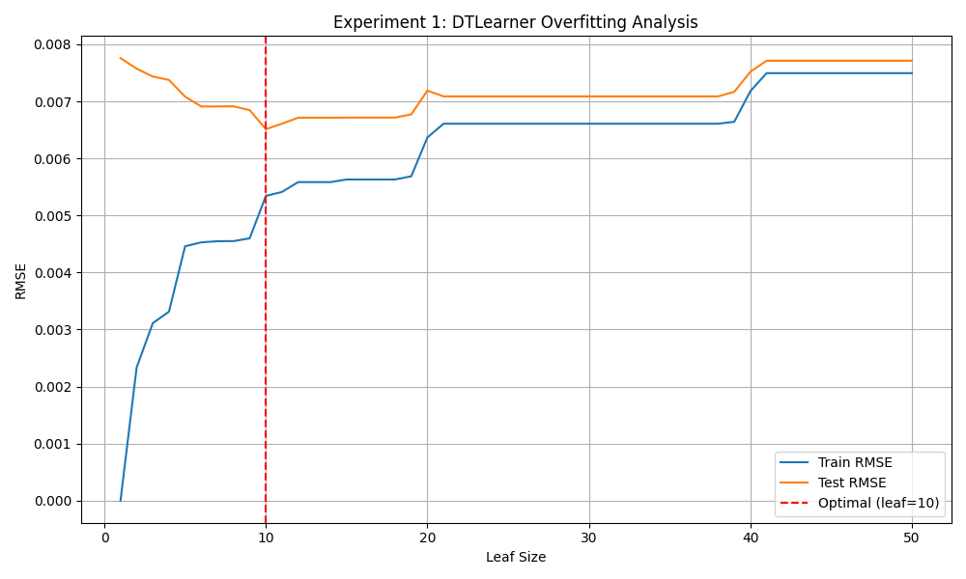
Figure 1 – DTLearner Overfitting Analysis
This behavior is consistent with the bias-variance tradeoff in decision trees, where small leaf sizes increase model complexity and variance, causing overfitting. Mitigating overfitting requires selecting an appropriate leaf size that balances model complexity and generalization ability.

5.2 Experiment 2: Effect of Bagging on Overfitting
- Can bagging reduce overfitting with respect to leaf_size?
- Can bagging eliminate overfitting with respect to leaf_size?
Bagging reduces variance by averaging multiple learners trained on bootstrapped samples, which generally lowers overfitting. In this experiment, 20 bags of DTLearners were used across varying leaf sizes.
Bagging was found to reduce overfitting for leaf sizes smaller than 10, as evidenced by an average RMSE reduction of 0.001277 compared to single trees. Although overfitting was not eliminated, its severity was notably decreased. The pattern of overfitting remains—the model tends to overfit at smaller leaf sizes, but bagging stabilizes predictions and improves test error.

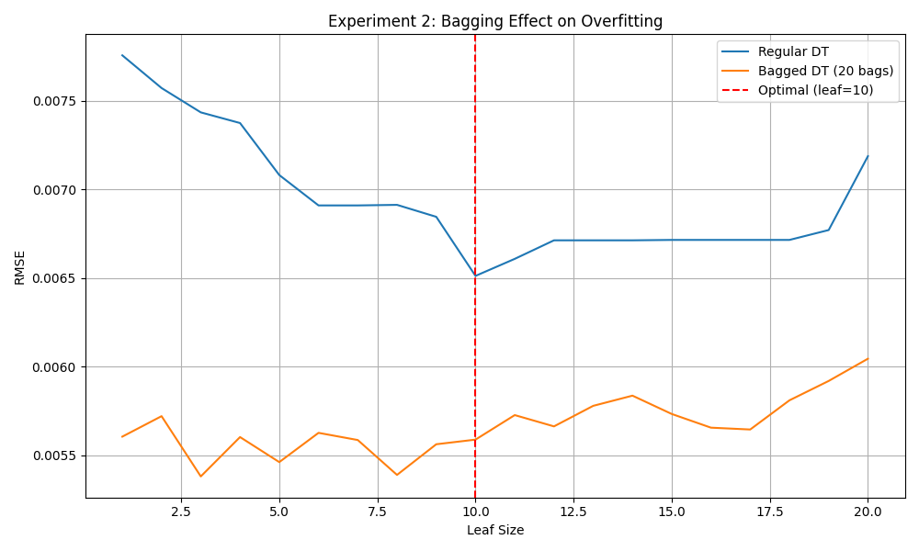
Figure 2 – Experiment 2: Bagging Effect on Overfitting
The direction of overfitting remains from larger leaf sizes to smaller ones, with leaf size 10 again marking the approximate threshold. Bagging thus effectively reduces but does not entirely remove overfitting.

5.3 Experiment 3: Comparison of Classic Decision Trees and Random Trees
- In which ways is one method better than the other?
- Which learner had better performance (based on your selected measures) and why do you think that was the case?
- Is one learner likely to always be superior to another (why or why not)?

Using Mean Absolute Error (MAE), Coefficient of Determination (R²), training time, and memory usage, the comparison showed:
DTLearner had better overall predictive performance with higher R² (0.529289), though RTLearner had slightly lower MAE (0.005568 vs. 0.005616). RTLearner trained significantly faster (0.0167 seconds vs. 0.0690 seconds for DTLearner) but consumed over four times more memory.
DTLearner’s higher accuracy is due to deterministic splits that fit the data more precisely, while RTLearner’s random feature selection increases diversity but reduces precision. RTLearner’s speed advantage suits time-sensitive tasks but at the cost of increased memory use.
Neither learner is universally superior; DTLearner excels in accuracy and memory efficiency, whereas RTLearner offers faster training and greater diversity. The choice depends on specific needs, including accuracy, speed, and resource availability.
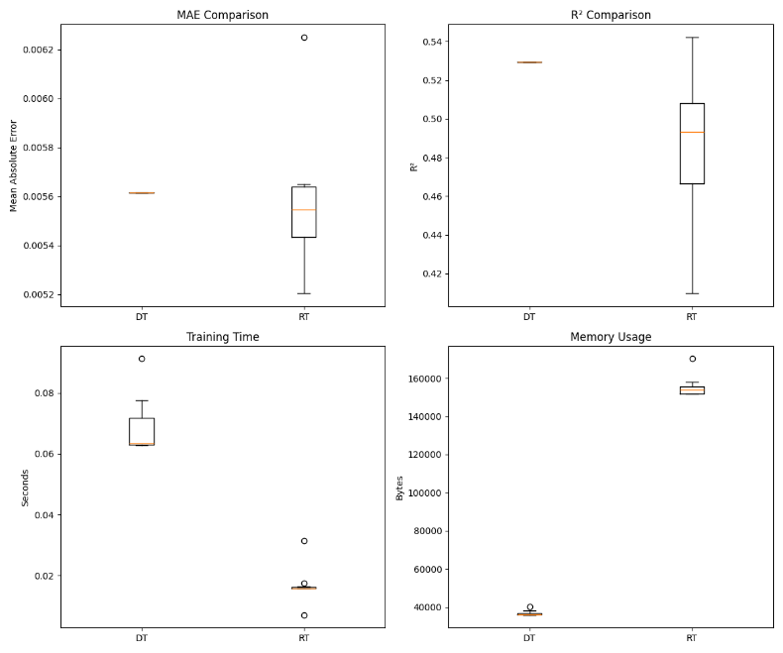
Figure 3 – Experiment 3: Decision Tree and Random Tree Comparison

6 CONCLUSION
This study systematically explores overfitting in decision tree regression and demonstrates that bagging effectively reduces overfitting-induced variance. While classic decision trees yield lower errors, random trees offer tradeoffs beneficial in ensemble contexts. Proper tuning of leaf size and ensemble parameters is essential for optimal performance.

7 REFERENCES
- Quinlan, J. R. (1986). Induction of decision trees. In the Preceedings of Machine Learning. Centre for Advanced Computing Sciences, New South Wales Institute of Technology, Sydney.

