  - Technical Indicators and Theoretically Optimal Strategy Analysis
  - Umar Rafi
urafi3@gatech.edu

Abstract— This report analyzes five key technical indicators—Simple Moving Average (SMA), Exponential Moving Average (EMA), Momentum, Bollinger Bands, and MACD (Moving Average Divergence)—to evaluate their effectiveness in stock trend analysis and trade signal generation. Using JPM stock data from 2008–2009, each indicator is mathematically defined, interpreted, and visualized. Additionally, a Theoretically Optimal Strategy assuming perfect future price knowledge is implemented as a benchmark. Performance comparison reveals the potential upper bound of trading returns. This study provides foundational insights for developing data-driven trading strategies and demonstrates the practical use of technical indicators in financial analysis.

INTRODUCTION
In the ever-evolving landscape of financial markets, traders and analysts constantly seek methods to extract insights from historical data to make informed decisions. Technical indicators, which are mathematical constructs derived from price and volume data, offer a systematic way to identify trends, momentum shifts, and potential turning points in asset prices.
The motivation behind this work lies in understanding how these indicators can be used to develop rule-based trading strategies. By studying market behavior during volatile periods, such as the 2008 financial crisis, we can evaluate the reliability and interpretability of technical signals. Furthermore, comparing realistic strategies with a theoretically optimal trading approach highlights the performance limits achievable under perfect foresight.

TECHNICAL INDICATORS
This section examines five widely used technical indicators—Simple Moving Average (SMA), Exponential Moving Average (EMA), Momentum, Bollinger Bands, and Moving Average Convergence (MACD) applied to JPMorgan Chase (JPM) stock data from January 2008 to December 2009. Each indicator is mathematically defined, its practical purpose explained, and its buy/sell signal logic discussed. Each is illustrated with a corresponding chart.
2.1 Simple Moving Average (SMA)
The Simple Moving Average smooths historical prices by computing the unweighted mean over a defined rolling window:
$$SMAₜ = (1⁄n) × ∑ⁿ⁻¹ᵢ₌₀ Pₜ₋ᵢ$$
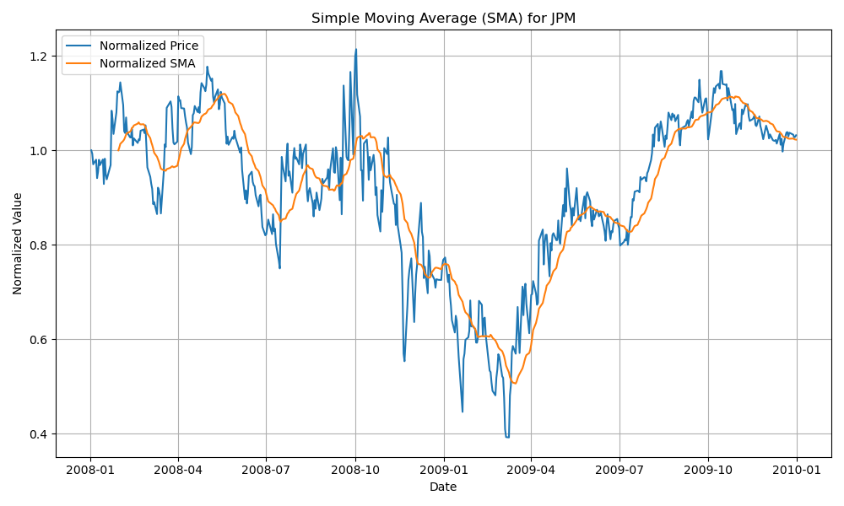
Here, P_{t} is the price on day t, and n is the window size (e.g., 20 days). SMA highlights long-term price trends and reduces market noise. A price crossing above the SMA indicates potential upward momentum (buy signal), while a cross below the SMA suggests a trend reversal or decline (sell signal). SMA’s delayed responsiveness makes it more effective when combined with quicker indicators.
Figure 1 - Simple Moving Average (SMA) Indicator Chart
2.1.1 Trade Decision / Strategy
A long position is triggered when the price crosses above the SMA, signaling an uptrend, while a short position occurs when the price crosses below, indicating a downtrend. If the price remains near the SMA without a clear crossover, holding cash helps avoid false signals. Trade decisions can be confirmed using other indicators such as Momentum or MACD. To reduce noise, trades are only executed if the price stays consistently above or below the SMA for several days, filtering out minor fluctuations. For visualization, the chart (in Figure 1) displays the normalized price and SMA lines, (and optionally the price-to-SMA ratio,) all scaled to 1.0 at the start of the period to make comparisons clear and intuitive.
2.2 Exponential Moving Average (EMA)
EMA emphasizes recent prices using the recursive formula.
EMAₜ = α·Pₜ + (1 − α) ·EMAₜ₋₁; where α = 2⁄ (n + 1)
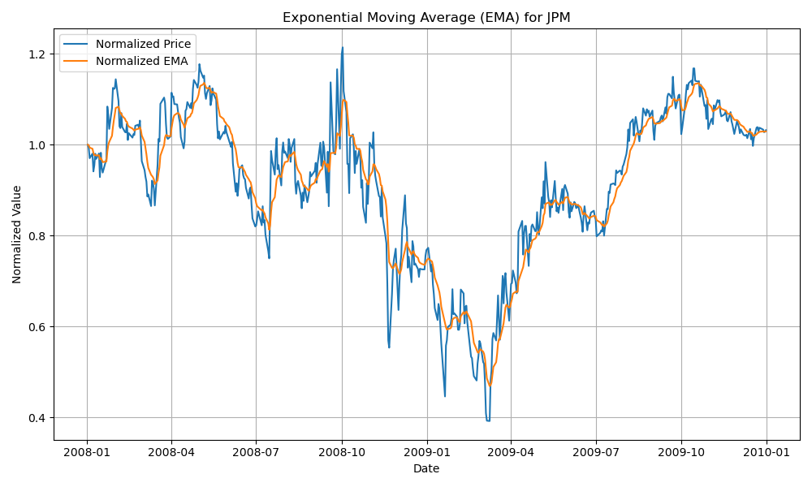
EMA reacts more quickly to price changes than SMA. A crossover above the EMA line may indicate bullish conditions, while a crossover below suggests bearish momentum. EMA is preferred for responsive short-term trading strategies.
Figure 2 - EMA vs Normalized Price for Trend Detection

2.2.1 Trade Decision / Strategy
A long position is initiated when the price moves above the EMA, indicating strengthening upward momentum, while a short position is taken when the price falls below the EMA, signaling potential downward momentum. If the price remains close to the EMA without clear crossover, holding cash is advisable to avoid false signals. Confirmation can be sought from other indicators like Momentum or MACD to validate trades. To minimize noise, trades are triggered only if the price stays above or below the EMA for a sustained period, reducing sensitivity to minor fluctuations. Visualization includes a chart (in Figure 2) with normalized price and EMA lines (optionally showing the price-to-EMA ratio), all scaled to 1.0 at the start for easy comparison.
2.3 Momentum
Momentum is a leading indicator that quantifies the rate of change in price over a specified period. It is calculated as:
Momentumₜ = (Pₜ / Pₜ₋ₙ) – 1
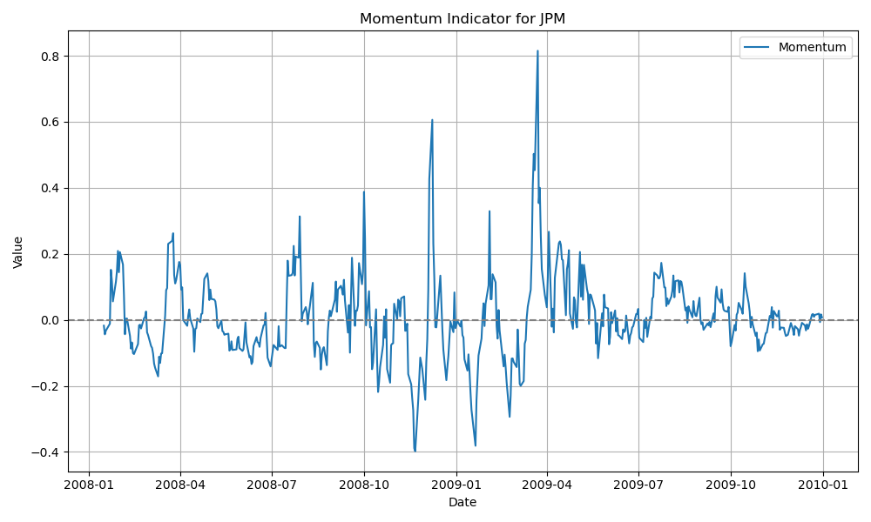
where P_{t}​ is the price at time t and P_{t−n}​ is the price n days earlier. A positive momentum value implies that the asset's price has increased over the period, while a negative value suggests a decline.
Figure 3: Momentum Indicator Over Time
This indicator is particularly useful in identifying the strength of ongoing trends. A rising momentum value may signal continued upward movement, encouraging buy decisions, whereas a falling value may indicate weakening strength or a potential reversal, supporting a sell decision. Traders often combine momentum with other indicators like SMA or Bollinger Bands to filter out noise and validate entry and exit points more effectively.
2.3.1 Trade Decision / Strategy
A long position is signaled when the momentum indicator rises above zero, indicating that the current price is higher than the price a specified number of days ago, reflecting positive price momentum. Conversely, a short position is initiated when momentum falls below zero, signaling negative momentum and a potential downtrend. When momentum hovers around zero without a clear direction, the strategy suggests holding cash to avoid uncertain market conditions. Trade confirmation can be obtained by combining momentum with trend-following indicators like SMA or MACD to ensure the strength and reliability of the signal. To filter out noise and avoid false signals, trades are only executed when momentum crosses the zero line and remains above or below for a minimum number of days, reducing sensitivity to minor price fluctuations.
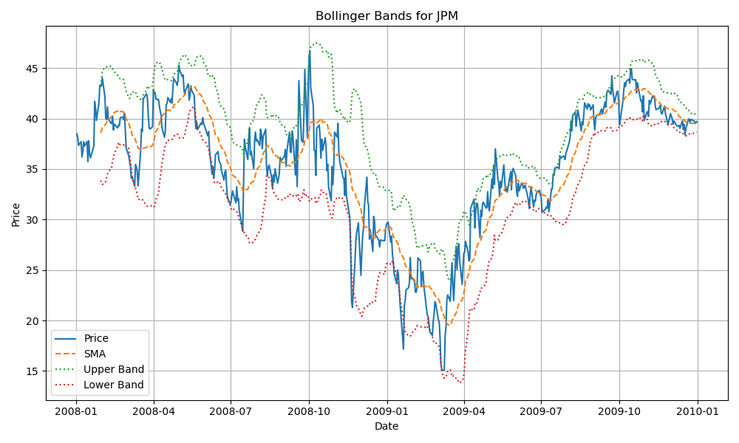
2.4 Bollinger Bands (BB)
Figure 4: BB Indicator Showing Price Volatility and Deviation from SMA
Bollinger Bands represent standardized price deviation from the moving average:
BB_{t} = (P_{t} – SMA_{t}) / (2 ⋅ σ_{t})
Here, σ_{t}​ is the rolling standard deviation. A BB value above +1 suggests overbought conditions, while values below –1 suggest oversold conditions. Bollinger Bands can help generate reversal signals, especially when the price returns inside the band range after breaching it.
2.4.1 Trade Decision / Strategy
A long position is typically initiated when the price falls below the lower band—indicating potential oversold conditions—and then moves back within the band, suggesting a likely upward reversal. Conversely, a short position is triggered when the price rises above the upper band—signaling overbought conditions—and then re-enters the band range, implying a possible downward correction. If the price remains between the bands without breaching either side, particularly near the SMA, it is advisable to stay in cash to avoid acting on weak or ambiguous signals.
Trade decisions based on Bollinger Bands can be confirmed using other indicators such as Momentum or MACD. For instance, a long signal is more reliable when accompanied by rising momentum or a MACD crossover from below zero. Similarly, a short signal is reinforced when declining momentum or a negative MACD supports the overbought condition.
To reduce the likelihood of false signals caused by short-term volatility or noise, a filter can be applied whereby the price must remain beyond a band threshold for a certain number of consecutive days before a reversal-based trade is executed. This helps enhance the reliability of the signals and prevents premature entries or exits.
The indicator is best visualized by plotting the stock’s price along with the SMA and both the upper and lower Bollinger Bands. This allows traders to clearly see overbought and oversold conditions and the points at which price returns inside the bands—indicating potential trading opportunities.
2.5 Moving Average Convergence Divergence (MACD)

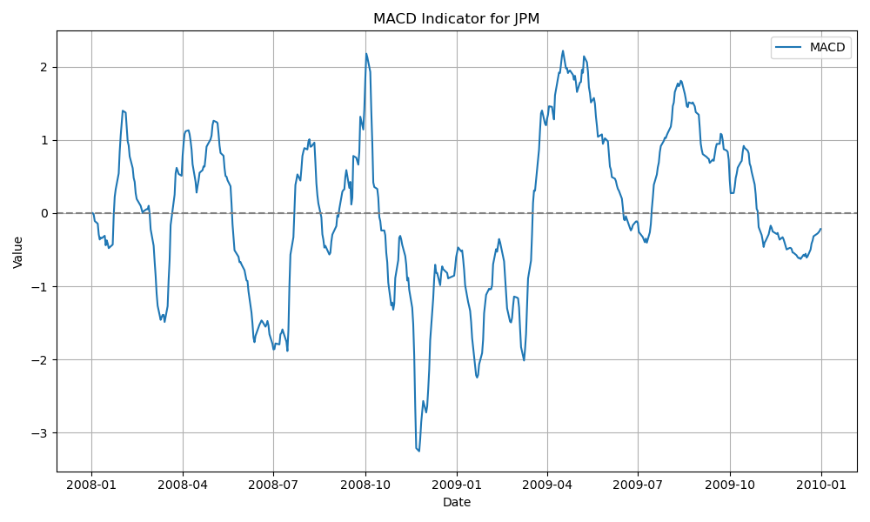
Figure 5: MCDA Over Time
MACD is calculated as the difference between two EMAs (typically 12-day and 26-day):
MACD_{t} = EMA₁₂(P_{t}) – EMA₂₆(P_{t})
MACD provides insight into trend reversals and momentum shifts. A positive MACD value indicates bullish divergence, while a negative value implies bearish momentum. MACD is often used with a signal line for trade confirmation, though this implementation uses only the MACD line.
2.5.1 Trade Decision / Strategy
A long position is triggered when the MACD line crosses above zero, indicating that the short-term momentum (usually 12-day EMA) has surpassed the long-term momentum (usually 26-day EMA), signaling a potential upward trend. Conversely, a short position occurs when the MACD line crosses below zero, suggesting bearish momentum. When the MACD hovers near zero without a clear crossover, holding cash is advisable to avoid uncertain market conditions. Trade confirmation often involves observing the MACD line alongside a signal line or other indicators like SMA or Momentum to reduce false signals, though in this implementation only the MACD line is used. To filter noise, trades are executed only when the MACD crosses zero and sustains its position for several days, helping to avoid whipsaws and minor fluctuations.
3 THEORETICALLY OPTIMAL STRATEGY (TOS)
3.1 Strategy Overview
The Theoretically Optimal Strategy (TOS) assumes perfect knowledge of the next day’s price movement, allowing it to make optimal trading decisions to maximize returns. The strategy trades in fixed increments of 1000 shares, maintaining positions of +1000 (long), 0 (flat), or -1000 (short) shares. Trade can be as large as ±2000 shares in one day to reverse positions from fully long to fully short or vice versa.
3.2 Algorithm Description
For each trading day t (except the last), the strategy compares the next day’s price (Pₜ₊₁) with the current day’s price (Pₜ). If the price is expected to rise, i.e., Pₜ₊₁ > Pₜ, the strategy buys enough shares to hold a total of +1000 shares. Specifically, if the current position is short (−1000 shares), it buys 2000 shares to reverse the position to +1000. If the position is flat (0 shares), it buys 1000 shares.
Conversely, if the price is expected to fall, i.e., Pₜ₊₁ < Pₜ, the strategy sells enough shares to hold −1000 shares. If the current position is long (+1000 shares), it sells 2000 shares to flip to −1000. If the position is flat, it sells 1000 shares. If the price is expected to remain unchanged (Pₜ₊₁ = Pₜ), the strategy maintains the current position and makes no trade. On the final trading day, it closes any open position by executing an offsetting trade to return holdings to zero.
3.3 Assumptions and Constraints
- No transaction costs or market impact are considered.
- Trades are only in increments of 1000 shares.
- Initial cash is set to $100,000 with zero shares held.
- Positions are capped at ±1000 shares.
3.4 Implementation Notes
The strategy is implemented in the function testPolicy () within the file TheoreticallyOptimalStrategy.py. It returns a DataFrame indexed by date with trade orders for the symbol. The function utilizes historical price data fetched via get_data ().
3.5 Performance Evaluation
Portfolio values were computed using the marketsimcode.py simulator with no commission or impact to reflect theoretical conditions. The benchmark for comparison is a buy-and-hold strategy of 1000 shares of JPM stock.
3.6 Performance Comparison Chart
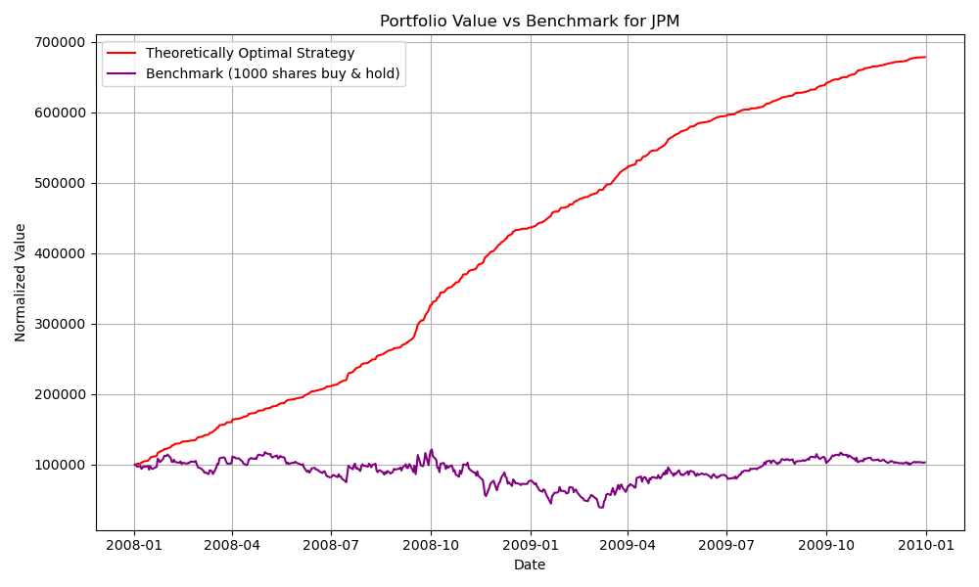
Figure 6 illustrates the normalized portfolio values of the TOS versus the benchmark for the period 2008–2009. The TOS significantly outperforms the benchmark, demonstrating the advantage of perfect foresight in trading decisions.
Figure 6: Portfolio Value Comparison: Theoretically Optimal Strategy vs. Benchmark

3.7 Performance Metrics
This section presents a detailed comparison of key performance metrics between the Theoretically Optimal Strategy (TOS) and the benchmark buy-and-hold approach. These metrics include cumulative return, daily return statistics, Sharpe ratio, and final portfolio value, providing a comprehensive view of each strategy’s risk-adjusted performance.

Table 1: Performance Metrics Comparison Between Benchmark and Theoretically Optimal Strategy (TOS)
Metric | TOS | Benchmark
Cumulative Return | 5.786100 | 0.031973
Standard Deviation (Daily Returns) | 0.004548 | 0.052145
Average Daily Returns | 0.003817 | 0.001396
Sharpe Ratio | 13.322770 | 0.424887
Final Portfolio Value | $678,610.00 | $103,197.30

The Theoretically Optimal Strategy (TOS) significantly outperformed the benchmark in every performance metric. Over the two-year period, TOS achieved a cumulative return of 478.61% and a Sharpe Ratio of 13.32, compared to just 3.20% and 0.42 for the benchmark. Despite its much higher returns, TOS exhibited lower daily volatility (0.45% vs. 5.21%), indicating a highly efficient strategy with minimal risk. This resulted in a final portfolio value of $678,610 versus $103,197 for the benchmark. However, it is important to note that such extreme outperformance is due to the use of perfect foresight in TOS and is not achievable in real-world trading. The strategy serves as a theoretical upper bound to benchmark the effectiveness of more realistic, learned strategies.
4 CONCLUSION
This report demonstrates the utility of multiple technical indicators for market analysis and trading decisions. Each indicator was defined mathematically, its trading logic explained and supported with visual examples on JPM stock data. The Theoretically Optimal Strategy, while not implementable in real markets, provides a valuable benchmark representing the maximal achievable performance given perfect future knowledge.
Future work could involve combining these indicators to design robust, practical trading algorithms, and testing on multiple securities over longer periods.

REFERENCES

- IG Group. (2019). 10 trading indicators every trader should know. Retrieved from https://www.ig.com/en/trading-strategies/10-trading-indicators-every-trader-should-know-190604
- Yves Hilpisch. (2018). Python for Finance: Mastering Data-Driven Finance (2nd ed.). Boston. O'Reilly Media.

