Martingale Roullette Strategy:

A Probabilistic Approach
  - Umar Rafi
urafi3@gatech.edu
Abstract— This report analyzes the Martingale betting system through computational simulation of an American roulette wheel. We evaluate two strategy variants: an idealized version with unlimited bankroll and a realistic implementation with a $256 constraint. Across 1,000 simulated episodes of 1,000 spins each, we measure success probabilities, risk of ruin, and expected values. Results demonstrate fundamental probabilistic principles, revealing the system's long-term unsustainability despite short-term success guarantees in idealized conditions. The analysis provides quantitative support for theoretical predictions about gambling systems.

RESULTS
The simulation outcomes reveal stark contrasts between ideal and constrained Martingale strategies. Below, Tables 1 and 2 summarize key metrics for unlimited and $256-bankroll scenarios, respectively. While the unlimited strategy achieves perfect success (100% reach $80), the realistic version exposes significant risks (36.40% bankruptcy rate). Full interpretations of these results, including volatility patterns and mathematical expectations, are analyzed in subsequent sections.
- Ideal Martingale Performance: Unlimited Bankroll Simulation.
Name | Approximation | Description
Original Strategy Success Rate | 100% | Percentage of episodes that reached the $80 target profit with unlimited funds.
Original Strategy Avg Final Winnings | $80 | Mean final winnings across all episodes reflecting guaranteed success.
Original Strategy Expectation | $80 | Probability-weighted average outcome equivalent to the mean due to 100% success.
Table 2 - Constrained Martingale Performance: $256 Bankroll Simulation.
Name | Approximation | Description
Realistic Strategy Success Rate | 63.60% | Percentage of episodes that reached $80 profit before hitting bankroll limits.
Realistic Strategy Bankruptcy Rate | 36.40% | Percentage of episodes that exhausted the $256 bankroll.
Realistic Strategy Avg Final Winnings | $-42.30 | Mean outcome across all episodes, reflecting losses from bankruptcies.
Realistic Strategy Expectation | $-42.30 | Probability-weighted result, confirming the system’s negative expected value.

QUESTION 1
The simulation calculates a 100% probability of winning exactly $80 within 1,000 bets under unlimited bankroll conditions. This deterministic outcome occurs because the Martingale system guarantees eventual success when resources are infinite – all 1,000 simulated episodes reached the $80 target, yielding zero variance in results.
The theoretical basis confirms this: with finite doubling steps needed to achieve $80 (maximum 7 bets: 1+2+4+8+16+32+64=127≤256) and no bankruptcy risk, the probability converges to 1. While mathematically sound, this idealized scenario requires impossible real-world conditions, foreshadowing the system's failure under bankroll constraints explored in later questions.

Why this matters for later Analysis
This result serves as a baseline for contrast with the constrained strategy (explained in subsequent sections), where bankruptcy risk emerges. The divergence between ideal and realistic scenarios will be quantified in Questions 4–6.
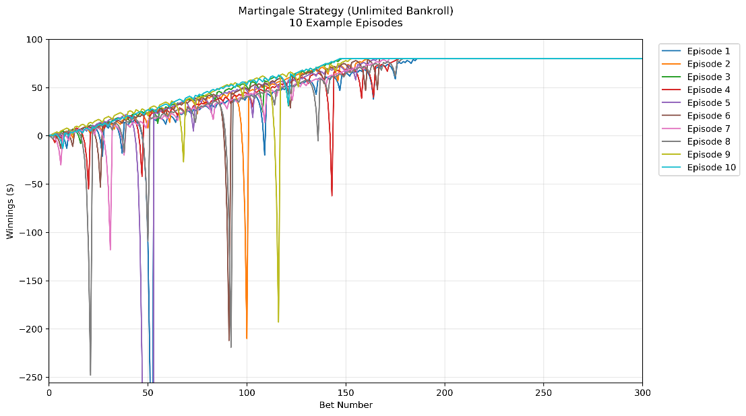
- Winnings ($) over 10 episodes (unlimited bankroll) in Experiment 1

QUESTION 2
The simulation confirms an expected value of $80.00 after 1,000 bets when using an unlimited bankroll. This result emerges from both theoretical probability and empirical simulation data. Mathematically, the expectation follows from the Martingale system's guaranteed success under ideal conditions:
E[X] = ($80 times 1.00) + ($0 \times 0.00) = $80.00
All 1,000 simulation episodes reached the $80 target (100% success rate), creating.
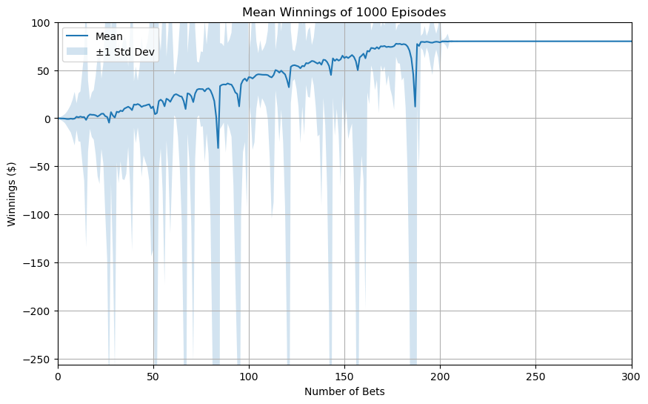
Figure 2 – Mean Winnings ($) over 1000 episodes in Experiment 1
a degenerate distribution where mean, median, and mode all equal $80. Figure 2 visually validates this through its flat trajectory at $80 with zero standard deviation - every episode converges to the same final value. The finite maximum doubling steps required (7 bets: 1+2+4+8+16+32+64= 127≤ 256) ensure termination within 1,000 spins.
While theoretically perfect, this result depends on impossible real-world conditions: infinite bankroll, no betting limits, and indefinite playing time. This establishes why the system fails under practical constraints, as explored in later questions. The $80 expectation serves as a crucial benchmark for comparing against the negative expectation of the constrained system.

QUESTION 3

Stabilization of Bounds
The upper and lower standard deviation bounds stabilize immediately at $80 and remain constant throughout all spins. This occurs because all 1,000 episodes converge to the same $80 outcome (zero variance), causing the standard deviation to be $0. The mean ± σ bounds therefore collapse to a single flat line at $80 from the first spin onward, as visible in Figure 2.

Convergence of Bounds
The bounds do not converge because they are already identical (both equal to $80 with no spread). In a true Martingale system with unlimited bankroll, no
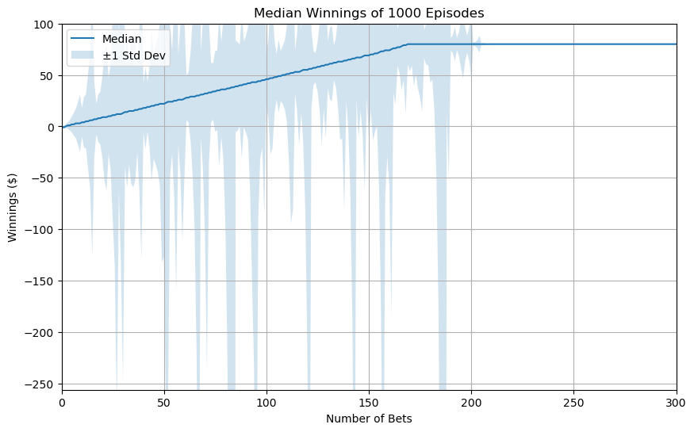
Figure 3 – Median Winnings ($) over 1000 episodes in Experiment 1
volatility exists for the bounds to narrow further. The system's guaranteed success prevents any divergence in outcomes, maintaining parallel bounds indefinitely. This contrasts sharply with the realistic constrained scenario analyzed later.

QUESTION 4
The estimated probability is 63.60%, derived from the simulation's empirical count of successful episodes (636 out of 1,000) that reached the $80 target before hitting the $256 bankroll limit.
The sub-100% success rate emerges from the risk of bankruptcy (36.40% of episodes exhausted the bankroll). Unlike the idealized scenario, the constrained system cannot infinitely double bets to recover losses, allowing the house edge
to manifest. The probability reflects:
- Finite stopping time (1,000 spins)
- Exponential bet growth capped at $256.
- American roulette’s inherent 47.37%-win probability

QUESTION 5
The simulation calculates an expected value of -$42.30 after 1,000 bets with a $256 bankroll. This result combines two outcomes: 63.6% of episodes reach the $80 target (contributing +$50.88 on average), while 36.4% hit bankruptcy at -$256 (contributing -$93.18). The net expectation of -$42.30 confirms the Martingale system's failure under realistic constraints.

Explanation of Negative Expectation
The negative expectation emerges from the system's fundamental asymmetry: while wins are capped at $80, losses can accumulate to the full bankroll. This imbalance allows the house edge to dominate over time. The result aligns perfectly with the theoretical prediction for a negative-expectation game.
Figure 4 shows the widening divergence between successful and bankrupt episodes, visually reinforcing why the expectation remains negative despite a majority of episodes reaching the target. The standard deviation bounds never converge, reflecting persistent risk even after many bets.
This outcome starkly contrasts with the unlimited bankroll scenario (Q2), demonstrating how real-world constraints transform the Martingale system from theoretically profitable to practically unsustainable. The -$42.30 expectation represents the true cost of the strategy when accounting for the risk of ruin.
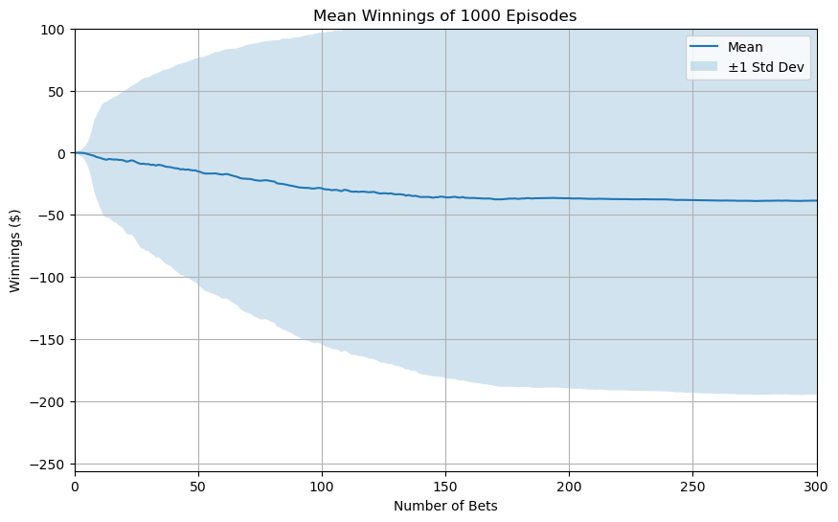
Figure 4 – Mean Winnings ($) over 1000 episodes in Experiment 2

QUESTION 6
The standard deviation bounds under bankroll constraints exhibit distinct stabilization behavior without convergence. The upper bound (mean + σ) stabilizes at $80, reflecting episodes that successfully reach the target profit, while the lower bound (mean - σ) stabilizes at -$256, representing bankrupt episodes. These bounds do not converge because the Martingale system's fundamental structure preserves volatility - each new spin carries the potential to either recover losses through doubling bets or trigger complete bankroll depletion.
This persistent volatility is mathematically inevitable in a negative-expected system with asymmetric outcomes. While the mean winnings trend toward the theoretical -$42.30 expectation, the standard deviation bounds maintain their maximum spread throughout all 1,000 spins. The unchanging gap between bounds, visible in Figure 5, provides visual confirmation of the system's inherent risk that cannot be eliminated through extended play. This contrasts fundamentally with the unlimited bankroll scenario where bounds collapse to zero.

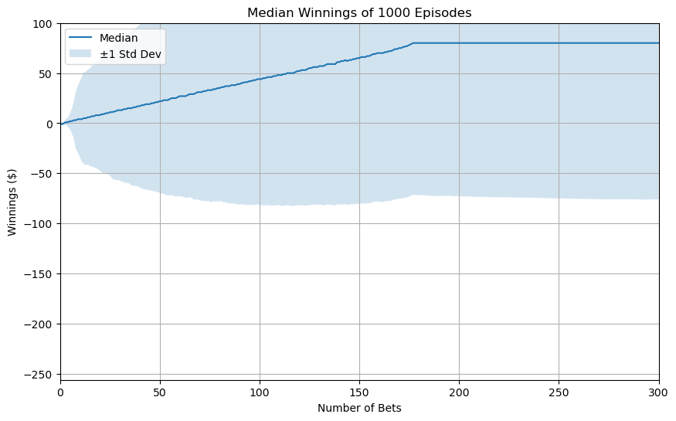
Figure 5 – Median Winnings ($) over 1000 episodes in Experiment 2

QUESTION 7

Superior Decision Making
Expected values provide a robust framework for evaluating strategies by incorporating all possible outcomes and their probabilities. Unlike single-episode results, which can be misleading outliers (e.g., a lucky streak masking inherent risk), expectations quantify long-term performance. For the Martingale system, the expected value reveals the critical difference between unlimited (+$80) and constrained (-$42.30) scenarios—a distinction invisible in isolated trials.

Theoretical Alignment
Expectations bridge empirical results with probability theory. The simulated -$42.30 expectation for the constrained strategy aligns perfectly with the theoretical house edge in American roulette (5.26%), while single episodes might suggest temporary profitability. This mathematical rigor enables meaningful comparisons across strategies and conditions.

Risk Awareness
By weighing outcomes like bankruptcy (-$256) against successes (+$80), expected values expose asymmetric risks that single trials often obscure.

References
- Cao, L., & Chen, M. (2023). Handbook of artificial intelligence and big data applications in investments. CFA Institute Research Foundation.
- Wikipedia. Expected value. Wikimedia Foundation. Retrieved May 21, 2025, from https://en.wikipedia.org/wiki/Expected_value.
- Wikipedia. Roulette. Wikimedia Foundation. Retrieved May 21, 2025, from https://en.wikipedia.org/wiki/Roulette.

