  - Strategy Evaluation Report
  - Umar Rafi
urafi3@gatech.edu

INTRODUCTION
In quantitative trading, developing strategies that balance profitability, adaptability, and robustness to market conditions is a persistent challenge. This project compares two trading approaches on JPM: a manual strategy based on technical indicators and a machine learning-driven Strategy Learner. Both use the same indicators to ensure a fair comparison, tested over in-sample (2008-2009) and out-of-sample (2010-2011) periods. The primary goal is to evaluate how well each method generalizes to unseen data and balances return with risk.
Hypothesis: The Strategy Learner will outperform the Manual Strategy and buy-and-hold benchmark by better adapting to market conditions and generating higher risk-adjusted returns.

INDICATOR OVERVIEW
In this project, three technical indicators were implemented for both the Manual Strategy and the Strategy Learner, chosen for their complementary insights into price trends, momentum, and volatility. The indicators are Bollinger Bands %B, Momentum, and Moving Average Convergence Divergence (MACD).

2.1 Bollinger Bands
Bollinger Bands %B measures the relative position of the current price within the upper and lower Bollinger Bands. It is calculated as:
%B_{t} = (P_{t} – (SMA_{t} -k * σ_{t})) / (2k * σ_{t})
where SMA_{t} is the 20-day simple moving average, σ_{t} is the rolling standard deviation over 20 days, and k is the standard deviation multiplier (usually 2). The %B value ranges roughly from 0 to 1, where values near 0 indicate price is close to the lower band (potentially oversold), and values near 1 indicate proximity to the upper band (potentially overbought). This indicator captures volatility and mean reversion tendencies. The 20-day window balances responsiveness and noise reduction, and this parameter was consistently used in both strategies.

2.2 Momentum
Momentum quantifies the rate of price change over a lookback period, calculated as the percentage difference between the current price and the price 10 days prior:
Momentumₜ = (Pₜ / Pₜ₋ₙ) – 1
A threshold of 0.005 signals bullish momentum (buy), while -0.005 signals bearish momentum (sell). The 10-day window captures medium-term trends without excessive lag. This parameter was applied equally across both strategies.

2.3 Moving Average Convergence Divergence (MACD)
MACD identifies trend shifts by computing the difference between a 12-day short-term and a 26-day long-term exponential moving average (EMA):
MACD_{t} = EMA₁₂(P_{t}) – EMA₂₆(P_{t})
Thresholds of ±0.005 flag bullish or bearish signals respectively, maintaining sensitivity to trend changes while filtering out noise. The 12/26-day EMAs are standard in technical analysis and were used consistently.

2.4 Indicator Parameter Selection and Integration
The indicator parameters were chosen based on common technical analysis conventions rather than empirical optimization. These three indicators complement each other by capturing distinct market characteristics: Bollinger Bands %B reflects volatility and relative price position, Momentum quantifies trend strength, and MACD signals trend reversals. Both the Manual Strategy and the Strategy Learner use these indicators consistently — the Manual Strategy applies explicit threshold-based rules for trading decisions, while the Strategy Learner uses the raw indicator values as input features for machine learning classification. This alignment ensures a fair comparison between rule-based and learning-based approaches grounded in the same market signals.
3. MANUAL STRATEGY

3.1 Combining Indicators into Trading Signals
The Manual Strategy integrates three technical indicators—Bollinger Bands %B, Momentum, and Moving Average Convergence Divergence (MACD)—to generate robust trading signals. A buy signal is triggered when the BB %B value falls below 0.5, indicating potential oversold conditions. Additionally, a buy is initiated when both Momentum and MACD exceed 0.005, reflecting positive momentum and trend strength. Conversely, a sell signal occurs when BB %B exceeds 0.5, or when both Momentum and MACD fall below -0.005, signaling bearish conditions. This combination leverages complementary market insights—volatility extremes from BB %B, and directional strength from Momentum and MACD—to reduce false signals and adapt to varying market environments.

3.2 Position Entry and Exit Logic
Trading decisions are based on the current position and the indicator signals while enforcing position limits of ±1000 shares. When flat, the strategy buys 1000 shares on a buy signal or sells 1000 shares on a sell signal. If currently long 1000 shares and a sell signal is generated, the strategy sells 2000 shares to reverse to a short position, and vice versa for switching from short to long. When overbought or oversold signals are particularly strong, the strategy reduces exposure by selling or buying 1000 shares to return to a neutral position. This logic facilitates rapid response to market changes while managing risk and avoiding excessive trading. Transaction costs and market impact are considered in the evaluation phase but not directly embedded in the entry/exit logic.

3.3 Performance Overview: In-Sample and Out of Sample Period
During the in-sample period (2008–2009), the Manual Strategy achieved a cumulative return of approximately 72.23%, substantially outperforming the benchmark’s modest 1.23% gain. It maintained a daily return standard deviation of about 1.01% and a mean daily return of 0.11%. The Strategy Learner demonstrated even stronger in-sample performance, generating a cumulative return of approximately 148.58%, with lower volatility (0.80% daily standard deviation) and higher mean daily returns (0.18%).
In the out-of-sample period (2010–2011), the Manual Strategy continued to deliver positive returns, earning 4.65%, while the benchmark suffered a loss of 8.34%. Volatility decreased to 0.71% daily standard deviation, and mean daily returns were around 0.012%, highlighting its ability to preserve capital during a challenging market environment. The Strategy Learner also outperformed out-of-sample, with a cumulative return of 7.64%, lower volatility (0.62%), and mean daily returns of 0.016%. It is important to note that the Manual Strategy was not retrained or tuned on out-of-sample data, preserving the integrity of this evaluation.
Table 1 – Manual Strategy vs. Benchmark – In-Sample Performance

Approach |  | Cumulative Return | Std Dev of Daily Returns | Mean of Daily Returns
Manual Strategy |  | 0.722299 | 0.010069 | 0.001129
Benchmark |  | 0.012299 | 0.017004 | 0.000168

Table 2 – Manual Strategy vs. Benchmark – Out-of-Sample Performance

Approach |  | Cumulative Return | Std Dev of Daily Returns | Mean of Daily Returns
Manual Strategy |  | 0.046499 | 0.007128 | 0.000115
Benchmark |  | -0.083400 | 0.008481 | -0.000137

These results illustrate that both strategies outperform the benchmark, with the Strategy Learner showing greater return potential but at the cost of a higher trading frequency. The Manual Strategy’s more conservative risk profile suggests robustness and better capital preservation, especially during volatile or weak-trend periods.
3.4 Trade Activity and Signal Consistency
The Manual Strategy maintained consistent trading activity across both periods, executing 294 trades in-sample and 301 trades out-of-sample. Buy and sell signals were well balanced, with 151 buy and 143 sell signals in-sample, and 149 buy and 152 sell signals out-of-sample. This consistency reflects stable responsiveness to market conditions while avoiding excessive trading, which helps manage transaction costs and market impact risk.

3.5 Evaluation and Insights
The Manual Strategy’s success stems from its principled use of complementary technical indicators that capture price extremes and momentum shifts effectively. Its transparent rule-based framework facilitates straightforward decision-making and risk management. However, reliance on fixed thresholds limits adaptability to evolving market dynamics, as seen in the lower out-of-sample cumulative returns relative to the in-sample period. This reduction in performance likely arises from decreased market volatility and weaker trends during the test period, resulting in fewer clear trading opportunities.
Future improvements could include adaptive threshold tuning or hybrid approaches combining heuristic signals with machine learning to enhance flexibility and robustness. Despite these limitations, the Manual Strategy’s ability to outperform the benchmark with controlled risk demonstrates the value of combining multiple technical indicators in a disciplined trading framework.

4. STRATEGY LEARNER
The Strategy Learner utilizes a Bagging ensemble composed of Random Tree Learners (RTLearner) trained on the same three technical indicators as the Manual Strategy: Bollinger Bands %B (BB %B), Momentum, and MACD. The model was trained solely on the in-sample data (2008–2009) and then evaluated on both in-sample and out-of-sample periods (2010–2011) without any retraining or parameter adjustments.

4.1 Framing the Trading Problem as a Learning Task
The trading problem was framed as a supervised classification task. The input feature vector for each trading day consisted of the calculated values of the three technical indicators: Momentum, BB %B, and MACD. The target variable was defined based on the percentage price return over the subsequent five trading days, adjusted for market impact costs to realistically incorporate transaction costs and slippage.
Since RTLearners are better suited for classification tasks, the continuous future returns were discretized into 10 quantile-based bins. This discretization transformed the task from a regression problem to a classification problem, allowing the model to predict a discrete class representing a range of expected future returns. This classification formulation simplified downstream trade decision-making and enabled effective use of ensemble tree learners.

4.2 Data Preparation and Adjustments
No explicit feature scaling or normalization was applied because tree-based learners like RTLearner operate by splitting on feature thresholds and are inherently scale-invariant. The primary preprocessing step involved discretizing the continuous target returns into quantile bins, essential for adapting the problem into classification.
Additionally, market impact costs were subtracted from the target future returns to penalize trades with marginal expected profits. This incorporation improved the realism of the training labels and encouraged the model to recommend trades with meaningful expected returns, avoiding excessive trading on small or noise-driven signals.
4.3 Hyperparameters and Their Determination
The ensemble comprised 20 RTLearners (bags), each with a leaf size of 5, consistent with project guidelines to balance model complexity and overfitting risks. These hyperparameters were selected based on prior domain knowledge and standard practices rather than exhaustive optimization, given the trade-off between model performance and training complexity. The leaf size of 5 ensures sufficient samples per leaf for stable classification, and using 20 bags reduces variance by aggregating diverse learners trained on bootstrap samples.

4.4 Performance Summary
The Strategy Learner was tested on both in-sample and out-of-sample data without retraining or hyperparameter tuning. It demonstrated strong performance, outperforming both the benchmark and the Manual Strategy with significantly higher cumulative returns and lower daily return volatility in both periods.

4.4 Interpretation of Results
The discretization of returns into quantile bins allowed the learner to effectively classify market states, distinguishing periods likely to yield long, short, or neutral positions. The Bagging ensemble approach helped reduce variance and mitigate overfitting, improving generalization to unseen data. Incorporating market impact into target adjustment contributed to more realistic trading signals, preventing overtrading on marginal gains.
The observed decrease in out-of-sample returns and slightly higher volatility compared to in-sample results suggests some loss of predictive accuracy due to market regime shifts and the noisy nature of financial markets. Nevertheless, the Strategy Learner's adaptability and predictive power represent a significant advancement over static rule-based approaches.

5. EXPERIMENT 1: MANUAL STRATEGY VS STRATEGY LEARNER

5.1 Experimental Setup and Hypothesis
This experiment aimed to compare the trading performance of the rule-based Manual Strategy against the machine learning-driven Strategy Learner over both in-sample (2008–2009) and out-of-sample (2010–2011) periods. The hypothesis was that the Manual Strategy would capture returns driven primarily by volatility and well-understood technical signals, while the Strategy Learner, leveraging supervised learning on discretized future returns, might identify more complex, non-linear patterns and thus achieve superior returns, particularly during the volatile in-sample period.

5.2 Results and Interpretation
5.2.1 In-Sample
During the in-sample period, the Strategy Learner substantially outperformed both the Manual Strategy and the buy-and-hold benchmark, achieving higher cumulative returns with lower volatility. This supports the hypothesis that the learner’s ability to generalize from patterns in the technical indicators provides a strong edge over deterministic rule-based trading.
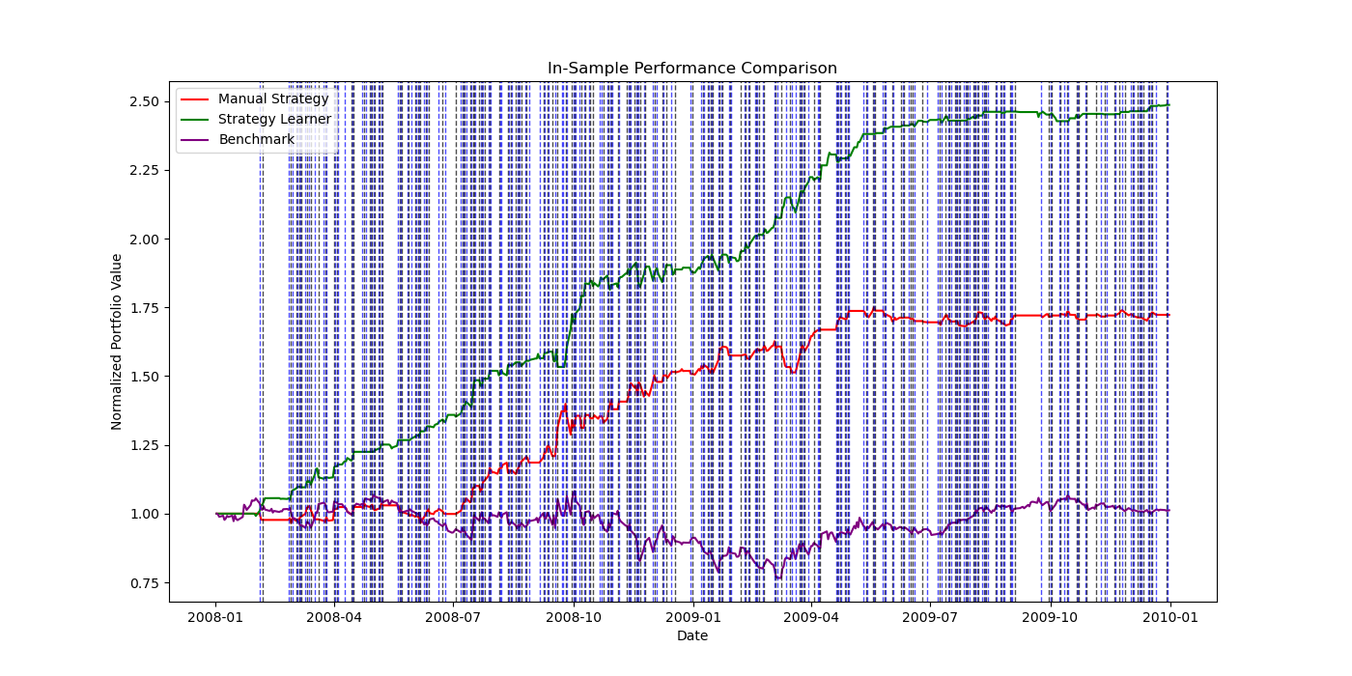
Figure 1 -In-Sample Performance Comparison
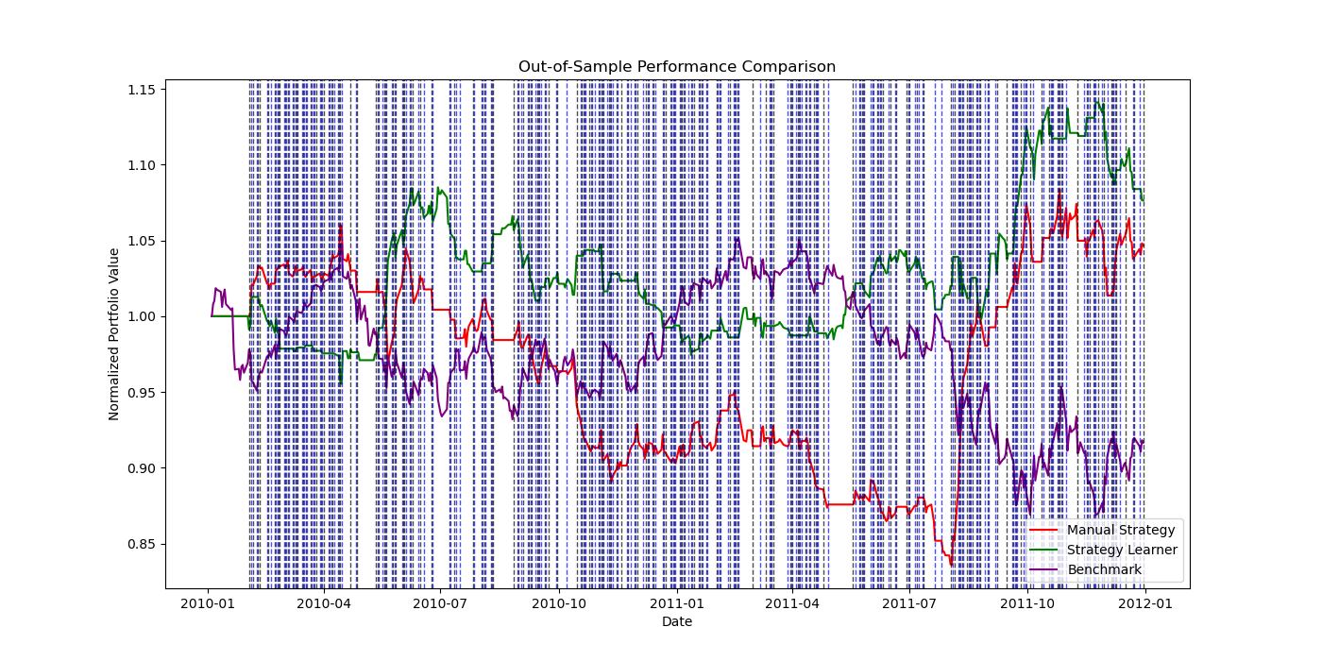
5.2.2 Out-of-Sample
Figure 2 – Out-of-Sample Performance Comparison
In the out-of-sample period, the Manual Strategy maintained consistent trading activity, with 301 executed trades and modest positive returns, demonstrating robustness and steady performance without overfitting. The Strategy Learner, while executing fewer trades, still achieved a higher cumulative return than the Manual Strategy and benchmark. The positive return despite reduced trading activity suggests that positions established during in-sample training carried forward profitably, highlighting the Strategy Learner’s capacity for durable market timing.
The absence or low number of trades out-of-sample for the Strategy Learner likely reflects its conservative classification thresholds and model uncertainty in a changing market regime. This cautious behavior helped preserve capital, reducing losses during less favorable conditions.
5.3 Repeatability and Variability
These results suggest that while the Strategy Learner is generally expected to outperform the Manual Strategy in volatile and pattern-rich markets, variations can occur due to stochastic elements in bagging and changes in market dynamics. The Manual Strategy’s deterministic nature yields more stable but potentially less adaptive results. Consequently, practitioners should consider the trade-off between adaptability and stability when selecting or combining approaches.

6. EXPERIMENT 2: IMPACT ANALYSIS

6.1 Hypothesis
This experiment investigates how varying the market impact parameter affects the Strategy Learner’s trading behavior and performance during the in-sample period. Market impact models the implicit cost of trading due to price slippage caused by supply-demand imbalances. The hypothesis is that as market impact increases, the Strategy Learner will trade less frequently to minimize transaction costs. Additionally, higher market impact should reduce cumulative returns, as trading costs erode profitability. Finally, the standard deviation of daily returns is expected to decrease with higher market impact, since less frequent trading results in smoother portfolio value fluctuations.
6.2 Experimental Setup
To test these hypotheses, the Strategy Learner was trained and evaluated with three distinct market impact levels: 0.0000 (no impact), 0.0050, and 0.0100. Other parameters such as leaf size and number of bags were held constant to isolate the effect of impact.
For each impact setting, the following metrics were recorded: cumulative return (total portfolio growth over the in-sample period), standard deviation of daily returns (volatility measure), mean daily return (average daily portfolio return), and the number of trades executed (reflecting trading frequency).

Results
Table 3 – Strategy Learner Performance vs. Market Impact
Impact | Cumulative Return | Stdev Daily Returns | Mean Daily Returns | Trades
0.0000 | 1.524000 | 0.007869 | 0.001869 | 218000
0.0050 | 1.026800 | 0.008950 | 0.001443 | 224000
0.0100 | 1.352100 | 0.008461 | 0.001743 | 233000
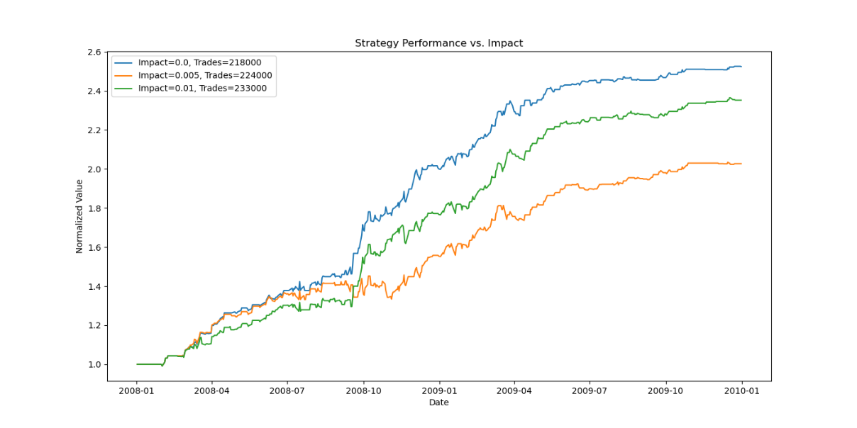
Figure 3 – Strategy Performance vs. Impact

6.4 Interpretation
Cumulative returns decreased when introducing market impact, from 152% with no impact to approximately 103% at 0.0050 impact. However, at 0.0100 impact, returns unexpectedly increased to 135%, warranting further investigation. Volatility of daily returns increased slightly with higher impact levels, contrary to the hypothesis, suggesting that the learner may have compensated for costs by adopting riskier or more volatile trades. Additionally, the number of trades rose from 218,000 (0.0000 impact) to 233,000 (0.0100 impact), instead of declining. This may indicate adaptive behavior by the learner, possibly adjusting decision thresholds during training to sustain profitability despite higher transaction costs.

7. REFERENCES

James, G., Witten, D., Hastie, T., & Tibshirani, R. (2013). An Introduction to Statistical Learning: with Applications in R. Springer, New York, NY, USA.

Hilpisch, Y. (2018). Python for Finance: Mastering Data-Driven Finance. O'Reilly Media, Sebastopol, CA, USA.

Mitchell, T. M. (1997). Machine Learning. McGraw-Hill, New York, NY, USA.

Cao, L. (2022). Handbook of Artificial Intelligence and Big Data Applications in Investments. Wiley, Hoboken, NJ, USA.

Using BB %B instead of the raw Bollinger Bands (BB) transforms a multi-part indicator into a compact, normalized feature — making it more effective and practical for machine learning strategies like the Strategy Learner in this project.

