**UXUY Product Overview**

**Product Overview**

**Platform Introduction**

UXUY is a decentralized exchange serving users worldwide, focused on delivering seamless on-chain trading experiences for stocks, index funds, and multi-chain assets. We are committed to bridging the gap between traditional finance and the crypto world, empowering everyone to easily invest in global assets on-chain.

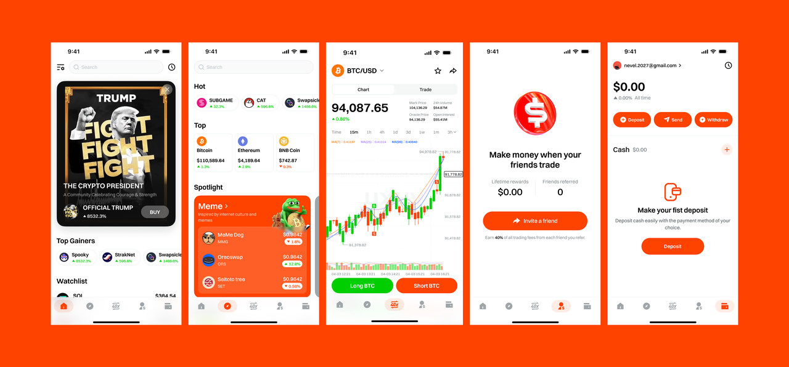

**Key Features**

* **Built on ERC-4337 Protocol**  
   UXUY is a smart contract-based decentralized exchange built on the abstract account standard **ERC-4337**. Leveraging its proprietary **GasLess** protocol, UXUY breaks the limitations of traditional EOA wallets, delivering a seamless, "chain-agnostic" trading experience. Even users unfamiliar with Web3 can start trading on-chain stocks, index funds, and multi-chain assets with just one click—offering Web2-level ease of use and security.
* **GasLess: Proprietary Gas-Free Interaction Protocol**  
   In traditional blockchain systems, every transfer or smart contract interaction requires paying gas fees, which complicates the user experience. UXUY’s self-developed **GasLess** protocol eliminates this burden, allowing users to broadcast and execute on-chain transactions with **zero gas cost**, lowering the barrier to blockchain trading.
* **Built-in Cross-Chain Bridge: Native Protocol for Seamless Multi-Chain Experience**  
   UXUY features an in-house cross-chain protocol based on stablecoin channels, enabling **instant cross-chain transfers and trading**. Users no longer need to rely on third-party bridges, sign repeatedly, or switch networks—UXUY provides a one-click multi-chain asset swap and trading experience with **zero perceptible delay**, significantly reducing the learning curve for Web3 adoption.
* **Multi-Chain Interaction Protocol: Smart Aggregation & Routing for Optimal Trades**  
   UXUY’s proprietary cross-chain infrastructure powers a **real-time multi-chain aggregation and smart routing system**. When a trade is initiated, the system automatically queries multiple chains to identify the optimal blockchain, protocol, and price path, ensuring **low slippage, high efficiency**, and near-instant cross-chain execution.
* **On-Chain Stocks and Index Fund Trading**  
   UXUY introduces Real World Assets (RWA) to the blockchain, enabling **24/7 on-chain trading** of popular U.S. stocks like Tesla and Apple, along with a variety of crypto-based index funds. This brings traditional financial products into the decentralized world, offering global users flexible and continuous investment opportunities.

**Contact Us**

Welcome to the UXUY community!  
 Follow our official **Telegram**, **Discord**, and social media channels to get real-time support and the latest updates — never miss a thing!

**X (Twitter)**

EN：https://x.com/uxuycom

CN：https://x.com/uxuyzh

VN：https://x.com/uxuyvn

KR：https://x.com/uxuykr

**Telegram**

Official Telegram Channel https://t.me/UXUYcom

English Official Group 1 https://t.me/UXUYen

English Official Group 2 https://t.me/UXUYen2

English Official Group 3 https://t.me/UXUYen3

Chinese Official Group https://t.me/uxuycom_cn

Vietnamese Official Group https://t.me/uxuy_Vietnam

India Official Group https://t.me/uxuy_India

Feedback group https://t.me/uxuyfeedback

Korean Official Group https://t.me/uxuy_SouthKorea

Russia Official Group https://t.me/uxuy_Russia

Indonesia Official Group https://t.me/uxuyIndonesia

Nigeria Official Group https://t.me/uxuy_Nigeria

Türkiye Official Group https://t.me/uxuy_Turkey

Brazil Official Group https://t.me/uxuy_Brazil

**Discord**

<https://discord.gg/vXRgWxARg6>

**Blog**

<https://medium.com/@uxuy>

**Terms of Service**

These terms of service are effective as of Mar 28, 2023

Thank you for your interest in UXUY. These terms of service, together with any documents and additional terms they incorporate by reference (collectively, these “Terms”), are entered into between UXUY Service and any of its subsidiaries or affiliates (collectively, “UXUY,” “we,” “us,” and “our”) and you or the company or other legal entity that you represent (“you” or “your”).

Please read these Terms carefully as they govern your use of our website located at our Site [https://uxuy.com](https://uxuy.com/) (the “Site”), and use of the products, features, content, applications, or services we provide (collectively with the Site, the “Services”). These terms describe your rights and obligations and our disclaimers and limitations of legal liability. By accessing or using our Site or our Services, you accept and agree to be bound by and to comply with these Terms, including the mandatory arbitration provision in Section 11. If you do not agree to these Terms, you must not access or use our Site or the Services. Please carefully review the disclosures and disclaimers set forth in Section 8 in their entirety before using any software developed by UXUY.

You must be able to form a legally binding contract online either on behalf of a company or as an individual. Accordingly, you represent that, if you are agreeing to these Terms on behalf of a company or other legal entity, you have the legal authority to bind the company or other legal entity to these Terms and you are at least 18 years old (or the age of majority where you reside, whichever is older), can form a legally binding contract online, and have the full, right, power and authority to enter into and to comply with the obligations under these Terms.

Additionally, you represent and warrant that you are not a citizen or resident of a state, country, territory, or other jurisdiction that is embargoed by Singapore or where your use of the Site or the Services would be illegal or otherwise violate any domestic or foreign law, rule, statute, regulation, by-law, order, protocol, code, decree, or other directives, requirement or guideline, published or in force which applies to or is otherwise intended to govern or regulate any person, property, transaction, activity, event or other matter, including any rule, order, judgment, directive or other requirement or guideline issued by any domestic or foreign federal, provincial or state, municipal, local or other governmental, regulatory, judicial or administrative authority having jurisdiction over UXUY, you, the Site or the Services, or as otherwise duly enacted, enforceable by law, the common law or equity (“Applicable Law”).

**MODIFICATIONS TO THESE TERMS**

We reserve the right, in our sole discretion, to modify these Terms from time to time. If we make changes, we will provide you with notice of such changes by sending an email, providing a notice through the Site or our Services or updating the date at the top of these Terms. Unless we say otherwise in our notice, any modifications are effective immediately, and your continued use of the Site or our Services will confirm your acceptance of the changes. If you do not agree to the amended terms, you must stop using our Services.

**SERVICES**

The "UXUY smart contracts" are publicly available open-source software programs deployed on the Ethereum blockchain that facilitate the peer-to-peer exchange of Ethereum-based tokens.

UXUY develops software through which users and developers can interact with the UXUY smart contracts. The primary purpose of the Site is to enable users to access and utilize the UXUY smart contracts and UXUY software products as well as to provide resources and information, including, without limitation, developer documentation, product examples, and other related services (all of which are covered under the definition of “Services”).

The “UXUY network” is comprised of all users, companies, applications, and any other device, service, or person interacting in any way, directly or indirectly, with the UXUY smart contracts on the Ethereum blockchain, including UXUY’s Services. The term UXUY network should be interpreted as broadly as possible to include anything that may be reasonably considered to be part of the network as that term is construed in normal use.

Some Services are offered by us or other participants in the UXUY network require payment or otherwise involve the use of an underlying blockchain or other decentralized or permissioned infrastructure (the “Distributed Ledger Technology”), which may require that you pay a fee, such as “gas” charges on the Ethereum network, for the computational resources required to perform a transaction on the particular Distributed Ledger Technology (such payments and fees, “Charges”).

You acknowledge and agree that UXUY has no control over any Distributed Ledger Technology transactions, the method of payment of any Charges, if applicable, or any actual payments of Charges, if applicable. Accordingly, you must ensure that you have a sufficient balance of the applicable Distributed Ledger Technology network tokens stored at your Distributed Ledger Technology-compatible wallet address (“Distributed Ledger Technology Address”) to complete any transaction on the UXUY network or the Distributed Ledger Technology before initiating such transaction.

As a condition to accessing or using the Services or the Site, you: (i) will only use the Services and the Site for lawful purposes and in accordance with these Terms; (ii) will ensure that all information that you provide on the Site is current, complete, and accurate; (iii) will maintain the security and confidentiality of access to your Distributed Ledger Technology Address; and (iv) agree (A) that no Protected Party (defined below) will be responsible for any loss or damage incurred as the result of any interactions you have with other users of the Site, Services or the UXUY network, including any loss of the tokens issued in the future by UXUY, any other tokens or other unit of value; and (B) if there is a dispute between you and any other site or other user, no Protected Party will be under any obligation to become involved.

As a condition to accessing or using the Site or the Services, you will not: (i) Violate any Applicable Law, including, without limitation, any relevant and applicable anti-money laundering and anti-terrorist financing laws and any relevant and applicable privacy and data collection laws, in each case, as may be amended; (ii) Export, re-export, or transfer, directly or indirectly, any UXUY technology in violation of applicable export laws or regulations; (iii) Infringe on or misappropriate any contract, intellectual property, or another third-party right, or commit a tort while using the Site or the Services; (iv) Misrepresent the truthfulness, sourcing or reliability of any content on the Site or through the Services; (v) Use the Site or Services in any manner that could interfere with, disrupt, negatively affect, or inhibit other users from fully enjoying the Site, Services or the UXUY network or that could damage, disable, overburden, or impair the functioning of the Site, Services or the UXUY network in any manner; (vi) Attempt to circumvent any content filtering techniques or security measures that UXUY employs on the Site or the Services, or attempt to access any service or area of the Site or the Services that you are not authorized to access; (vii) Use any robot, spider, crawler, scraper, or other automated means or interface not provided by us, to access the Site or Services or to extract data; (viii) Introduce any malware, virus, Trojan horse, worm, logic bomb, drop-dead device, backdoor, shutdown mechanism or other harmful material into the Site or the Services; (ix) Post content or communications on the Site or through the Services that are, in our sole discretion, libelous, defamatory, profane, obscene, pornographic, sexually explicit, indecent, lewd, vulgar, suggestive, harassing, hateful, threatening, offensive, discriminatory, bigoted, abusive, inflammatory, fraudulent, deceptive or otherwise objectionable; (x) Post content on the Site or through the Services containing unsolicited promotions, political campaigning, or commercial messages or any chain messages or user content designed to deceive or trick the user of the Service; or (xi) Encourage or induce any third party to engage in any of the activities prohibited under these Terms.

**PRIVACY POLICY**

Please refer to our privacy policy for information about how we collect, use, share and otherwise process information about you.

**CHANGES; SUSPENSION; TERMINATION**

The UXUY Network is intended to be decentralized and self-operating, with or without any Services provided by UXUY. Accordingly, we may, at our sole discretion, from time to time and with or without prior notice to you, modify, suspend or disable, temporarily or permanently, the Services offered by UXUY, in whole or in part, for any reason whatsoever, including, but not limited to, as a result of a security incident.

We will not be liable for any losses suffered by you resulting from any modification to any Services or from any suspension or termination, for any reason, of your access to all or any portion of the Site or the Services.

All of these terms will survive any termination of your access to the Site or the Services, regardless of the reasons for its expiration or termination, in addition to any other provision which by law or by its nature should survive.

**ELECTRONIC NOTICES**

You consent to receive all communications, agreements, documents, receipts, notices, and disclosures electronically (collectively, our “Communications”) that we provide in connection with these Terms or any Services. You agree that we may provide our Communications to you by posting them on the Site or through the Services or by emailing them to you at the email address you provide in connection with using the Services. You should maintain copies of our communications by printing a paper copy or saving an electronic copy. You may also contact our support team to request additional electronic copies of our Communications by filing a support request at [legal@uxuy.com](mailto:legal@uxuy.com).

**INDEMNIFICATION**

You will defend, indemnify, and hold harmless UXUY, our affiliates, and our affiliates’ respective shareholders, members, directors, officers, employees, attorneys, agents, representatives, suppliers, licensors, and contractors (collectively, “Protected Parties”) from any claim, demand, lawsuit, action, proceeding, investigation, liability, damage, loss, cost or expense, including without limitation reasonable attorneys’ fees, arising out of or relating to your use of, or conduct in connection with, the Site, Services, the UXUY Network, Distributed Ledger Technology assets associated with your Distributed Ledger Technology Address, any other digital assets, any Feedback or Your Content; your violation of these Terms; your violation of applicable laws or regulations; or your infringement or misappropriation of the rights of any other person or entity. If you are obligated to indemnify any Protected Party, UXUY (or, at its discretion, the applicable Protected Party) will have the right, in its sole discretion, to control any action or proceeding and to determine whether UXUY wishes to settle, and if so, on what terms.

1. DISCLOSURES; DISCLAIMERS

UXUY is primarily a developer of open-source software. UXUY does not operate a virtual currency or derivatives exchange platform or offer trade execution or clearing services and therefore has no oversight, involvement, or control with respect to your transactions, including existing or future token purchases and sales.

You are responsible for complying with all laws and regulations applicable to your transactions, including, but not limited to, the Commodity Exchange Act and the regulations promulgated thereunder by the U.S. Commodity Futures Trading Commission (“CFTC”), the Bank Secrecy Act and the regulations promulgated thereunder by the Financial Crimes Enforcement Network (“FinCEN”), and the federal securities laws and the regulations promulgated thereunder by the U.S. Securities and Exchange Commission (“SEC”).

You understand that UXUY is not registered or licensed by the CFTC, SEC, FinCEN, or any financial regulatory authority. No financial regulatory authority has reviewed or approved the use of the UXUY open-source software or Services. This Site and the Services do not constitute advice or a recommendation concerning any commodity, security, or other assets. UXUY is not acting as an investment adviser or commodity trading adviser to any person.

UXUY does not have the ability to modify or control in any manner the code underlying the smart contract. The ability to modify the UXUY smart contracts is managed by a multi-signature wallet currently controlled by UXUY and described in more detail here. In general, the underlying protocols are open-source and anyone can use, copy, modify, and distribute them. UXUY is not responsible for the operation of the underlying protocols such as Ethereum, and UXUY makes no guarantee of its functionality, security, or availability.

To the maximum extent permitted under Applicable Law, the Site and the Services (and any of their content or functionality) provided by or on behalf of us are provided on an “AS IS” and “AS AVAILABLE” basis, and we expressly disclaim, and you hereby waive, any representations, conditions or warranties of any kind, whether express or implied, legal, statutory or otherwise, or arising from statute, otherwise in law, course of dealing, or usage of trade, including, without limitation, the implied or legal warranties and conditions of merchantability, merchantable quality, quality or fitness for a particular purpose, title, security, availability, reliability, accuracy, quiet enjoyment and non-infringement of third party rights. Without limiting the foregoing, we do not represent or warrant that the Site or the Services (including any related data) will be uninterrupted, available at any particular time or error-free. Further, we do not warrant that errors in the Site or the Service are correctable or will be corrected.

You acknowledge that your data on the Site or through the Services may become irretrievably lost or corrupted or temporarily unavailable due to a variety of causes, and agree that, to the maximum extent permitted under Applicable Law, we will not be liable for any loss or damage caused by denial-of-service attacks, software failures, viruses or other technologically harmful materials (including those which may infect your computer equipment), protocol changes by third-party providers, Internet outages, force majeure events or other disasters, scheduled or unscheduled maintenance, or other causes either within or outside our control.

The disclaimer of implied warranties contained in these Terms may not apply if and to the extent such warranties cannot be excluded or limited under the Applicable Law of the jurisdiction in which you reside.

**EXCLUSION OF CONSEQUENTIAL AND RELATED DAMAGES**

In no event will the Company, together with any Protected Party, be liable for any incidental, indirect, special, punitive, exemplary, consequential or similar damages or liabilities whatsoever (including, without limitation, damages for loss of data, information, revenue, goodwill, profits or other business or financial benefit) arising out of or in connection with the Site, the Services, and the UXUY Network (and any of their content and functionality), any execution or settlement of a transaction, any performance or nonperformance of the Services, your Distributed Ledger Technology assets, other digital assets, or any other product, service, or other item provided by or on behalf of a Protected Party, whether under contract, tort (including negligence), civil liability, statute, strict liability, breach of warranties, or under any other theory of liability, and whether or not any Protected Party has been advised of, knew of or should have known of the possibility of such damages and notwithstanding any failure of the essential purpose of these Terms or any limited remedy nor is UXUY in any way responsible for the execution or settlement of transactions between users of UXUY open-source software or the UXUY Network.

**LIMITATION OF LIABILITY**

In no event will the Protected Parties' aggregate liability arise out of or in connection with the Site, the Services, and the UXUY Network (and any of their content and functionality), any performance or nonperformance of the Services, your Distributed Ledger Technology assets, other digital assets, or any other product, service, or other item provided by or on behalf of a Protected Party, whether under contract, tort (including negligence), civil liability, statute, strict liability or other theory of liability exceed the amount of fees paid by you to us under these Terms in the twelve (12) month period immediately preceding the event giving rise to the claim for liability.

**RELEASE**

To the extent permitted by applicable law, in consideration for being allowed to use the Site, the Services, and/or the UXUY Network, you hereby release and forever discharge the Company and all Protected Parties from and hereby waive and relinquish, each and every past, present, and future dispute, claim, controversy, demand, right, obligation, liability, action, and cause of action of every kind and nature (including personal injuries, death, and property damage), that has arisen or arises directly or indirectly out of, or that relates directly or indirectly to, the Site, the Services and/or the UXUY Network (including any interactions with, or act or omission of, other Site or UXUY Network users or any third-party services). YOU HEREBY WAIVE ANY APPLICABLE PROVISION IN LAW OR REGULATION IN CONNECTION WITH THE FOREGOING, WHICH STATES IN SUBSTANCE: “A GENERAL RELEASE DOES NOT EXTEND TO CLAIMS WHICH THE CREDITOR DOES NOT KNOW OR SUSPECT TO EXIST IN HIS OR HER FAVOR AT THE TIME OF EXECUTING THE RELEASE, WHICH IF KNOWN BY HIM OR HER MUST HAVE MATERIALLY AFFECTED HIS OR HER SETTLEMENT WITH THE DEBTOR.”

**DISPUTE RESOLUTION AND ARBITRATION**

Please read the following section carefully because it requires you to arbitrate certain disputes and claims with UXUY and limits the manner in which you can seek relief from us, unless you opt out of arbitration by following the instructions set forth below. In addition, arbitration precludes you from suing in court or having a jury trial.

You and UXUY agree that any dispute arising out of or related to these Terms or our Services is personal to you and UXUY and that any dispute will be resolved solely through individual action, and will not be brought as a class arbitration, class action or any other type of representative proceeding.

Except for small claims disputes in which you or UXUY seeks to bring an individual action in small claims court located in the county or other applicable jurisdiction where you reside or disputes in which you or UXUY seeks injunctive or other equitable relief for the alleged unlawful use of intellectual property, you and UXUY waive your rights to a jury trial and to have any dispute arising out of or related to these Terms or our Services resolved in court. Instead, for any dispute or claim that you have against UXUY or relating in any way to the Services, you agree to first contact UXUY and attempt to resolve the claim informally by sending a written notice of your claim (“Notice”) to UXUY by email at legal@uxuy.com. The Notice must include your name, residence address, email address, and telephone number, describe the nature and basis of the claim, and set forth the specific relief sought. Our notice to you will be similar in form to that described above. If you and UXUY cannot reach an agreement to resolve the claim within thirty (30) days after such Notice is received, then either party may submit the dispute to binding arbitration administered by the JAMS, or, under the limited circumstances set forth above, in court. All disputes submitted to JAMS will be resolved through confidential, binding arbitration before one arbitrator. Arbitration proceedings will be held in California, in accordance with the JAMS Comprehensive Arbitration Rules & Procedures (“JAMS Rules”). The most recent version of the JAMS Rules are available on the JAMS Site and are hereby incorporated by reference. You either acknowledge and agree that you have read and understand the JAMS Rules or waive your opportunity to read the JAMS Rules and waive any claim that the JAMS Rules are unfair or should not apply for any reason.

You and UXUY agree that the enforceability of this Section 11 will be substantively and procedurally governed by the Federal Arbitration Act, 9 U.S.C. § 1, et seq. (the “FAA”), to the maximum extent permitted by applicable law. As limited by the FAA, these Terms and the AAA Rules, the arbitrator will have exclusive authority to make all procedural and substantive decisions regarding any dispute and to grant any remedy that would otherwise be available in court, including the power to determine the question of arbitrability. The arbitrator may conduct only an individual arbitration and may not consolidate more than one individual’s claims, preside over any type of class or representative proceeding or preside over any proceeding involving more than one individual.

The arbitrator, UXUY, and you will maintain the confidentiality of any arbitration proceedings, judgments and awards, including, but not limited to, all information gathered, prepared and presented for purposes of the arbitration or related to the disputes. The arbitrator will have the authority to make appropriate rulings to safeguard confidentiality, unless the law provides to the contrary. The duty of confidentiality does not apply to the extent that disclosure is necessary to prepare for or conduct the arbitration hearing on the merits, in connection with a court application for a preliminary remedy or in connection with a judicial challenge to an arbitration award or its enforcement, or to the extent that disclosure is otherwise required by law or judicial decision.

You and UXUY agree that for any arbitration you initiate, you will pay the filing fee and UXUY will pay the remaining AAA fees and costs. For any arbitration initiated by UXUY, UXUY will pay all AAA fees and costs. You and UXUY agree that the courts of Germany have exclusive jurisdiction over any appeals and the enforcement of an arbitration award.

Any claim arising out of or related to these Terms or our Services must be filed within one year after such claim arose; otherwise, the claim is permanently barred, which means that you and UXUY will not have the right to assert the claim.

You have the right to opt out of binding arbitration within 30 days of the date you first accepted the terms of this Section 11 by emailing us at legal@uxuy.com. In order to be effective, the opt-out notice must include your full name and address and clearly indicate your intent to opt-out of binding arbitration. By opting out of binding arbitration, you are agreeing to resolve disputes in accordance with Section 11.

If any portion of this Section 11 is found to be unenforceable or unlawful for any reason, the unenforceable or unlawful provision will be severed from these Terms, severance of the unenforceable or unlawful provision will have no impact whatsoever on the remainder of this Section 11 or the parties’ ability to compel arbitration of any remaining claims on an individual basis under this Section 11, and to the extent that any claims must therefore proceed on a class, collective, consolidated, or representative basis, such claims must be litigated in a civil court of competent jurisdiction and not in arbitration, and the parties agree that litigation of those claims will stay pending the outcome of any individual claims in arbitration. Further, if any part of this Section 11 is found to prohibit an individual claim seeking public injunctive relief, that provision will have no effect to the extent such relief is allowed to be sought out of arbitration, and the remainder of this Section 11 will be enforceable.

**GOVERNING LAW**

The interpretation and enforcement of these Terms, and any dispute related to these Terms, the Site, or the Services, will be governed by and construed and enforced in accordance with the laws of Germany, as applicable, without regard to conflict of law rules or principles that would cause the application of the laws of any other jurisdiction. You agree that we may initiate a proceeding related to the enforcement or validity of our intellectual property rights in any court having jurisdiction. With respect to any other proceeding that is not subject to arbitration under these Terms, the courts located in Germany will have exclusive jurisdiction. You waive any objection to venue in any such courts.

**MISCELLANEOUS**

Any right or remedy of UXUY set forth in these Terms is in addition to, and not in lieu of, any other right or remedy whether described in these Terms, under Applicable Law, at law or in equity. Our failure or delay in exercising any right, power, or privilege under these Terms will not operate as a waiver thereof. The invalidity or unenforceability of any of these Terms will not affect the validity or enforceability of any other of these Terms, all of which will remain in full force and effect. We will have no responsibility or liability for any failure or delay in performance of the Site or any of the Services, or any loss or damage that you may incur, due to any circumstance or event beyond our control, including without limitation any flood, extraordinary weather conditions, earthquake, or other act of God, fire, war, insurrection, riot, labor dispute, accident, action of government, communications, power failure, or equipment or software malfunction. You may not assign or transfer any right to use the Site or the Services, or any of your rights or obligations under these Terms, without our express prior written consent, including by operation of law or in connection with any change of control. We may assign or transfer any or all of our rights or obligations under these Terms, in whole or in part, without notice or obtaining your consent or approval. Headings of sections are for convenience only and will not be used to limit or construe such sections. These Terms contain the entire agreement and supersede all prior and contemporaneous understandings between the parties regarding the Site and the Services. If there is a conflict between these Terms and any other agreement you may have with us, these Terms will control unless the other agreement specifically identifies these Terms and declares that the other agreement supersedes these Terms.

**Privacy Policy**

This Privacy Policy describes how UXUY (referred to in this Privacy Policy as "App," "Company," "Services," "We," "Us," or "Our,") collects information when you use the App (separately and collectively as the "Services"). It also explains how we use and disclose the information we collect from you, and your rights in relation to that information.

By accessing, visiting or using the Services, you expressly consent to our collection, storage, use and disclosure of your information as described in this Privacy Policy. Please note that if you disagree with anything in this Privacy Policy, you must not use the Service.

**Information Collected through the Services & Information You Directly and Voluntarily Provide to Us.**

If you are a user of the App, we may collect information that you provide to us when you communicate with any of our departments such as customer service or technical services. If you sign up to access our Services, you may be required to provide an email address or other personal or non-personal information as part of the registration process.

**Information Automatically Collected Through the Services.**

We automatically collect information about you when you use the Services. If you access the Service through a mobile device, we may be able to identify the general location of your mobile device. We will collect information including, but not limited to: your mobile device’s brand, model, operating system, resolution, screen size, system version, Bluetooth settings, internet connection, mobile device’s Android Advertising ID, your IP address, your mobile country code, and your identity. We will also request access to your photos, media and files, your device’s camera, your Wi-Fi connection information and your device ID.

You may be able to limit the amount of information collected from your device (computer, phone, or tablet) with us by adjusting your mobile device’s settings.

How We Use the Information We Collect.

We use the information we gather through the Service to help us better understand how the Services and our products and services are being used. By identifying patterns and trends in usage, we are able to better design the Services and our products and services to improve your experience. We may also use this information for commercial and marketing purposes, as described below.

How We Share Your Information with Third Parties.

We also share user information with third parties in some other circumstances as follows: Employees, Third-Party Processors and Third-Party Service Providers.

We disclose your information to our employees, contractors, affiliates, distributors, dealers, vendors and suppliers ("Service Providers") who provide certain services to us or on our behalf, such as operating and supporting the Service, analyzing data, or performing marketing or consulting services. These Service Providers will only have access to the information needed to perform these limited functions on our behalf.

Response to Subpoenas or Court Orders or to Protect Rights and to Comply with Our Policies. To the extent permitted by law, we will disclose your information to government authorities or third parties if:

1. required to do so by law, or in response to a subpoena or court order or similar request from judicial authority; we believe in our sole discretion that disclosure is reasonably necessary to protect against fraud, to protect the property or other rights of us, or
2. other users, third parties or the public authorities or we believe that you have abused the Services by using it to attack other systems or to gain unauthorized access to any other system, to engage in spamming or otherwise to violate applicable laws.

You should be aware that, following disclosure to any third party, your information may be accessible by others to the extent permitted or required by applicable law, unless specific restrictions have been implemented.

In the event of a merger, acquisition, bankruptcy or other sale of all or a portion of our assets, any user information owned or controlled by us may be one of the assets transferred to third parties. We reserve the right, as part of this type of transaction, to transfer or assign your information and other information we have collected from users of the Services to third parties.

Other than to the extent ordered by a bankruptcy or other court, the use and disclosure of all transferred user information will be subject to this Privacy Policy. However, any information you submit or that is collected after this type of transfer may be subject to a new privacy policy adopted by the successor entity.

Aggregated Information.

We may share information relating to users of the Service with affiliated or unaffiliated third parties on an anonymous, aggregate basis. While this information will not identify you personally, in some instances these third parties may be able to combine this aggregate information with other data they have about you, or that they receive from third parties, in a manner that allows them to identify you personally.

**Our Affiliates.**

We may share some or all of your information with our parent company, subsidiaries and corporate affiliates, joint ventures, or other companies under common control with us. If you opt in to receive marketing communications from third parties, we may permit these entities to use your information for their own marketing purposes. If you would like us to stop providing your information to our affiliates for their own marketing purposes, you may opt out by contacting us as provided in the "How to Contact Us" section. Third Party Marketing Partners.

If you opt in to receive marketing communications from third parties, we may, from time to time, share the information you provide to us with selected third party marketing partners that we believe offer products or services that may be of interest to you. If you would like us to stop providing your information to our third party marketing partners, you may opt out by contacting us as provided in the "How to Contact Us" section Children Under Age 13.

The Service is not intended for children under age 13, or for anyone under age 18 or the applicable age of majority without involvement of a parent or guardian. We do not knowingly collect or distribute personal information from or about children under the age of 13. Amendments to this Privacy Policy.

We will notify users of changes to this Privacy Policy by posting the amended terms on the Service in advance of the effective date of the changes. If you do not agree to the changes, you should discontinue your use of the Service prior to the time the modified privacy policy takes effect. If you continue using the Service after the modified privacy policy takes effect, you will be bound by the modified privacy policy. Use of Information Outside Your Country of Residence.

If you choose to use the Service or provide your information to us, your information may be transferred to, processed and maintained on servers or databases located outside of the country or jurisdiction where you are located. Your use of the Service represents your consent and agreement to these practices. If you do not want your information transferred to or processed or maintained outside of the country or jurisdiction where you are located, you should not use the Service.

**Personal Data Protection**

**Data Controller**

The Data Controller refers to the natural or legal person who determines the purposes for which and the manner in which personal data is processed. In the context of this Privacy Policy and under the Cayman Data Protection Law (DPL), the Data Controller is UXUY, which is responsible for the collection, use, and safeguarding of personal data.

**Data Processor**

The Data Processor refers to any natural or legal person who processes personal data on behalf of the Data Controller. In certain situations, we may engage third-party service providers as Data Processors to assist in the provision of services and the processing of personal data.

**Personal Data**

Personal Data refers to any information relating to an identified or identifiable individual. This includes but is not limited to names, contact information, identification details, financial information, employment information, technical data, and any other data that can directly or indirectly identify an individual.

**Processing**

Processing refers to any operation or set of operations performed on personal data, whether by automated means or not, such as collection, recording, organization, structuring, storage, adaptation, alteration, retrieval, consultation, use, disclosure by transmission, dissemination, alignment, combination, restriction, erasure, or destruction.

**Legal Basis for Processing**

Under the Cayman DPA, personal data can be processed only when there is a lawful basis for doing so. The legal bases may include consent, contractual necessity, compliance with legal obligations, or pursuit of legitimate interests, provided that such interests are not overridden by the rights and freedoms of the individual.

**Data Subject's Rights**

Individuals, as Data Subjects, have certain rights under the Cayman DPA, which include:

1. Right to Access: The right to obtain confirmation as to whether personal data concerning them is being processed, and if so, to access that personal data.
2. Right to Rectification: The right to request the correction of inaccurate personal data.
3. Right to Erasure: The right to request the deletion of personal data under specific circumstances, such as when the data is no longer necessary for the purposes for which it was collected. If you would like to do so, you may follow these steps to delete your account within our App, which includes all your personal information & account profiles:

* 3.1) Proceed to “Security” in your “Account Profile”, then click “Manage Account”
* 3.2) Under “Manage Account”, click “Delete Account” If you were unable to complete the above steps, please contact our team [contact@uxuy.com](mailto:contact@uxuy.com) for further assistance.

1. Right to Restriction of Processing: The right to request the restriction of processing under certain circumstances, such as when the accuracy of the personal data is contested.
2. Right to Data Portability: The right to receive personal data in a structured, commonly used, and machine-readable format, and the right to transmit that data to another Data Controller.
3. Right to Object: The right to object to the processing of personal data under certain circumstances, including processing based on legitimate interests or for direct marketing purposes.

**Data Security**

UXUY is committed to implementing appropriate technical and organizational measures to ensure the security and confidentiality of personal data. These measures are designed to protect personal data from unauthorized access, disclosure, alteration, and destruction.

**Data Transfer**

In certain circumstances, personal data may be transferred to third parties, including Data Processors, outside of the Cayman Islands. Such transfers will be subject to appropriate safeguards to ensure the protection of personal data, as required by the Cayman DPA.

**Data Breach Notification**

In the event of a data breach that is likely to result in a risk to the rights and freedoms of individuals, UXUY will promptly notify the relevant supervisory authority and, where necessary, affected individuals, in accordance with the requirements of the Cayman DPA.

**Retention of Personal Data**

Personal data will be retained for as long as necessary to fulfil the purposes for which it was collected, or as required by applicable laws and regulations.

**Updates to the Privacy Policy**

UXUY reserves the right to update this Privacy Policy from time to time. Any changes will be posted on our website, and the effective date will be updated accordingly.

**Disclaimers**

TO THE EXTENT PERMITTED BY APPLICABLE LAW, ALL MATERIALS OR ITEMS PROVIDED THROUGH THE SERVICE ARE PROVIDED "AS IS" AND "AS AVAILABLE," WITHOUT WARRANTY OR CONDITIONS OF ANY KIND. TO THE EXTENT PERMITTED BY APPLICABLE LAW, WE MAKE NO WARRANTIES OR REPRESENTATIONS ABOUT THE ACCURACY, RELIABILITY, TIMELINESS OR COMPLETENESS OF THE SERVICE’S CONTENT, THE CONTENT OF ANY SITE LINKED TO THE SERVICE, INFORMATION OR ANY OTHER ITEMS OR MATERIALS ON THE SERVICE OR LINKED TO BY THE SERVICE.

WE ASSUME NO LIABILITY OR RESPONSIBILITY FOR ANY (A) ERRORS, MISTAKES OR INACCURACIES OF CONTENT AND MATERIALS, (B) PERSONAL INJURY OR PROPERTY DAMAGE, OF ANY NATURE WHATSOEVER, RESULTING FROM YOUR ACCESS TO AND USE OF THE SERVICE, (C) ANY UNAUTHORIZED ACCESS TO OR USE OF OUR SECURE SERVERS AND/OR ANY AND ALL PERSONAL INFORMATION STORED THEREIN, (D) ANY INTERRUPTION OR CESSATION OF TRANSMISSION TO OR FROM THE SERVICE, (E) ANY BUGS, VIRUSES, TROJAN HORSES,HACKER CYBER ATTACK,CYBER THEFT, OR THE LIKE, WHICH MAY BE TRANSMITTED TO OR THROUGH THE SERVICE BY ANY THIRD PARTY, AND/OR (F) ANY ERRORS OR OMISSIONS IN ANY CONTENT AND MATERIALS OR FOR ANY LOSS OR DAMAGE OF ANY KIND INCURRED AS A RESULT OF THE USE OF ANY CONTENT POSTED, TRANSMITTED, OR OTHERWISE MADE AVAILABLE VIA THE SERVICE.

BY OPERATING THE SERVICE, WE DO NOT REPRESENT OR IMPLY THAT WE ENDORSE ANY MATERIALS OR ITEMS AVAILABLE ON OR LINKED TO BY THE SERVICE, INCLUDING WITHOUT LIMITATION, CONTENT HOSTED ON THIRD PARTY SITES, OR THAT WE BELIEVE ANY MATERIALS OR ITEMS TO BE ACCURATE, USEFUL OR NON-HARMFUL.

WE CANNOT GUARANTEE AND DO NOT PROMISE ANY SPECIFIC RESULTS FROM USE OF THE SERVICE. NO ADVICE OR INFORMATION, WHETHER ORAL OR WRITTEN, OBTAINED BY YOU FROM US SHALL CREATE ANY WARRANTY NOT EXPRESSLY STATED IN THESE TERMS OF SERVICE. YOU AGREE THAT YOUR USE OF THE SERVICE WILL BE AT YOUR SOLE RISK. TO THE FULLEST EXTENT PERMITTED BY LAW, WE AND EACH OF OUR LICENSORS, SUPPLIERS, OFFICERS, DIRECTORS, INVESTORS, EMPLOYEES, AGENTS, SERVICE PROVIDERS AND OTHER CONTRACTORS DISCLAIM ALL WARRANTIES, EXPRESS OR IMPLIED, IN CONNECTION WITH THE SERVICE AND YOUR USE THEREOF. How to Contact Us.

If you have any questions about this Privacy Policy, please feel free to contact us as follows:

* By email: [legal@uxuy.com](mailto:legal@uxuy.com)
* Name: UXUY Legal
* Legal Address: Willow House, Cricket Square, #24-02 Grand Cayman, KY1-1001, Cayman Islands.

**New User Guide**

**Installing UXUY**

* Visit the official UXUY website and click the “Download” button to complete the application installation.
* Please ensure you download only from the official domain: **uxuy.com**. Avoid third-party links to prevent phishing risks.

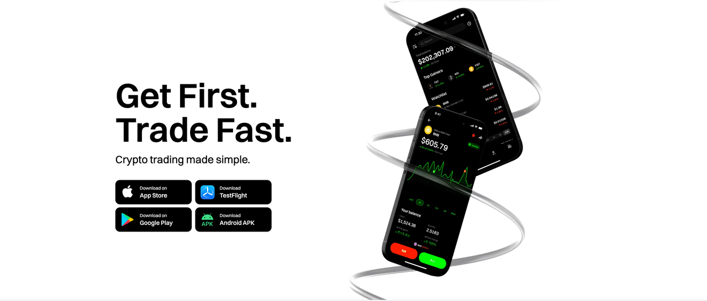

**Download UXUY from App Stores**

* **Android users:** Please go to Google Play, search for **“UXUY”**, and tap **Install**.
* **Apple users:** Please open the App Store, search for **“UXUY”**, and tap **Download** and install.

📌 Make sure to look for the official app name: **UXUY** to avoid downloading counterfeit apps.

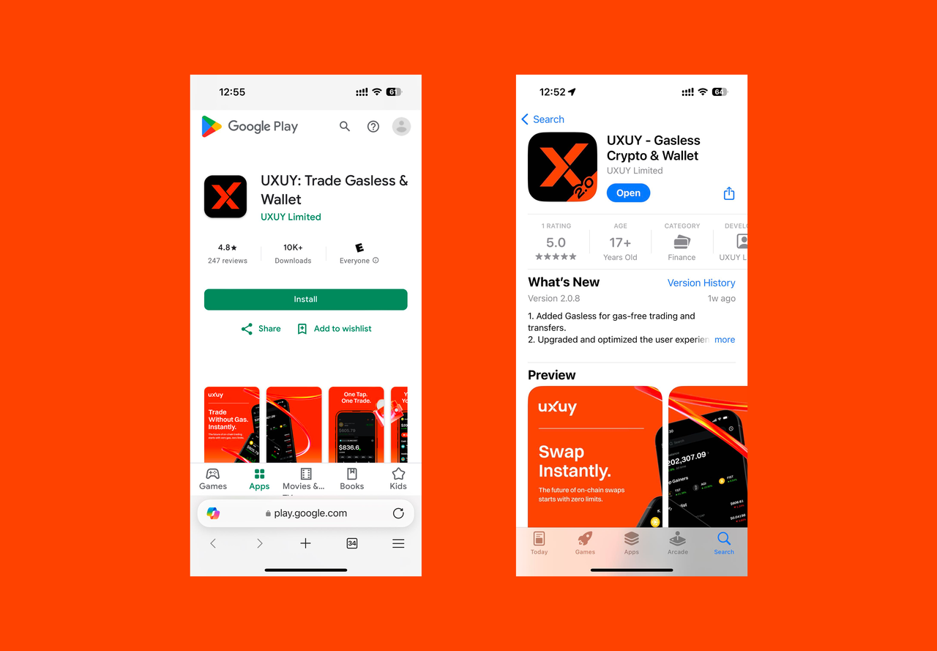

**Using UXUY via TestFlight (iOS Beta Version)**

* Visit the official UXUY website and click the “Download” button, then select the TestFlight version.
* Follow the on-screen instructions to be redirected to TestFlight and complete the official installation process.
* After installation, you can experience the latest iOS beta features of UXUY.

📌 TestFlight is an official Apple testing tool. Please ensure you have the TestFlight app installed before use.

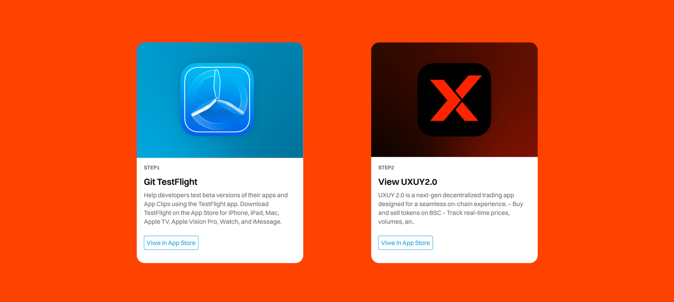

**Create an Account  
 After launching the UXUY 2.0 app, you can quickly create and log in to your account via:**

* One-click login using **Apple ID** or **Google account**
* Register and log in with **email verification code**, no password required

📌 No need for a mnemonic phrase—register and start using immediately for a seamless, barrier-free decentralized exchange experience.

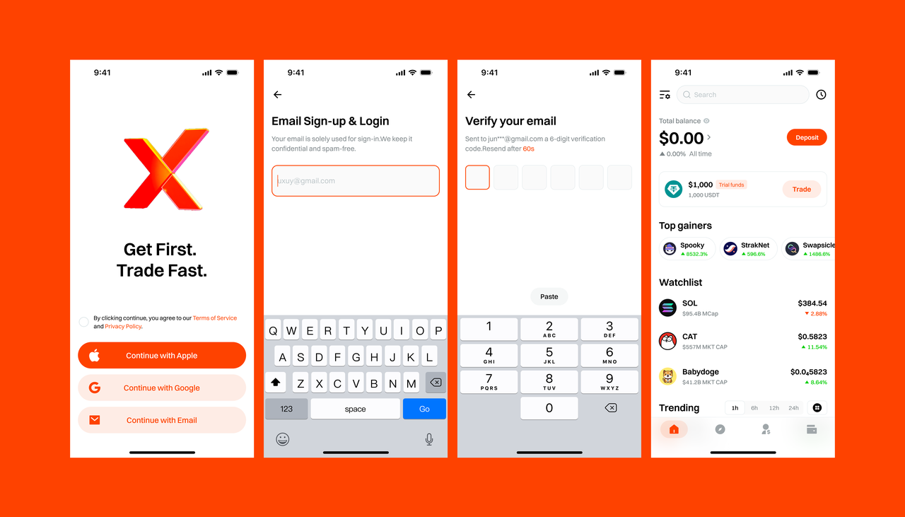

**New User Trial Funds  
 To help every user easily step into the Web3 world, UXUY offers a trial fund trading service for beginners:**

* Receive **$1000 equivalent trial funds** immediately after creating an account
* Experience real on-chain trading processes **without any deposit**
* Use trial funds to buy and sell crypto assets, simulate profits, and learn market mechanisms and trading strategies
* Receive notifications when you earn profits, and you can instantly “sell” trial assets to enjoy the feeling of earning rewards

📌 Risk-free and zero-threshold experience

Allowing every user to quickly understand how decentralized exchanges operate without bearing any financial risk.

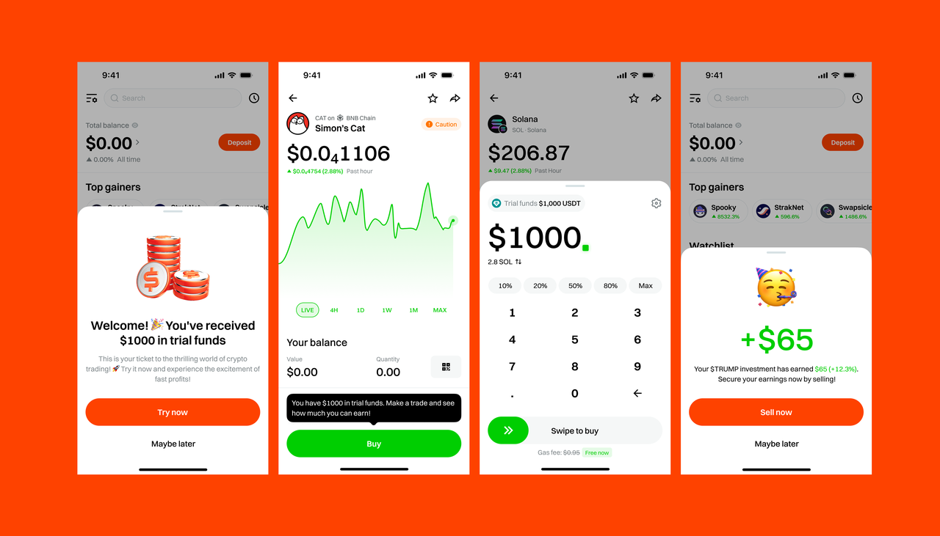

**Referral Commissions**

Invite friends to trade on UXUY and earn over **$10,000+ monthly commissions**. The platform offers high commission rates for stable and continuous earnings—start your crypto income stream now!

**How to Get Your Invitation Code**

* Open the UXUY 2.0 App
* Switch to the **“Referral”** tab
* Tap **“Invite Friends”** to generate and copy your unique referral link

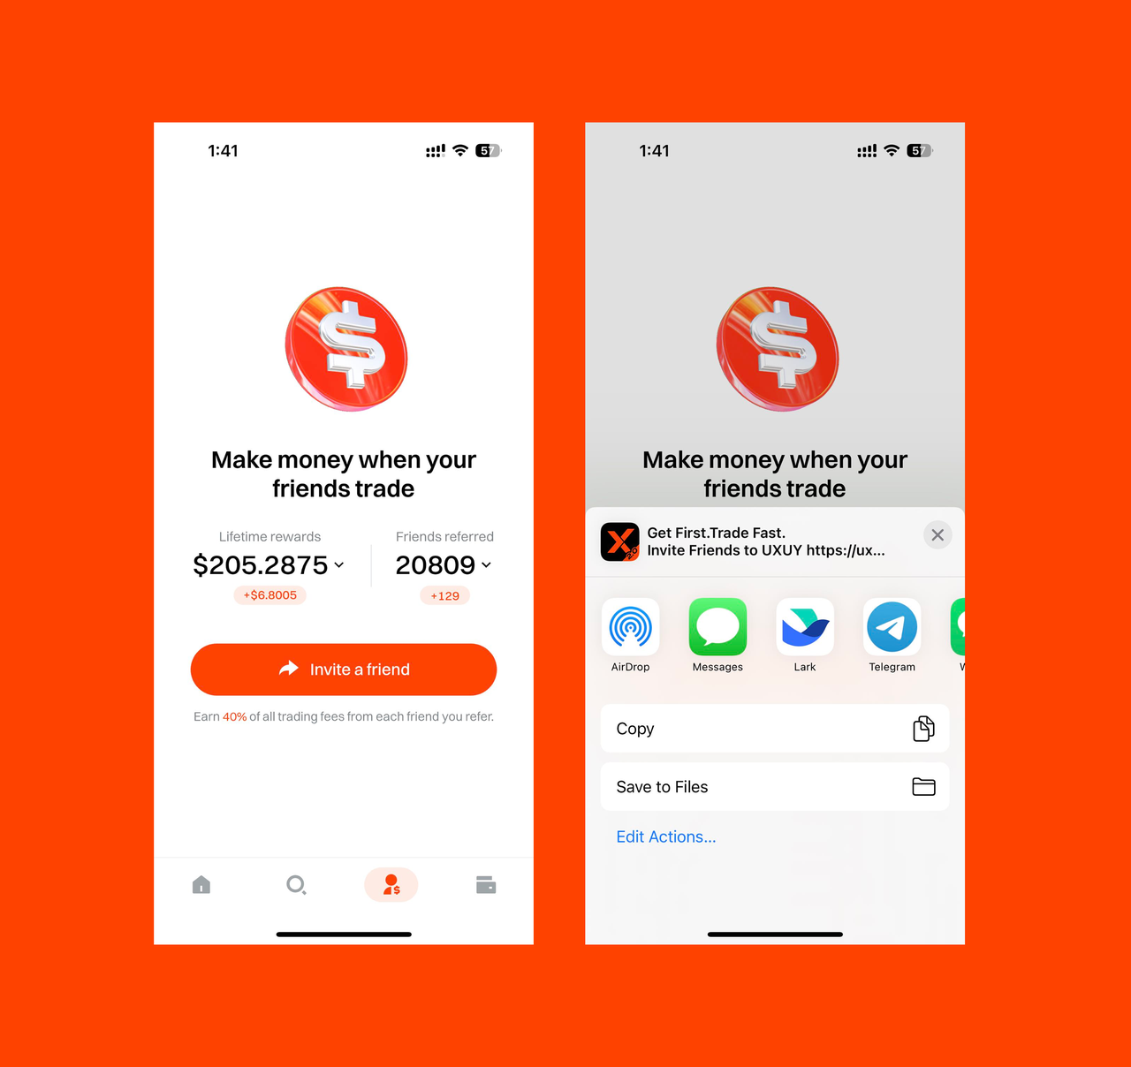

**Share Your Trades & Earn Commissions**

Every time you complete a trade, a personalized shareable image is generated.  
 Friends can scan the QR code to download and register.  
 Trade together, earn together — sharing profits has never been easier!

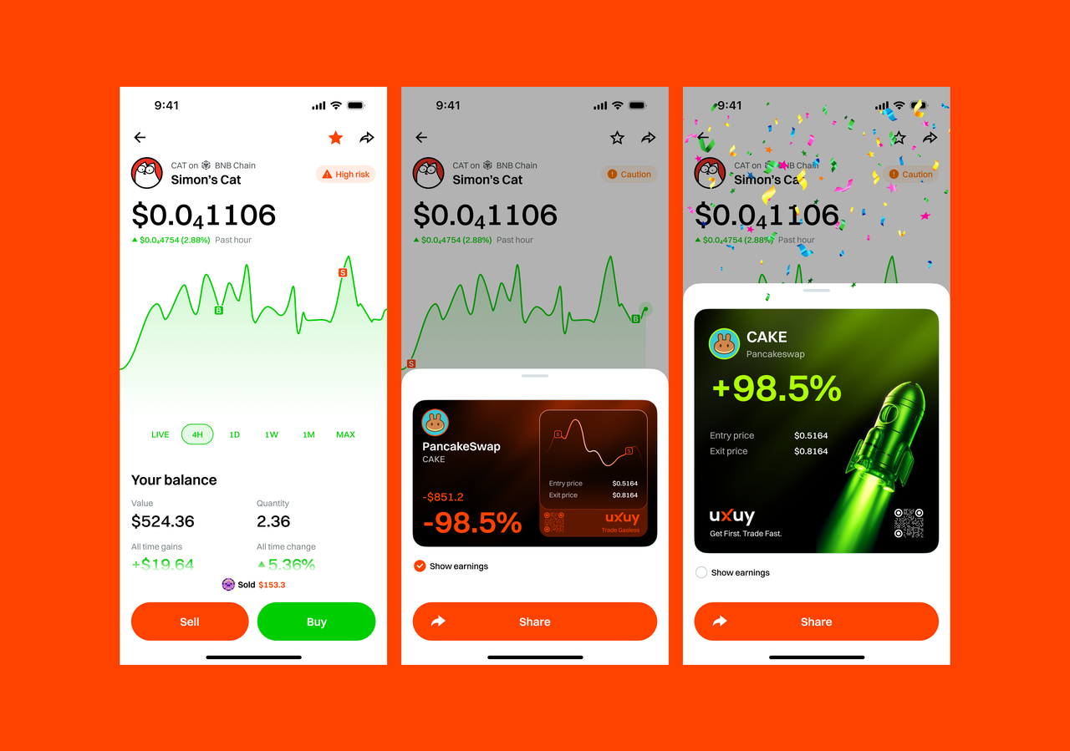

**Mystery Box Invitations**

The mystery box invitation feature is coming soon! More rewards and surprises await you — stay tuned!

**Referral Commission Rates**

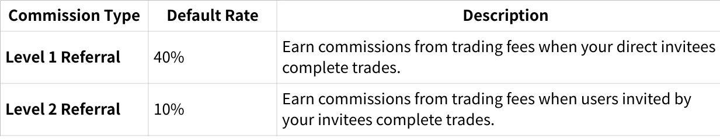

**点击图片可查看完整电子表格**

**Note:** The Level 2 referral commission feature is coming soon. Stay tuned!

**Funds Account**

**Convenient Deposit & Withdrawal Services**

UXUY features an integrated fiat on-ramp and off-ramp aggregation channel, supporting users from countries and regions compliant with local regulations. For single transactions under **$2000**, no KYC is required to quickly buy or sell crypto assets—safe, convenient, and smooth experience.

**How to Operate:**

Open the UXUY 2.0 App, go to the **“Funds”** module, tap **“Deposit”**, then select **“Fiat Purchase”**. The system will automatically detect your IP and match the optimal local fiat channel to help you complete transactions efficiently.

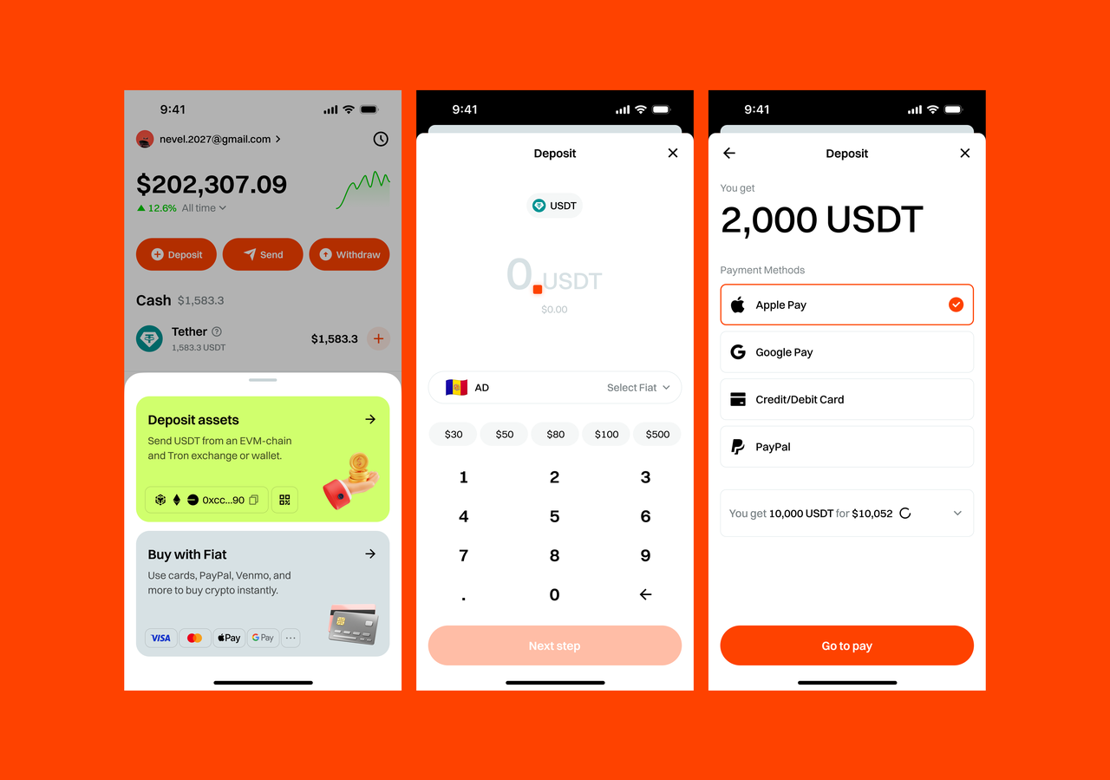

**On-Chain Deposit**

UXUY supports fast and secure deposits via on-chain wallet addresses.

**Steps to Deposit:**

Open the UXUY 2.0 App, go to the **“Funds”** module, tap **“Deposit”**, then select your desired token and network. You can then transfer assets from other wallets or exchanges to the UXUY-supported network address.

**Currently Supported Networks:**

* Ethereum
* BNB Smart Chain
* Base

**Coming Soon:**

* Solana
* TRON

⚠️ Please ensure you select the correct network when depositing to avoid asset loss.

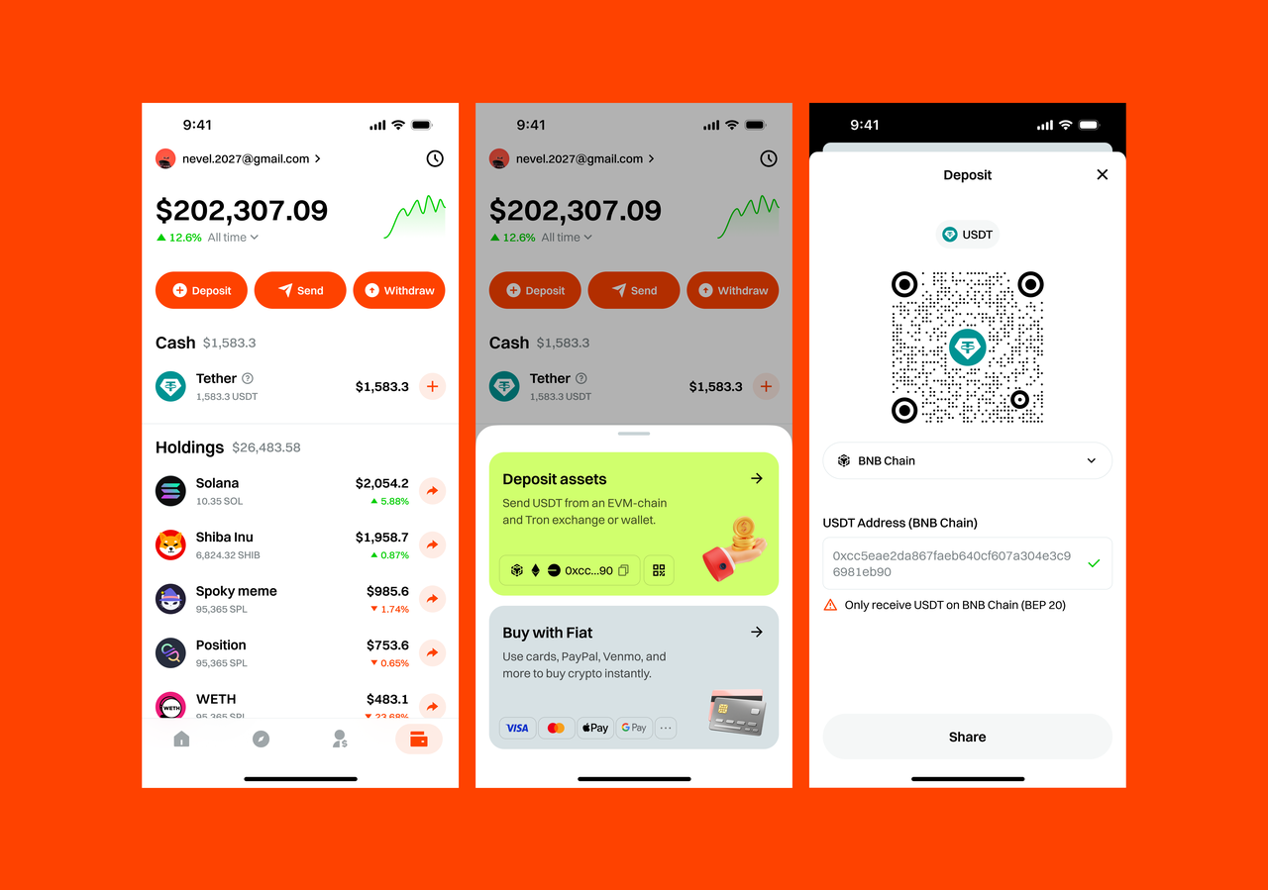

**Product Features**

**GasLess: Gas-Free On-Chain Interaction**

In traditional blockchains, every transfer or contract interaction requires paying gas fees, which can be complex and costly. To lower barriers and enhance user experience, UXUY has independently developed the **GasLess** protocol, enabling truly **“zero-cost on-chain transactions.”**

**Core Advantages:**

* Single transfer or trade amount **≥ 10 USDT** qualifies for gas fee exemption
* No need to pre-fund gas; on-chain broadcasting completes seamlessly
* Currently supports **BNB Smart Chain** and **Base** networks, with more major chains coming soon

GasLess makes every on-chain transaction easier and more efficient!

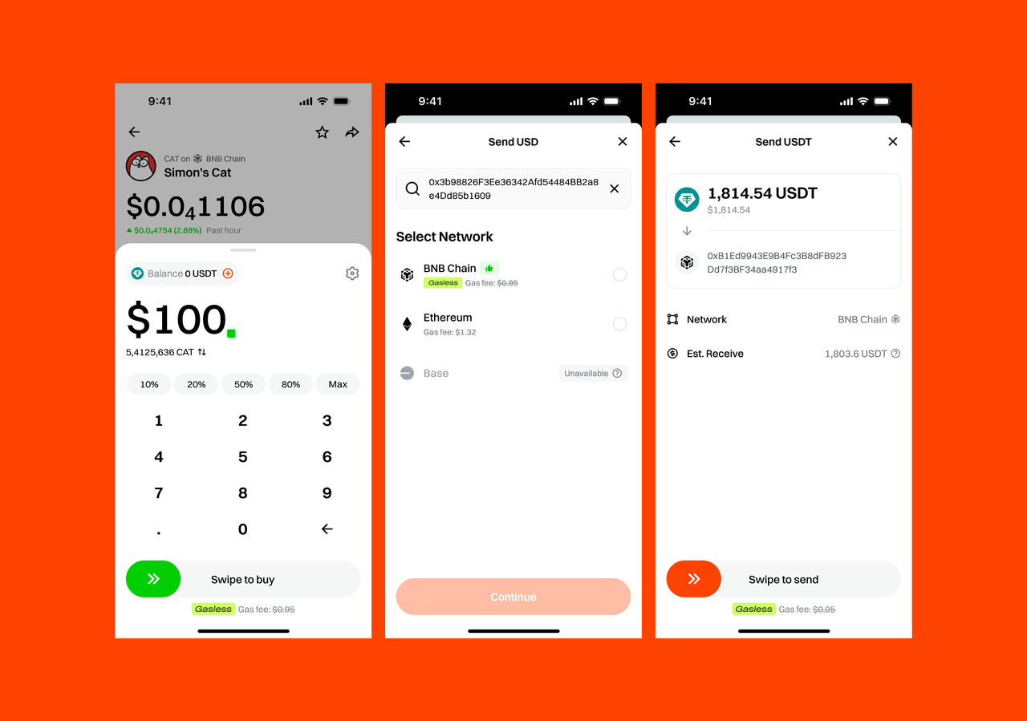

**Cross-Chain Transfers: Multi-Chain Stablecoins, One-Click Connectivity**

UXUY’s built-in instant cross-chain bridge now supports aggregated stablecoin transfers across multiple chains. When you hold USD assets (such as USDT, USDC, etc.) from different networks in your funds account, you can transfer them to any target chain with one click—no need for manual chain switching or intermediaries. This ensures security, efficiency, and a smooth user experience.

**Key Advantages:**

* Instant cross-chain speed with rapid fund arrival
* Supports multi-chain stablecoin aggregation, automatically detecting the source network
* Smart matching of cross-chain paths without complex steps

Making cross-chain transfers simpler and asset flow freer.

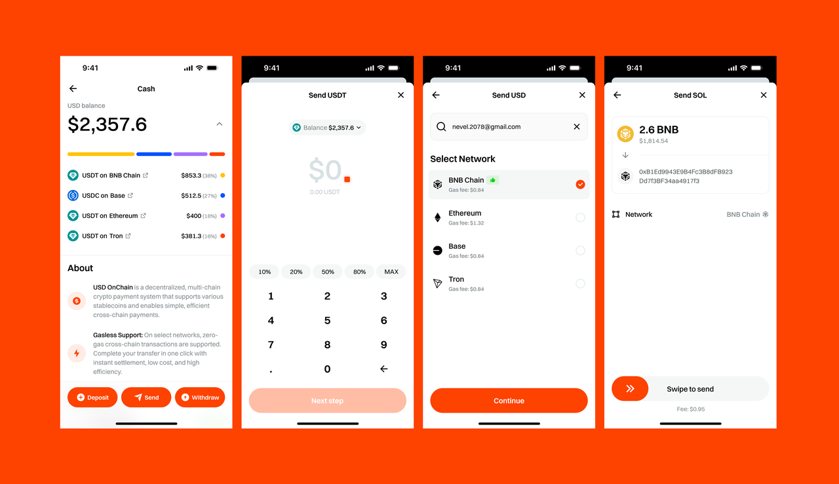

**Cross-Chain Trading Routing: Global Optimal Path Calculation Engine**

Built on UXUY’s proprietary instant cross-chain bridge, we introduce an innovative one-stop cross-chain trading routing mechanism.

When users hold USD stablecoins across multiple chains (such as USDT/USDC on BNB Smart Chain, Base, Ethereum) and want to purchase an asset (e.g., ETH), UXUY automatically queries prices across multiple chains, identifies the best-priced chain, and completes the swap directly on that chain—no manual network switching or asset splitting required.

✅ **Key Features:**

* Automatically detects multi-chain balances
* Smart price inquiries and cross-chain price comparison
* Executes swaps on the chain with the optimal price
* Users only need to click once; the system handles cross-chain allocation and swapping automatically

|  |
| --- |
| Plain Text **[User Wallet Multi-Chain USD Assets]**  ├── Ethereum: 50 USDT  ├── Base: 30 USDT  └── BNB: 20 USDT   │  ▼ **[On-Chain Route Scanning]** → Uniswap、Sushiswap（ETH） → BaseSwap、Aerodrome（Base） → PancakeSwap、MDEX（BNB）   │  ▼ **[Cross-Chain Bridge Cost Evaluation]** → ETH <-> Base → BNB <-> ETH → Base <-> BNB   │  ▼ **[Slippage, Gas, and Swap Outcome Calculation]**   │  ▼ **[Optimal Route Combination Recommendation]**   │  ▼ **[Execute Composite Transactions]** → **Multi-Chain Transaction Initiation** → **Aggregated Routing** → **User Receives ETH** |

**Trading**

**Asset Trading: Breaking Chain Barriers, One-Stop Access to Global Assets**

UXUY leverages its proprietary cross-chain trading protocol to support major public chains such as Ethereum, BNB Smart Chain, Base, Solana, and more. It completely breaks down inter-chain barriers, enabling a seamless multi-chain asset trading experience.

Users can purchase with one click:

* Native on-chain crypto assets
* Real-World Asset (RWA) stocks backed by physical assets
* Multi-asset diversified virtual index funds

No matter which chain the assets are deployed on, UXUY achieves direct cross-chain access and instant execution, making multi-chain asset trading as efficient and convenient as single-chain operations.

**Fee Policy:**

* A 1% service fee is charged on all transaction amounts
* Discounted 0.5% service fee applies to mainstream assets (e.g., ETH, BTC, USDT)
* Single transaction fee capped at $99

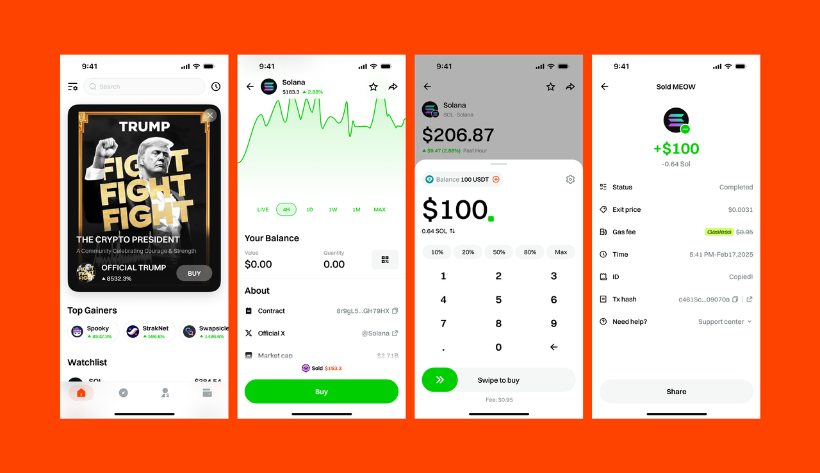

**Leverage Trading — Coming Soon!**

UXUY is launching a brand-new leveraged contract trading feature, supporting multi-asset margin positions, flexible leverage adjustment, and real-time risk monitoring to help users seize more market opportunities.

**Feature Preview:**

* Supports mainstream crypto contract trading (ETH, BTC, etc.)
* Up to 40x leverage
* Real-time liquidation warnings & automatic risk control protection
* Instant execution experience with transparent on-chain settlement

🚀 Exciting upgrade coming soon! (Preview image)

