International UAV Competition
FLight science 2 class project
Uygar Tolga Kara, Tuğrul Yazgan, Arda Furkan Yıldırım, Serdar Yavuz Küçükberber, Deniz Gül Demir, Süleyman Batuhan Demirtaş
TEAM AURORA | YILDIZ TECHNICAL UNIVERSITY

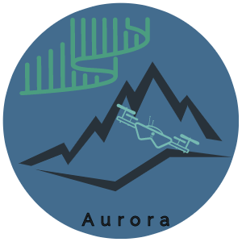

Table of Contents
Figure Contents 2
1. Statement of Work 4
1.1 Intro 4
1.2 What is The Purpose of This Project? 4
1.3 Scope of Work 4
1.4 Tasks 5
1.5 Milestones 5
1.6 Deliverables 5
1.7 Schedule 6
2. System Architecture and System Functions at User Level 7
2.1 Use Case Scenarios 7
2.2 System Architecture 9
3. Test Cases, Criterias and Requirements 11
3.1 User Level Requirements 11
3.2 System Level Requirements 12
3.3 Test Cases and Pass/Fail Criteria at User Level 12
3.4 Test Cases and Pass/Fail Criteria at System Level 13
4. Implementation 14
4.1 System Level Models 14
4.2 Simulation with Simple Controls- Input Methods 16
A. Signal Editor Input Method 16
B. Joystick Input Method 18
C. Data Input Method 19
D. Spreadsheet Data Input Method 20
4.3 Simulation with Simple Controls- Output Methods 21
A. Scopes Data 22
B. Workspace Data 24
C. FlightGear Data 25
D. Simulink 3D Data 26
E. Extract Flight Instruments 28
F. Flight Instruments 29
4.4 Simulation With Simple Controls- Results 29
References 31

Figure Contents
Figure 1- V Diagram Representation ( (Allouis, 2013)) 4
Figure 2- Task 1 Circuit Map 5
Figure 3- Task 2 Circuit Map 5
Figure 4- Task 1 Circuit Map Lengths 8
Figure 5- Task 2 Circuit Map Lengths 8
Figure 6- System Architecture 9
Figure 7- Drone System Architecture 10
Figure 8- Simulation System Architecture 11
Figure 9- Overview System Level Model 14
Figure 10- Signal Editor Selected Command 16
Figure 11- Signal Editor Subsystem 17
Figure 12- Signal Editor X-Y-Z graphs (square route) 17
Figure 13- Signal Editor XYZ coordinates (square route) 18
Figure 14- Joystick Selected Command 18
Figure 15- Joystick Subsystem 19
Figure 16- Data Selected Command 19
Figure 17- Data Subsystem 20
Figure 18- Spreadsheet Data Selected Command 20
Figure 19- Spreadsheet Data Subsystem 21
Figure 20- Scopes Data Subsystem 22
Figure 21- Inside of the Scopes Data Subsystem 22
Figure 22- V_body Scope Results 23
Figure 23- Euler Scope Results 23
Figure 24- X_ned Scope Results 24
Figure 25- Workspace Data Subsystem 24
Figure 26- Inside of Workspace Data Subsystem 25
Figure 27- FlightGear Data Subsystem 25
Figure 28- Flightgear Subsystem Inside 26
Figure 29- Simulink 3D Data Subsystem 26
Figure 30- Inside of Simulink 3D Subsystem 27
Figure 31- Simulink 3D Isometric Caption 27
Figure 32- Extract Flight Instruments Subsystems 28
Figure 33- Inside of Extract Flight Instruments Subsystem 28
Figure 34- Flight Instruments Subsystem 29
Figure 35- X Values Comparison 29
Figure 36- Y Values Comparison 30
Figure 37- Z Values Comparison 30

Table Contents
Table 1- Project Milestones 5
Table 2- Deliverables 6
Table 3- Schedules Task Sharing 6
Table 4- User Level Requirements 11
Table 5- System Level Requirements 12
Table 6- Pass Fail Criteria at User Level 12
Table 7- Pass Fail Criteria at System Level 14
Table 8- System and Subsystem Table 15

Statement of Work

Intro
This project contains the modeling and simulation of a quadcopter for Teknofest competition. Yıldız Technical University, Applied Sciences Faculty, Aviation Electrical and Electronics department second year students are involved in this project. As an external factor, AURORA UAV competition team is affected by this project as means of design and simulation needs.

What is The Purpose of This Project?
The purpose of this project is to construct a simulation environment for quadcopter to test in different situations. Deliverables are the report, simulation model, design model and other files. (scripts, models) Objectives are to construct a simulation environment, run the simulation and obtain the results. Also, another objective is that to try different equipment choices and find the optimum solution with the help of software applications. Due to optimum solution, making simulation is required. Since this is a nonprofit simulation project, the return on investment is hundred percent.

Scope of Work
Simulating a quadcopter is needed in this project. This requires software options such as: MATLAB, Simulink, Stateflow. Also, some external CAD design tools might be used minimally. For the aim of completing the simulation, we need to use the left half of V diagram. Outcomes are an simulation environment that might be used for live competition testing, scripts for testing different kind of models and finding the optimum configuration. Nearly 2 months are given for this project.
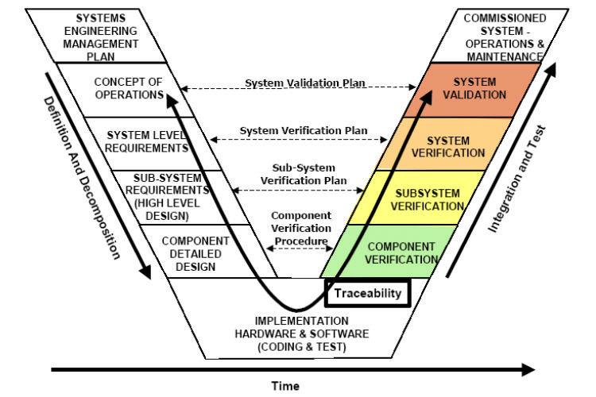
Figure 1- V Diagram Representation ( (Allouis, 2013))

Tasks
For competition wise, tasks are as following:
- As task 1, complete a lap which includes turning from 3 poles. This includes two 180 degrees turns and one 360 degrees turn. Make two laps in 5 minutes maximum. In detail:
- Take off from point A
- Make 180 degrees turn around pole 1
- Make 360 degrees turn around pole 2
- Make 180 degrees turn around pole 3
- Repeat previous steps for the second lap
- Land at point B
- As task 2, complete a lap which includes turning from 2 poles. This includes two 180 degrees turns. In lap 2, take water from red zone and deliver it to blue zone and complete the lap. Complete the task in 5 minutes maximum. Least needed water to take is 250 ml.
- Take off from point A
- Make 180 degrees turn around pole 1
- Make 180 degrees turn around pole 2
- Make 180 degrees turn around pole 1
- Take water from red zone (extra weight)
- Deliver water to blue zone (reduce weight)
- Make 180 degrees turn around pole 2
- Land at point B
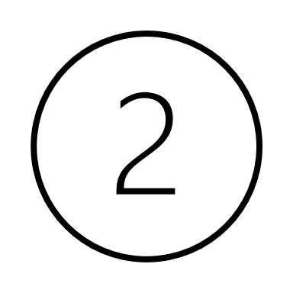
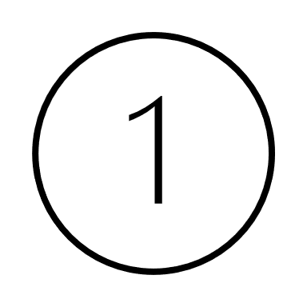
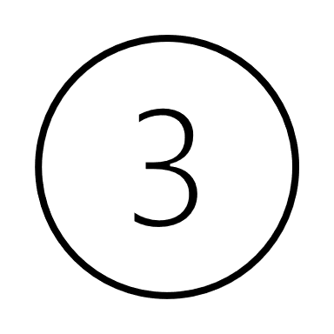
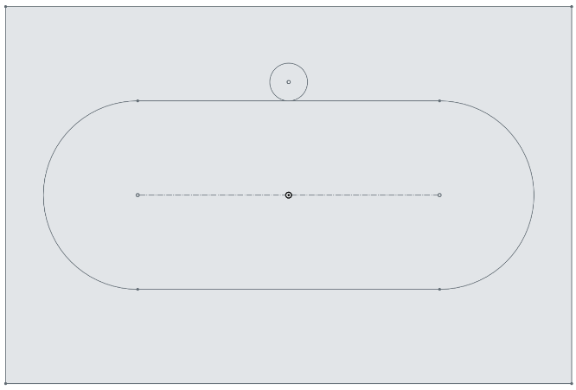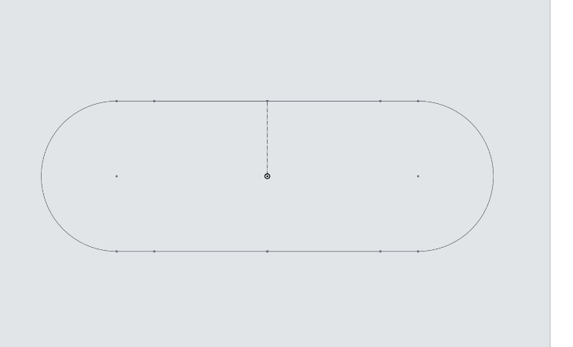
A
B
B
A
Figure 2- Task 1 Circuit Map
Figure 3- Task 2 Circuit Map

Milestones
Project Start | 08/03/2021
Project Finish | 07/06/2021
Amount of Time | 93 days
Table 1- Project Milestones

Deliverables
Week | Date | Deliverables
1 | 08/03/2021 | Project report page 1
2 | 15/03/2021 | Statement of work
3 | 22/03/2021 | System architecture and system functions/ Use case scenario(s)
4 | 29/03/2021 | Test cases to satisfy the requirements and pass/fail criteria at system level and user level.  User Level Requirements / System Level Requirements
5 | 05/04/2021 | Implementation (System level models, simulation with simple controls)  Components and Component Level Requirements (COTS - Use actual components)
6 | 12/04/2021 | Component level models and simulations per requirements
7 | 19/04/2021 | Component level models and simulations per requirements
8 | 26/04/2021 | Subsystem level models and simulations per requirements
9 | 03/05/2021 | Subsystem level models and simulations per requirements
10 | 10/05/2021 | System level models and simulations per requirements
11 | 17/05/2021 | System level models and simulations per requirements
12 | 24/05/2021 | Design of experiments
13 | 31/05/2021 | Design of experiments
Table 2- Deliverables

Schedule
This project is kicked off in 8 March. The period of performance 93 days. The review stage is between 1st - 8th days, development stage is between 8th- 22nd days, implementation stage is between 22nd -71st days, testing stage is 71st -86th days and verification stage in 86th-93rd days. The closing date of the project is 7 June. There might be minimal time differentiations between stages due to factors.

Table 3- Schedules Task Sharing

System Architecture and System Functions at User Level

Use Case Scenarios
For competition wise, tasks are as following:
- As task 1, complete a lap which includes turning from 3 poles. This includes two 180 degrees turns and one 360 degrees turn. Make two laps in 5 minutes maximum. In detail:
- Autonomously or manually take off from point A in 5 seconds.
- Make 180 degrees turn around pole 1.
- Make 360 degrees turn around pole 2.
- Make 180 degrees turn around pole 3.
- Repeat previous steps for the second lap.
- Cross the finishing line autonomously.
- Autonomously or manually land at point B.
Task 1 point system is as following:
- $P_{G1}=10\frac{W_{min}}{W_{tk}}+10\frac{t_{min}}{t_{tk}}$
Where the parameters are:
- $W_{min}=$ The lowest take-off weight of all teams successful in the relevant task
- $W_{tk}=$ Team take-off weight on the respective task
- $t_{min}=$ Minimum time for all teams in the relevant task
- $t_{tk}=$ Time for the team to perform the task

- As task 2, complete a lap which includes turning from 2 poles. This includes two 180 degrees turns. In lap 2, take water from red zone and deliver it to blue zone and complete the lap. Complete the task in 7 minutes maximum. Least needed water to take is 250 ml.
- Autonomously or manually take off from point A in 5 second.
- Make 180 degrees turn around pole 1
- Make 180 degrees turn around pole 2
- Make 180 degrees turn around pole 1
- Take water from blue zone (extra weight)
- Deliver water to red zone (reduce weight)
- Make 180 degrees turn around pole 2
- Cross the finishing line autonomously
- Autonomously or manually land at point B
Task 2 point system is as following:
- $P_{G2}=15\frac{t_{min}}{t_{tk}}+20\frac{{DSM}_{tk}}{{DSM}_{max}}$
Where the parameters are:
- ${DSM}_{tk}=$ The body of water poured by the team
- ${DSM}_{max}=$ Maximum water mass for all teams in the respective task
30 meters
30 meters
150 meters
100 meters
150 meters
100 meters
30 meters
80 meters
A
B
B
A
Figure 4- Task 1 Circuit Map Lengths
Figure 5- Task 2 Circuit Map Lengths
The general rules for the tasks are as follows:
- There should be no plagiarism in simulation modelling.
- The images of the UAV’s take off, horizontal endless cycle flight maneuver and uninterrupted landing are recorded in a maximum of 2 minutes.
- The UAV in the report and the UAV in the simulation must have same characteristics.
- The first mission needs to be completed before second mission.
- Planned maximum flight times are 6 in the simulation. The planned days to simulate is 3.
- Flight needs to be completed in appropriate environment conditions.
- Minimum flight altitude is 5 meters while maximum flight altitude is 30 meters.
- UAV in simulation needs to protect structural integrity.
- Maximum preparation time for both tasks are 3 minutes.
- Maximum simulation time for task 1 is 5 minutes.
- Maximum simulation time for task 2 is 7 minutes.
- AES system needs to be implemented to provide a means of safe flight. In AES mode,
- Half thrust
- Controlled landing
- Zero thrust (With referee command)
- Weight taking and leaving system needs to be implemented.
- While water taking and leaving flight altitude control is not applied.
- In after the mission and before the mission, measured UAV weight’s differences need to be at maximum of 10 grams.
- Maximum UAV weight is 4 kilograms. (with extra weight)
- There needs to be a button to shut the connection to battery.
- Autonomously, according to the coordinate, speed, and altitude data to be uploaded to the software, it manages the hover, cruise, and landing processes.
- GPS, IMU, sonar, lidar, pressure sensor etc. of the UAV. data from sources works.
- Speed, altitude, position, stance values during flight needs to be reported.
- The height of the reference poles are 5 meters.
- Water taking area’s diameter is 3 meters and the height is nearly 70 cm. Water leaving area’s diameter is 2.5 meters and height is nearly 100 cm.
- The Water Drop Area happens along a specific line. The water drop area is above the center line thirty (30) m left or thirty (30) m right in any intermediate zone.
- The water should be poured into the Water Drop Area. Pouring water out of the area the task is considered unsuccessful.
- During the mission flight, the UAVs will move from the flight zone to the buffer zone for a maximum of two can exit times. Buffers departing to the restricted area or more than two Duties of UAVs leaving the region are deemed unsuccessful.
- Ten (10) meters distance between no-fly zone and flight zone It is considered as a buffer zone.
- It is planned to be done on MATLAB and Simulink in modeling.
- The criteria must be followed when modeling the parts of the HA and the components used. Each of the UAV projects is a multi-disciplinary engineering project.

System Architecture
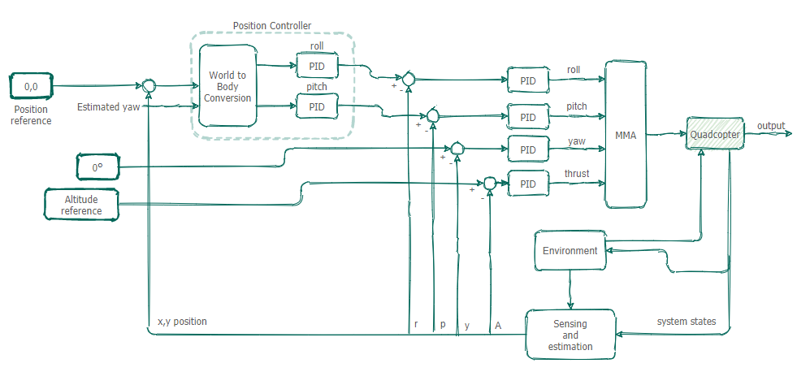
Figure 6- System Architecture
System architecture consists of:
- 6 PID controllers
- Environment block
- Sensor “Sensing” block
- Plant “Quadcopter” block
- Motor mixing algorithm
- Reference blocks
- Conversion block
- Simulation block
System architecture may be thinked as a close loop feedback control system. There may also be some extra blocks for simulation, joystick control, visualization, support utilities.
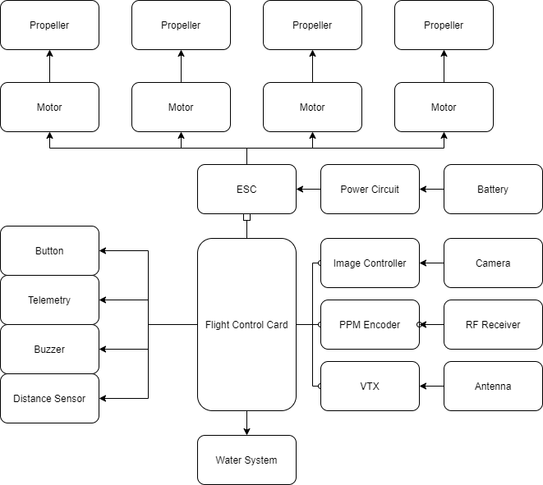
Figure 7- Drone System Architecture
In drone-wise, the system architecture consists of these parts. These parts may be changeable.
We may see that some of the parts that the drone consists of:
- Flight Control Card
- ESC
- 4 Motors
- 4 Propellers
- Power Circuit
- Battery
- Button
- Telemetry System
- Buzzer
- Distance Sensor
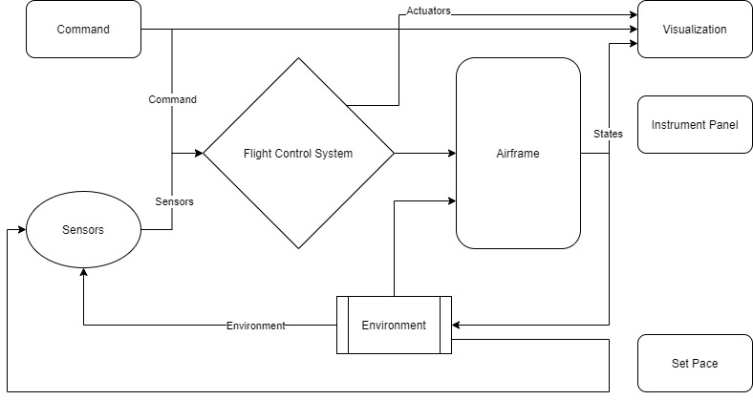
Figure 8- Simulation System Architecture
The system architecture regarding simulation is given in figure 8, above. Sensors block include multiple sensors, for example distance sensor, altimeter, gyrometer, IMU and so on.

Test Cases, Criteria and Requirements

User Level Requirements

No | Type of Requirement | Explanation of Requirement
1 | Transferability | Simulation files needs to be able to get transferred between computers.
2 | Compatibility | Simulation files needs to be compatible with different computer types.
3 | Preparation | Simulation files needs to load themselves while getting opened.
4 | No Error Work | When worked, simulation file needs to be simulated without errors.
5 | Observability | User needs to be able to observe the simulation in 4 ways:  - Scopes  - Workspace Variables  - Flightgear Environment  - Simulink 3D Environment
6 | Controllability | User needs to be able to control the simulation in 4 ways:  - Signal Editor  - Joystick  - MATLAB Data  - Spreadsheet Data
7 | Analyze Work | User needs to be able to pause and analyze the simulation as well as save flight parameters and store the parameters in a MAT file.
Table 4- User Level Requirements

System Level Requirements
No | Type of Requirement | Explanation of Requirement
1 | Autonomous take off | Drone needs to take off autonomously or take off manually and pass to autonomous mode in 5 seconds from the take-off area.
2 | Autonomous hovering | Drone needs to hover autonomously at a fixed altitude.
3 | Autonomous flight | Drone needs to be able to fly autonomously in 3 modes of control. In 3 modes, the drone needs to follow a set of coordinates.
4 | Autonomous landing | Drone needs to land at designated area autonomously.
5 | Usage of Emergency Features | Drone needs to use Land and Return to Home features in case of emergency.
6 | Water intake | At the designated water intake area, drone needs to get at least 250ml of water as an extra weight in the simulation.
7 | Water removal | At the designated water removal area, drone needs to remove at least 250 ml of water as reduced weight in the simulation.
8 | Joystick Control | In control mode 2, drone needs to be able to get controlled with a joystick while following a designated path.
9 | Data Logging | System needs to save previous flight characteristics.
Table 5- System Level Requirements

Test Cases and Pass/Fail Criteria at User Level
Test Cases | Scenario | Pass Criteria | Fail Criteria
Task 1,2 | Transferability | The simulation files can be transferred between computers. | The simulation files cannot be transferred between computers.
Task 1,2 | Compatibility | The simulation files are compatible with reader’s program. | The simulation files are not compatible with reader’s program.
Task 1,2 | Preparation | Simulation project file gets loaded during the sequence. | Simulation project file does not gets loaded during the sequence.
Task 1,2 | Errors | There are no errors before, during and after the simulation. | There are errors before, during and after the simulation.
Task 1,2 | Observability | User can observe the simulation in 4 different ways. | User cannot observe the simulation in 4 different ways.
Task 1,2 | Controllability | User can control the simulation in 4 different ways. | User cannot control the simulation in 4 different ways.
Task 1,2 | Analyze Work | User can analyze the simulation in different methods. | User cannot analyze the simulation in different methods.
Table 6- Pass Fail Criteria at User Level

Test Cases and Pass/Fail Criteria at System Level
Test Cases | Scenario | Pass Criteria | Fail Criteria
Task 1,2 | Autonomous Take Off | The drone takes off autonomously by the aid of an altitude controller into which the potential resulting error is fed and which uses that information to determine how to increase or decrease thrust. Or take off manually and pass to autonomous in 5 seconds. | The drone does not take off autonomously or manually and pass to autonomous in 5 seconds, which can be caused by incorrect measurement of the drone altitude and failing to feed it back to compare it to an altitude reference.
Task 1,2 | Autonomous Hovering | The drone hovers autonomously and maintain level flight with the use of a position controller that will know when the drone is wandering off and make the  necessary corrections. | The drone does not hover autonomously or wanders off from the reference point due to disturbances which induce roll or pitch into the system, getting incorrect position errors because of maloperation of the position controller.
Task 1,2 | Autonomous Flight | The drone follows a set of coordinates in 3 modes. Also drone stays in flight zone | The drone does not follow a set of coordinates in 3 modes. Also drone drifting apart from the flight zone
Task 1,2 | Autonomous Landing | The drone lands autonomously to the landing zone in simulation. | The drone does not land autonomously to the landing zone in the simulation.
Task 1,2 | Usage of Emergency Features | The drone can apply Land and Return to Home features.  Land: The drone will land in its current location.  Return to Home: The drone will ascend to a safe altitude and return to the home point. | The drone can not apply Land and Return to Home features in case of emergency.
Task 2 | Water Intake | The drone gets at least 250 ml of water in simulation. Also, drone does not drop water until water removal. | The drone does not get at least 250 ml of water in simulation. Also, drone does drop water until water removal.
Task 2 | Water Removal | The drone removes at least 250 ml of water to the water removal zone in simulation. | The drone does not remove at least 250 ml of water to the water removal zone.
Task 1,2 | Joystick Control | The drone can be controlled with a joystick. | The drone cannot be controlled with a joystick.
Task 1,2 | Data Logging | The drone saves flight characteristics; stores location, altitude, and speed data as a log record during the flight. | The drone does not save flight characteristics.
Table 7- Pass Fail Criteria at System Level

Implementation

System Level Models
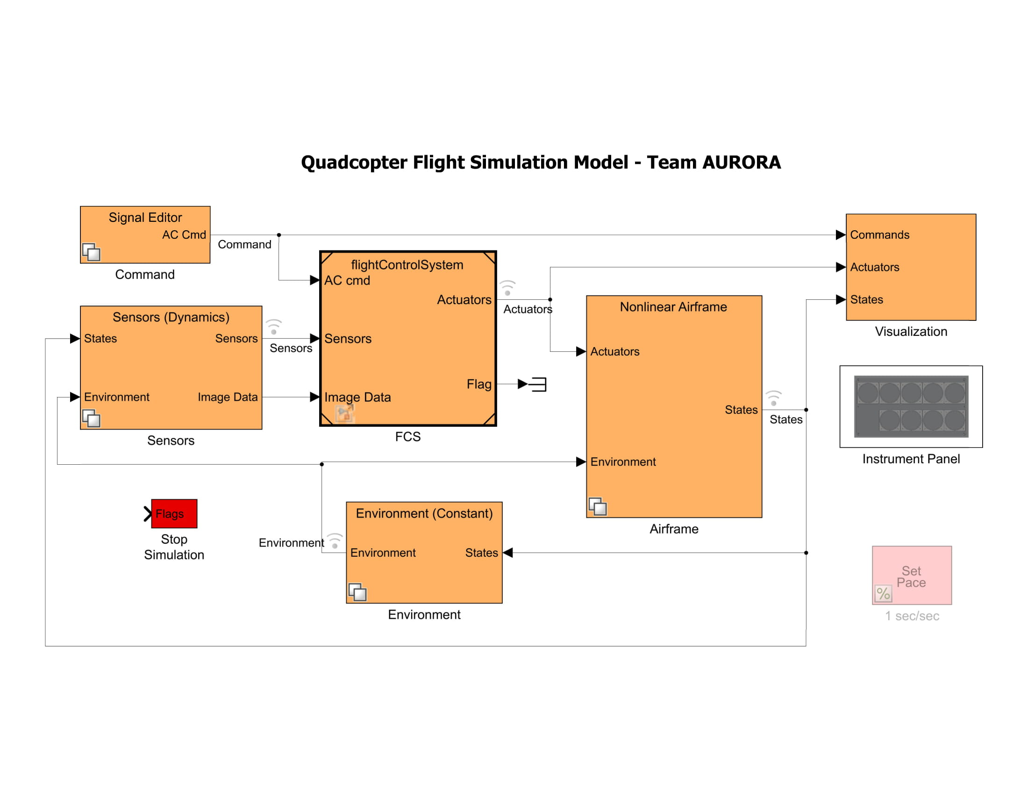
Figure 9- Overview System Level Model
Overview of whole system is given in figure 9 above. We need to note that whole system divides into several systems of systems where we are going to consider as systems. Therefore, the system and subsystem table are as following:
For this section, we are only going to analyze divided systems. (Not subsystems)

Table 8- System and Subsystem Table

Simulation with Simple Controls- Input Methods
For simulation control, we have 4 methods:
- Signal Editor method
- Joystick method
- Data method
- Spreadsheet Data method

Signal Editor Input Method
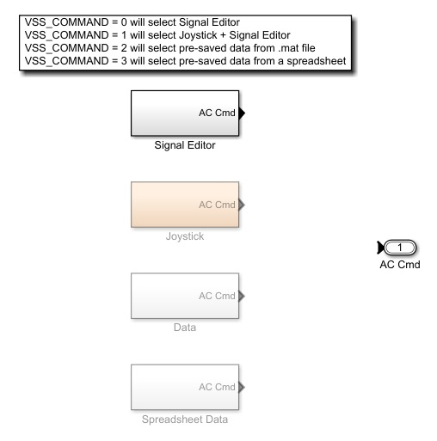
Figure 10- Signal Editor Selected Command
For this type of control method, we need to enter several coordinates. Among the 3 of the pre entered autonomous control methods this method may be the most practical thinking that the program fills the required coordinates between entered coordinates. To run a simulation, let try to enter a set of coordinates for a square waypoint spanning 500 meters:
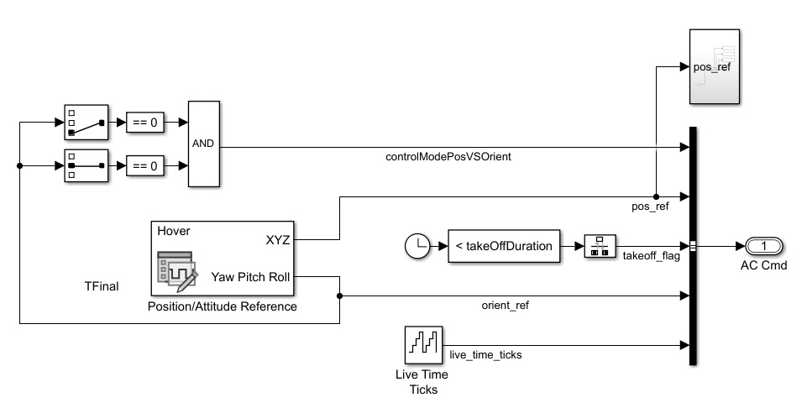
Figure 11- Signal Editor Subsystem
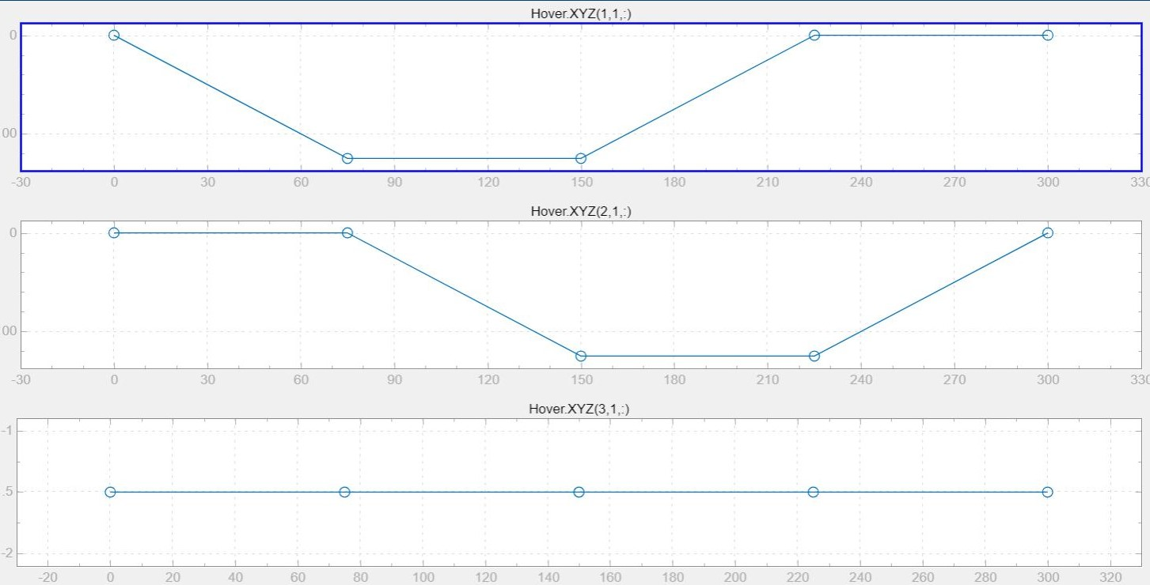
Figure 12- Signal Editor X-Y-Z graphs (square route)
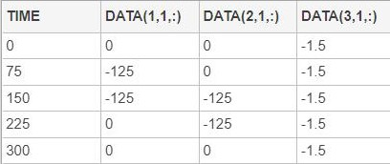
Figure 13- Signal Editor XYZ coordinates (square route)

Joystick Input Method
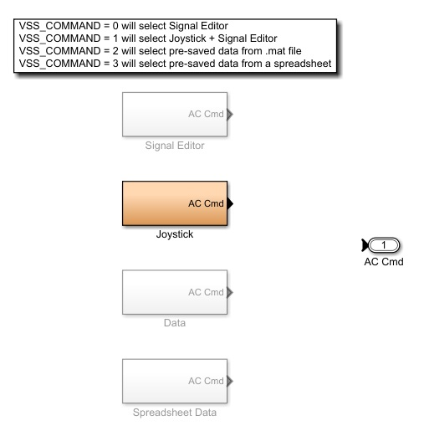
Figure 14- Joystick Selected Command
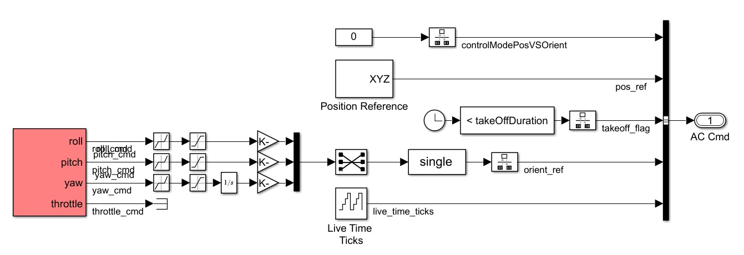
Figure 15- Joystick Subsystem

Data Input Method
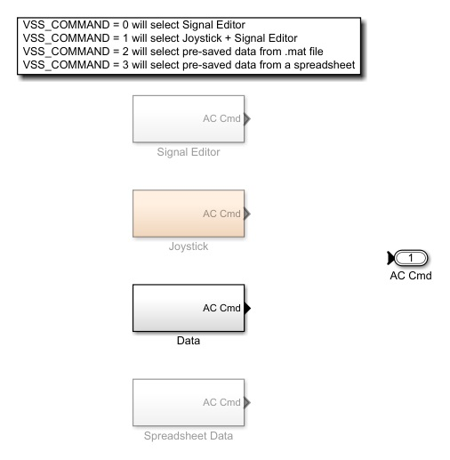
Figure 16- Data Selected Command
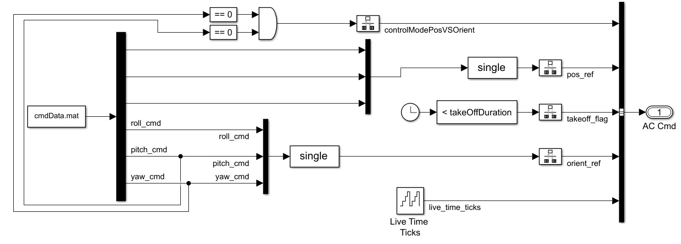
Figure 17- Data Subsystem
cmdData.mat file is a double timeseries consisting of 6 data columns and time values column.

Spreadsheet Data Input Method
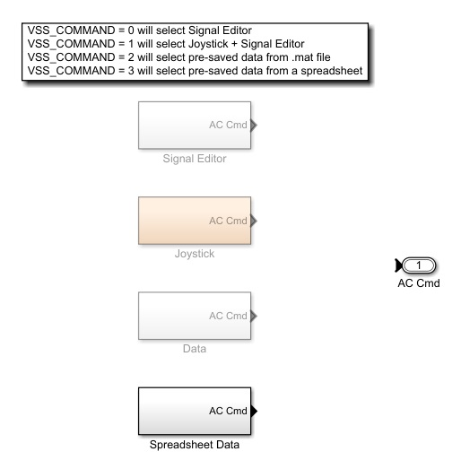
Figure 18- Spreadsheet Data Selected Command
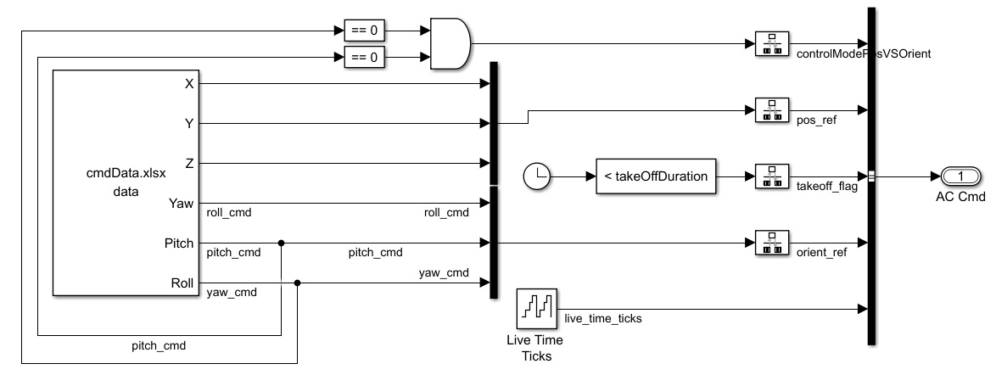
Figure 19- Spreadsheet Data Subsystem
cmdData.xlsx file is an excel file consisting of 6 data columns and time values column.

Simulation with Simple Controls- Output Methods

For simulation observation, we have 4 methods:
- Scope’s data
- Workspace data
- FlightGear data
- Simulink 3D Data
- Extract Flight Instruments
- Flight Instruments

Scopes Data
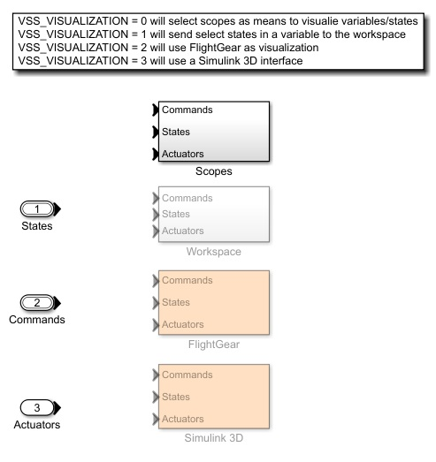
Figure 20- Scopes Data Subsystem
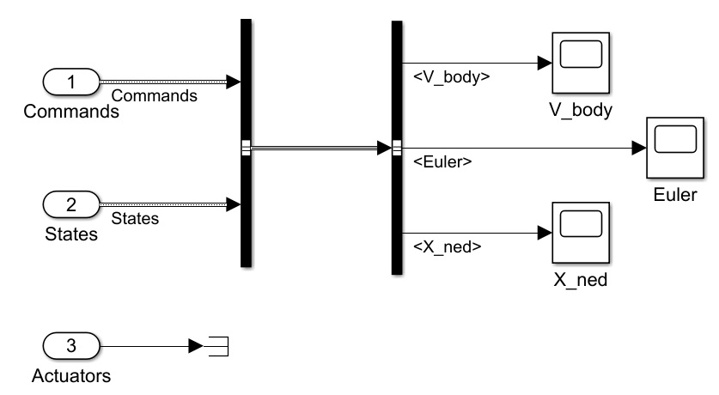
Figure 21- Inside of the Scopes Data Subsystem
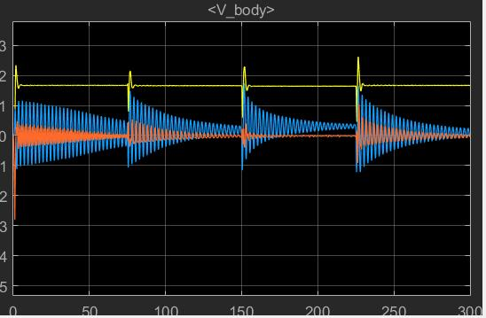
Figure 22- V_body Scope Results
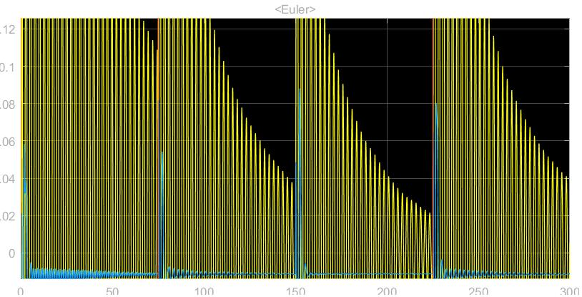
Figure 23- Euler Scope Results
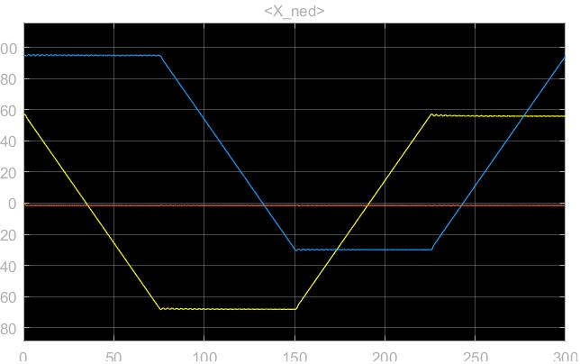
Figure 24- X_ned Scope Results

Workspace Data
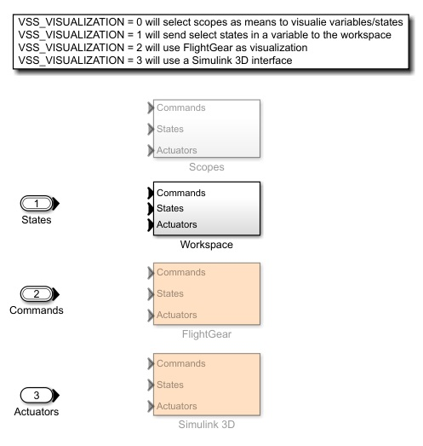
Figure 25- Workspace Data Subsystem
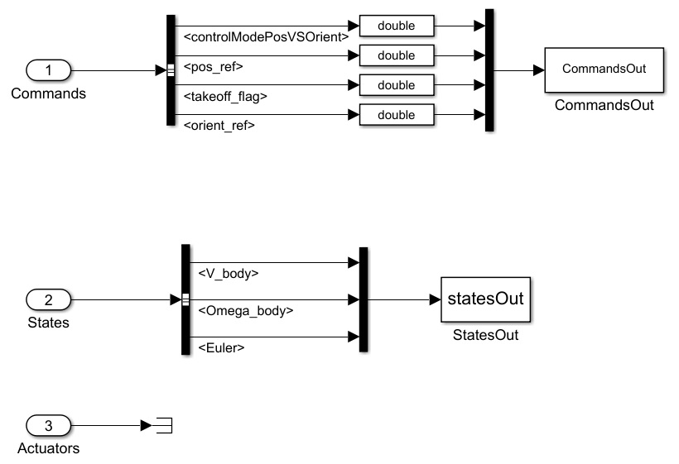
Figure 26- Inside of Workspace Data Subsystem

FlightGear Data
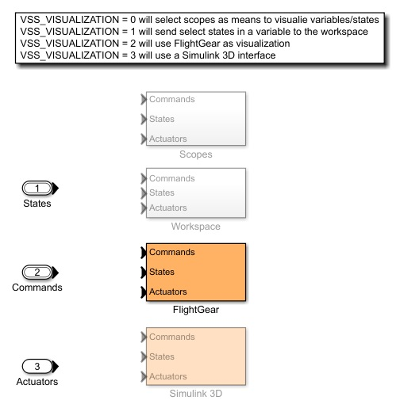
Figure 27- FlightGear Data Subsystem
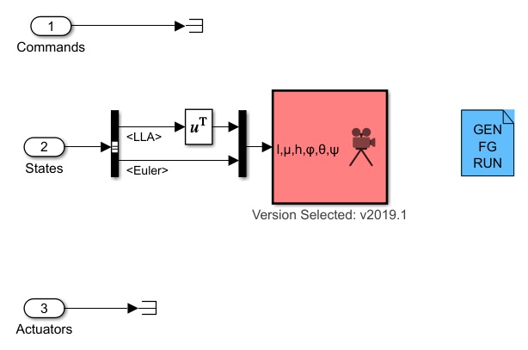
Figure 28- Flightgear Subsystem Inside

Simulink 3D Data
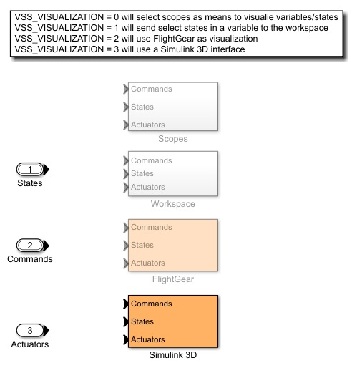
Figure 29- Simulink 3D Data Subsystem
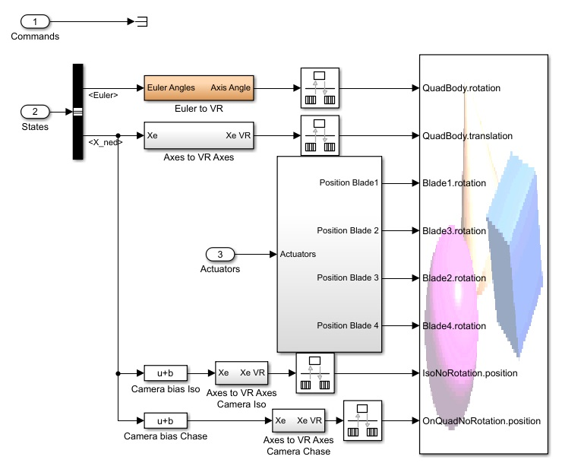
Figure 30- Inside of Simulink 3D Subsystem
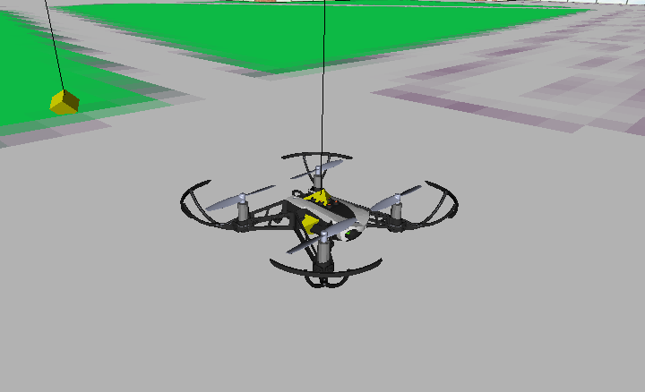
Figure 31- Simulink 3D Isometric Caption

Extract Flight Instruments
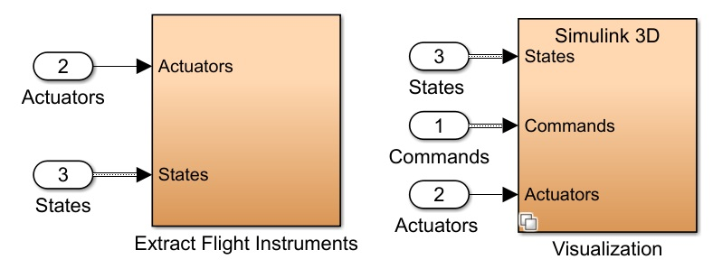

Figure 32- Extract Flight Instruments Subsystems
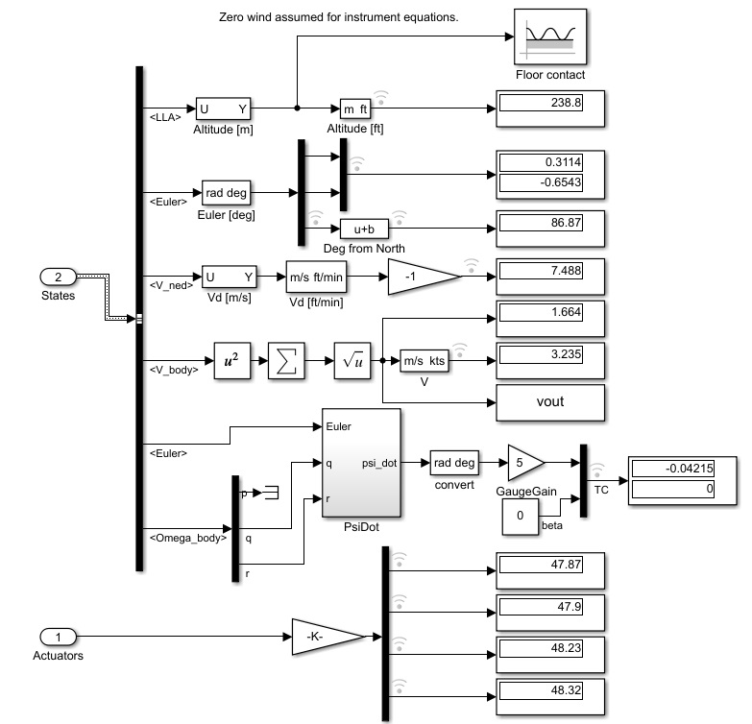
Figure 33- Inside of Extract Flight Instruments Subsystem

Flight Instruments
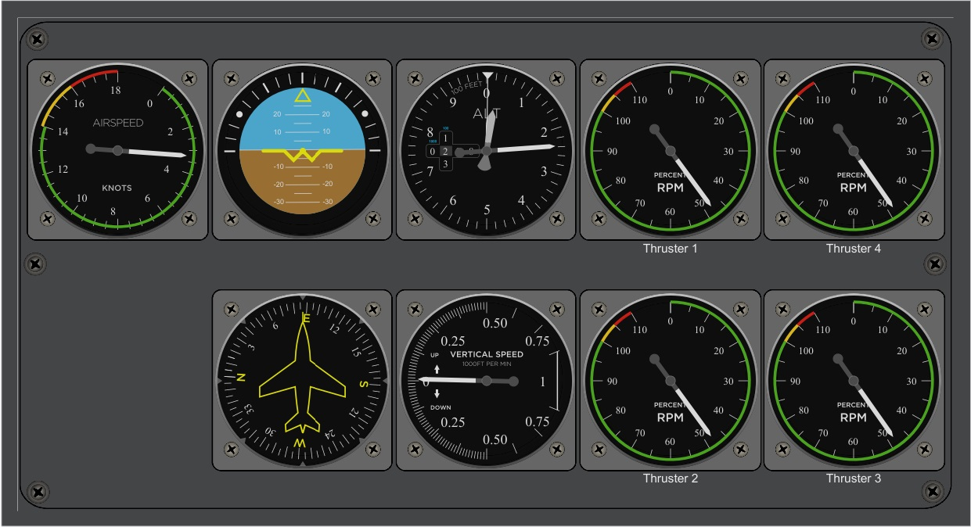
Figure 34- Flight Instruments Subsystem

Simulation with Simple Controls- Results
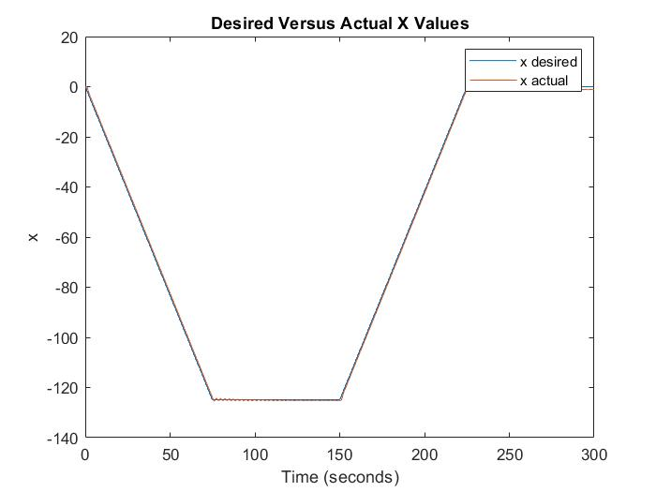
Figure 35- X Values Comparison
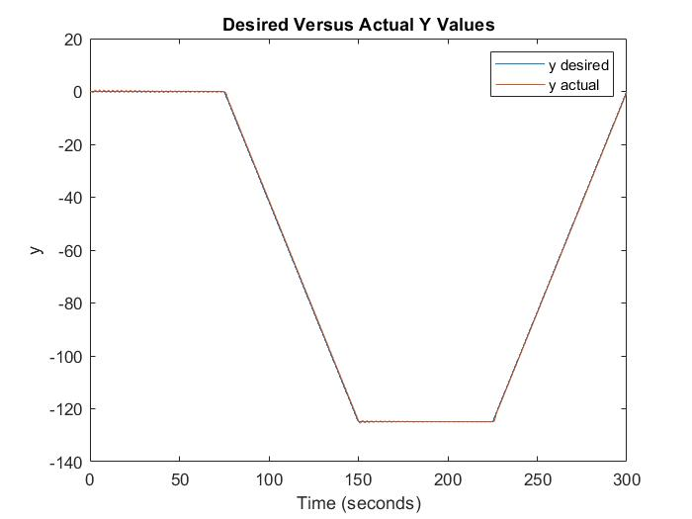
Figure 36- Y Values Comparison
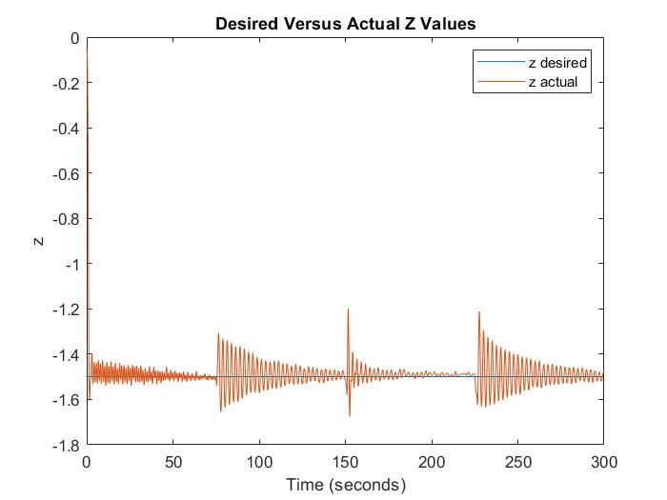
Figure 37- Z Values Comparison

References
Allouis, E. (2013, May). Figure 2 - uploaded by Elie Allouis. Retrieved from ResearchGate: https://www.researchgate.net/figure/The-Systems-Engineering-V-Diagram_fig2_320585817

