This week my task is to create and test markers with the logo of Words Worth Learning. I have created a marker with the logo(Figure 1.) I found on the web site of WWL and tested it but it was unable to be processed by marker detection algorithm, probably due to white and black ratio in the marker.



Figure 1.

Then I created 6 different markers with different ratios. Also I modified the logo slightly in some markers and created some bolder logos in order to test if that would affect the end result.
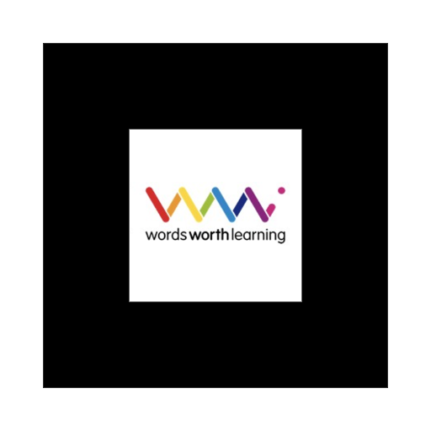
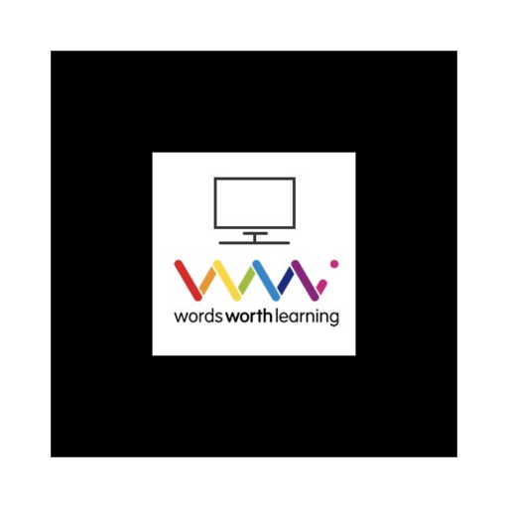
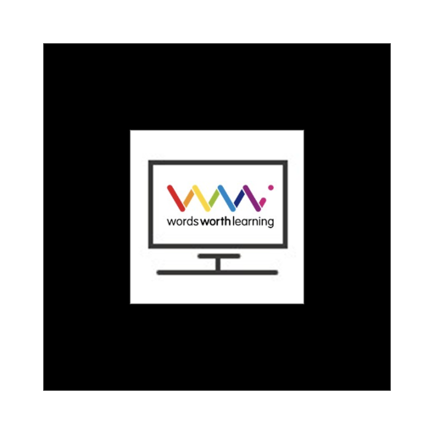
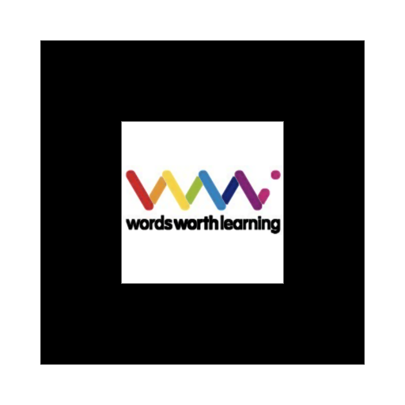
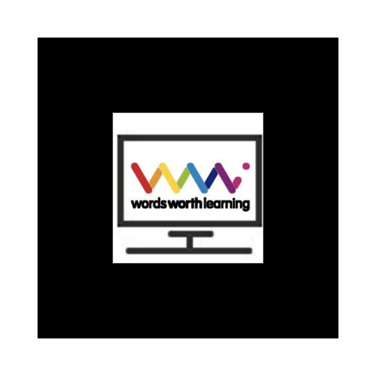
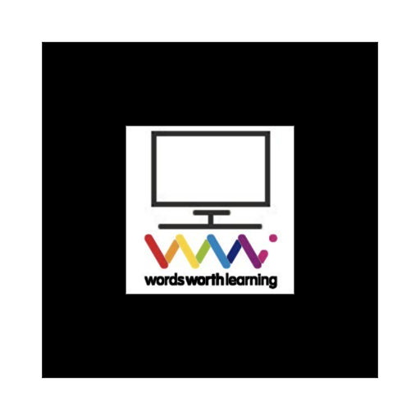
Marker A. Marker B. Marker C.
Marker D. Marker E. Marker F.

Marker A and marker B were also unable to be recognized by the detection algorithm. Even though the Marker C was able to be recognized by AR.js, the result was unsatisfying since the models appeared on top of the marker was constantly disappearing and reappearing which rendered it useless.

After this initial test I modified the company logo even further in GIMP and dilated the images to make it bolder and more noticeable on poorer light conditions. Marker D, E and F were all successful to be recognized by AR.js but the most useful and reliable one is the last one, Marker F, which was very stable. I made a couple tests with a new layout which I integrated the marker with WWL logo in as a content marker (Figure 2.) and tested hand gestures which was also pretty satisfying.
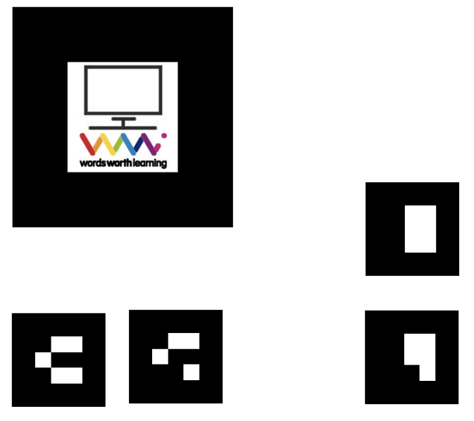

Figure 2.

I also made a few optimization in hand gesture recognition system which made it more tolerable for unwanted flickering of markers, making it a more smooth experience.
I also installed Unity in my system this week and started to work on an AR.js way of representing the reference materials.

